1. List of tickets:

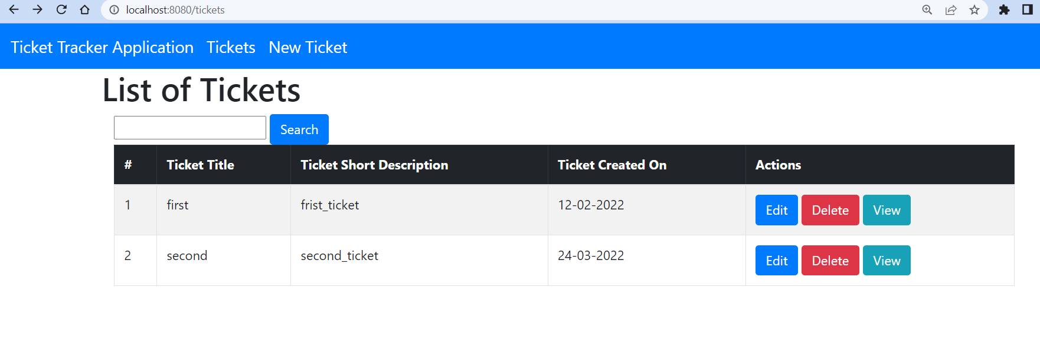

1. Create new ticket
2. 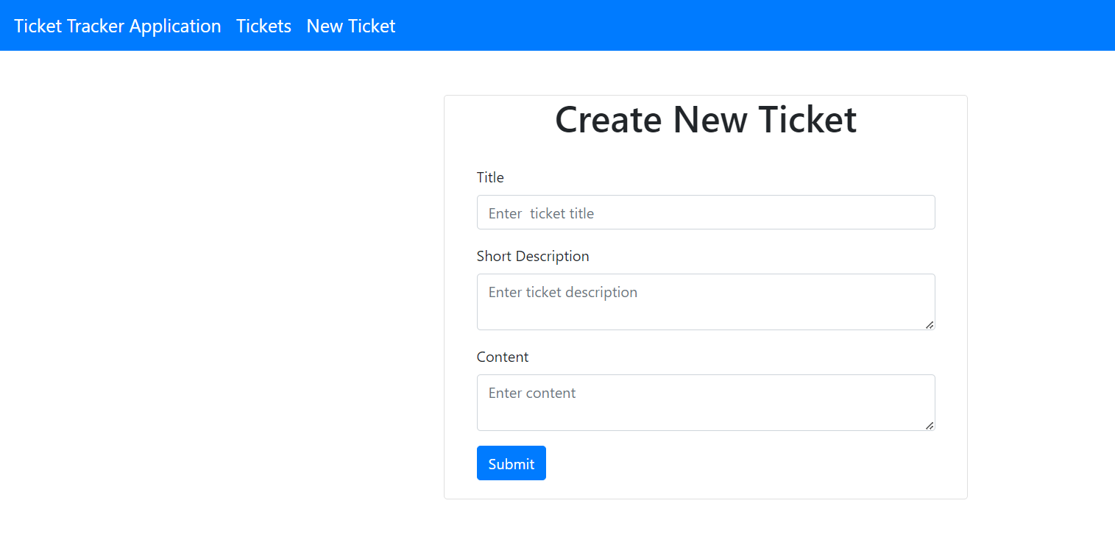

3.Edit Ticket:

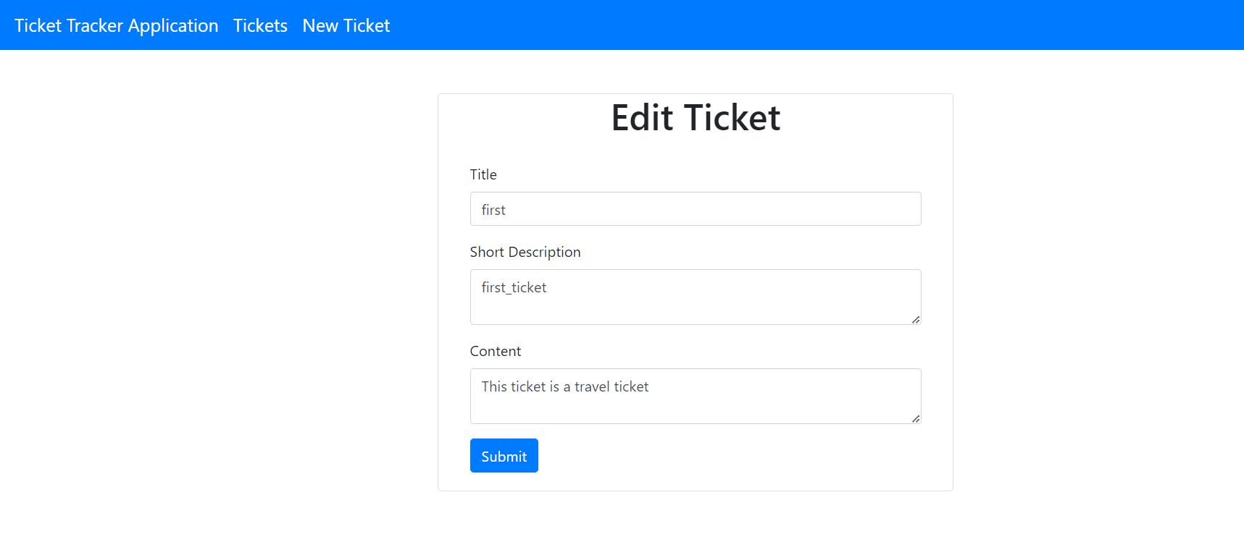

1. Search operation:
2. 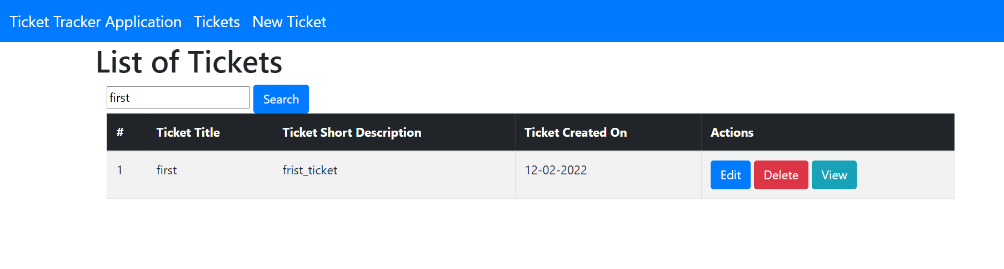

5.