FEATURES OF JAVA: [SOPSPRM]
-------------------------------
A list of most important features of java.
Simple:
- Simple to learn (Syntax's)
Object-Oriented:
- Object-oriented programming (OOPs) is a methodology that simplifies software development and maintenance by providing some rules.
Basic concepts of OOPs are: [IPEA]
- Object
- Class
- Inheritance
- Polymorphism
- Encapsulation
- Abstraction

Portable:
- Can be used with any other language.
Secured:
- any problem happens only JVM (JAVA VIRTUAL MACHINE) will get effected, but operating system is safe.
Platform independent:
- Java code can be run on multiple platforms, for example, Windows, Linux, Sun Solaris, Mac/OS, etc.
- Java code is compiled by the compiler and converted into byte code.
- This byte code is a platform-independent code because it can be run on multiple platforms, i.e., Write Once and Run Anywhere (WORA)
Robust:
- Most of things are automated Ex: garbage collection.
Garbage Collection:
It is the automated process of deleting code that's no longer needed or used.
Multithreaded:
- Running multiple processes (tasks) at same time.

----------------------- BASIC STRUCTURE OF PROGRAM -----------------------

public class Demo .......(1)
{
public static void main(String args[ ] ) .......(2)
{
System.out.println("This is my first program"); .......(3)
}
}

Every programme has 3 main parts:
1.CLASS DECLARATION
Ex: public class Demo
It consists of 3 things:
1.Access Modifier: -
- It indicates that program is accessible to other users or not.
- There are 4 access modifiers in java public, private, protected and default.
- in above section class is public so it is freely accessible
- All access modifiers will be in lower case.
2.class: -
- class is a keyword (reserve word or predefine word) in java.
- Every program must start with class keyword.
- all keyword must starts with smaller case so class-c is small.
3. class Name: -
- Every class has some name i.e. class name or program name or file name.
- class name for standard should start with Capital letter.
- Java File name and class name must be same for remembering purpose.
- class name can only be combination of A-Z,a-z,0-9,$,_
2.DEFINING MAIN METHOD
Ex: public static void main(String args[ ] )
{
/ / LOGIC OF APP
}
It consists of 5 parts
1.Access Modifier :
2.Non-Access Modifier:
static--------------> can be used without object creation.
non-static ---------> needs to be used with object creation.
3.return type:
void indicated no specific return type.
4.method name:
if anyword contains ()----> we can identified it as a method Ex: main( ),run( ),display( ) etc.
main is name of method.
5.command line arguments:
String args [] String - S is capital -This statement can be written in 3 ways.
1.String args []
2.String [] args
3.String[ ] args
Note: In syntax of main method only String-S is capital remaining all words starting letters are small.
3.PRINTING STATEMENT:
System.out.println("This is my sample program");
System------> it is a pre define class[class System]
.--------------> it is a dot operator, any word after it can be reference variable/object or method.
out-----------> it is an object (predefine)
println()----> it is a method (predefine)
- In simple println() is accessed through out object but out object is present in system class.
- System is a class which contains out object and out object is referring to println().
- whatever we gave in double quotes that message will be printed as it is.

Parts of java:
- J2SE/JSE (java 2 std edition) - Basic/core java.
- J2EE/JEE (java 2 enterprise edition) - Full stack development.
- J2ME/JME (java 2micro edition).
Architecture of Java:

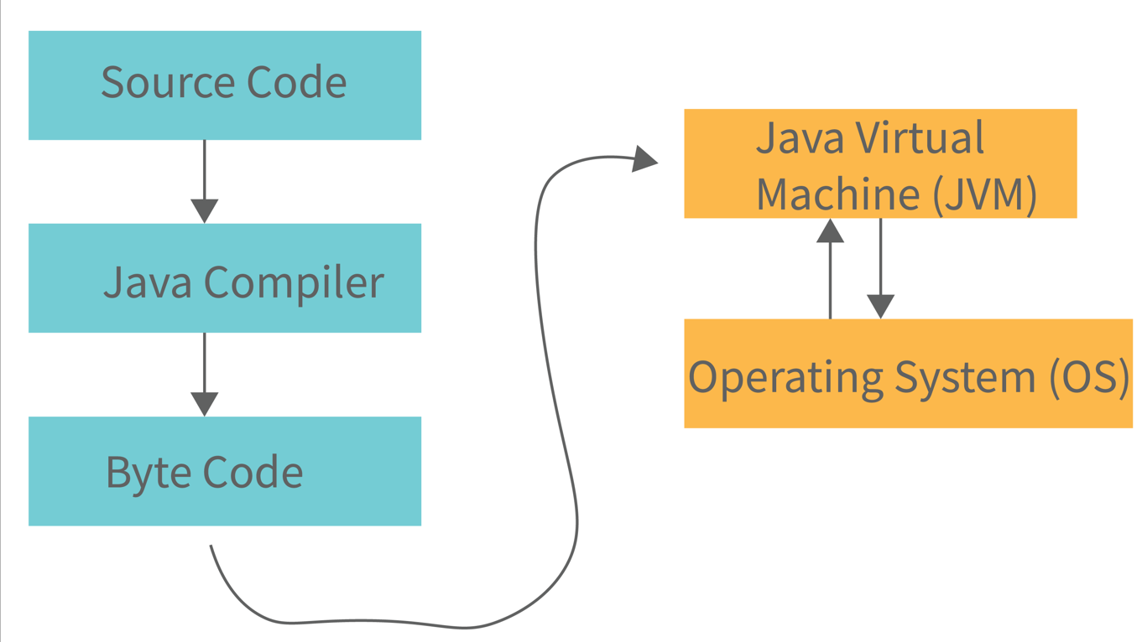

Step-1:
-whatever program we write it is called as source code.
-source code should always save as ext ".java"
-above program should save as Hello.java
Step-2: Compilation
-The process of converting our program into system understandable form (byte code) is purpose of compiling a program.
-to compile a program, go to cmd prompt and enter command as
-javac programname.java
-Ex: javac Hello.java
-Compilation is done at once.
-During compilation, compiler will check syntax errors like [ ], ;,(),{ },:,spellings and case sensitivity.
-If anything is wrong we will get compile time error.
-If nothing is wrong there is one class file get generated (byte code file) with same
as .class
Step-3: Execution
-JVM -java virtual machine is responsible for execution of every java program.
-JVM's can identify by ------> Public static void main (String [ ] args).
-it is like one software or one program.
-execution will happen in line-by-line manner.
-during execution JVM will find logical error of program.
-for executing program go to command prompt and enter command as
-java program_name
-Ex: java Hello
-Once we enter this command JVM will go to class file and take first line and give to operating system for execution, once OS responds that i understood that line and it sends second line and it continues till last line like this whole code of class file gets executed.

JDK-JAVA DEVELOPMENT KIT
- IF WE WANT TO DEVELOP AND EXECUTE JAVA PROGRAM IN OUR SYSYTEM WE HAVE TO INSATLL JDK(JRE,JVM,SUPPORTING TOOLS AND SUPPORTING CLASSES).
