**Ethereum Dapp for Tracking Items through Supply Chain – Project WriteUp**

**Activity Diagram**

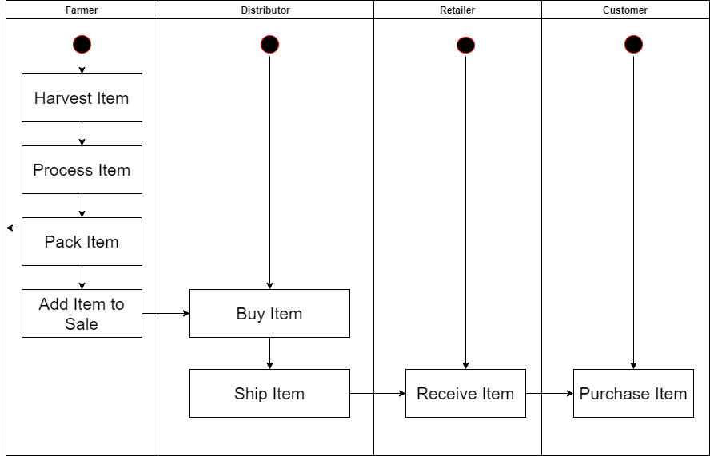

**Sequenc Diagram**

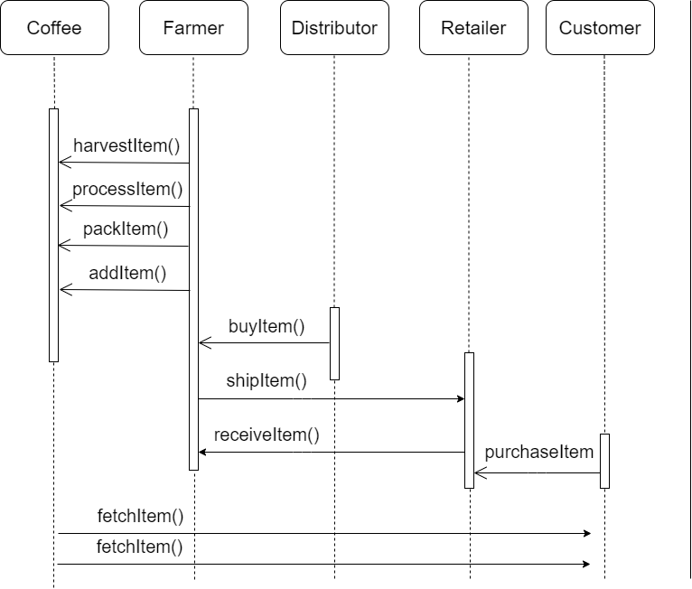

**State Diagram**

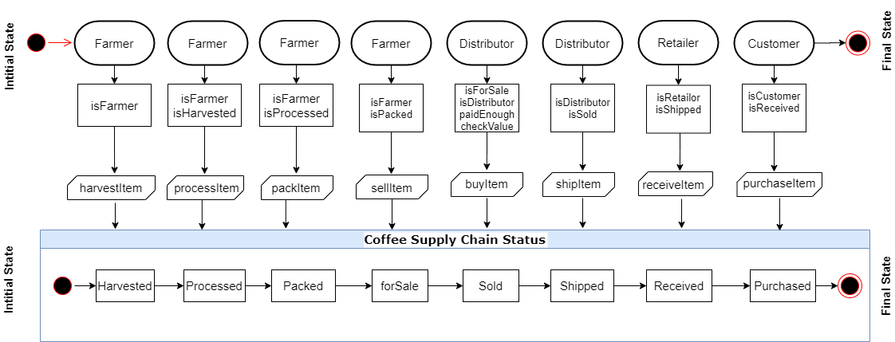

**Class Diagram**

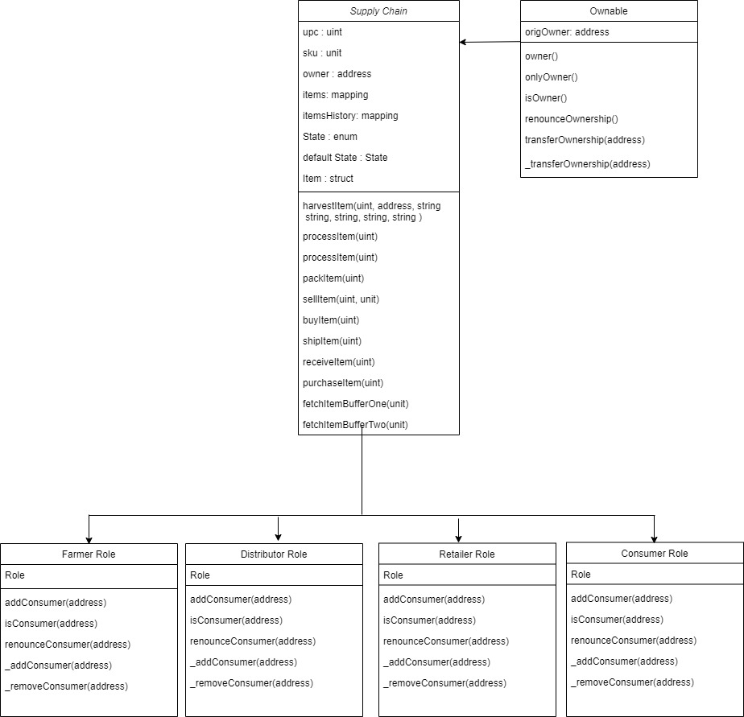

**Packages Used :**

truffle-hdwallet-provider- HD Wallet-enabled Web3 provider used for signing transactions

**IPFS Not used in the project**

**Rinkeby Contract code :**

**Version 1:**

<https://rinkeby.etherscan.io/address/0x2b20cb29c73a9f6365356bfd6a326b12b5af721c>

version 2:

Contract address: 0xc19f40aAD60ffC5ca5EC047d5d7a8fBb37794089

Transaction hash:

0x523911e3d1fadfc53a8e60ef3e09c95972f65d798f7e1b6a8f294a2c9b43b9fa

**Snap shot of the rinkeby deployment**

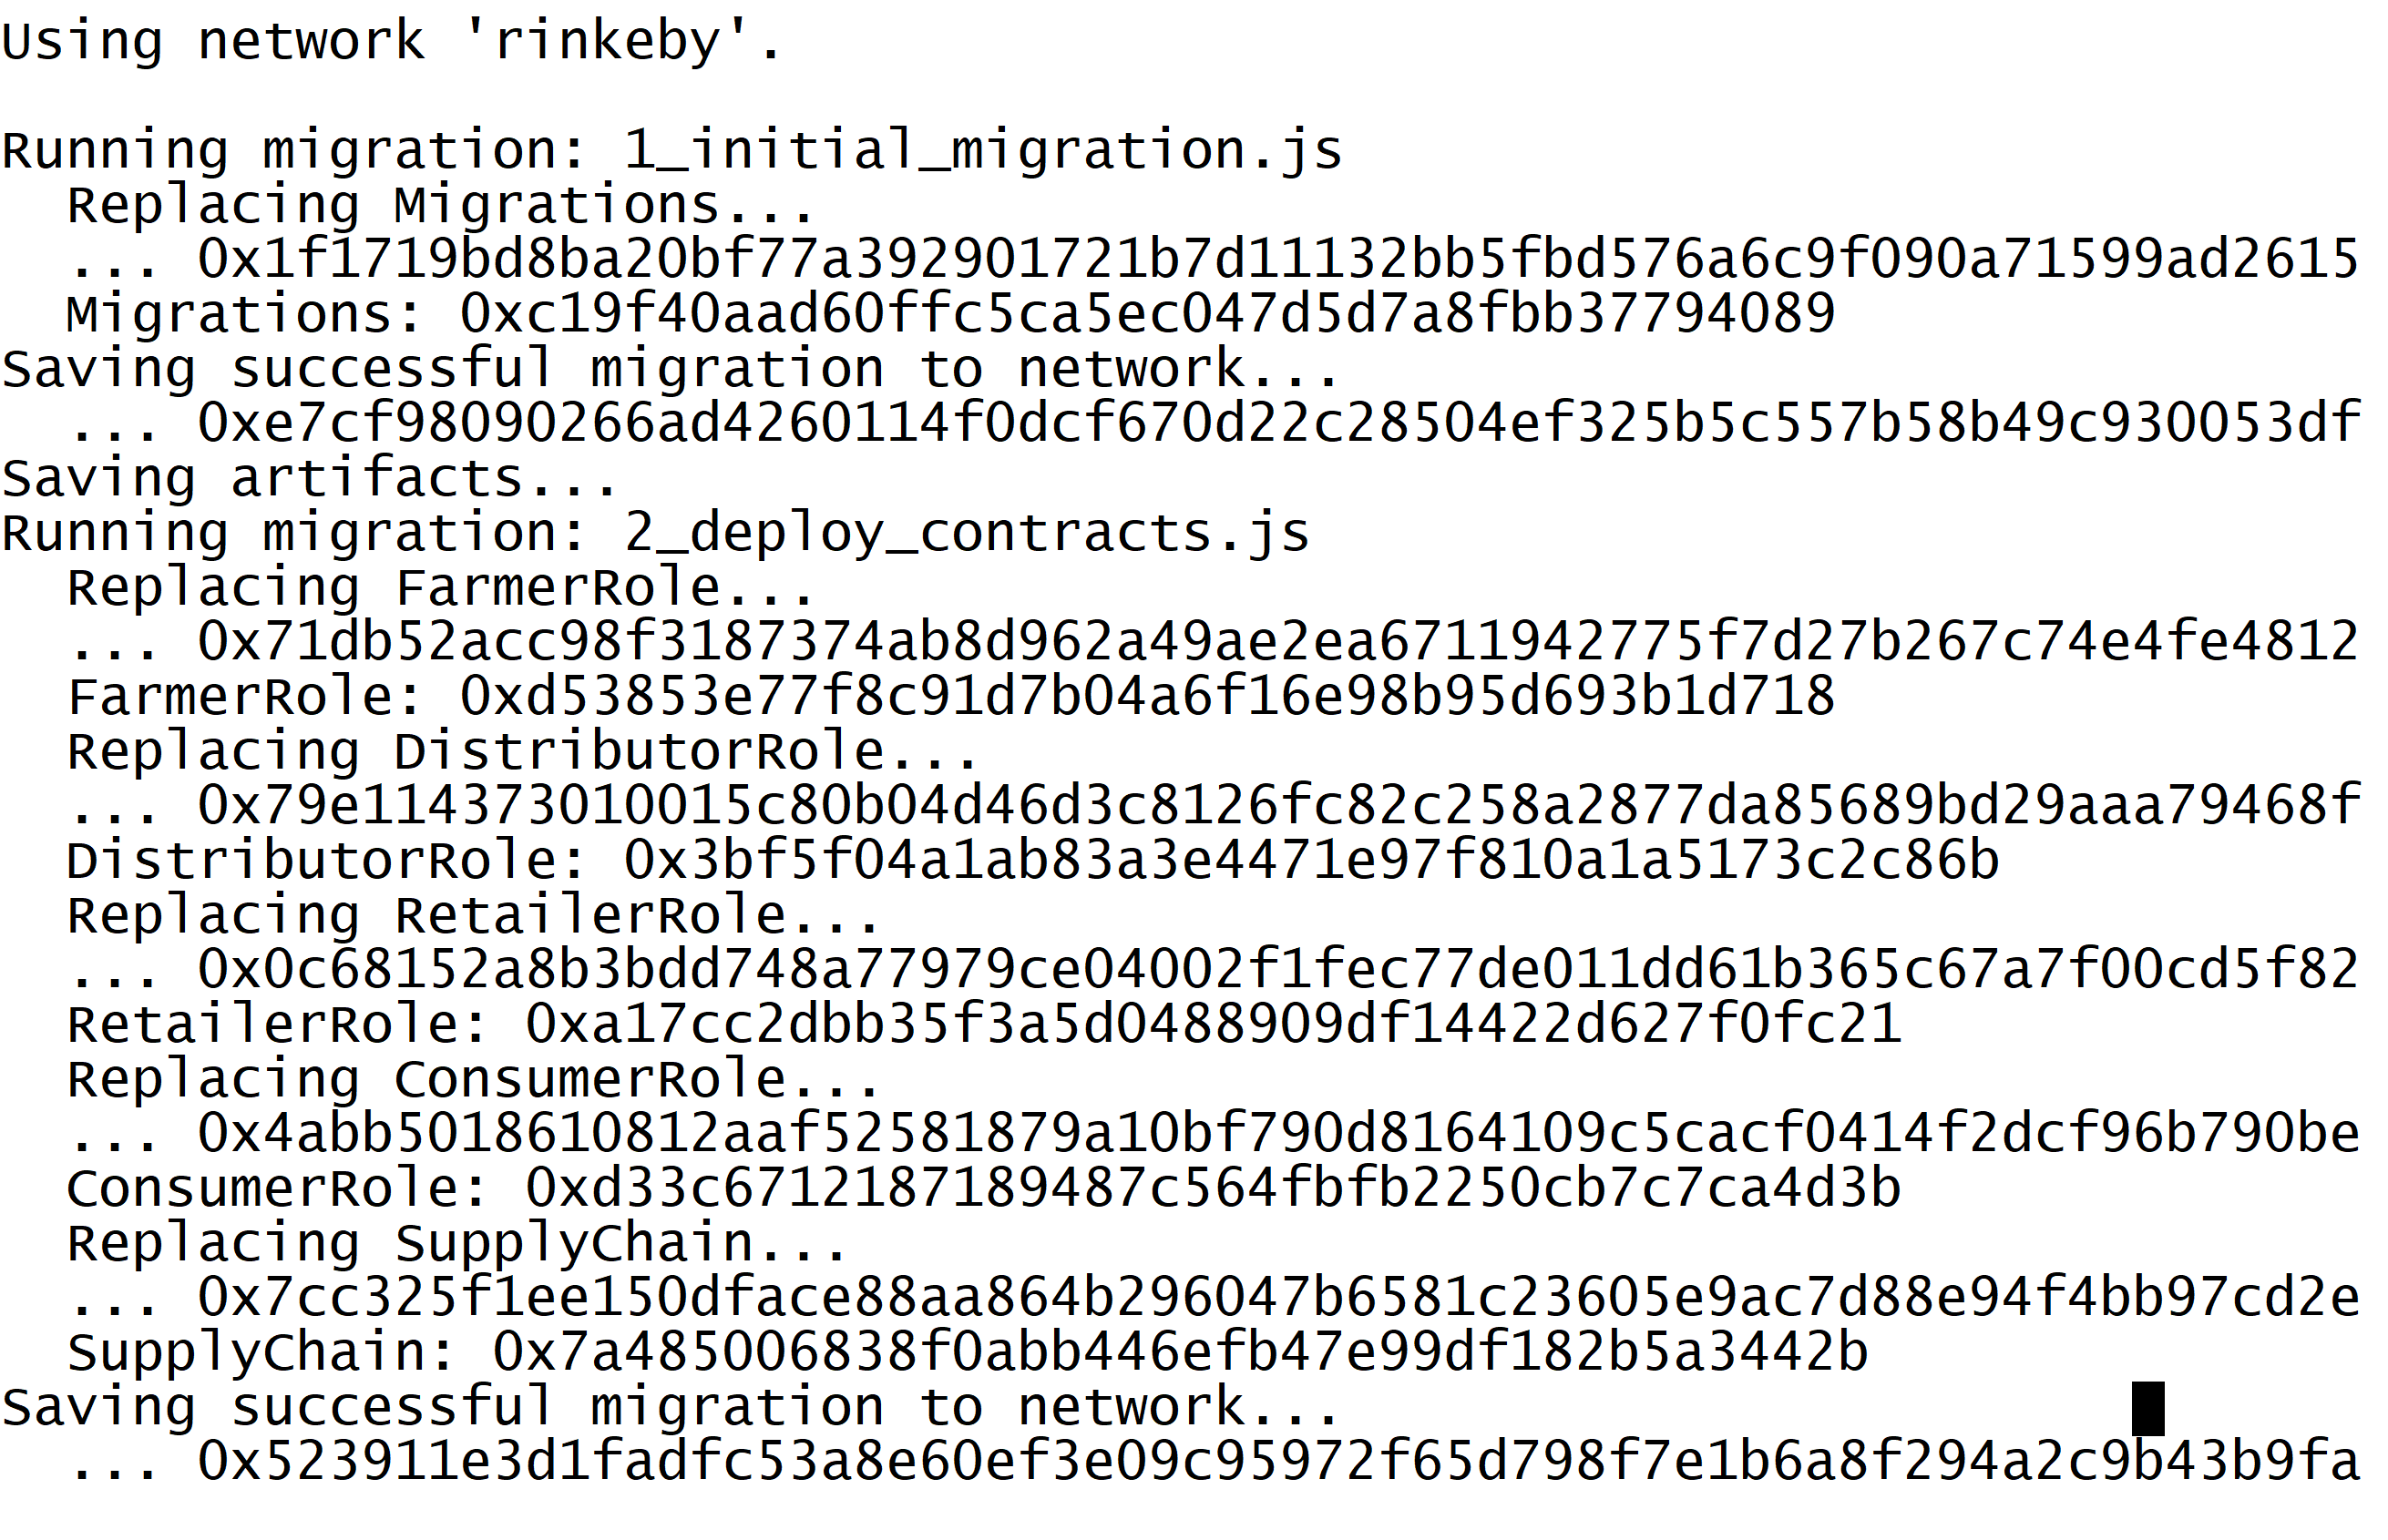

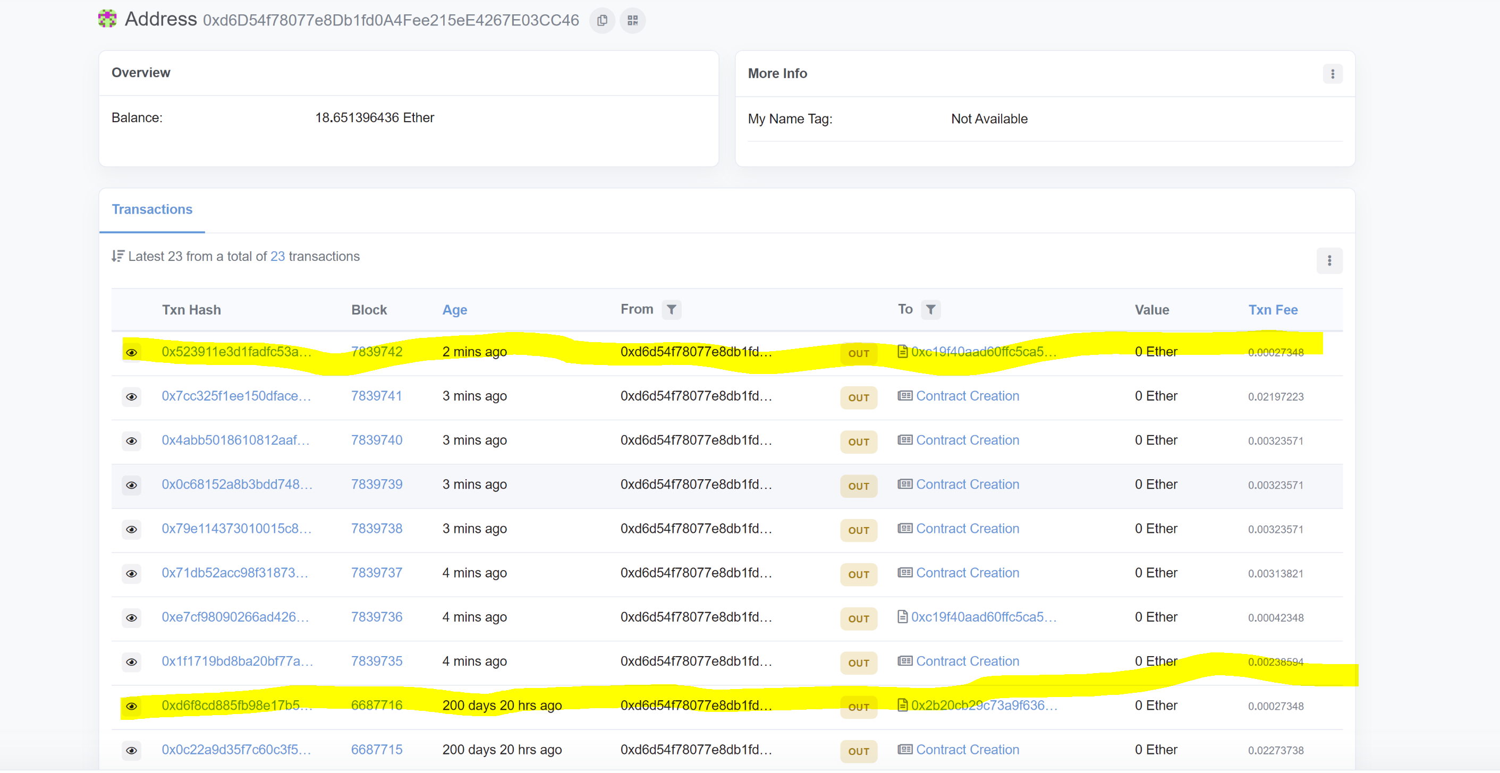

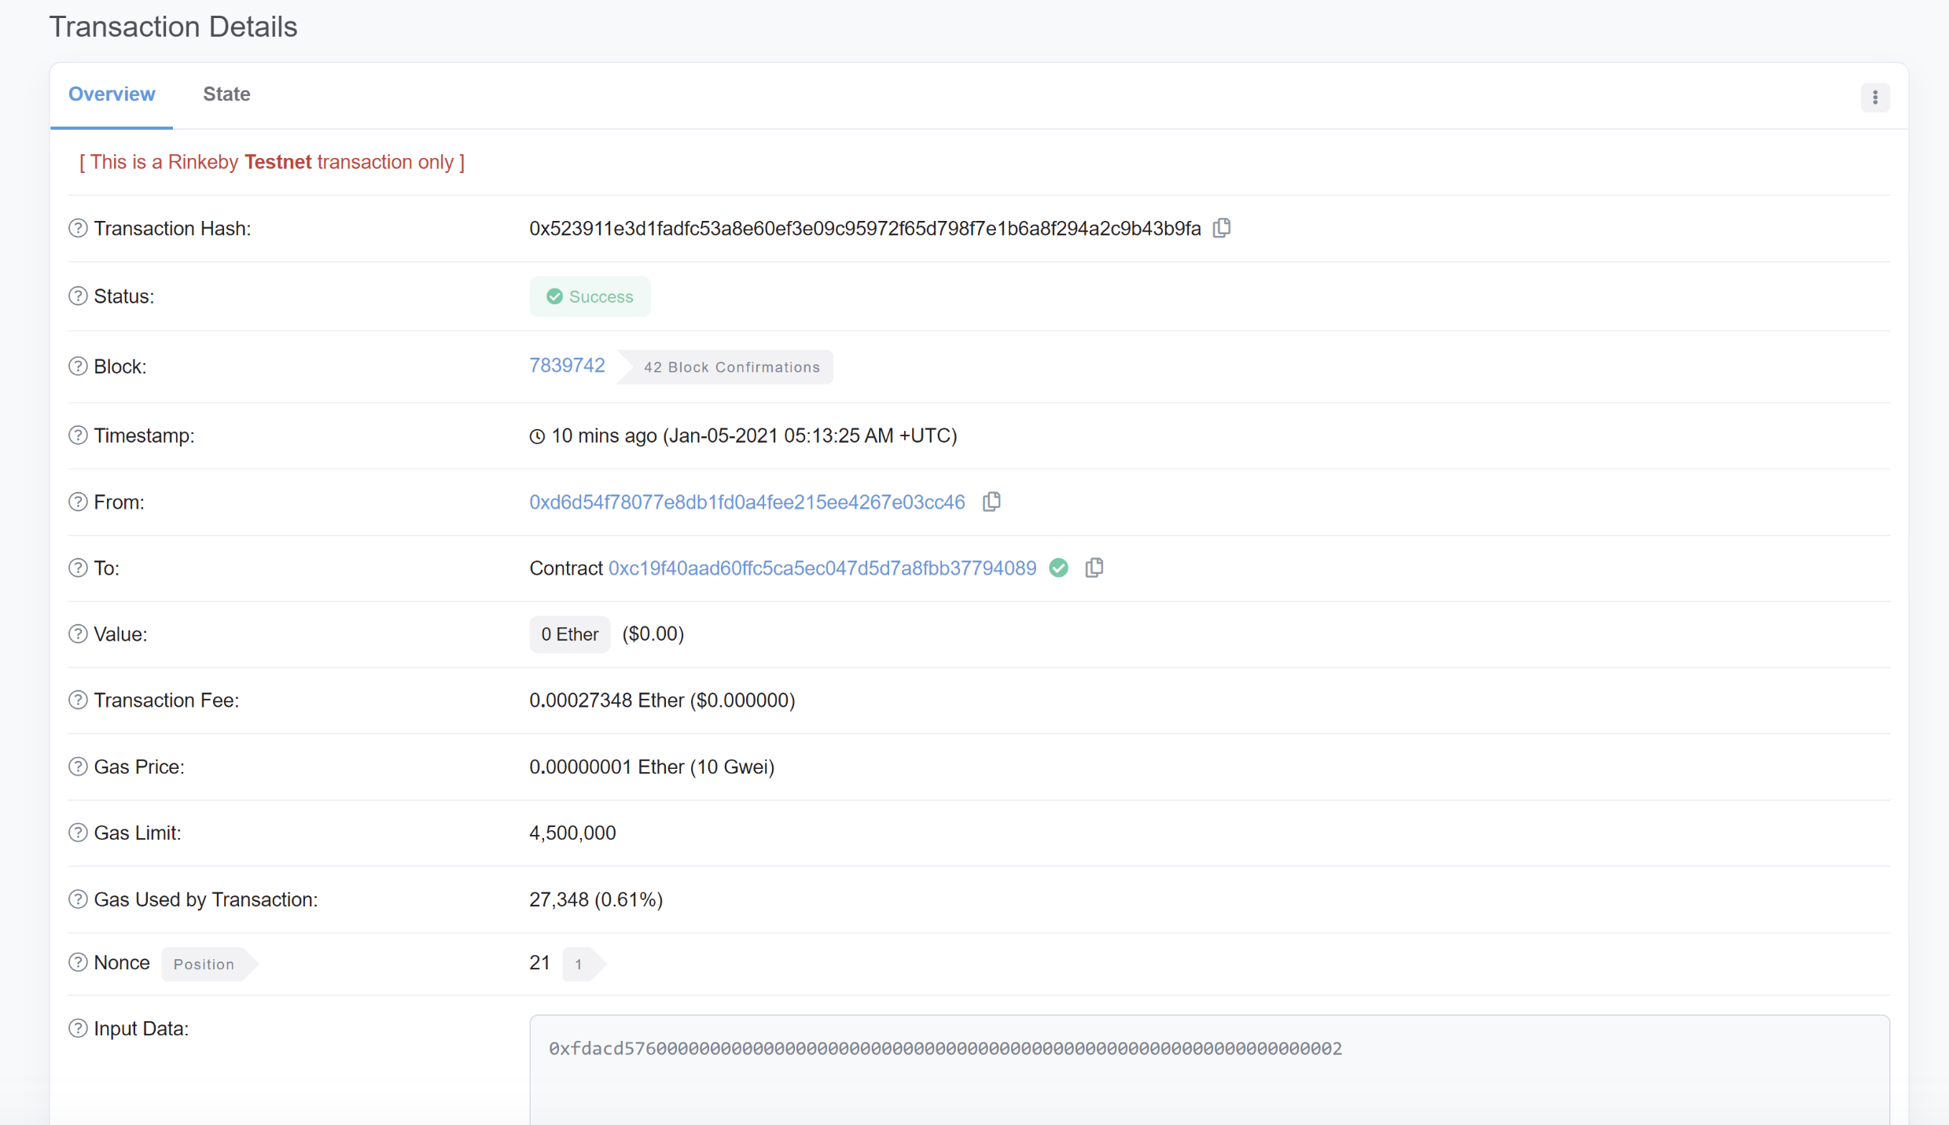

Testing and Running the Code on local truffle

Step1 : Navigate to the project directory in command prompt and type **truffle develop**

Step2: type **Compile –** No errors returned and compiled successfully

Step 3- test

Step3: type **Test – Screen shot attached below.**

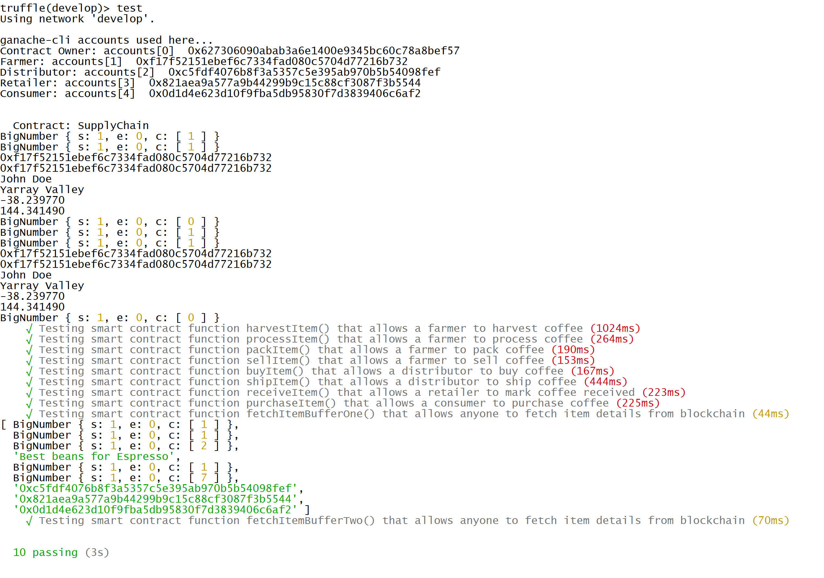

**Step 4 : migrate –reset**

**Step 5: open a new cmd window and type npm run dev**

**The web application is hosted and can be accessed via bowser as shown below.**

