**Cloud Front**

*Amazon CloudFront is a web service that speeds up distribution of your static and dynamic web content, such as .html, .css, .js, and image files, to your users. CloudFront delivers your content through a worldwide network of data centers called edge locations. When a user requests content that you’re serving with CloudFront, the user is routed to the edge location that provides the lowest latency (time delay), so that content is delivered with the best possible performance. If the content is already in the edge location with the lowest latency, CloudFront delivers it immediately. If the content is not in that edge location, CloudFront retrieves it from an Amazon S3 bucket or an HTTP server (for example, a web server) that you have identified as the source for the definitive version of your content.*

Go to services🡪 Cloud Front 🡪 Create Distribution 🡪

<https://codeburst.io/deploy-angular-2-node-js-website-using-aws-1ac169d6bbf>

Click on Create Distribution 🡪 Web 🡪 Get started.

Enter the values shown like in the screenshot.

**Create new Origin with Origin domain name:** select the s3 bucket name you deployed from the dropdown. And Redirect Http to Https and select all REST methods. **Configure index.html file in Default root object text field.**

Need not change any other options.

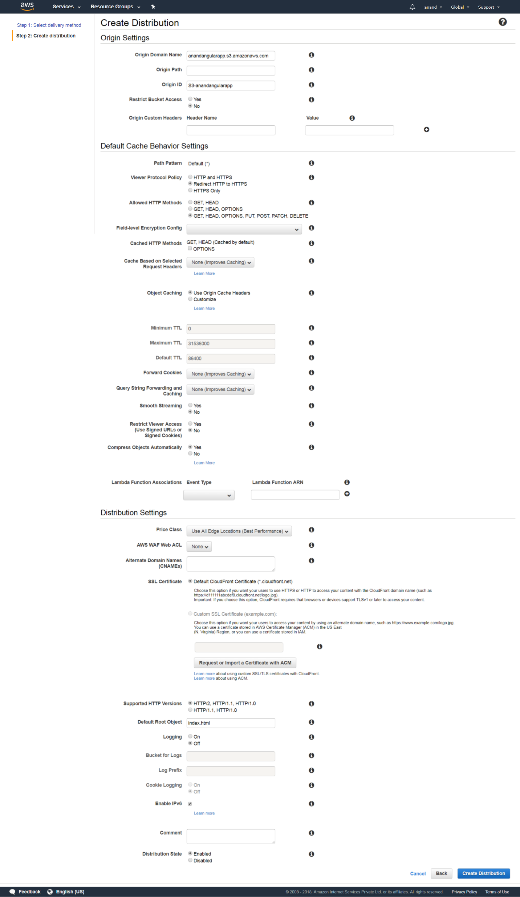

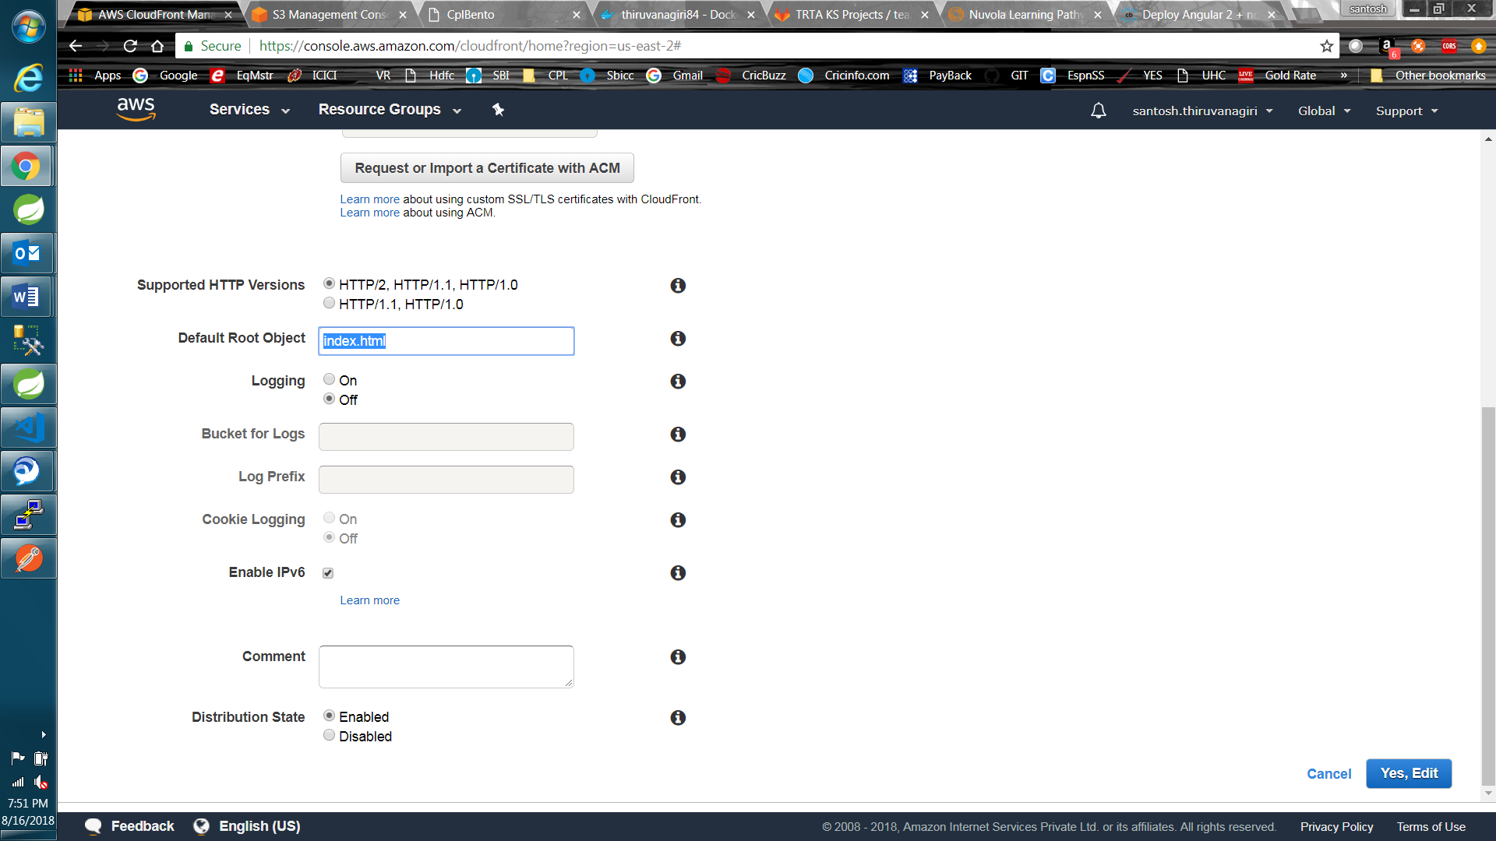

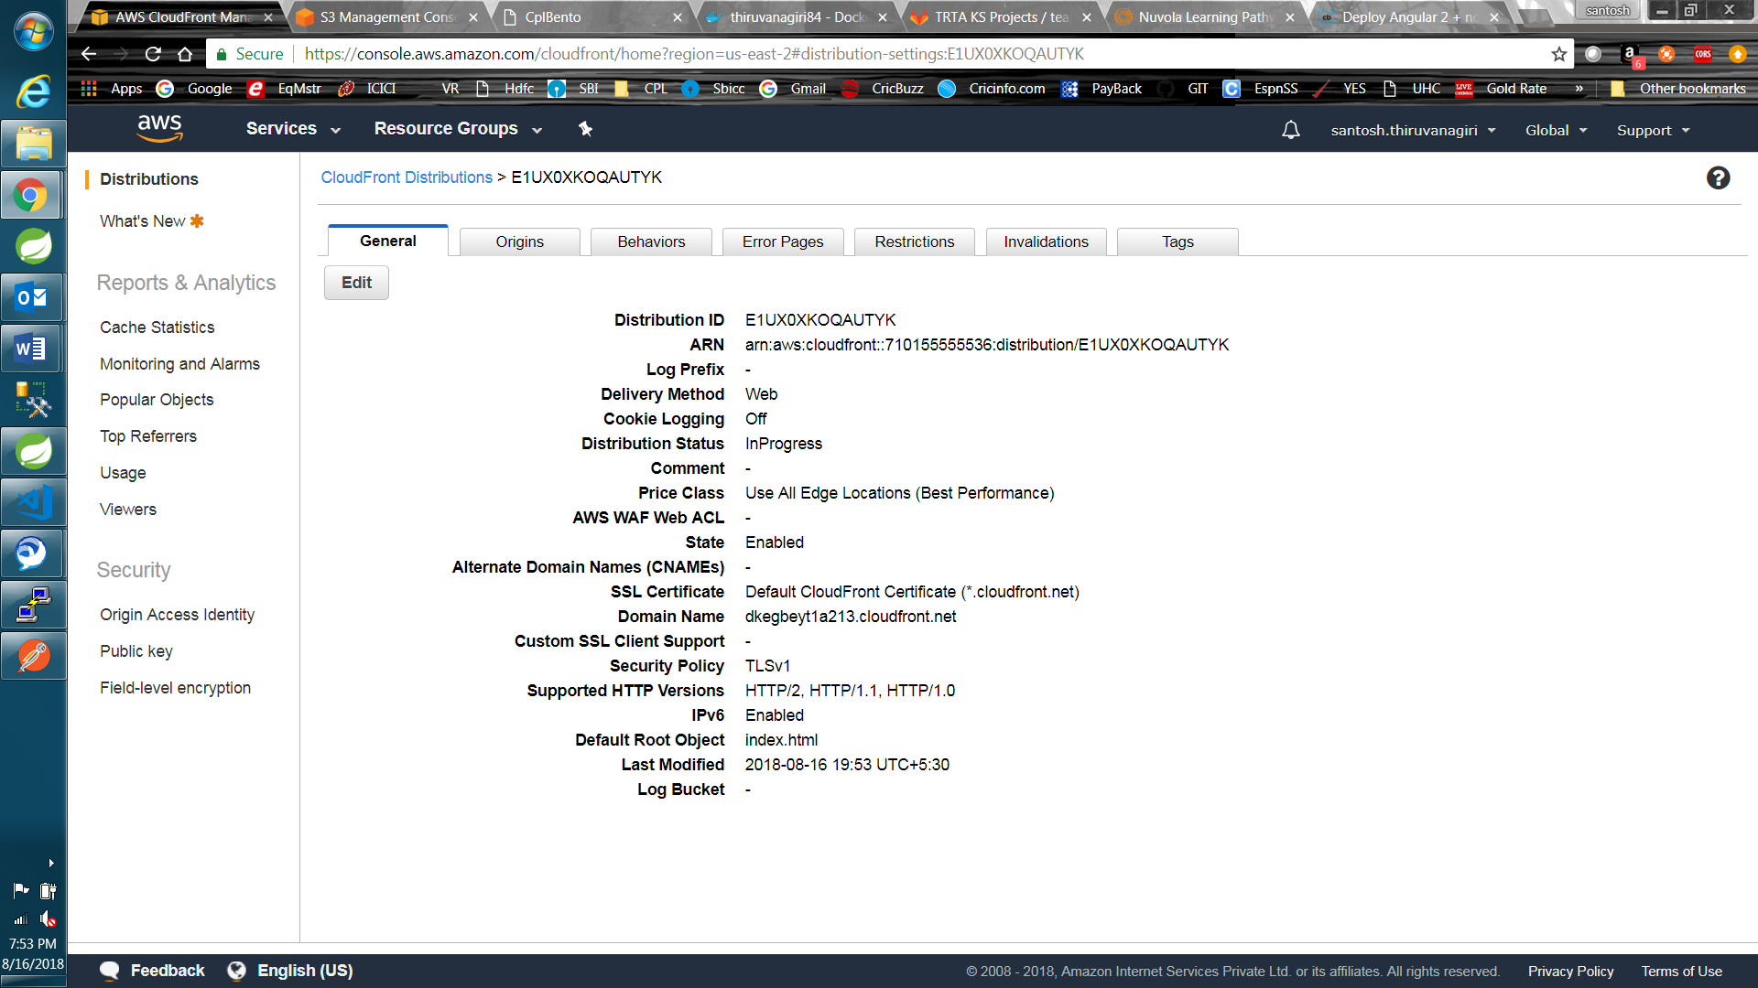

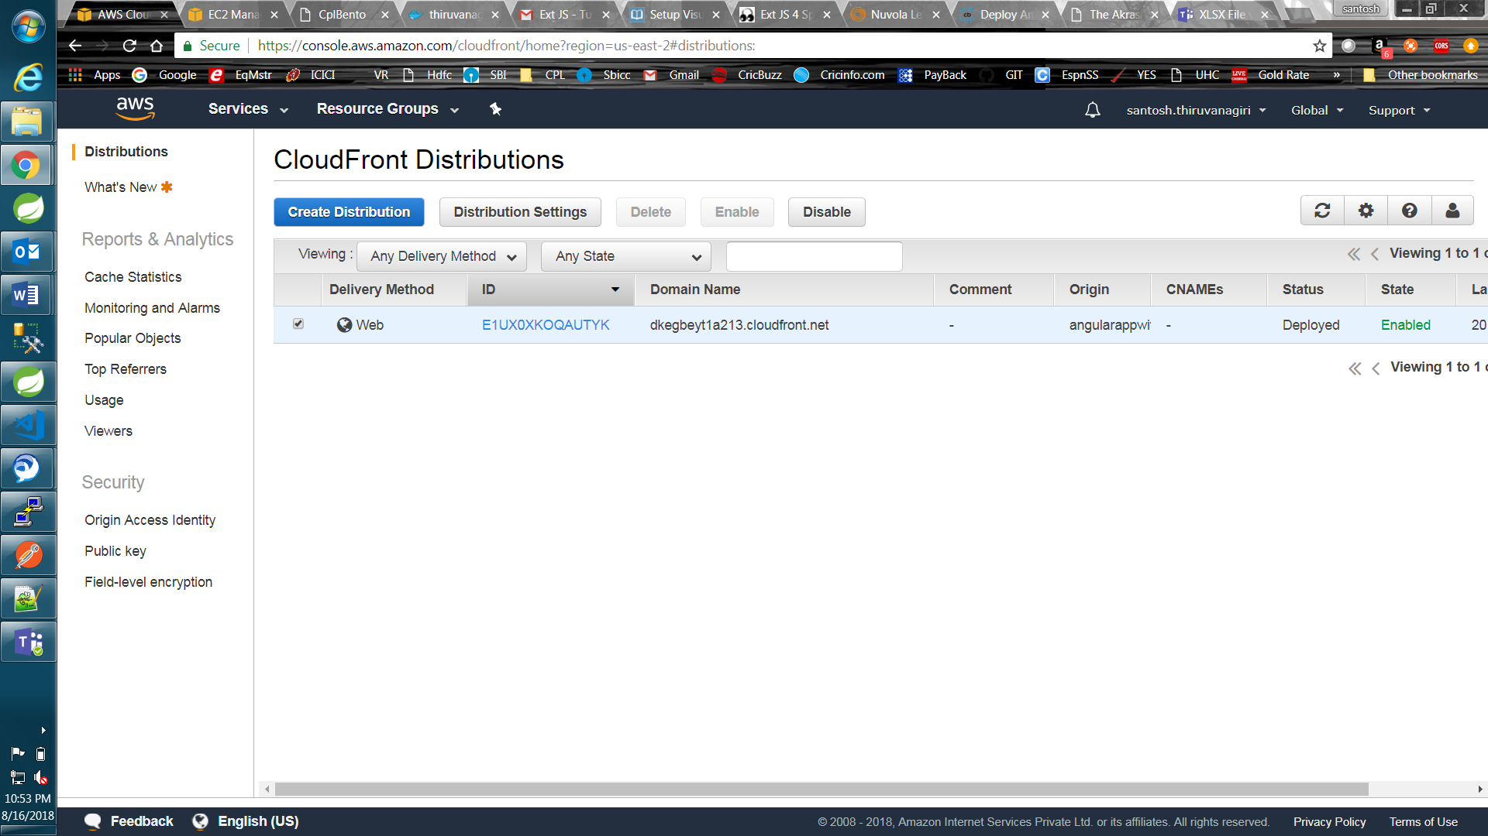

Now Just copy paste the Domain name mentioned in above screenshot as the url in browser:

<https://dkegbeyt1a213.cloudfront.net>

This should open the angular app same like from S3 bucket static web hosting url. Until now we didn’t configure Ec2.

Now Click on the above cloud front distribution ID and navigate to Origin Tab.

Click Create New origin: This is for ec2 instance to navigate the api’s. Give the complete domain name of Ec2 instance in the Origin Domain name as shown. And click Create. This will create new origin as shown

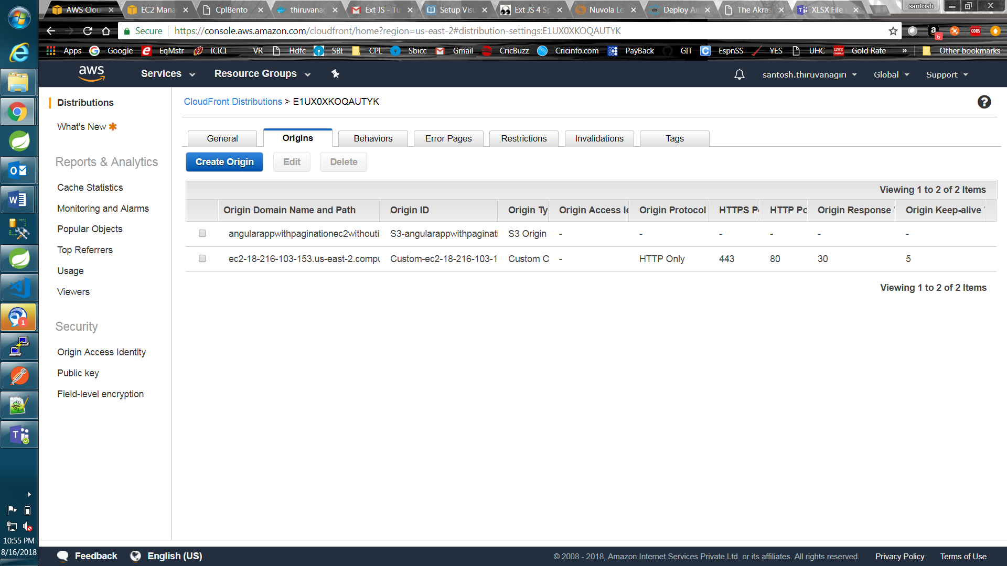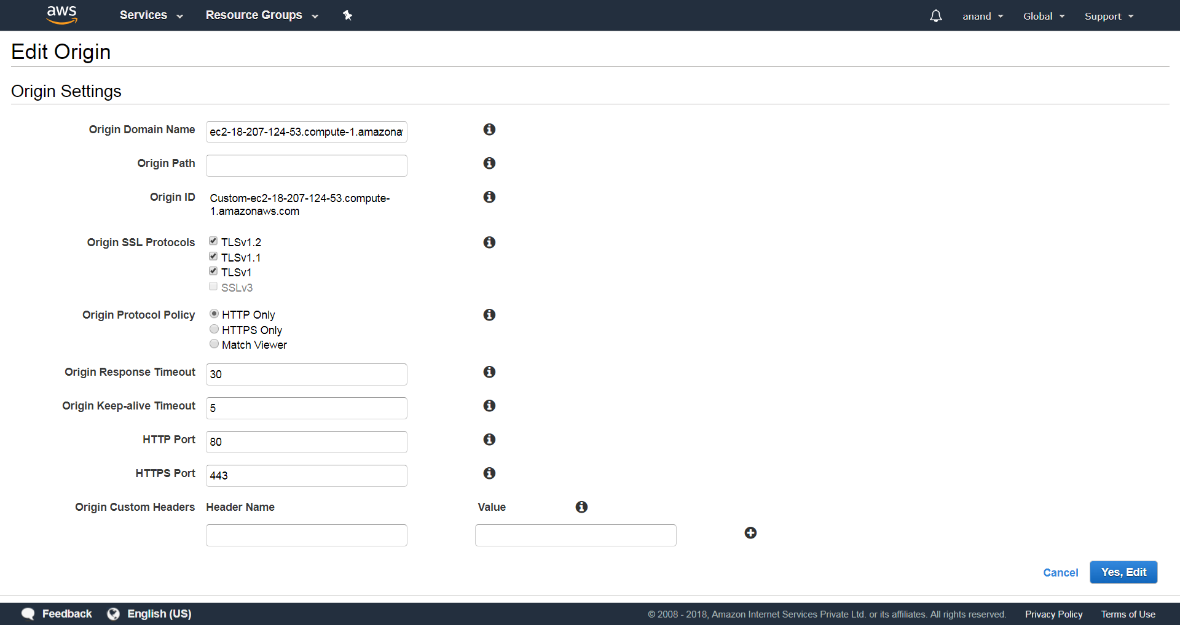

Now Navigate to Behavior tab of the same cloud front distribution.

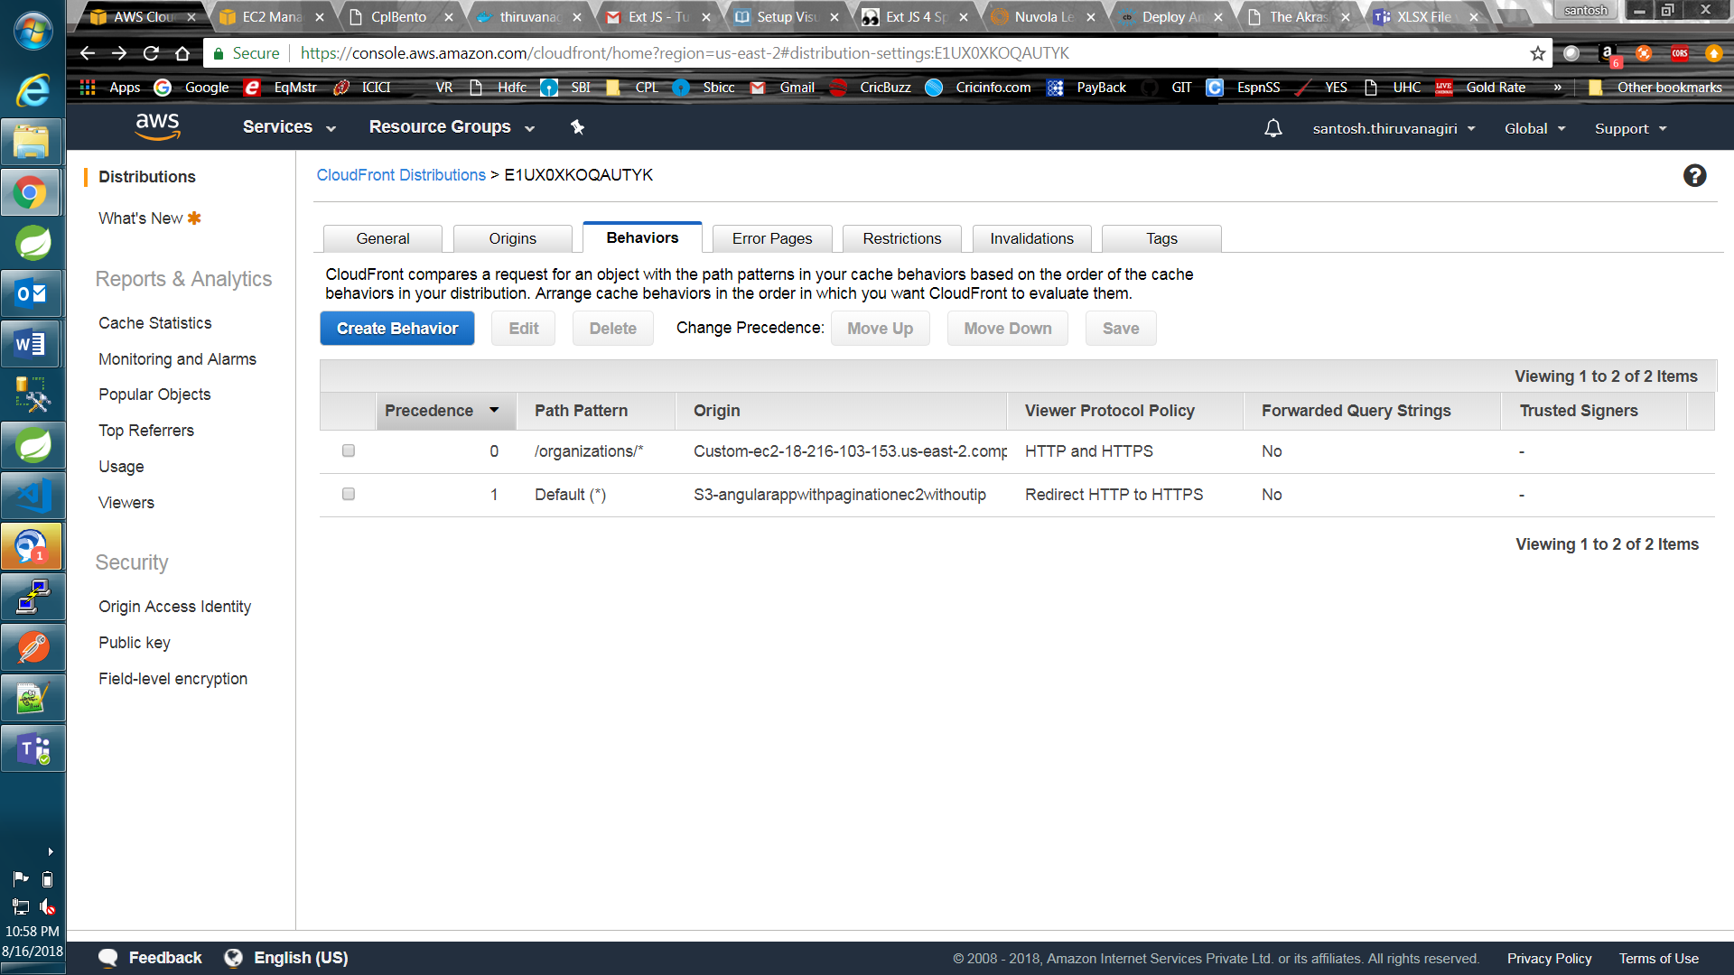

Add the Custom behavior for mapping api url to EC2 instances.

Add the api url as path pattern and select appropriate options as shown in the screen shot.

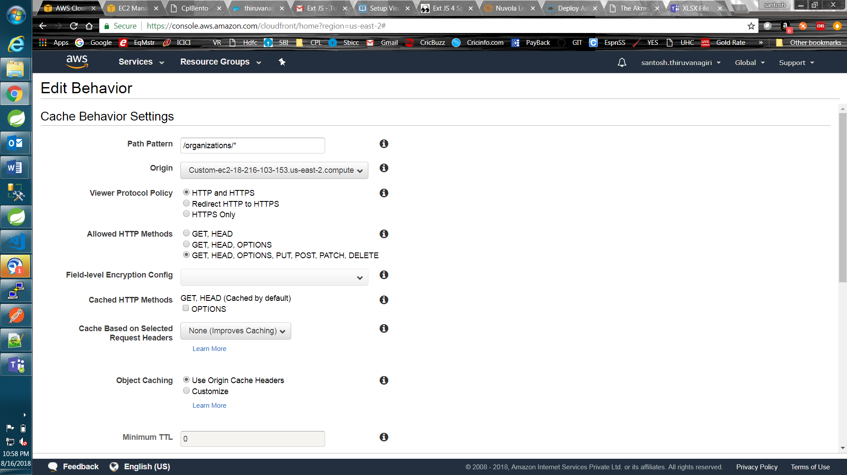

Then it will take some time to create the cloudfront(20min) .Then we can the access the angular app and we should be api’s from the angular app. Make sure Ec2 instance is up and docker container is up and also load balance nginx service is started (sudo service nginx start)

Finally, When you click on the ID of CloudFront, this is what we see, the configurations:

General:

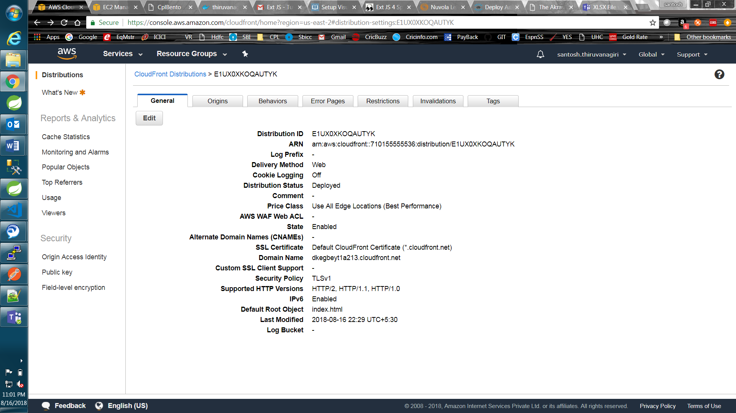

Origins:

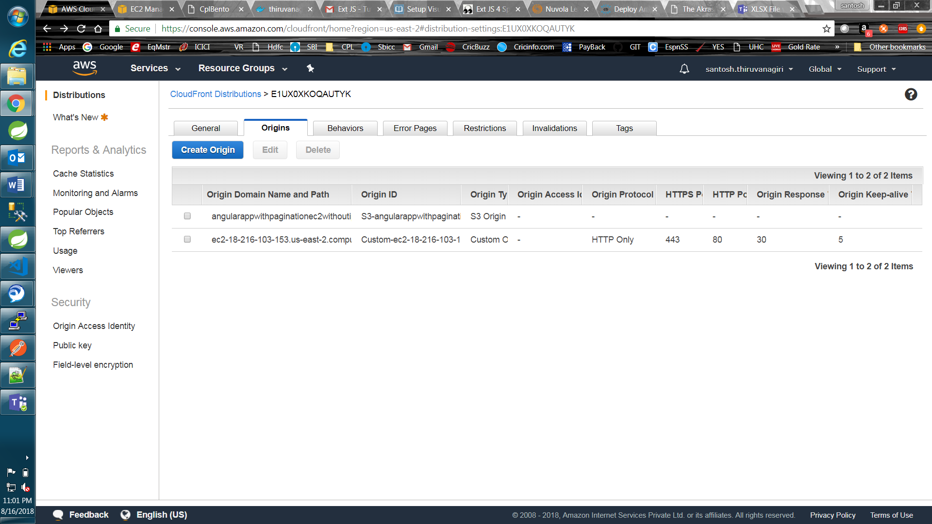

Behaviors:

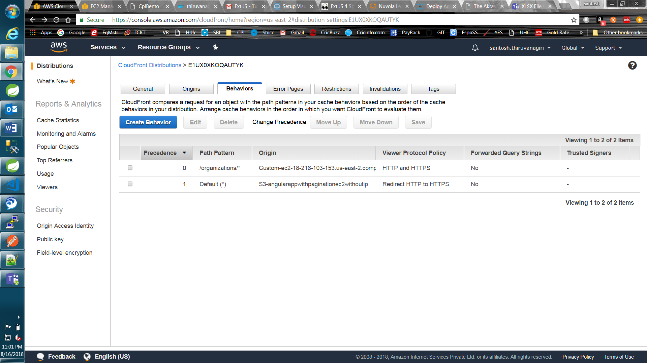

That’s it !!

