**Cloud Front**

*Amazon CloudFront is a web service that speeds up distribution of your static and dynamic web content, such as .html, .css, .js, and image files, to your users. CloudFront delivers your content through a worldwide network of data centers called edge locations. When a user requests content that you’re serving with CloudFront, the user is routed to the edge location that provides the lowest latency (time delay), so that content is delivered with the best possible performance. If the content is already in the edge location with the lowest latency, CloudFront delivers it immediately. If the content is not in that edge location, CloudFront retrieves it from an Amazon S3 bucket or an HTTP server (for example, a web server) that you have identified as the source for the definitive version of your content.*

Go to services🡪 Cloud Front 🡪 Create Distribution 🡪

<https://codeburst.io/deploy-angular-2-node-js-website-using-aws-1ac169d6bbf>

enter the values shown like in the screenshot.

Origin domain name: select the s3 bucket name you deployed in the dropdown

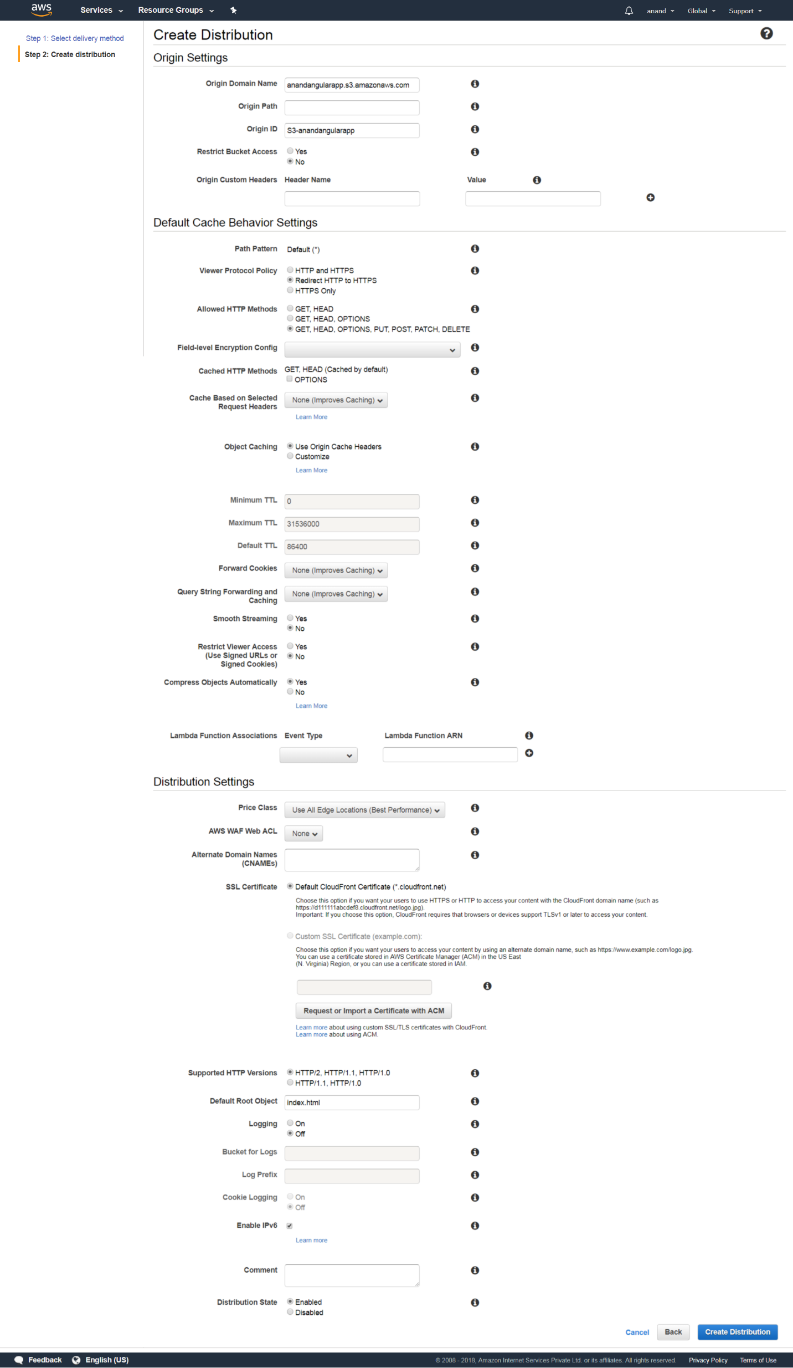

`Create origin for ec2 instance to navigate the api’s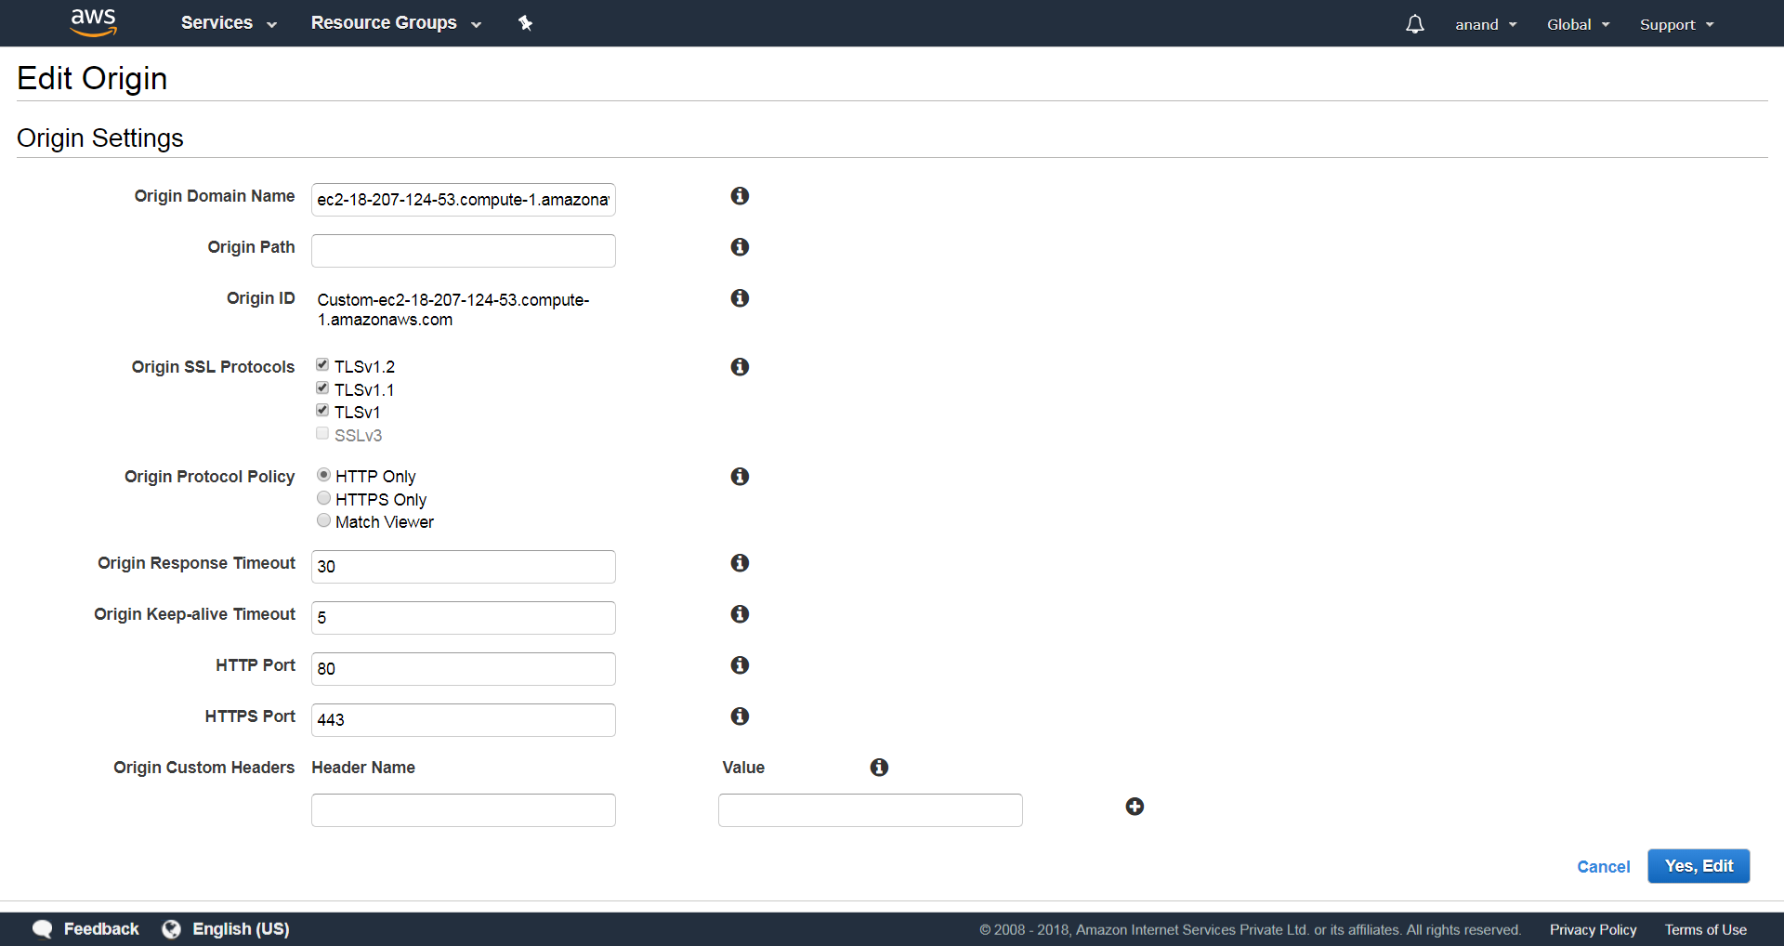

Custom behavior for mapping api url to EC2 instances.

Add the api url as path pattern and select appropriate options as shown in the screen shot.

Then it will take some time to create the cloud formation.

Then we can the access the angular app and we should be api’s from the angular app

