RESEARCH PAPER

zkVM Security Best Practices
and Common Vulnerabilities

Essential security patterns and anti-patterns when building
zero-knowledge virtual machines

Based on research from zkSecurity, Veridise, and industry audits

Abstract
Zero-knowledge virtual machines (zkVMs) have emerged as a transformative technology for verifiable computation, enabling developers to prove the correct execution of arbitrary programs without revealing sensitive inputs. This research paper provides a comprehensive examination of security considerations specific to zkVM development, covering the technical architecture, threat models, common vulnerabilities, and best practices for secure implementation. Drawing from authoritative sources including zkSecurity, Veridise audit reports, and real-world vulnerability disclosures, we explore the unique attack surfaces introduced by the host-guest architecture, the critical importance of input commitment mechanisms, and the security implications of state continuity in sequential proof systems. This paper serves as both an educational resource and a practical guide for developers, security researchers, and architects working with zkVM technology.

Table of Contents

Abstract 1
Table of Contents 2
1. Introduction to zkVM Security 3
2. Technical Foundation: How zkVMs Work 4
2.1 Host-Guest Architecture Security Implications 5
3. Understanding the zkVM Threat Model 6
4. Common Security Vulnerabilities 7
5. Security Best Practices 9
6. Anti-Patterns to Avoid 10
7. Testing and Auditing Strategies 11
8. Future Considerations 12
9. Conclusion 12
References 13

Note: Right-click and select 'Update Field' to refresh page numbers

1. Introduction to zkVM Security
A zkVM (Zero-Knowledge Virtual Machine) uses zero-knowledge proofs to prove and verify computations run on a specific Instruction Set Architecture (ISA). Existing zkVM implementations have taken different architectural approaches: RISC Zero, SP1, and Jolt target RISC-V architecture, ZKM uses MIPS, while Valida employs a custom instruction set optimized for proving efficiency. These systems allow developers to write programs in high-level languages like Rust or C++ without needing to understand the complexities of zero-knowledge proofs, abstracting away the underlying cryptographic details.
However, while zkVMs simplify development, they are still complex systems that integrate many technical components—from compilers to proof systems and on-chain verification. A single bug in any of these components can lead to catastrophic security failures. According to research from argument.xyz, "every month, there should be at least a dozen new vulnerabilities likely to lead to an exploit in a formally verified RISC-V ZKVM." Understanding the complete technology stack behind zkVMs is crucial for builders to create secure systems and for users to evaluate the reliability of applications they rely on.
The security model of a zkVM fundamentally differs from conventional computing environments. While the zkVM framework ensures that the execution trace is correctly proven, application-level bugs can still lead to proofs of incorrect computations. A vulnerability in guest program logic will produce a valid proof of an incorrect result—the proof system guarantees that the code executed as written, not that the code was correct. This distinction is critical: zkVMs provide computational integrity, not semantic correctness.

2. Technical Foundation: How zkVMs Work
The zkVM workflow consists of four main phases: compilation, execution, proving, and verification. In the compilation phase, programs written in high-level languages are compiled to assembly code targeting the zkVM's specific ISA. RISC Zero and SP1 target riscv32im (32-bit RISC-V with integer multiplication), while SP1 additionally supports riscv32imac (with atomic and compressed instructions). During execution, the VM interprets instructions to generate an execution trace—a sequence of steps where each step represents an instruction with operands and read/write actions to registers and memory.
The proving phase validates the execution trace through constraints expressed in Algebraic Intermediate Representation (AIR). These constraints enforce three critical properties: instruction execution correctness (e.g., add 1 2 produces 3), memory consistency (reads return the most recently written values), and control flow integrity (correct instruction sequencing). To improve prover speed, many zkVMs split traces into segments for parallel proving, then combine them. RISC Zero uses a STARK-to-SNARK circuit to verify STARK proofs within a Groth16 verifier, reducing on-chain verification gas costs.
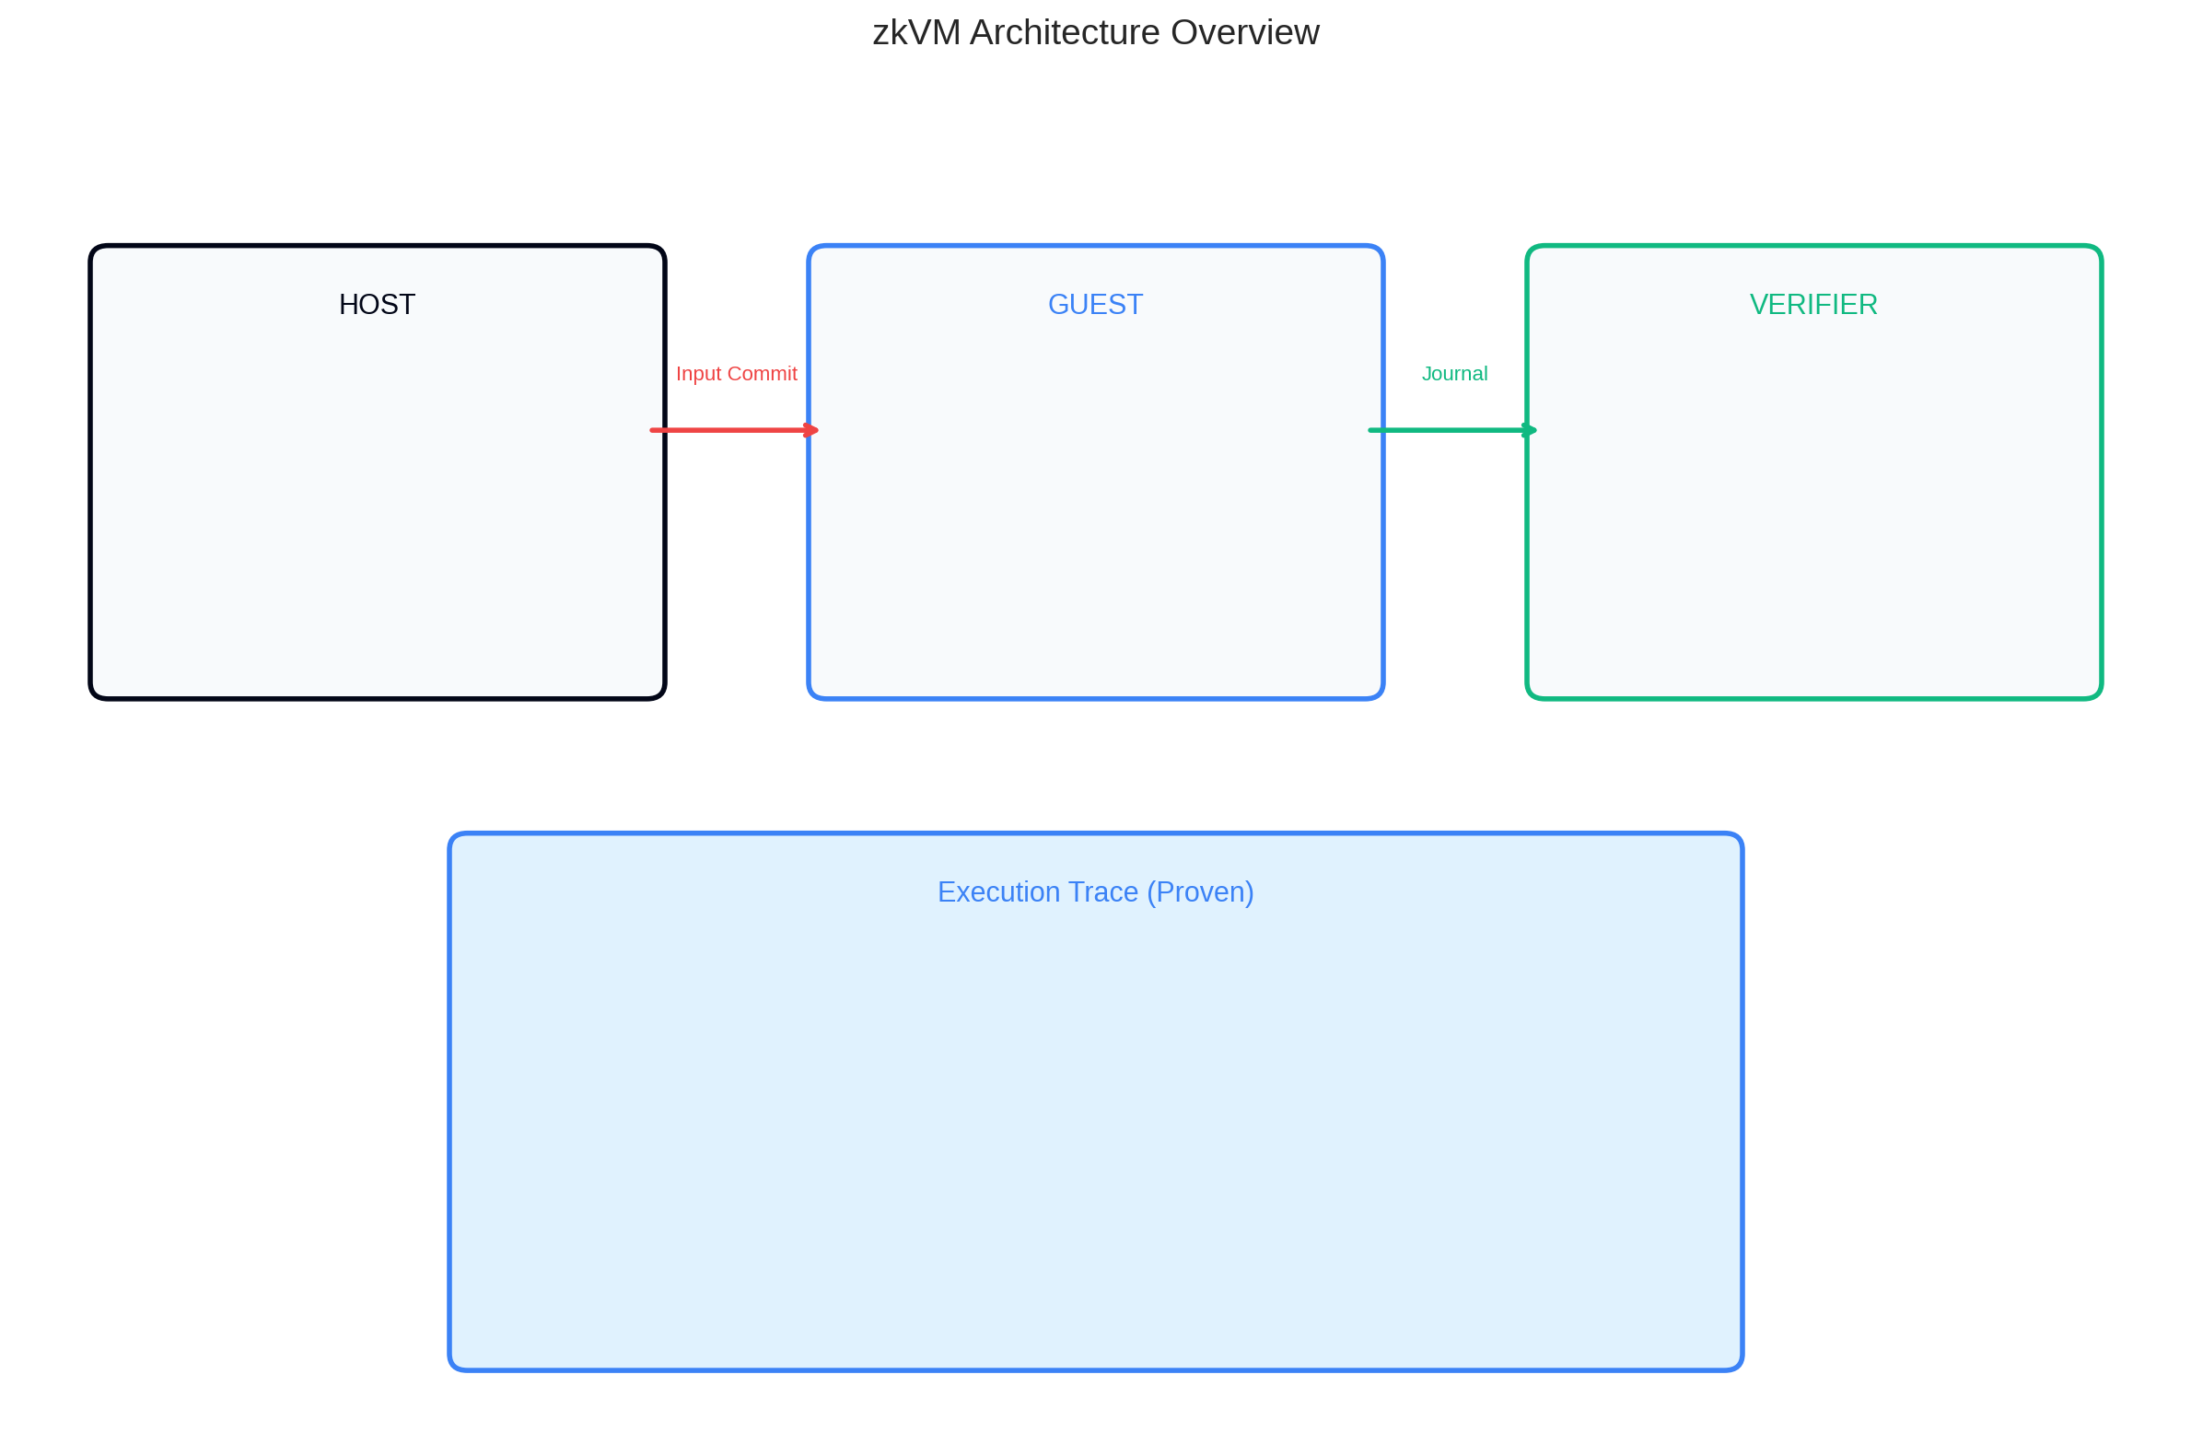
Figure 1: zkVM Architecture Overview - The host-guest model with execution trace generation

2.1 Host-Guest Architecture Security Implications
The host-guest architecture separates the proving environment from execution. The host invokes the prover, provides inputs through the InputCommitment mechanism (in RISC Zero), and receives outputs via the Journal. This boundary is critical: the input commitment cryptographically binds the guest execution to specific inputs before execution begins. However, vulnerabilities arise when guests use data that bypasses this commitment. In RISC Zero, syscalls like sys_getenv and sys_argv communicate with the host directly during execution—data received through these channels is NOT part of the input commitment and can vary between executions with the same committed input.

3. Understanding the zkVM Threat Model
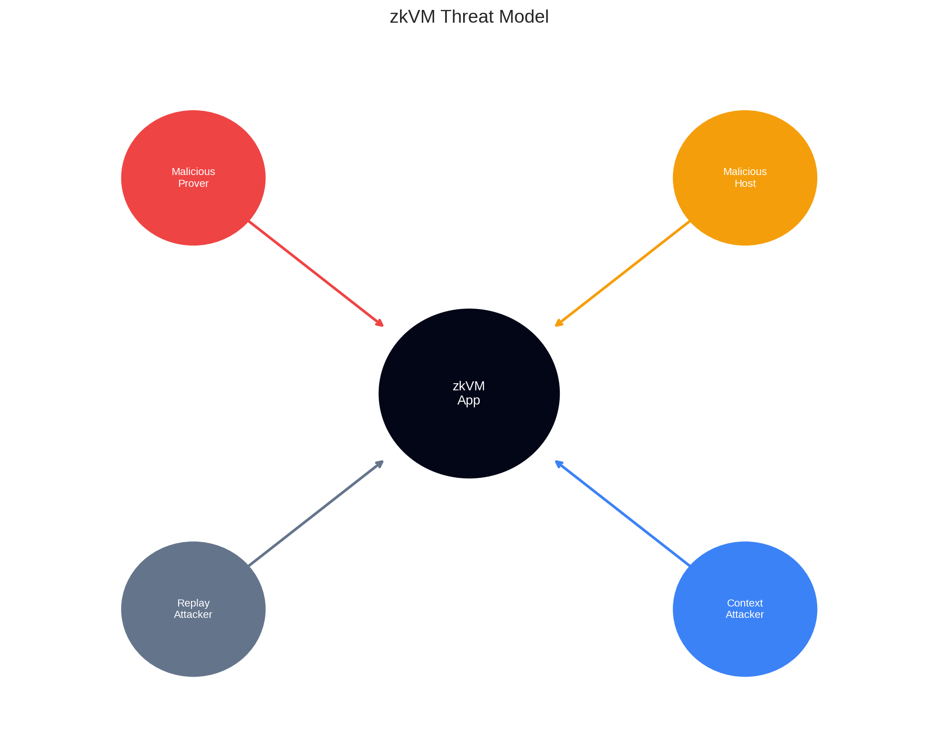
Figure 2: zkVM Threat Model Classification - Primary adversary categories

3.1 Malicious Prover
A malicious prover controls guest program inputs and attempts to craft inputs that exploit logical bugs. The prover cannot forge proofs—the STARK system ensures computational integrity assuming collision-resistant hash functions—but can provide any inputs the guest accepts. Real-world examples include integer overflow bugs producing incorrect balances, incorrect signature verification accepting forged signatures, and Merkle proof validation errors allowing membership proofs in non-existent trees.

3.2 Malicious Host
The host controls inputs and proof generation timing. A malicious host can provide inconsistent inputs through uncommitted channels (sys_getenv, sys_argv), manipulate environment variables, or interfere with syscalls. The security model assumes the host is untrusted, which is why committed inputs and the journal mechanism are cryptographically bound to the proof. However, if a guest trusts host-provided data without verification—particularly data received via syscalls—this trust can be exploited.

4. Common Security Vulnerabilities
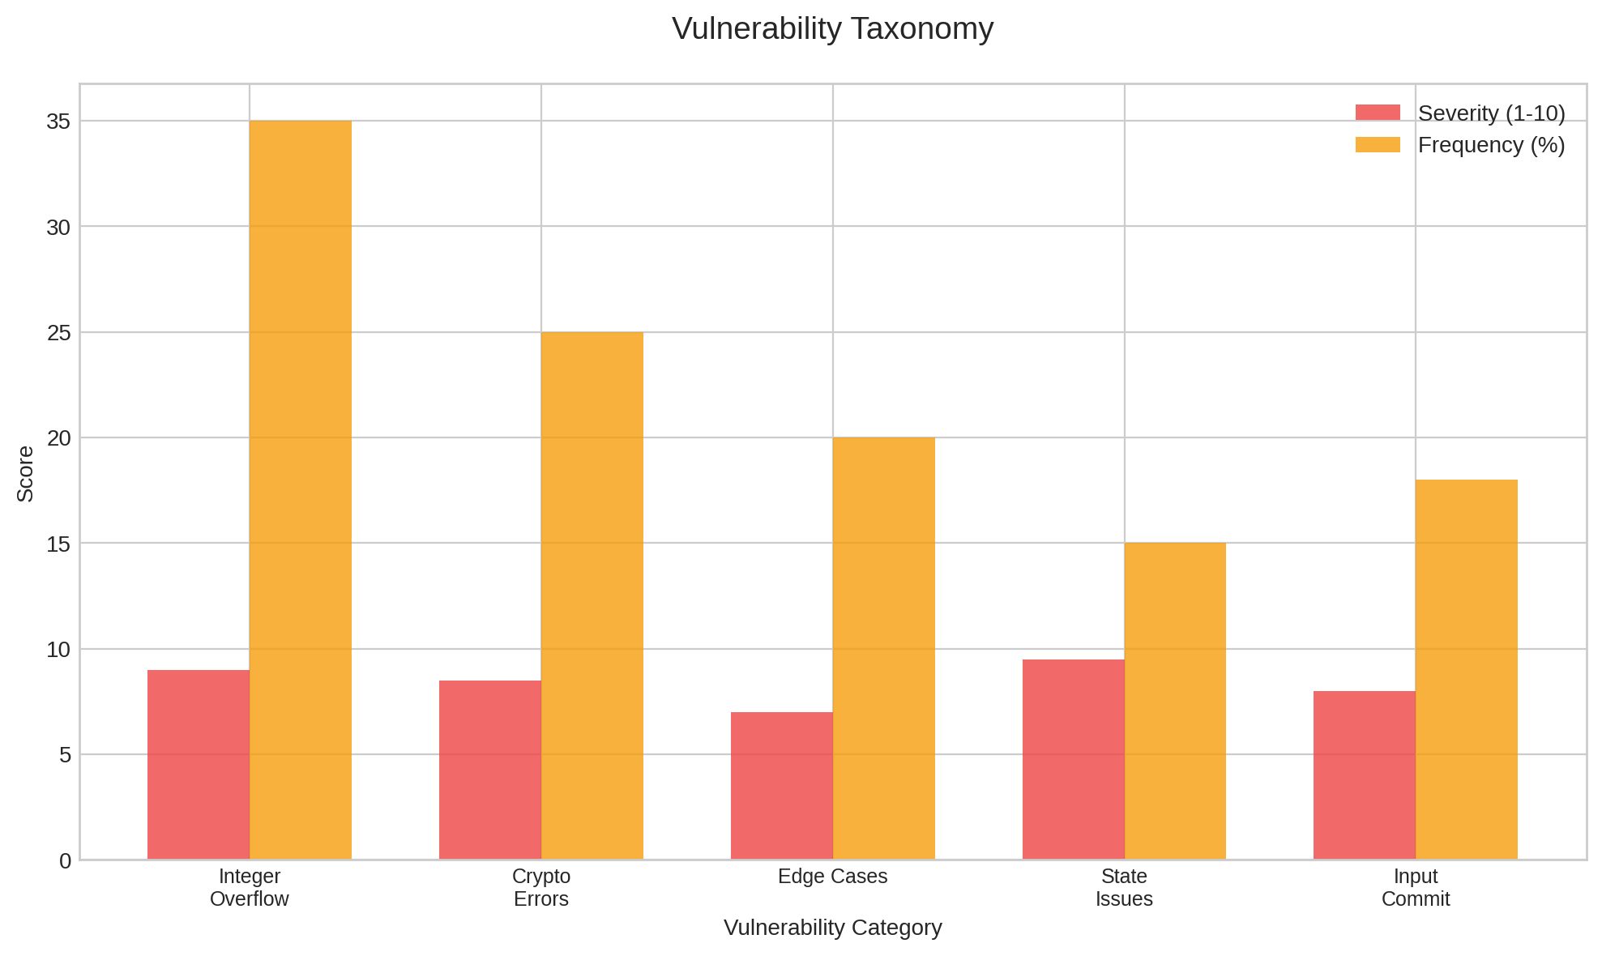
Figure 3: Vulnerability Taxonomy Analysis

4.1 Integer Overflow and Underflow
In RISC-V execution, integer overflow follows two's complement arithmetic—values wrap on overflow. Crucially, Rust's behavior differs between build modes: debug builds panic on overflow (checked arithmetic), but release builds—which zkVMs use for performance—use wrapping arithmetic by default. Unless developers explicitly use checked methods (checked_add, checked_sub, checked_mul), overflow silently produces incorrect values that are faithfully proven. An unsigned subtraction like payment_amount - item_price where payment_amount < item_price underflows to a very large positive value, producing a valid proof of an incorrect computation.

4.2 VM Constraint Vulnerabilities
While developers don't write circuits in zkVMs, the circuitry still exists at the VM layer. Under-constraining any part can lead to severe vulnerabilities. A missing constraint in Valida (github.com/valida-xyz/valida/issues/122) allowed incorrect traces to pass verification. Memory consistency checks are critical—an SP1 audit (github.com/succinctlabs/sp1/blob/dev/audits/kalos.md) found the CPU doesn't constrain memory being loaded onto registers in load opcodes. Division-by-zero handling must match RISC-V semantics: it doesn't panic but returns specified values depending on operands. Failing to implement this correctly (as found in RISC Zero audits) allows discrepancies between trace and expected behavior.

4.3 Verification Stage Vulnerabilities
The verifier must ensure proof validity and correct program termination. A Jolt issue (#490) revealed that if a verifier takes memory layout directly from proof data, a malicious prover can alter the layout to overwrite output. Another Jolt issue (#480) demonstrated truncated trace attacks: without termination checks, a prover can submit partial traces with incorrect outputs. These vulnerabilities highlight that verification logic requires careful auditing beyond just proof validation.

4.4 Precompile and Custom Library Vulnerabilities
zkVMs use precompiles (custom circuits) to accelerate specific operations like SHA-256. These require separate security auditing—RISC Zero's Stark2Snark circuit audit by Hexens shows the complexity involved. Custom libraries also introduce risk: SP1 implemented custom memcpy and memset for efficiency, which could introduce subtle bugs. Jolt replaces instructions like DIV with virtual instruction sequences for lookup operations, potentially introducing semantic differences.

5. Security Best Practices
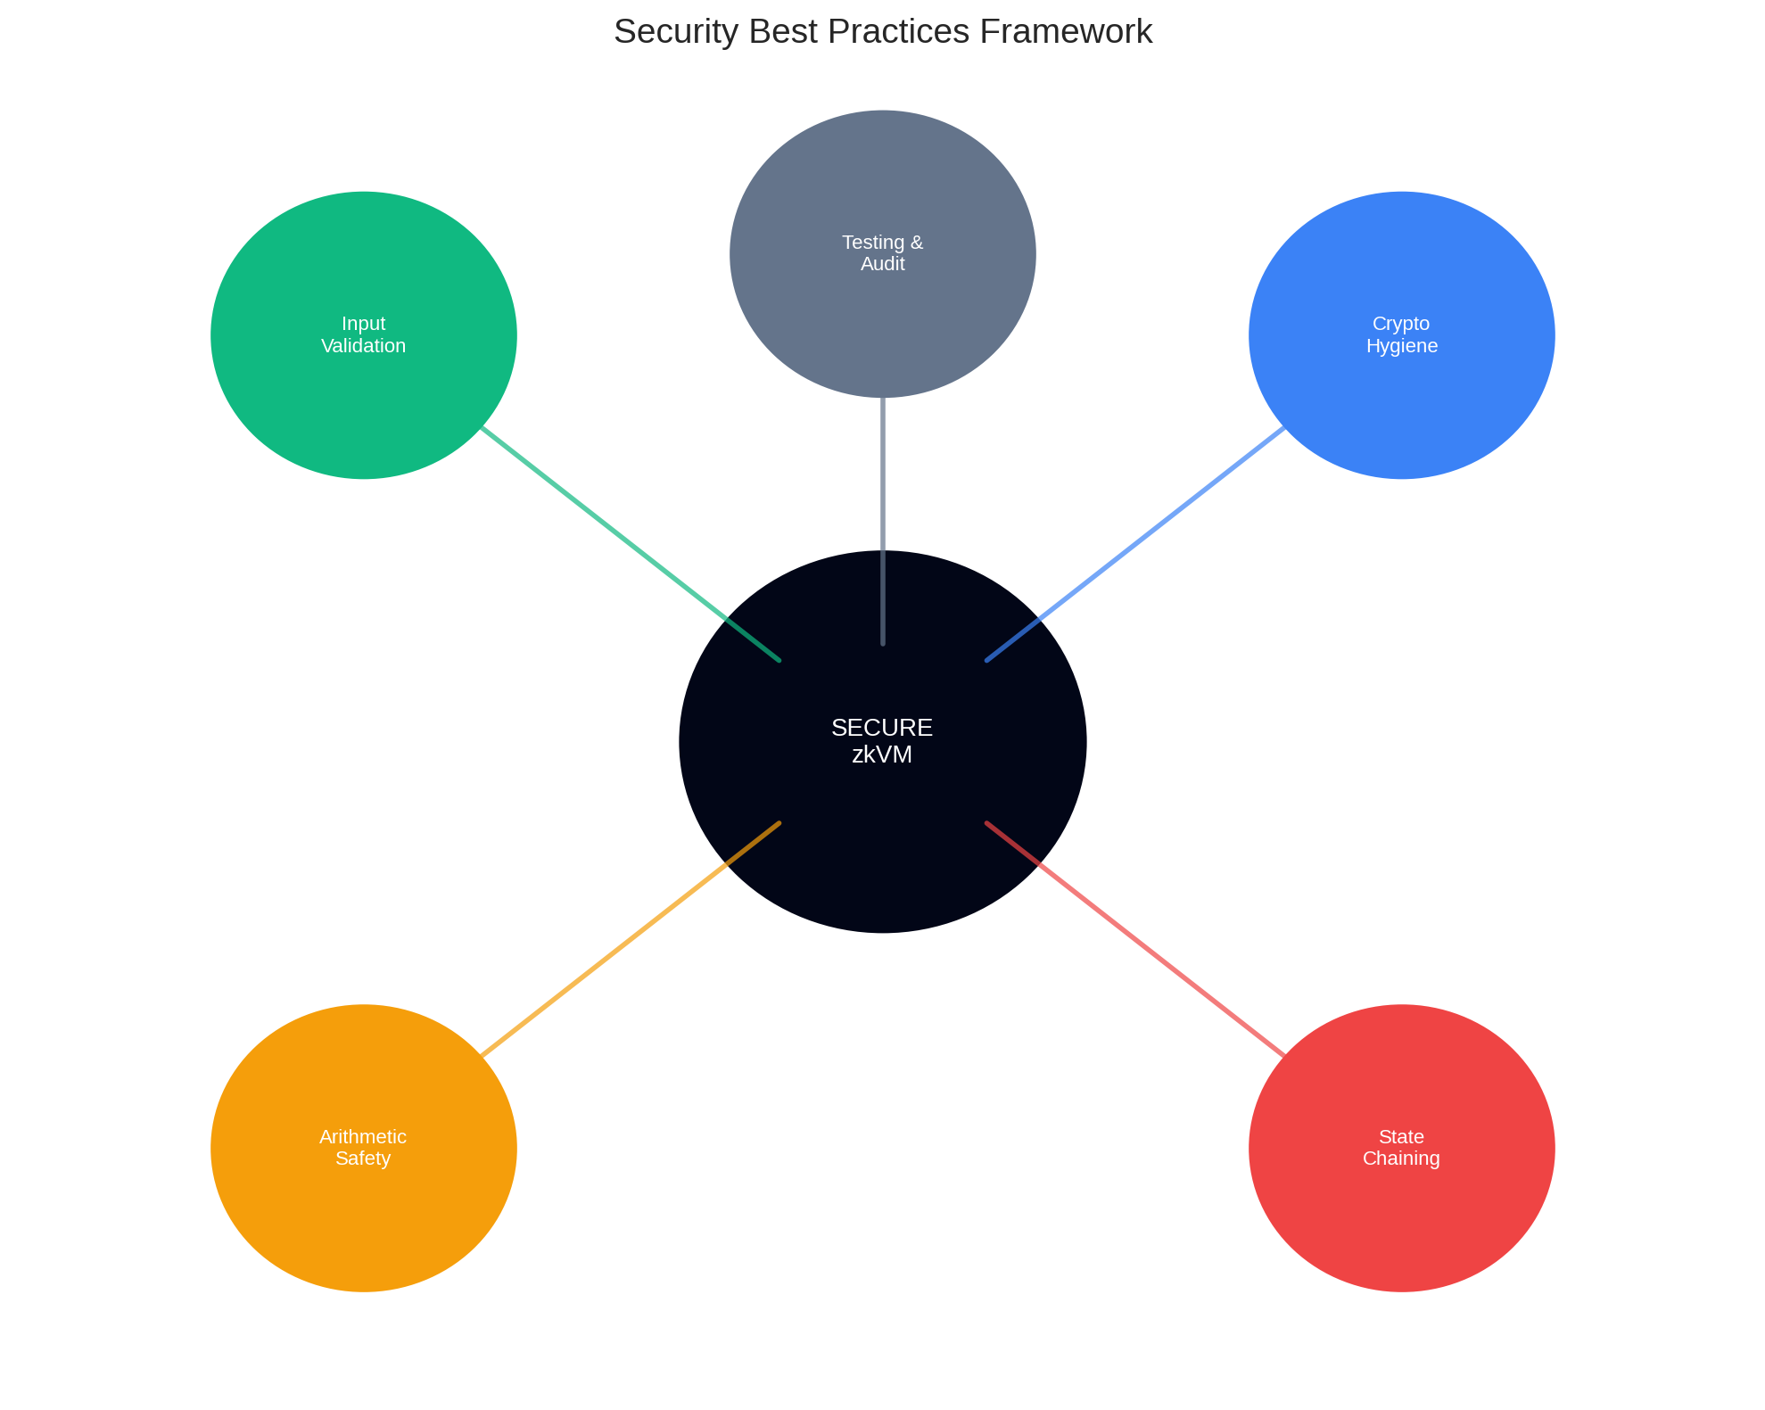
Figure 6: Security Best Practices Framework

5.1 Use Explicit Checked Arithmetic
Explicitly use checked arithmetic methods (checked_add, checked_sub, checked_mul, checked_div) for all operations involving financial values or security-sensitive data. These methods return None on overflow, allowing explicit handling. Never rely on debug-mode overflow checking—zkVM guest programs are compiled in release mode. For performance-critical code where overflow is provably impossible, add explicit assertions with comments explaining why.

5.2 Verify All External Data Cryptographically
Any data influencing security-sensitive decisions must be cryptographically verified. Merkle roots must be committed inputs or derived from verified state. Signatures must be verified within the guest using exact message bytes. For syscalls receiving host data (sys_getenv, sys_argv), commit to expected values in the input commitment and verify that syscall-provided data matches this commitment before use.

5.3 Implement Proper State Chaining
Each proof's public inputs should include the previous state commitment. The guest verifies this matches expected state before processing. Output journals include new state commitments, creating unbreakable chains. Include context identifiers (chain IDs, contract addresses) in state commitments to prevent cross-chain replay attacks.

6. Anti-Patterns to Avoid
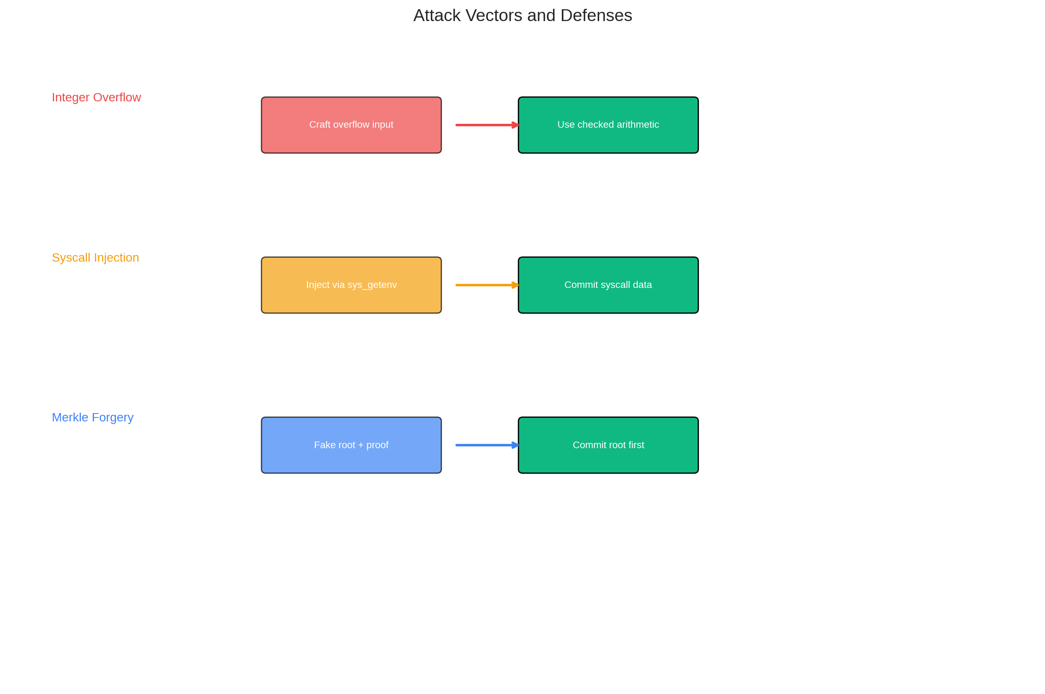
Figure 7: Common Attack Vectors and Defense Mechanisms

6.1 Trusting Syscall Data Without Commitment
Using data from sys_getenv or sys_argv for security-critical decisions without cryptographic commitment is a critical anti-pattern. A malicious host can provide arbitrary values through these channels, producing valid proofs of incorrect computations. Either avoid using syscall data for security decisions, or commit to expected values before execution.

6.2 Implicit Assumptions About Input Validity
Assuming inputs have certain properties (positive amounts, non-empty arrays, valid indices) without explicit validation is dangerous. The prover controls inputs and will actively try to violate assumptions. Validate every assumption explicitly through constraints.

7. Testing and Auditing Strategies
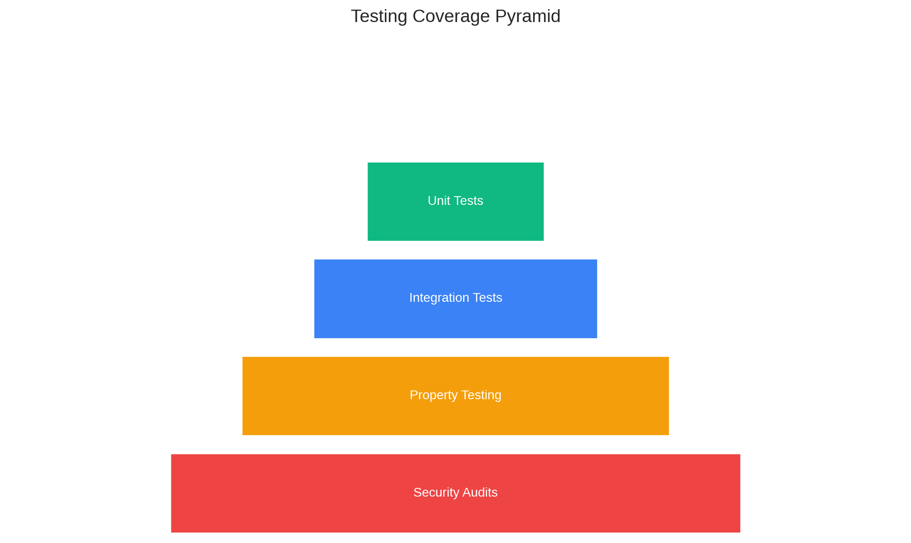
Figure 9: Testing Coverage Pyramid
Testing zkVM applications requires covering both functional correctness and adversarial scenarios. Property-based testing using frameworks like Proptest generates thousands of test cases exploring edge cases. Fuzzing with malformed inputs reveals vulnerabilities that structured testing misses. Professional security audits by firms with specific zkVM expertise (such as Veridise, zkSecurity, Hexens) are essential before deployment. Multiple audits from different firms provide defense in depth.

8. Future Considerations
STARK proof systems underlying zkVMs are post-quantum secure in their core construction, relying on collision-resistant hash functions rather than elliptic curve discrete log. However, application-layer cryptography (Ed25519, ECDSA) would be broken by quantum computers. For long-term security, consider migration paths to post-quantum signatures. Side-channel attacks on proving infrastructure remain relevant—consider running provers in secure environments for sensitive applications.

9. Conclusion
zkVMs offer powerful abstraction for zero-knowledge proofs but require rigorous security practices. The proof system guarantees computational integrity—not semantic correctness. Developers must use explicit checked arithmetic, verify all external data cryptographically, implement proper state chaining, handle edge cases explicitly, and use audited cryptographic libraries. Equally important are avoiding anti-patterns: trusting uncommitted syscall data, making implicit assumptions about input validity, and using floating-point for financial calculations. As zkVM technology evolves, staying engaged with the security research community and participating in responsible disclosure practices remains essential.

References
[1] Gong, S. "zkVM Security: What Could Go Wrong?" zkSecurity Blog, November 2024. https://blog.zksecurity.xyz/posts/zkvm-security/
[2] Diamond, T. "Identifying common vulnerabilities in zkVMs." Veridise Blog, July 2025. https://veridise.com/blog/zero-knowledge/identifying-common-vulnerabilities-in-zkvms/
[3] Diamond, T. "How to write and audit a secure zkVM application." Veridise Blog, July 2025. https://veridise.com/blog/zero-knowledge/how-to-write-and-audit-a-secure-zkvm-application/
[4] RISC Zero. "RISC Zero zkVM Documentation." https://dev.risczero.com/
[5] Succinct Labs. "SP1 Documentation." https://docs.succinct.xyz/
[6] Valida. "Valida zkVM." https://github.com/valida-xyz/valida
[7] Jolt. "a16z/jolt zkVM." https://github.com/a16z/jolt
[8] ZKM. "ZKM zkVM." https://www.zkm.io/
[9] Hexens. "RISC Zero Stark2Snark Circuit Audit." May 2024. https://github.com/risc0/rz-security/blob/main/audits/
[10] Kalos. "SP1 Audit Report." https://github.com/succinctlabs/sp1/blob/dev/audits/kalos.md

