Customer Behavior Data Analytics Report

Author: Le Quang hung

1. June

* As we can see in this Dashboard, the most viewed and searched program by users in June was Tv Series. The prominent keywords are also words related to love or the names of film mostly the theme is about love. Therefore, we can promote the advertising of more long-form drama series on love themes to increase the user's viewing rate.

* Anime, or animated films, mostly produced and distributed by Japanese companies, are the second most popular program category among users. This indicates that there is a significant number of users who enjoy watching anime.
* Through the analysis of popular keywords, we can observe that popular anime series such as Conan, Doraemon, and One Piece, Naruto continue to attract user interest. Therefore, the company should maintain a consistent stream of new content for these programs to avoid boredom among viewers.
* Additionally, there are also users who are interested in less popular anime series. The company could consider contacting the distributors directly to acquire exclusive licensing rights for these series and run advertising campaigns to attract more viewers.

1. July

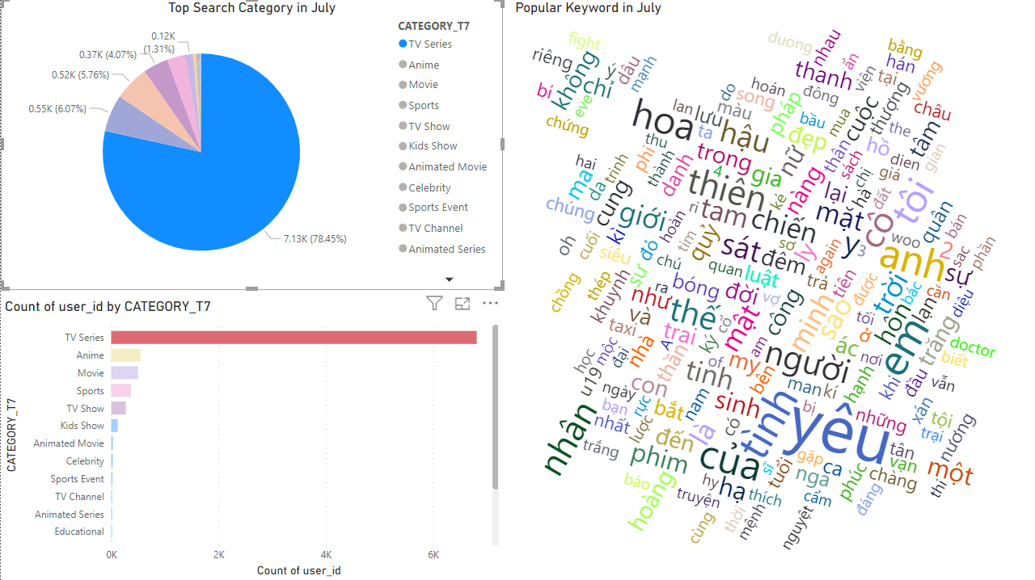

* Moving on to the July dashboard, we observe that there are no significant changes in content preferences. TV - Series remains the dominant category in terms of viewership and search popularity.
* At the fourth position, there's a notable change as reality shows have been replaced by sports content. This suggests that a major sporting event likely took place in July. A graph with colorful bars and numbers

  Description automatically generated

1. Change - Unchange

- On the plot below we can see while TV-Series remains the most popular program category, there are no significant changes in overall viewing habits among users. The observed changes in other categories suggest that users are shifting their attention from other types of programs to TV-Series, further reinforcing its dominance in the dataset.

