Impact of Denoising Retinal OCT images in Classification
A thesis paper submitted in partial fulfillment of the requirements for the degree of
B.Sc (Engineering) in Electrical and Electronic Engineering

Course Title: Project/Thesis
Course Code: EEE 400

Submitted by
Student ID: 1502216 Student ID: 1602266 Student ID: 1602273

Approved as to style and content by

……………………………………… ………………………………………
Supervisor Co-Supervisor



Hajee Mohammad Danesh Science and Technology University,
Dinajpur-5200

This is to certify that this thesis is prepared by Student ID: 1502216, 1602266, 1602273 and complies with the regulations of this university and meets the accepted standards with respect to originality and quality.
Signed by the final examining committee:

…………………………………………………………………………………...
Chairman

…………………………………………………………………………………...
External

………………………………………………………………………………….
Internal

…………………………………………………………………………………...
Supervisor

…………………………………………………………………………………...
Co-Supervisor
DECLARATION

This is to certify that the thesis work entitled “Impact of Denoising Retinal OCT images in Classification” carried out by the student ID: 1502216, 1602266, 1602273, under our supervisor as a requirement for the award of Bachelor of Science in Electrical and Electronic Engineering.

Signature of Supervisor

Md. Ferdous Wahid
Assistant Professor
Department of Electrical and Electronic Engineering
Hajee Mohammad Danesh Science and technology Universiry
Dinajpur- 5200
Signature of Co-Supervisor

Md. Safiqul Islam
Assistant Professor
Department of Electrical and Electronic Engineering
Hajee Mohammad Danesh Science and technology Universiry
Dinajpur- 5200

DEDICATED TO
OUR BELOVED PARENTS AND RESPECTABLE TEACHERS

Acknowledgments

We would like to thank everyone who has helped and supported us during our graduate study. Their direct and indirect contributions to this dissertation are highly appreciated. At the very first we thank the almighty Allah for giving us the opportunity and ability to complete this thesis.
Then we are honored to express our deepest and sincerest gratitude to our parents who supported us all the time and helped us all the way they could to continue our work.
Then we express our sincerest gratitude to our supervisor Md. Ferdous Wahid, Assistant Professor, Department of Electrical & Electronic Engineering and Co-supervisor Md. Safiqul Islam, Assistant Professor, Department of Electrical & Electronic Engineering, for their continuous support during our Thesis work. Their patience, motivation, enthusiasm and immense knowledge have helped us to make our work successful and so we are extremely grateful to them. Anytime when we had difficulties in our research, they were always there to help with their intelligence, diligence and patience.
We also thank Specially to Md. Faruk Kibria, Assistant professor and chairman, Department of Electrical & Electronic Engineering, for his wise supervision, proper guidance and continuous support that encouraged us to go on with our work.
Finally, we also thank our group members and friends for their dedication and hard-work to complete the thesis.

Abstract

In this paper the main motive is to coming up with the impact of denoising Optical Coherence Tomography (OCT) Retinal images via showing accuracy rate difference between classification with noisy images and denoised images. Retinal OCT images are always noisy. Even in better cases, it’s hard to find a single image without any noise. Image classification is used for classify among different types of that same category. Block Matching 3D (BM3D) is the denoising algorithm which will be used for preparing denoised dataset with the help of Sk-image (scikit-image) and OpenCV. For classification, Convolutional Neural Networks (CNN), specifically Inception V3 network is used on the both data sets (Noisy Images Data set and Denoised Image Data set) with Python and the Keras deep learning library. In data sets, they are prepared with Drusen and Normal Images. Applying classification models over those data sets, a clear concept will come out as the impact of denoising retinal OCT images in classification.
Key-words: Speckle noise, Optical Coherence Tomography (OCT), Block Matching 3D (BM3D), Scikit-image, OpenCV, Convolutional Neural Networks (CNN), Inception V3, Keras, Python, Druse

List of Contents
Dedication
Acknowledgments
Abstract
List of figure
List of Table
List of abbreviation
Chapter 1
Introduction
Chapter 2
Literature Review
Chapter 3
Data set Preparation
Chapter 4
Methodology
4.1 Noise in OCT image
4.2 Image denoising with Block Matching 3D
4.3 Classification with Inception V3
Chapter 5
Experimental Setup
5.1 Hardware Requirement
5.2 Software Requirement
Chapter 6
Result and Discussion
6.1 Performance Evaluation
6.2 Comparative Study
Chapter 7
Conclusion and Future Work
7.1 Conclusion
7.2 Future Work
References

List of Figure

List of Table

List of abbreviation

Chapter1
Introduction

Optical coherence tomography (OCT) is a recently established imaging technique to describe different information about the internal structures of an object and to image various aspects of biological tissues, such as structural information, blood flow, elastic parameters, change of polarization states, and molecular content. In contrast to OCT technology development which has been a field of active research since 1991, OCT image segmentation has only been more fully explored during the last decade. Segmentation, however, remains one of the most difficult and at the same time most commonly required steps in OCT image analysis. No typical segmentation method exists that can be expected to work equally well for all tasks.
One of the most challenging problems in OCT image segmentation is designing a system to work properly in clinical applications. There is no doubt that algorithms and research projects work on a limited number of images with some determinate abnormalities (or even on normal subjects) and such limitations make them more appropriate for bench and not for the bedside. Moreover, OCT images are inherently noisy, thus often requiring the utilization of 3D contextual information. Furthermore, the structure of the retina can drastically change during disease. Nevertheless, OCT image denoising is a rapidly growing and important area and a great deal of efforts went into designing algorithms for automatic noise reduction of retinal OCTs.
Covering the inside of most of the eye, the retina is a multilayered structure responsible for transforming light energy into neural signals for further use by the brain. In very general terms, the processing of light starts with the light sensitive photoreceptor cells (rods and cones), which are actually located in the outer portion of the retina (away from the incoming light). These cells convert the light signal into action potentials that are transmitted by the bipolar neurons in the central layers of the retina to the ganglion cells of the inner retina. It is the axons of the ganglion cells that eventually exit the eye to form the optic nerve. Other cells in the retina, such as horizontal cells, amacrine cells and inter plexiform neurons, also help in the processing of the neural signal at a local level. Neuroglial cells (such as Muller cells) provide structure and support. Based on its appearance from light microscopy, the retina is traditionally considered to be composed of the following ten major “layers” (starting with the outermost layer).
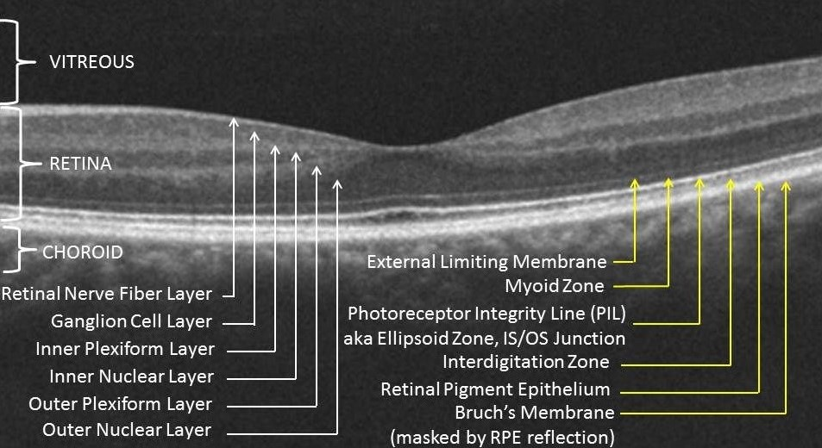

Figure: Different Layers of Retinal OCT Images

Reginal pigment epithelium (RPE): single layer of pigmented hexagonal cells
Photoreceptor layer: the outer (containing the light-sensitive discs) and inner segments of rods and cones
External (or outer) limiting membrane (ELM or OLM): intercellular junctions between photoreceptor cells and between photoreceptor and Muller cells (not an actual membrane)
Outer nuclear layer (ONL): rod and cone cell bodies
Outer plexiform layer (OPL): synapses between photoreceptor cells and cells from the inner nuclear layer
Inner nuclear layer (INL): cell bodies of bipolar cells, horizontal cells, amacrine cells, inter plexiform neurons, Muller cells, and some displaced ganglion cells
Inner plexiform layer (IPL): synaptic connections between bipolar cell axons and ganglion cell dendrites
Ganglion cell layer (GCL): mostly ganglion cell bodies
Nerve fiber layer (NFL): ganglion cell axons
Internal limiting membrane (ILM): innermost membrane of retina separating the retina from the vitreous.
These show that Retinal OCT Images have a lot of information in it to deal with. But the biggest problem that arises is the noises. There are many kinds of noises arrive in dealing with these types of images. Such as- Amplifier Noise (Gaussian Noise), Salt-and-pepper noise, Poisson noise, Speckle noise. But for OCT images, speckle noise is our main focus.
For examining the OCT images, we’ll reduce the speckle noises of those. There are many methods those are already applied but we’ll use Python as our main tool. Two very popular and efficient libraries of Python are OpenCV (CV stands for Computer Vision) and Sk-image (Scikit image). OpenCV is a cross-platform library using which we can develop real-time computer vision applications. It mainly focuses on image processing, video capture and analysis including features like face detection and object detection and scikit-image is an open-source image processing library for the Python programming language. It includes algorithms for segmentation, geometric transformations, color space manipulation, analysis, filtering, morphology, feature detection, and more.
Applying these libraries, we’ll apply some algorithms in order to denoising those. Such as- Block Matching 3D (BM3D), Anisotropic Diffusion Filter (ADF), Non-local means filter, Median Filter and Gaussian Filter. Then after applying those, we’ll do some comparison among them and have good enough knowledge on which algorithm is better than the others for this purpose.

Chapter 3

Chapter 4
Methodology

3.1 Noise in Optical Coherence Tomography Images:

Amplifier noise (Gaussian noise):
The standard model of amplifier noise is additive, Gaussian, independent at each pixel and independent of the signal intensity. In color cameras where more amplification is used in the blue color channel than in the green or red channel, there can be more noise in the blue channel. Amplifier noise is a major part of the "read noise" of an image sensor, that is, of the constant noise level in dark areas of the image.
Salt-and-pepper noise:
An image containing salt-and-pepper noise will have dark pixels in bright regions and bright pixels in dark regions. This type of noise can be caused by dead pixels, analog-to-digital converter errors, bit errors in transmission, etc. This can be eliminated in large part by using dark frame subtraction and by interpolating around dark/bright pixels.
Poisson noise:
Poisson noise or shot noise is a type of electronic noise that occurs when the finite number of particles that carry energy, such as electrons in an electronic circuit or photons in an optical device, is small enough to give rise to detectable statistical fluctuations in a measurement.
Speckle noise:
Speckle noise is a granular noise that inherently exists in and degrades the quality of the active radar and synthetic aperture radar (SAR) images. Speckle noise in conventional radar results from random fluctuations in the return signal from an object that is no bigger than a single image-processing element. It increases the mean grey level of a local area. Speckle noise in SAR is generally more serious, causing difficulties for image interpretation. It is caused by coherent processing of backscattered signals from multiple distributed targets. In SAR oceanography, for example, speckle noise is caused by signals from elementary scatters, the gravity-capillary ripples, and manifests as a pedestal image, beneath the image of the sea waves.

3.2 Image Denoising Algorithms in OCT images

3.2.1 Block Matching 3D Filter
Block-matching and 3D filtering (BM3D) is a 3-D block-matching algorithm used primarily for noise reduction in images. It is an algorithm for attenuation of additive spatially correlated stationary (aka colored) Gaussian noise. This package provides a wrapper for the BM3D binaries for use for grayscale, color and other multichannel images for denoising and deblurring. Collaborative filtering is a special procedure developed to deal with these 3D groups. We realize it using the three successive steps: 3D transformation of 3D group, shrinkage of transform spectrum, and inverse 3D transformation. The result is a 3D estimate that consists of the jointly filtered grouped image blocks. By attenuating the noise, the collaborative filtering reveals even the finest details shared by grouped blocks and at the same time it preserves the essential unique features of each individual block. The filtered blocks are then returned to their original positions.
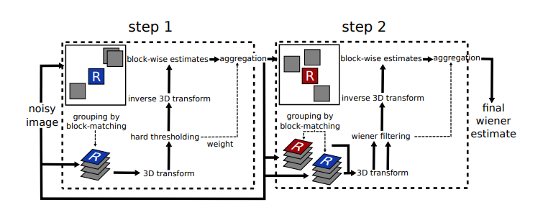

Figure: Scheme of the BM3D algorithm.
For performing the algorithm, we are going to use OpenCV library from Python as our primary tool. On the other hand, BM3D is also a library of python. After importing those, we need to set a parameter of that library to perform the task.
Those are: sigma_psd and stage_arg.
where for our noisy image, we’ve used
sigma_psd=30/255,
stage_arg=bm3d.BM3DStages.HARD_THRESHOLDING

Chapter 4
Experimental Setup

4.1 Hardware Requirement:
This whole process doesn’t need a lot of hardware. We just need to capture the images then process those. For capturing the OCT images, we need to use a hardware named OCT Machine / Optical Coherence Tomography Machine. OCT Machine is a non-invasive imaging evaluation and useful in diagnosing many eye problems. OCT uses light waves to take images of your retina. With OCT, your ophthalmologist can view each of the retina's distinctive layers. OCT uses rays of light to measure retinal thickness. No radiation or X-rays are used in this test, an OCT scan does not hurt and it is not uncomfortable.
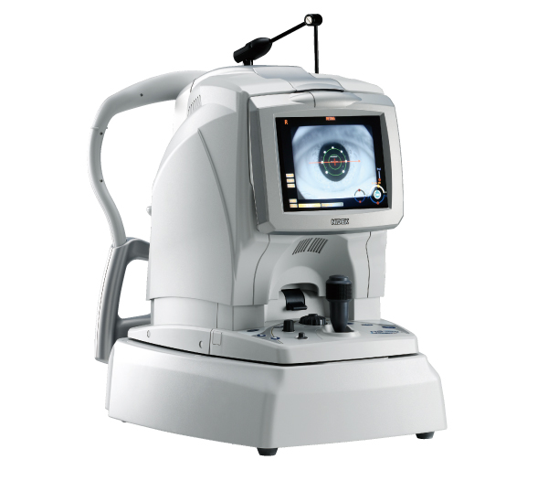

–––

––

Figure: OCT Machine

4.2 Software Requirement:

This whole process is mainly based on the Software works. After getting the images from the OCT Machine, it’s all about the software works. In previous chapters, we’ve already mentioned that our main tool will be Python.
Some basic requirements are given below:
- Anaconda Environment
- Python
- OpenCV
- Scikit image
- Jupyter Notebook

Anaconda Environment: In Anaconda Environment, all new environments created with conda automatically include Python, Jupyter Notebooks and pip. You can specify any other packages you want included in your new environment. By default, conda creates a new environment in the project’s env directory—so that all team members have access to the environment. Anaconda provide conda command for you to do a lot of common tasks such as install / uninstall packages, create / remove isolated python environment etc. Isolated python environment is very useful when you develop Python application for different Python version. For example, if you want to run the Python app on both Python 2.7 and Python 3.6, then you need to test the app on both the two Python version.



Figure: Anaconda Environment

Python:
Python is a popular programming language. It was created by Guido van Rossum, and released in 1991.
It is used for:
web development (server-side), software development, mathematics, system scripting.
Python is used for many purposes. Such as:
Python can be used on a server to create web applications. It can be used alongside software to create workflows. Python can connect to database systems. It can also read and modify files. Python can be used to handle big data and perform complex mathematics. Python can be used for rapid prototyping, or for production-ready software development.
Python works on different platforms (Windows, Mac, Linux, Raspberry Pi, etc). It has a simple syntax similar to the English language. It has syntax that allows developers to write programs with fewer lines than some other programming languages. It runs on an interpreter system, meaning that code can be executed as soon as it is written. This means that prototyping can be very quick. Python can be treated in a procedural way, an object-oriented way or a functional way.
Python was designed for readability, and has some similarities to the English language with influence from mathematics. It uses new lines to complete a command, as opposed to other programming languages which often use semicolons or parentheses. It relies on indentation, using whitespace, to define scope; such as the scope of loops, functions and classes. Other programming languages often use curly-brackets for this purpose.
Most importantly this language is very good and easy for doing image processing.

OpenCV:
OpenCV-Python is a library of Python bindings designed to solve computer vision problems. OpenCV-Python makes use of NumPy, which is a highly optimized library for numerical operations with a MATLAB-style syntax. All the OpenCV array structures are converted to and from NumPy arrays.
OpenCV is extensively used in companies, research groups, and governmental bodies. Well-established companies like Google, Yahoo, Microsoft, Intel, IBM, Sony, Honda, Toyota employ this library. Moreover, significant startups like Applied Minds, VideoSurf, and Zeit era make extensive use of OpenCV. It is basically a free open-source library used in real-time image processing. It's used to process images, videos, and even live streams.
For our paper, we have used this library to process almost all of our algorithms. Even we can say this as the main sub tool for our project.

Scikit Image:
The scikit-image project started as scikits.image, by Stéfan van der Walt. Its name stems from the notion that it is a "SciKit" (SciPy Toolkit), a separately-developed and distributed third-party extension to SciPy. The original codebase was later extensively rewritten by other developers. Of the various scikits, scikit-image as well as scikit-learn were described as "well-maintained and popular" in November 2012. Scikit-image has also been active in the Google Summer of Code.
scikit-image is a Python package dedicated to image processing, and using natively NumPy arrays as image objects. This chapter describes how to use scikit-image on various image processing tasks, and insists on the link with other scientific Python modules such as NumPy and SciPy.
After OpenCV, This is the most used library for us which is used for this paper.
Specially, for measuring the Peak Signal to Noise Ratio (PSNR), Mean Square Error (MSE);
we’ve used this library.

Chapter 5
Result and Discussion

5.1 Performance Evaluation
In the previous chapters we’ve mentioned that we are going to use 5 algorithms. Block Matching 3D, Anisotropic Diffusion Filter, Non-Local Means Filter (NLM), Median Filter and Gaussian Filter. Using OpenCV, we’ve applied those to our OCT image and few of them gave us very fantastic outputs. Some of them couldn’t come out as our expectation. Th–en we’ve used Peak Signal to Noise Ratio (PSNR), Mean Square Error (MSE) parameters for comparing the outputs.
The outputs of the algorithms are showed below one by one:
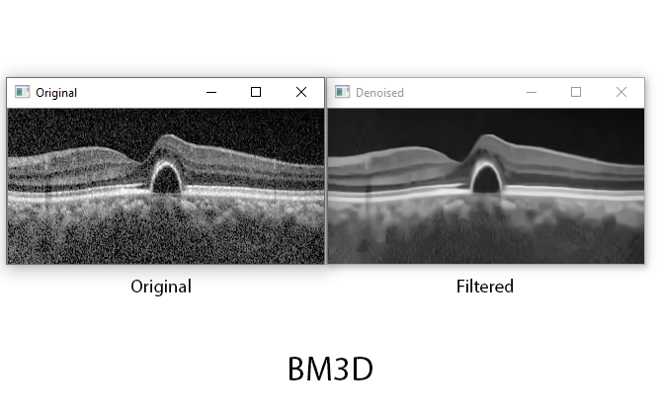
BM3D:

Figure: Denoising with BM3D

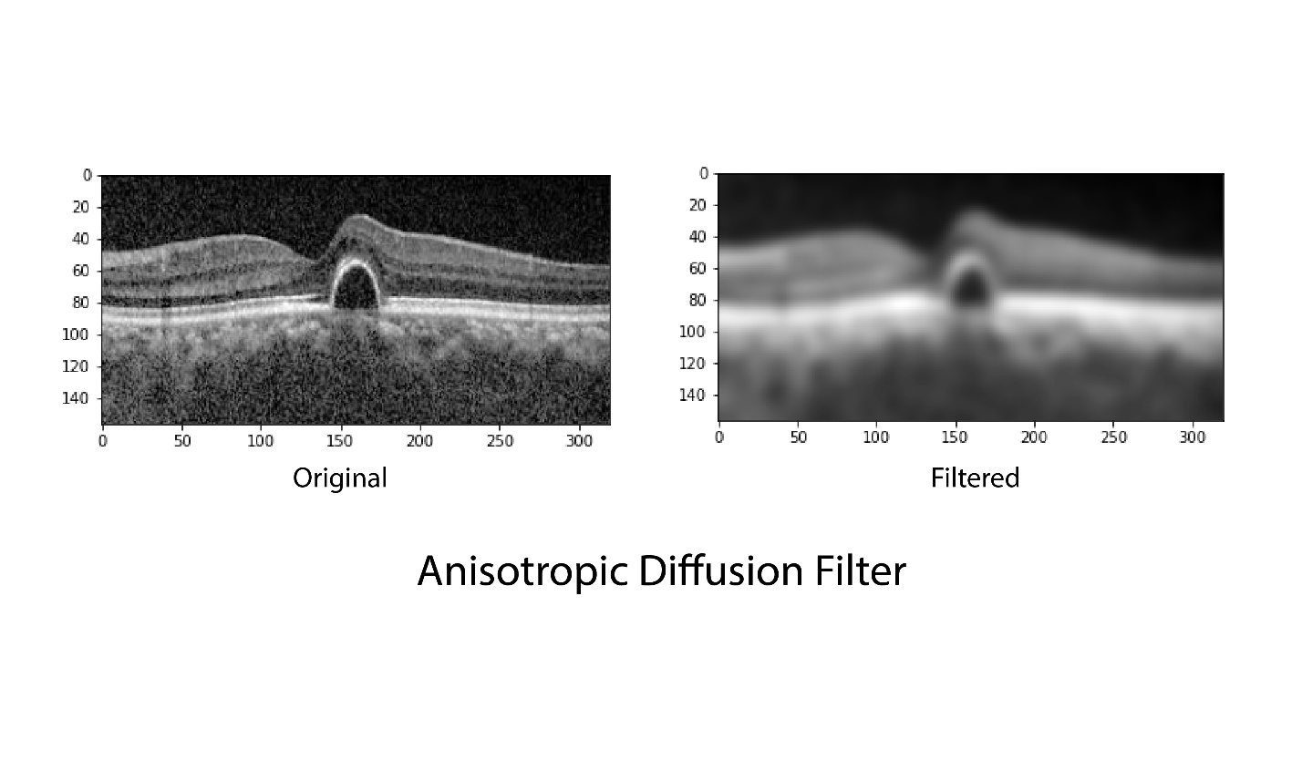
Anisotropic Diffusion Filter:

Figure: Denoising with Anisotropic Diffusion Filter

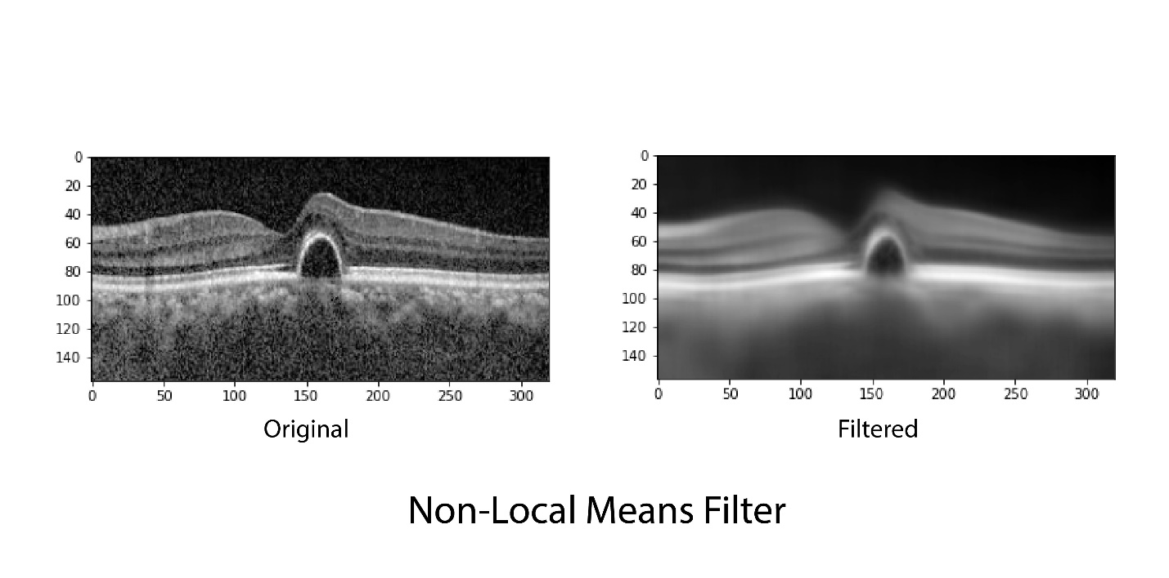
Non-Local Means Filter:

Figure: Denoising with Non-Local Means Filter

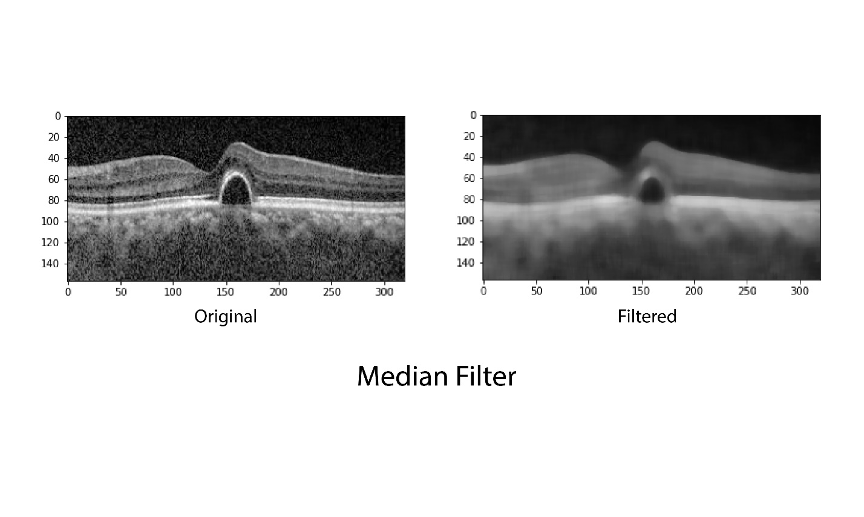
Median Filter:

Figure: Denoising with Median Filter

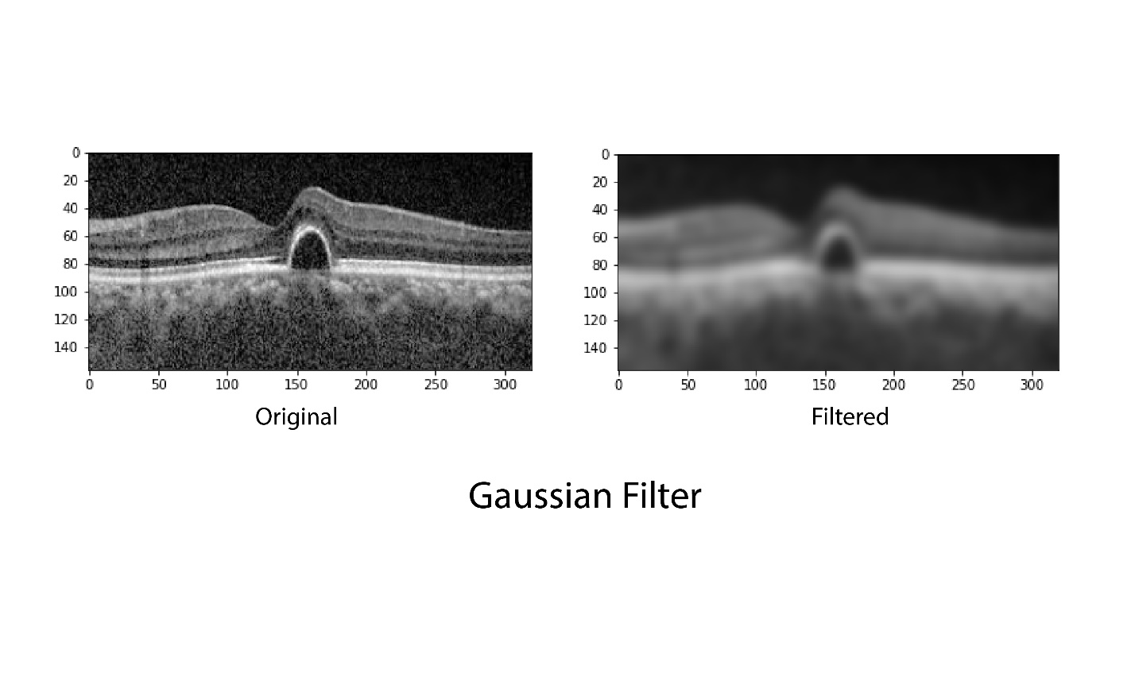
Gaussian Filter:

Figure: Denoising with Gaussian Filter

From those outputs, we can have a good enough concept about which is doing great and which is lagging behind but it’s not always good to judge on the basis of naked eye evolution. We are going to use two parameters to see the difference with each other. For that we are going to use Peak Signal to Noise Ratio (PSNR) and Mean Square Error (MSE).

Peak Signal to Noise Ratio (PSNR)

Algorithm | Peak Signal to Noise Ratio (PSNR)
Block Matching 3D | 23.335388125318786
Anisotropic Diffusion Filter | 19.46844013617428
Non-Local Means Filter | 20.143317108438644
Median Filter | 19.880473598299577
Gaussian Filter | 19.603439389353742

Mean Square Error (MSE):

Algorithm | Mean Square Error (MSE)
Block Matching 3D | 0.0046393932626272606
Anisotropic Diffusion Filter | 0.011302017785228843
Non-Local Means Filter
Median Filter
Gaussian Filter

5.2 Comparative Study

Chapter 6
Conclusion and Future Work
6.1 Conclusion

6.2 Future Work

References

