|  |  |
| --- | --- |
| page1image3828864 | **B. P. Poddar Institute of Management and Technology**  **Department of Computer Science & Engineering**  **Software Engineering Lab (ESC-591)**  **AY: 2021-22 ODD Semester**  **Assignment-2 (Use Case Diagram)** |

Group No. (Case Study No.) _ 4__

Case Study Title: _ MediLab & Drug Store Information System ___

**Student Details:**

|  |  |
| --- | --- |
| **University Roll. No.** | **Name** |
| **11500119047** | **SOUMYAJIT PRAMANIK** |
| **11500119048** | **TUHIN HAZRA** |
| **11500119051** | **TANDRIMA GHOSH** |
| **11500119052** | **SNEHA TIWARI** |

**Please do not write anything below the dotted line >**

...................................................................................................................................................................................................

**Marks awarded (Total Marks = 20)**

|  |  |  |  |  |
| --- | --- | --- | --- | --- |
| Student Name |  |  |  |  |
| Marks Awarded |  |  |  |  |

Signature of Faculty with date________________________________________________

**List of Features/Functions summarized (from Assignment-1)**

|  |  |  |
| --- | --- | --- |
| **Sl. No.** | **Function/Feature of the system (USECASE)** | **User (ACTOR)** |
| 1. | Registration | Physician, Patient/User |
| 2. | Login | Physician, Patient/User, Staff member |
| 3. | Manage the patient history | Admin, Physician, Staff member |
| 4. | Track status of the lab equipments | Admin, Staff member |
| 5. | Generate test report | Physician |
| 6. | Check availability of drugs | Admin, Staff member |
| 7. | Search for Medicine and Test availability | Patient/User |
| 8. | Request Medication | Patient/User |
| 9. | Make an appointment | Patient/User |
| 10. | Cancel an appointment or order | Patient/User |
| 11. | Contact & Support | Patient/User, Physician |
| 12. | Payment & transaction details | Patient, Admin |

**Use Case Diagram** *(Insert Use case diagram here)*

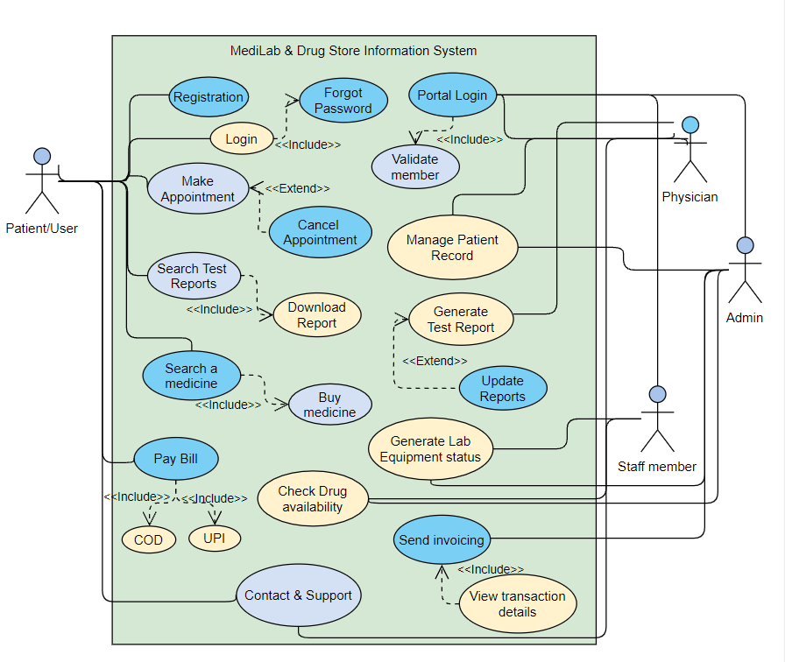

**Tool Used:** Visual Paradigm (Online)

**General Scenario Description**

A patient/user needs to get certain tests done. He/she will connect to our MediLab system to get an appointment for a test. The patient will need to see the reports and later on buy medicines. Hence, the patient can easily find medicines on the Drug Store Information system and purchase them.

**Usecase Name: 1)** Make Appointment

**Actor(s):** Patient

**Usecase Description:**

A patient will make an appointment to get a test done. Patients can fix an appointment according to their convenience.

**Flow of Events/Scenario:**

1. A new user is required to register in order to use the system and make appointments.
2. A new patient ID and password will be generated once basic info of the user is collected.
3. Existing users can easily Login by entering password.
4. The patient will click on ‘Make Appointment’.
5. He’ll find an option to select a time slot.
6. Click ‘Confirm’ to book.

**Alternate flow of events:**

**2a)** In case, the patient forgets his password, he’ll find the included ‘Forgot Password’ function which will direct him to the page to generate a new password.

**4a)** If for some reason, the patient wants to cancel any pre-booked appointment, he can easy do that using the software.

**Usecase Name: 2)** Generate Test Report

**Actor(s):** Physician

**Usecase Description:**

The physician at the clinic will perform the required tests on his patients. Once, done he will upload the reports using the system.

**Flow of Events/Scenario:**

1. Physician will search patient by entering name or ID.
2. After generating the test report, he will upload it on the system.
3. He can also look for any previous reports/patient history if needed.

**Alternate:**

1. In case of any discrepancy in the report, the physician can update any existing report. Changes will be reflected every time.

**Usecase Name: 3)** Search Test Reports

**Actor(s):** Patient

**Usecase Description:**

A patient will search for the test reports once uploaded. He can look for any previous reports as well. He can also download a copy of his reports.

**Flow of Events/Scenario:**

1. Once test reports are uploaded, a notification via email will be sent to the user.
2. The patient/user can directly click over ‘Reports section’ to open & check reports.
3. He can also search previous tests reports; all sorted by date & time.
4. He can click on ‘Download’ to receive a copy of it in PDF format.

**Alternate flow of events:**

**2a)**  In case, patient looks for a report which is not yet uploaded, the status will show ‘Pending’.

**3a)**  If there’s a glitch due to which patient is unable to open or download the reports, he can get help from ‘Contact & Support’. He’ll receive a copy of desired report via email.

**Usecase Name: 4)** Generate Lab Equipment status

**Actor(s):** Staff member, Admin

**Usecase Description:**

The job of a staff member is to check if the equipments required for the tests are available in the stock. Thus, he needs to check the status of the equipments at any given point. The Admin also has the permission to view it.

**Flow of Events/Scenario:**

1. The staff member will click on ‘Generate Lab Equipment status’ to see if there’s enough stock of both reusable and non-reusable tools.
2. The system automatically keeps updating the status.
3. At the end of the day, staff member can send a copy of the equipment status to Admin if needed.

**Alternate flow of events:**

**3a)** The system will give some kind of red signal or warning if immediate refills for tools are required.

**Usecase Name: 5)** Search Medicine

**Actor(s):** Patient

**Usecase Description:**

A patient can search and buy a medicine using the system. The medicines will we delivered at home.

**Flow of Events/Scenario:**

1. Any user can look for medicines or prescribed drugs using the ‘Search Medicine’ option.
2. He then needs click on ‘Buy medicine’.
3. Now he can proceed to the payment.
4. The medicine/drug will be delivered at user’s doorstep within 5 business days.
5. The status of the product can be monitored.
6. Once Out for Delivery, the user will be informed via email.

**Alternate flow of events:**

**4a)** In case of a delayed delivery, it will be notified via mail with a valid reason.

**6a)** Once the product is received, if there’s any issue (say, poor packaging, broken seal, expired or wrong medicine), patient can get support from ‘Contact & Support’. A fresh vial of the same drug will be delivered soon.

**Usecase Name: 6)** Pay Bill

**Actor(s):** Patient

**Usecase Description:**

To purchase a medicine/drug, patient can easily find modes of payment over the system. A secured gateway for payment will be generated.

**Flow of Events/Scenario:**

1. Patient will click on ‘Proceed to Payment’.
2. Two modes of payment will appear: COD (Cash on Delivery) and UPI.
3. Once selected, the user will be redirected to a secured Payment Gateway page (preferably RazorPay).
4. A confirmation message will pop up once an order successfully placed.
5. Within minutes, an email with the confirmation & transaction details will be sent by the system.

**Assumption:**

For security reasons and protection against frauds, we do not prefer keeping Credit Card details or any financial data of the patients. Hence, only 2 modes of payments are available for simplicity.

**Alternate flow of events:**

**4a)** Incase, a confirmation doesn’t show up after payment, the user will be requested to wait for the next 30 minutes.

If still no message is received, the patient can get help from ‘Contact & Support’.