Name: Sneha Tiwari (B1)

Roll No.: 11500119052

Assignment 3

1. Create a file Using head &tail Command display any intermediate lines of the file.

Solution: Intermediate lines have been shown from line no. 2 to line no. 6.

Output:

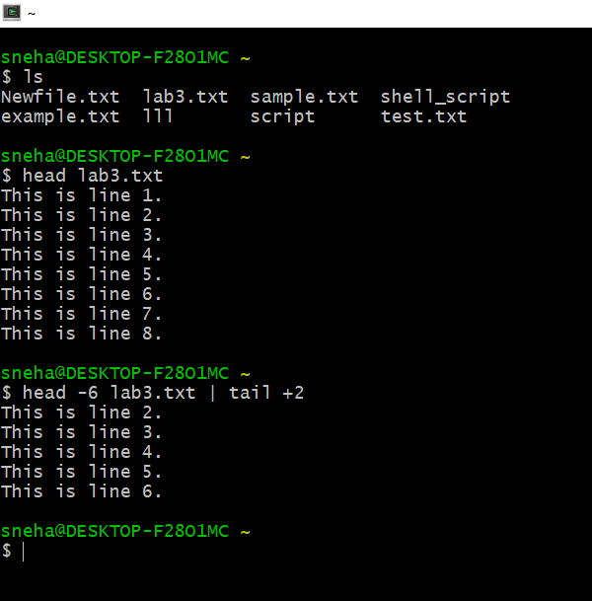

2. Create a shell script to display average of N numbers.

Solution:

#shell script to find average of N numbers

echo "enter the size(N)"

read N

sum=0

echo "enter the numbers"

for ((i=1; i<=N; i++))

do

read n

sum=$((sum+n))

done

avg=$(expr $sum / $N)

echo "Average = $avg"

Output:



