|  |  |
| --- | --- |
| page1image3828864 | **B. P. Poddar Institute of Management and Technology**  **Department of Computer Science & Engineering**  **Software Engineering Lab (ESC-591)**  **AY: 2021-22 ODD Semester**  **Assignment-4 (Data Flow Diagrams)** |

Group No. (Case Study No.)___________4________________

Case Study Title: ____MediLab & Drug Store Information System____________

**Student Details:**

|  |  |  |
| --- | --- | --- |
| **Univ. Roll. No.** | **Name** | **Contributions in DFD (Level/process)** |
| **11500119047** | **SOUMYAJIT PRAMANIK** | **0, 2.1** |
| **11500119048** | **TUHIN HAZRA** | **1, 2.3** |
| **11500119051** | **TANDRIMA GHOSH** | **2.3, 3** |
| **11500119052** | **SNEHA TIWARI** | **0, 1, 2.2, 2.4** |

**Please do not write anything below the dotted line >**

...................................................................................................................................................................................................

**Marks awarded (Total Marks = 20)**

|  |  |  |  |  |
| --- | --- | --- | --- | --- |
| Student Name |  |  |  |  |
| Marks Awarded |  |  |  |  |

Signature of Faculty with date________________________________________________

**Case Study Description:**

MLDIS is a system designed to cater to the needs of a typical test laboratory where patients can go for different types of prescribed tests and also buy prescription drugs.

**Functional Design using Data Flow Diagrams**

A Data Flow Diagram (DFD) is a traditional visual representation of the information flows within a system. A neat and clear DFD can depict the right amount of the system requirement graphically. It can be manual, automated, or a combination of both.

It shows how data enters and leaves the system, what changes the information, and where data is stored.

The objective of a DFD is to show the scope and boundaries of a system as a whole. It may be used as a communication tool between a system analyst and any person who plays a part in the order that acts as a starting point for redesigning a system. The DFD is also called as a data flow graph or bubble chart.

**Context Level/DFD Level 0:**

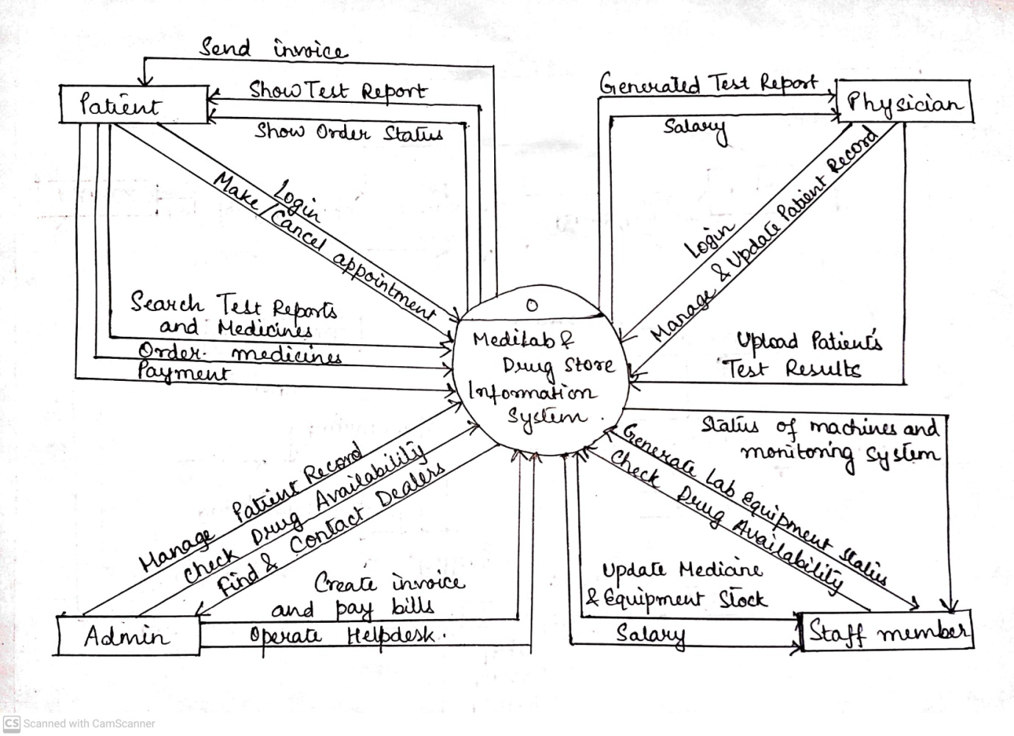

**DFD Level 1:**

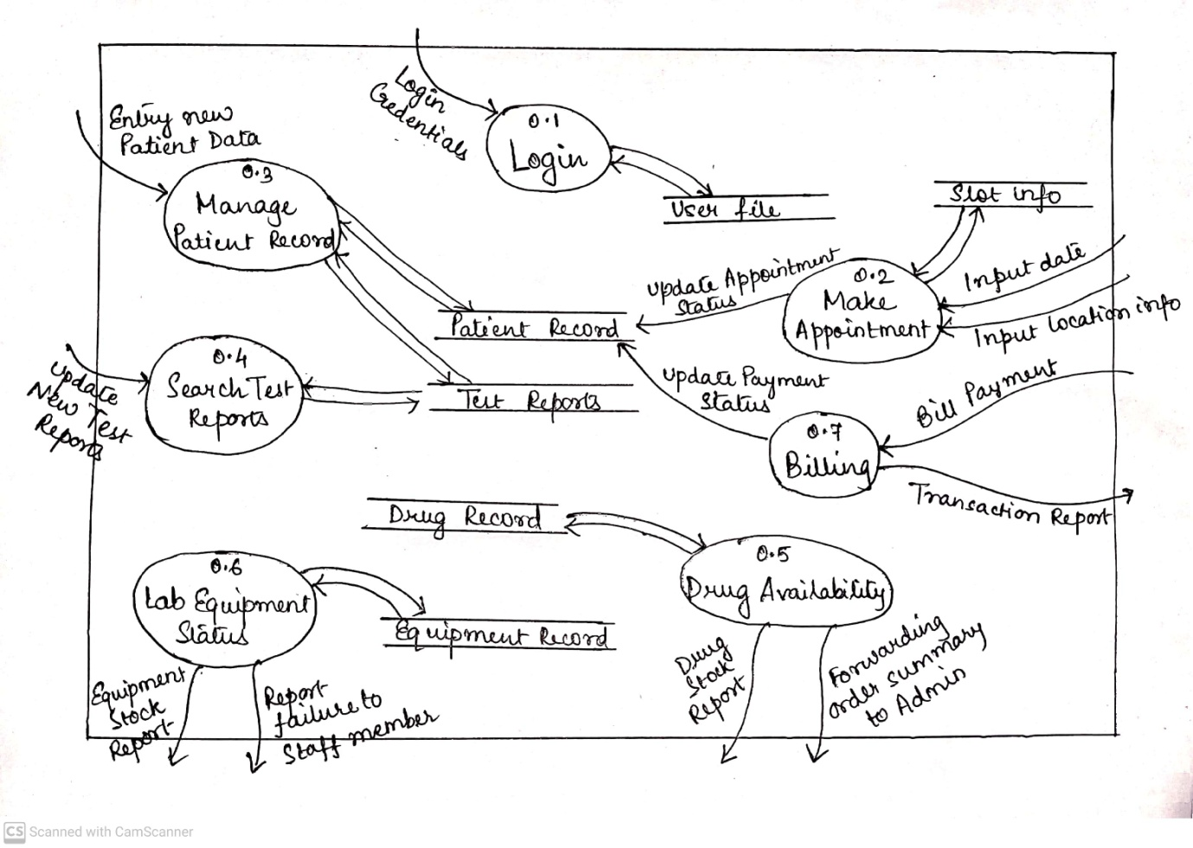

**DFD Level 2:**

**LOGIN (2.1)**

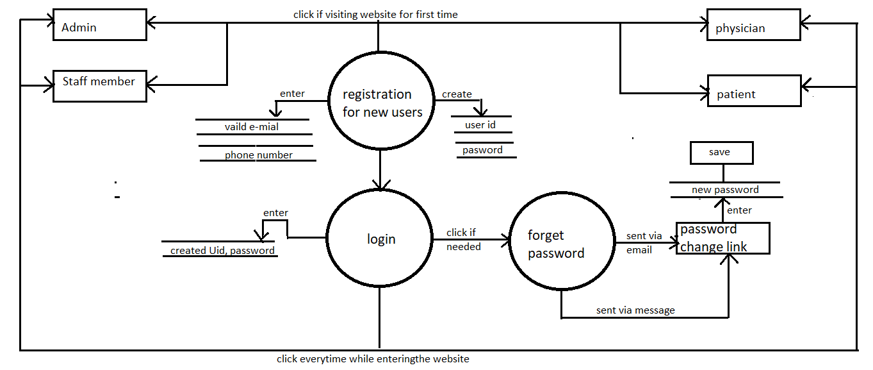

**MAKE APPOINTMENT (2.2)**

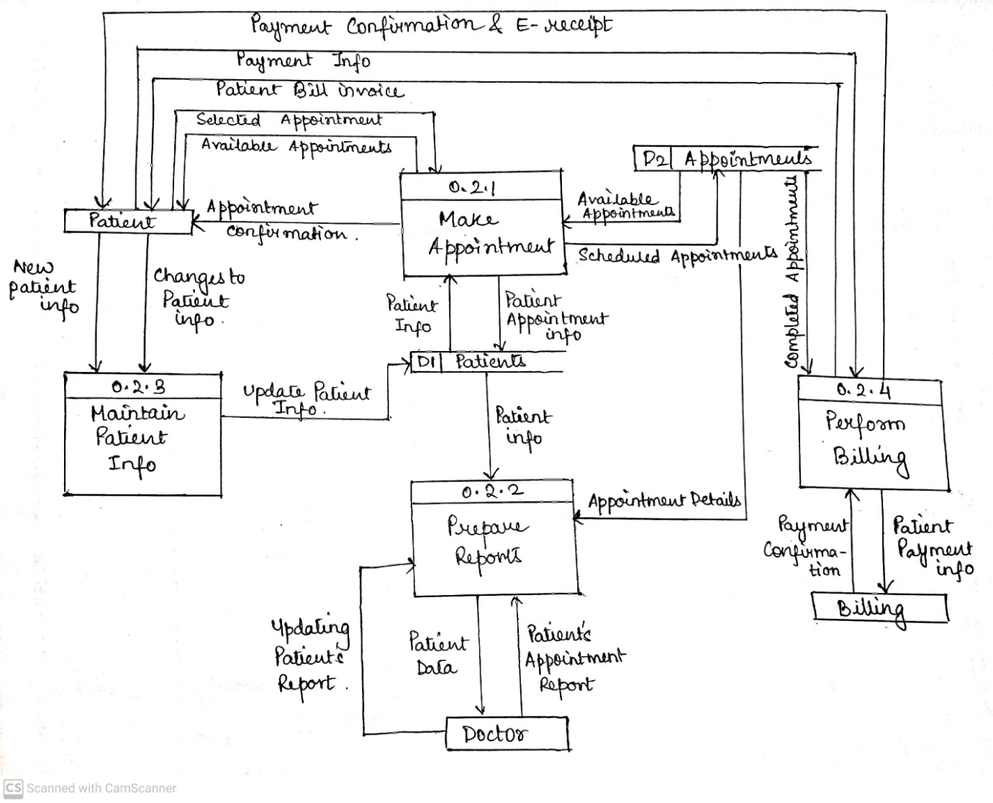

**DRUG AVAILABILILY (2.3)**

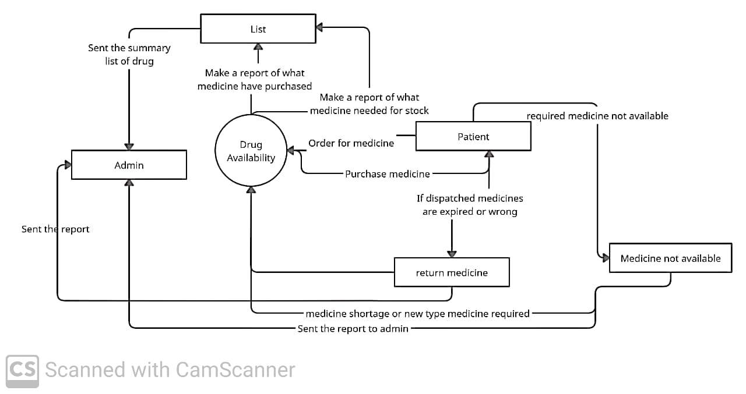

**BILLING (2.4)**

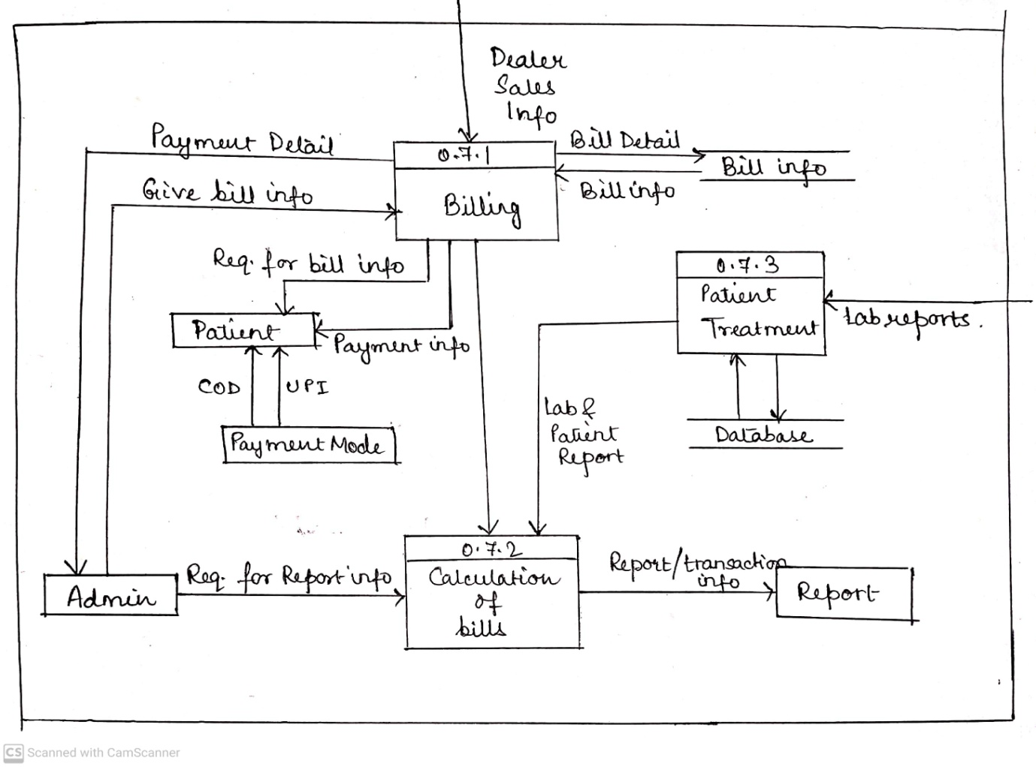

**DFD Level 3:**

**DRUG AVAILABILITY (2.3.1)**

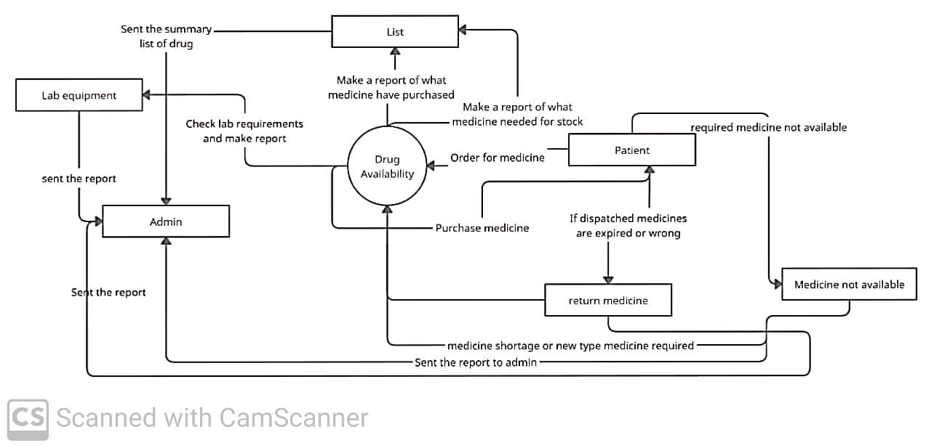

**Data Dictionary:**

*No data dictionary has been used.*