Name: Sneha Tiwari

Roll: 11500119052 | Group: B1

Assignment 4 - Shell script

**1. Write a shell script to perform all arithmetic operations using "expr"**

**Solution:**

**Script**

echo "Enter a"

read a

echo "Enter b"

read b

echo "Sum"

expr $a + $b

echo "Diff"

expr $b - $a

echo "Product"

expr $a \* $b

echo "Quotient"

expr $b / $a

echo "Modulo"

expr $b % $a

**Output**

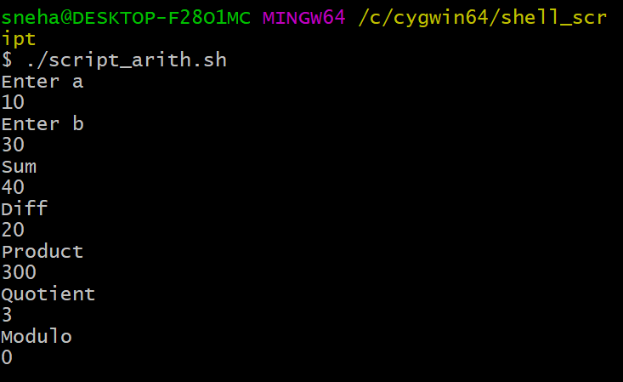

**2. Write a shell script to display biggest number among n numbers.**

**Solution:**

**Script**

#find largest number among N numbers

echo "Enter Size(N)"

read N

i=1

max=0

echo "Enter Numbers"

while [ $i -le $N ]

do

read num

if [ $i -eq 1 ]

then

max=$num

else

if [ $num -gt $max ]

then

max=$num

fi

fi

i=$((i + 1))

done

echo "Largest number= $max"

**Output**

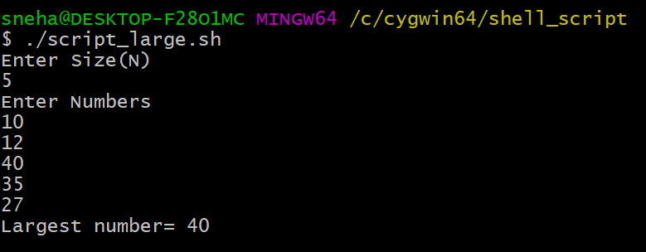

**3. Write a shell script to display n numbers in reverse order.**

**Solution:**

**Script**

echo enter number to reverse

read n

num=0

while [ $n -gt 0 ]

do

num=$(expr $num \* 10)

k=$(expr $n % 10)

num=$(expr $num + $k)

n=$(expr $n / 10)

done

echo Reversed Number is= $num

**Output**



