|  |  |
| --- | --- |
| page1image3828864 | **B. P. Poddar Institute of Management and Technology**  **Department of Computer Science & Engineering**  **Software Engineering Lab (ESC-591)**  **AY: 2021-22 ODD Semester**  **Assignment-4 (Data Flow Diagrams)** |

Group No. (Case Study No.)___________4________________

Case Study Title: ____MediLab & Drug Store Information System____________

**Student Details:**

|  |  |  |
| --- | --- | --- |
| **Univ. Roll. No.** | **Name** | **Contributions in DFD (Level/process)** |
| **11500119047** | **SOUMYAJIT PRAMANIK** | **2** |
| **11500119048** | **TUHIN HAZRA** | **2** |
| **11500119051** | **TANDRIMA GHOSH** | **1** |
| **11500119052** | **SNEHA TIWARI** | **3** |

**Please do not write anything below the dotted line >**

...................................................................................................................................................................................................

**Marks awarded (Total Marks = 20)**

|  |  |  |  |  |
| --- | --- | --- | --- | --- |
| Student Name |  |  |  |  |
| Marks Awarded |  |  |  |  |

Signature of Faculty with date________________________________________________

**Case Study Description:**

MLDIS is a system designed to cater to the needs of a typical test laboratory where patients can go for different types of prescribed tests and also buy prescription drugs.

**Summary of DFD:**

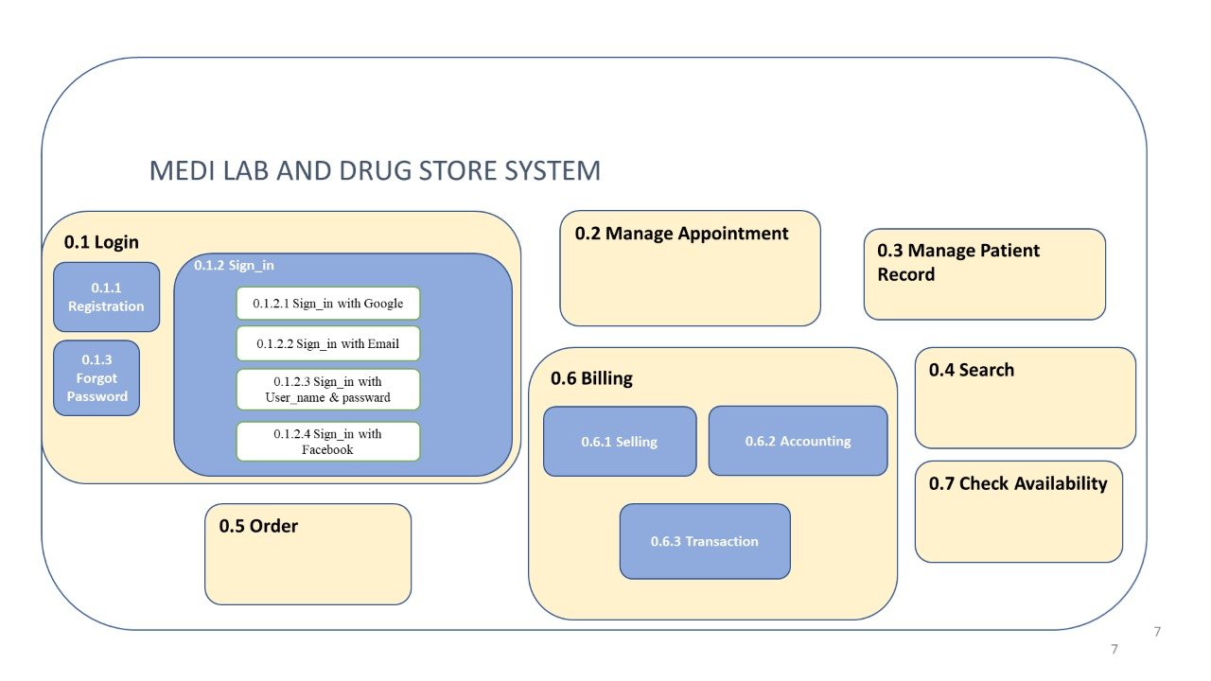

**Structured Chart:**

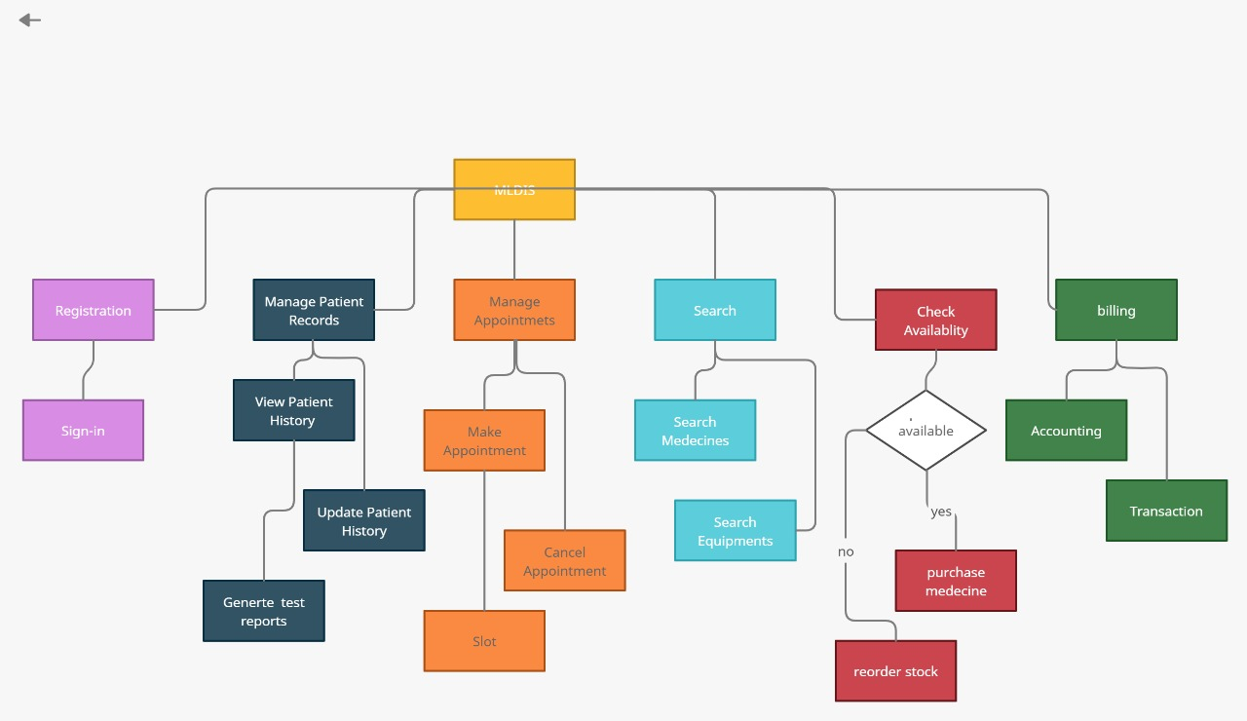

**Class Diagram:**

