Name: Sneha Tiwari

Roll: 11500119052 | Group: B1

Assignment 5 – Command Line Arguments

**1. Write a Script to find out biggest number from given three nos. Numbers are supplied as command line argument. Print error if sufficient arguments are not supplied.**

**Solution:**

**Script**

if [ $# -ne 3 ]

then

echo "All three command line arguments not given"

exit 1

fi

a=$1

b=$2

c=$3

if [ $a -gt $b ] && [ $a -gt $c ]

then

echo "$a is the largest."

elif [ $b -gt $a ] && [ $b -gt $c ]

then

echo "$b is the largest."

elif [ $c -gt $a ] && [ $c -gt $b ]

then

echo "$c is the largest."

elif [ $1 -eq $2 ] && [ $1 -eq $3 ] && [ $2 -eq $3 ]

then

echo "All are equal."

else

echo "Invalid arguments. Try again."

fi

**Output**

**# No or lesser arguments throws error message.**

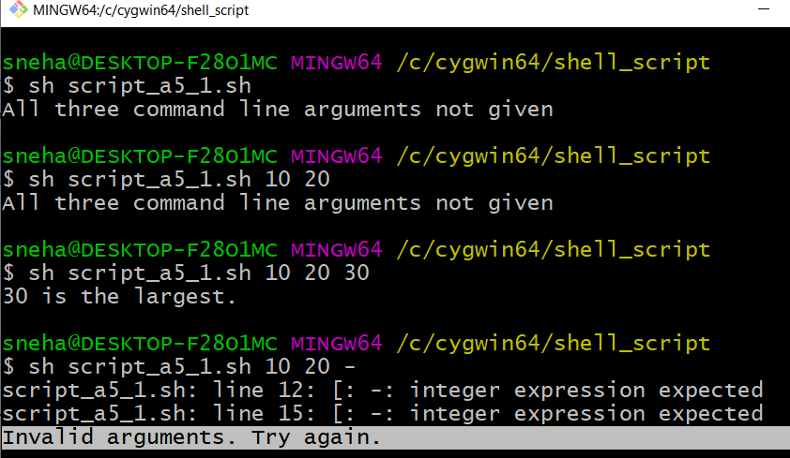

**2. Write a script to print nos as 5,4,3,2,1 using while loop.**

**Solution:**

**Script**

n=5

echo "Printing 5 4 3 2 1 ..."

while test $n != 0

do

echo "$n"

n=$(( $n - 1))

done

**Output**

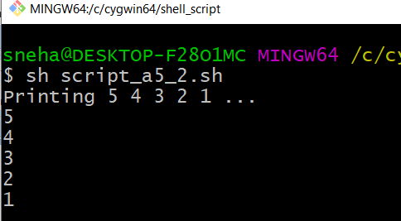

**3. Write a Script, using case statement to perform basic arithmetic operation.**

**Solution:**

**Script**

if test $# = 3

then

case $2 in

+) let z=$1+$3;;

-) let z=$1-$3;;

/) let z=$1/$3;;

x|X) let z=$1*$3;;

*) echo Warning: $2 invalid operator, only x,X allowed for multiply

exit;;

esac

echo Result: $z

else

echo "Correct syntax is value1 operator value2"

echo "Operators can be +,-,/,x (For Multiplication)"

fi

**Output**

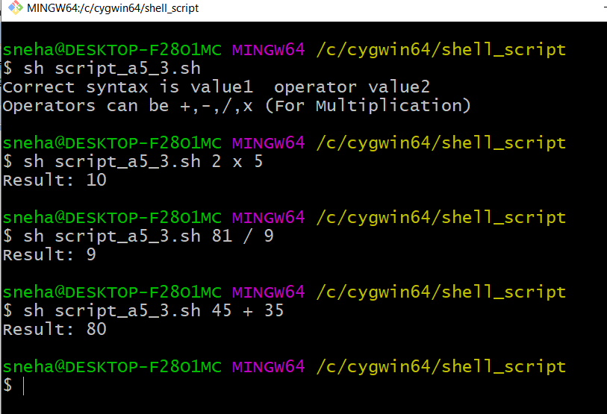

**4. Write a Script to see current date, time, username, and current directory.**

**Solution:**

**Script**

echo "Hello people!"

echo "Current time & date is: `date`."

echo "User is `whoami`."

echo "Current directory is: `pwd`."

**Output**

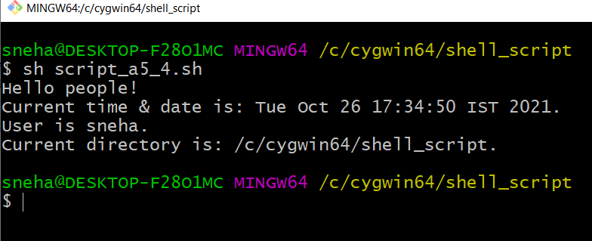

**5. Write a Script to print given number in reverse order, for eg. If no is 123 it must print as 321.**

**Solution:**

**Script**

if [ $# -ne 1 ]

then

echo "Syntax Error"

echo "Enter a number as argument, eg. 123, it will print reverse, 321"

exit 1

fi

n=$1

rev=0

sd=0

while [ $n -gt 0 ]

do

sd=`expr $n % 10`

rev=`expr $rev \* 10 + $sd`

n=`expr $n / 10`

done

echo "Reverse number: $rev"

**Output**



