|  |  |
| --- | --- |
| page1image3828864 | **B. P. Poddar Institute of Management and Technology**  **Department of Computer Science & Engineering**  **Software Engineering Lab (ECS 591)**  **AY: 2021-22 ODD Semester**  **Assignment-(CFG)** |

Last digit of Roll no. (Question No.)____ **2__________**

**Student Details:**

|  |  |
| --- | --- |
| **Univ. Roll. No.** | **Name** |
| **11500119052** | **SNEHA TIWARI** |

**Please do not write anything below the dotted line >**

...................................................................................................................................................................................................

**Marks awarded (Total Marks = 20)**

|  |  |
| --- | --- |
| Student Name |  |
| Marks Awarded |  |

Signature of Faculty with date________________________________________________

**2. Draw a CFG for the following piece of code. Find cyclomatic complexity and list out the minimum number of independent paths.**

for ( i=0; i < N ; i++)

{

if( keynum == array[i] )

{

found = 1;

break;

}

}

if ( found == 1)

printf("SUCCESSFUL SEARCH\n");

else

printf("Search is FAILED\n");

}

**=> CFG for the given code:**

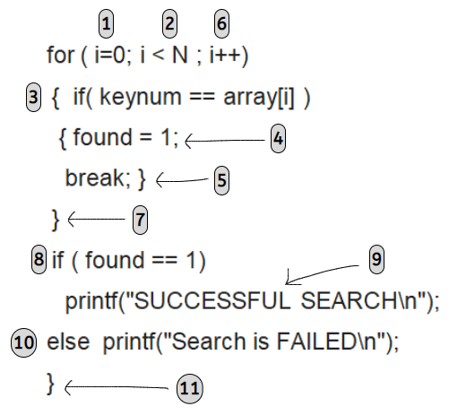 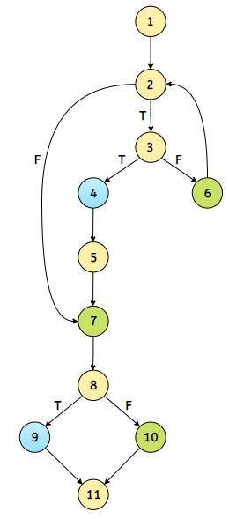

**=> Cyclomatic Complexity:**

**E = no. of edges = 13**

**N = no. of nodes = 11**

**R = no. of bounded regions = 3**

**For the given CFG ‘G’, Cyclomatic complexity is:**

**V(G) = E – N + 2 =** 13 - 11 + 2 = **4**

**Or, V(G) = R + 1 =** 3 + 1 = **4**

**=> Minimum Number of Independent Paths:**

**Test Paths:**

**Path (1): 1-2-3-4-5-7-8-9-11**

**Path (2): 1-2-3-4-5-7-8-10-11**

**Path (3): 1-2-7-8-9-11**

**Path (4): 1-2-3-6-2-3-4-5-7-8-10-11**

**---------------------------------------------------------**