|  |  |
| --- | --- |
| page1image3828864 | **B. P. Poddar Institute of Management and Technology**  **Department of Computer Science & Engineering**  **Software Engineering Lab (ESC-591)**  **AY: 2021-22 ODD Semester**  **Assignment-4 (Data Flow Diagrams)** |

Group No. (Case Study No.)___________4________________

Case Study Title: ____MediLab & Drug Store Information System____________

**Student Details:**

|  |  |
| --- | --- |
| **Univ. Roll. No.** | **Name** |
| **11500119047** | **SOUMYAJIT PRAMANIK** |
| **11500119048** | **TUHIN HAZRA** |
| **11500119051** | **TANDRIMA GHOSH** |
| **11500119052** | **SNEHA TIWARI** |

**Please do not write anything below the dotted line >**

...................................................................................................................................................................................................

**Marks awarded (Total Marks = 20)**

|  |  |  |  |  |
| --- | --- | --- | --- | --- |
| Student Name |  |  |  |  |
| Marks Awarded |  |  |  |  |

Signature of Faculty with date________________________________________________

**Case Study Description:**

MLDIS is a system designed to cater to the needs of a typical test laboratory where patients can go for different types of prescribed tests and also buy prescription drugs.

**Static Design using UML Class Diagrams:**

**What are the Class Diagrams?**

Class diagrams are the main building block in [object-oriented modeling](https://creately.com/lp/object-diagram-tool). They are used to show the different objects in a system, their attributes, their operations and the [relationships](https://creately.com/lp/interrelationship-diagram) among them.

The following figure is an example of a simple class:

[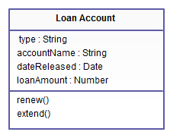](https://d3n817fwly711g.cloudfront.net/blog/wp-content/uploads/2012/03/Class-Diagram.jpeg)

*Simple class diagram with attributes and operations*

In the example, a class called “loan account” is depicted. Classes in [class diagrams](https://creately.com/diagram-type/class-diagram) are represented by boxes that are partitioned into three:

1. The top partition contains the name of the class.
2. The middle part contains the class’s attributes.
3. The bottom partition shows the possible operations that are associated with the class.

The example shows how a class can encapsulate all the relevant data of a particular object in a very systematic and clear way. A class diagram is a collection of classes similar to the one above.

**Relationships in Class Diagrams**

Classes are interrelated to each other in specific ways. In particular, relationships in class diagrams include different types of logical connections. The following are such types of logical connections that are possible in [UML](https://creately.com/lp/uml-diagram-tool):

* Association
* [Directed Association](https://creately.com/blog/diagrams/class-diagram-relationships/#Directed)
* [Reflexive Association](https://creately.com/blog/diagrams/class-diagram-relationships/#Reflexive)
* [Multiplicity](https://creately.com/blog/diagrams/class-diagram-relationships/#Multiplicity)
* [Aggregation](https://creately.com/blog/diagrams/class-diagram-relationships/#Aggregation)
* [Composition](https://creately.com/blog/diagrams/class-diagram-relationships/#Composition)
* [Inheritance/Generalization](https://creately.com/blog/diagrams/class-diagram-relationships/#Inheritance)
* [Realization](https://creately.com/blog/diagrams/class-diagram-relationships/#Realization)

**Class Diagram of Case Study:**

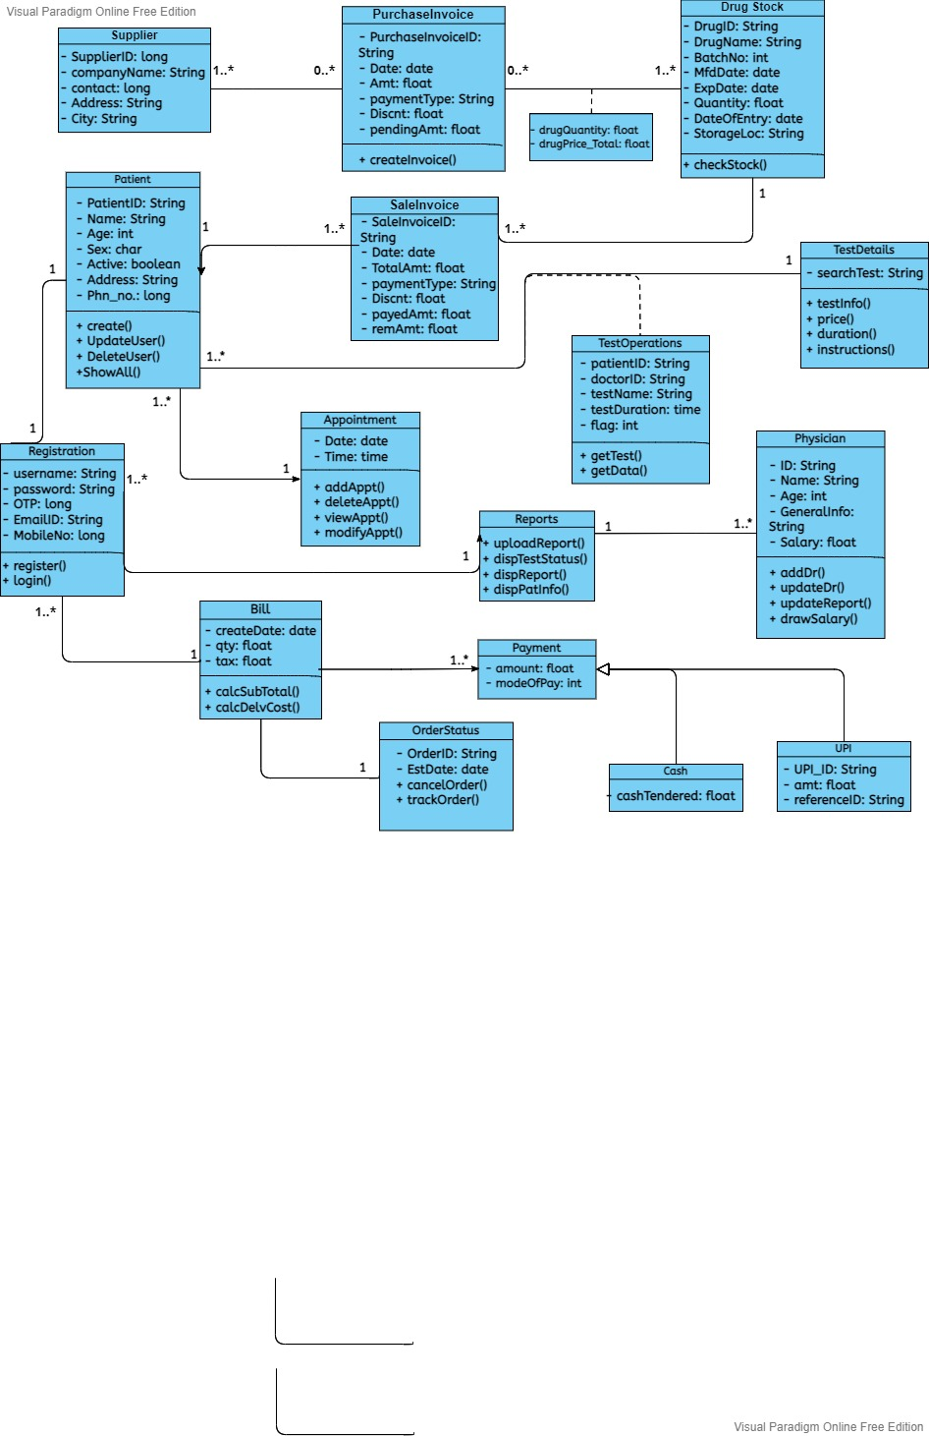

**References:**

* <https://www.visual-paradigm.com/guide/uml-unified-modeling-language/what-is-class-diagram/>
* <https://creately.com/blog/diagrams/class-diagram-relationships/>

**Online Tools used:**

**1. Visual Paradigm -**<https://online.visual-paradigm.com/drive/#diagramlist:proj=0&new =ClassDiagram>

**-------------------------------------------------------**