**NAME: SNEHA TIWARI**

**UNIV ROLL NO.: 11500119052**

**ASSIGNMENT 6 - SOLUTION**

i. Display name, phone number of students with ‘a’ as the second letter in their names who read subject CS301.

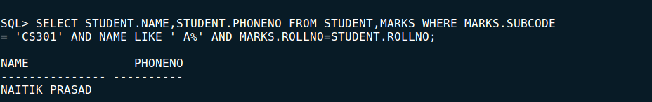

ii. Display the marks for all available subjects for the students who born in JUNE.

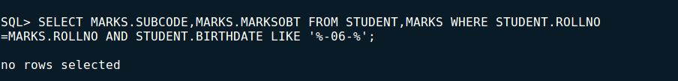

iii. Show the student details of 5th semester Computer science and engineering Department.

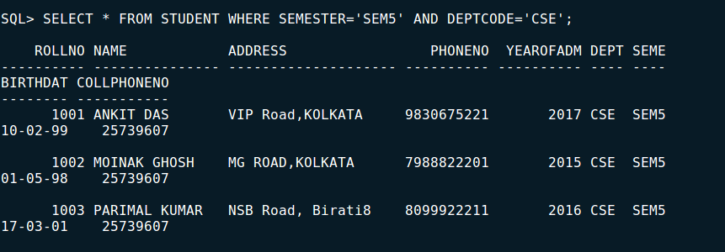

iv. Show the subject details of 3rd semester Computer science and engineering Department.

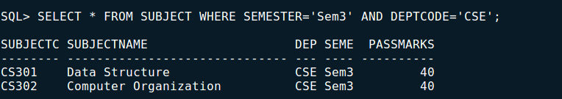

v. Display the department name for which some student get more than 90.

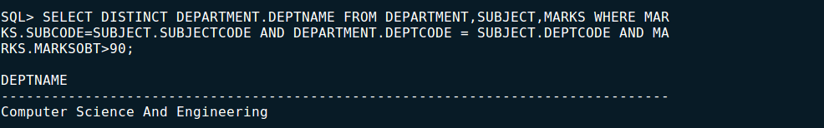

vi. Display the student name who reads in 5th semester and get more than 80 in any subject.

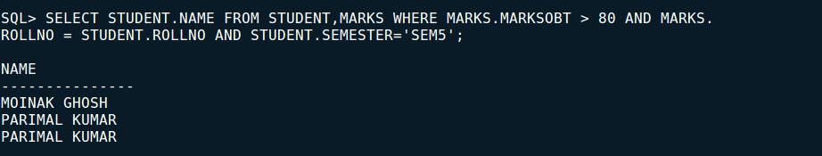

vii. Display the name of CSE student who born in 2000 and get more than 80 in CS301.

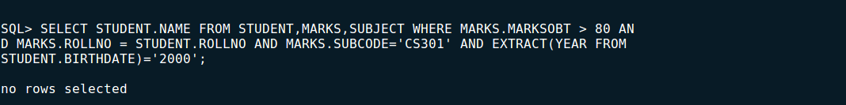

viii. Display the department details with less than 80 students which has subject name Data Communication.

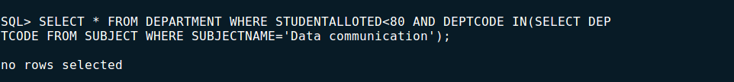

ix. Display subject name, subject code of the department with allotted student less than 100.



x. Show Roll number, subject code and marks for CSE 3rd year students where subject name starts with D.

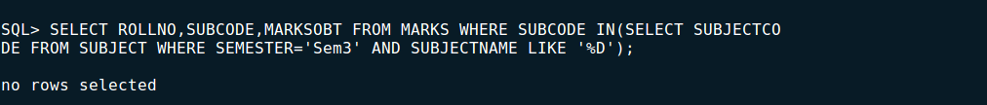

xi. Display roll number, subject and marks of students who took admission in the year 2017 and read subject CS505.



xii. Find the student details of CSE students whose marks are not available in result.

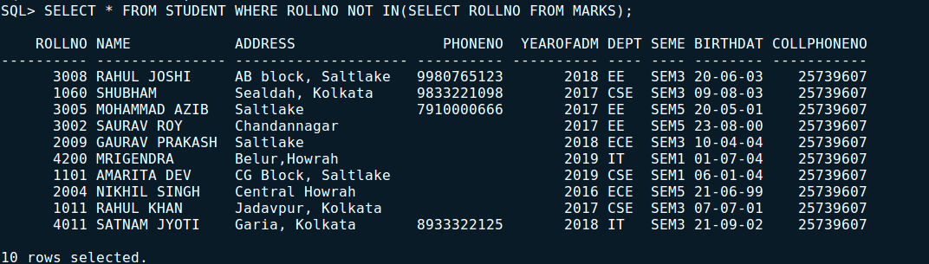

xiii. Find the subject name, subject code which is not included in result.



