Name: Sneha Tiwari

Roll: 11500119052 | Group: B1

Assignment 6

**1. Write shell script using for loop to print the following patterns on screen.**

**Solution:**

**Script**

num=1

rows=5

echo "Number pattern ..."

for((i=1; i<=rows; i++))

do

for((j=1; j<=i; j++))

do

echo -n "$num"

num=$((num + 1))

done

num=1

echo

done

**Output**

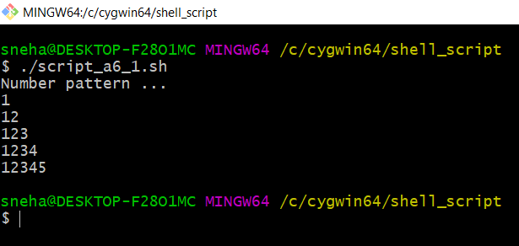

**2. Write shell script using for loop to print the following patterns on screen.**

**Solution:**

**Script**

n=9

space=n

echo "Printing number pyramid pattern ..."

for((i=1;i<=n;i++))

do

space=$((space-1))

for((j=1;j<=space;j++))

do

echo -n " "

done

for((k=1;k<=i;k++))

do

echo -n "$i"

echo -n " "

done

echo -e #print new line after each row

done

**Output**

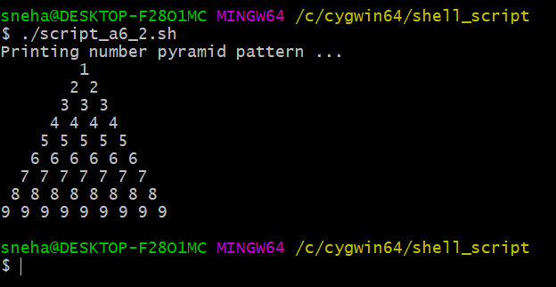

**3. Write shell script to print factorial of a number.**

**Solution:**

**Script**

echo "Enter a number to find factorial: "

read num

fact=1

while [ $num -gt 1 ]

do

fact=$((fact * num))

num=$((num - 1))

done

echo Factorial= $fact

**Output**

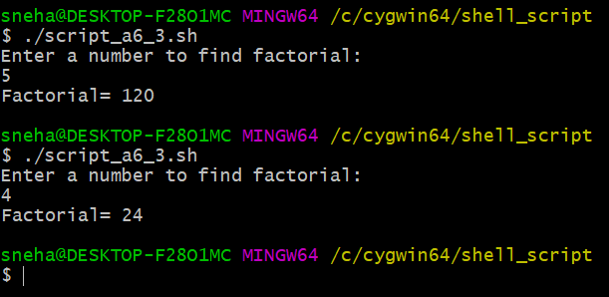

**4. Write a Shell Script to multiply two numbers using function.**

**Solution:**

**Script**

function mul()

{

mul=$(($1 * $2))

echo "Product = $mul"

}

echo "Enter a: "

read a

echo "Enter b: "

read b

mul $a $b

**Output**

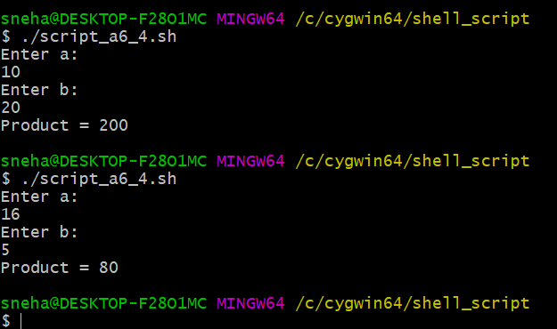

**5. Write a Shell Script to Print Fibonacci Series.**

**Solution:**

**Script**

echo "Enter the number of terms: "

read n

function fib

{

x=0

y=1

i=2

echo "Fibonacci Series up to $n terms:"

echo "$x"

echo "$y"

while [ $i -lt $n ]

do

i=`expr $i + 1 `

z=`expr $x + $y `

echo "$z"

x=$y

y=$z

done

}

r=`fib $n`

echo "$r"

**Output**



