**NAME: SNEHA TIWARI**

**UNIV ROLL NO.: 11500119052**

**ASSIGNMENT 7 – OUTPUT**

1. **Display student names along with the department name.**

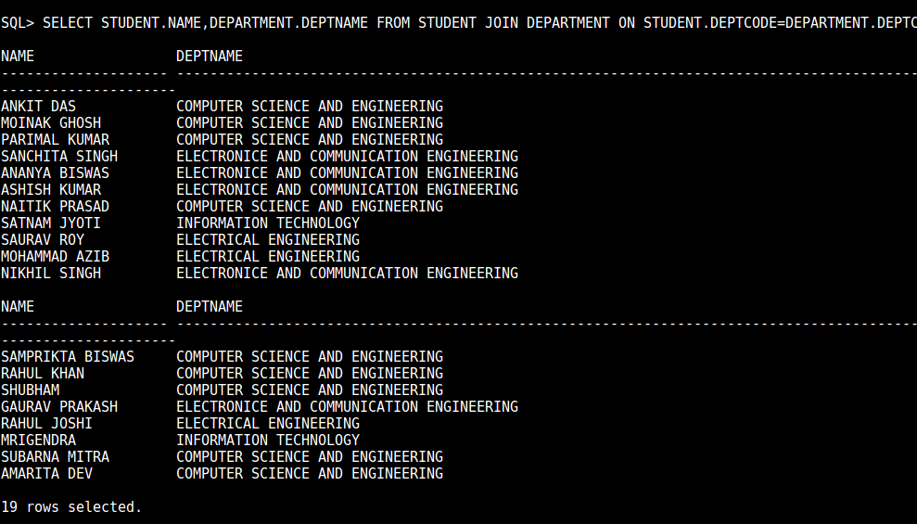

1. **Display student names, subject code and marks of students who took admission in the year 2017 and read subject CS502.**



1. **Find the name of the students who got marks between 70 to 89 in CS501.**



1. **Find the student name, roll no who appeared in the examination for paper DBMS.**



1. **Show student names, subject code and marks for CSE 3rd year students.**

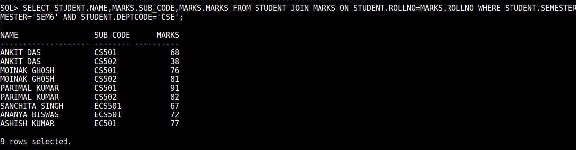

1. **Show student names, department name for 5 th semester students who born in MAY.**

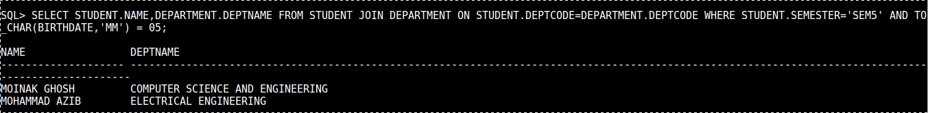

1. **Show student names, subject name for 5th semester student where subject name contains the word ‘DATA’**

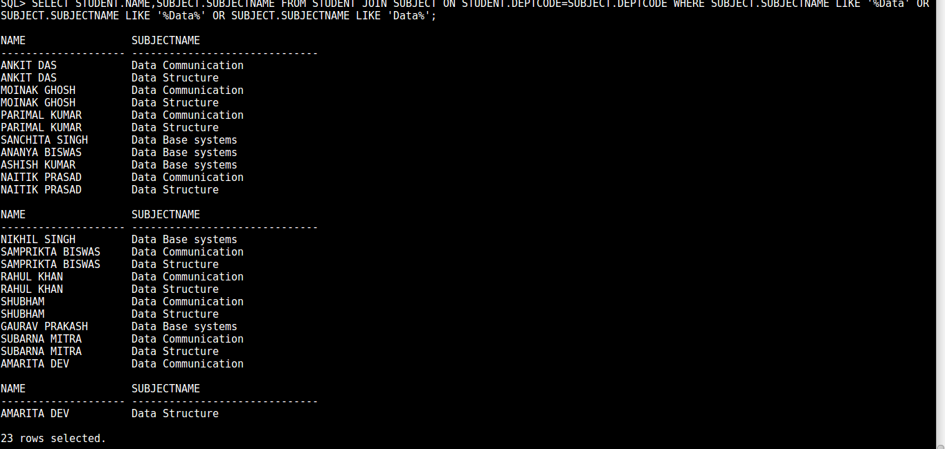

1. **Show student names, subject name and marks for 5th semester students.** 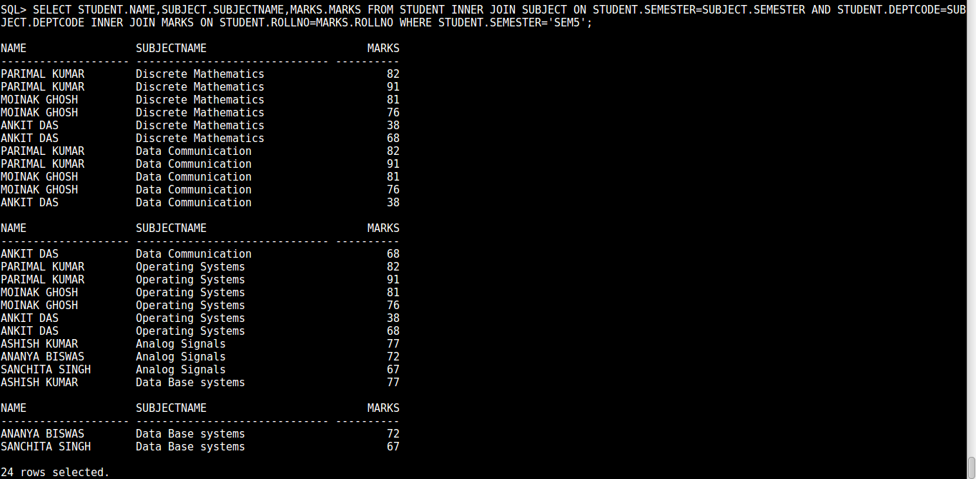
2. **Find the roll number, student names and marks for CSE students who get more than 80 in Data Structure.**

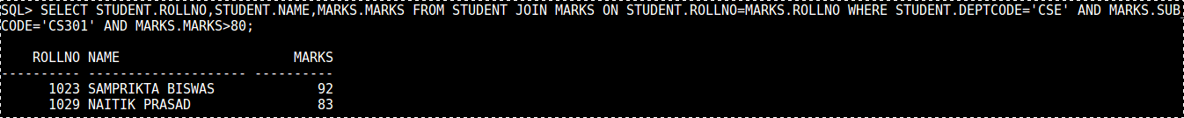

1. **Show student names, department name, subject name and subject wise marks for which the student get more than 90.**

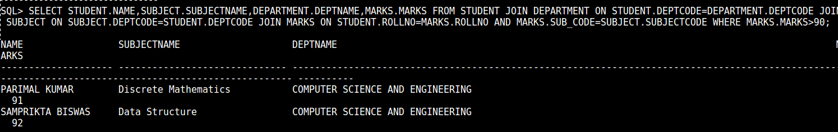

1. **Add column HOD in DEPARTMENT. Insert faculty id in place of HoD.**

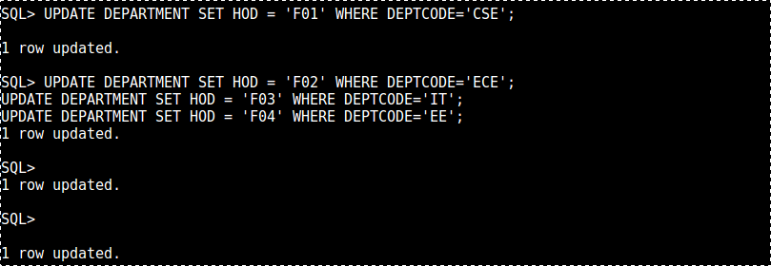

1. **Add column TEACHER in table SUBJECT. Insert faculty id in this column.**

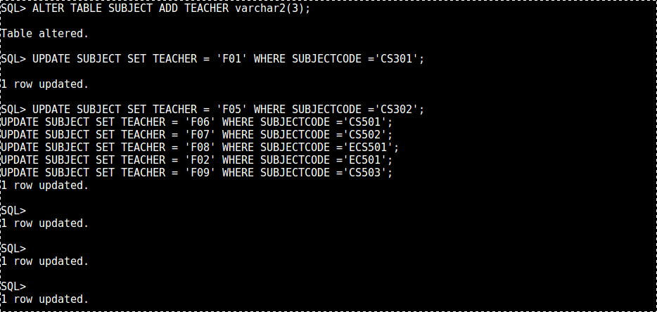

1. **Show the department name, semester, subject name along with faculty name.**

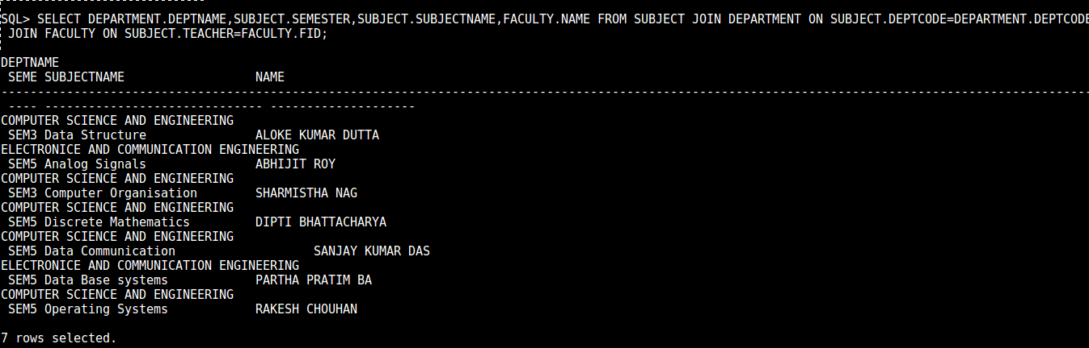

1. **Find the names of all faculties whose HOD name is given.**

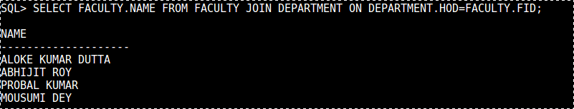

1. **Display subject name, subject code, marks including all subjects. [Outer join ]**

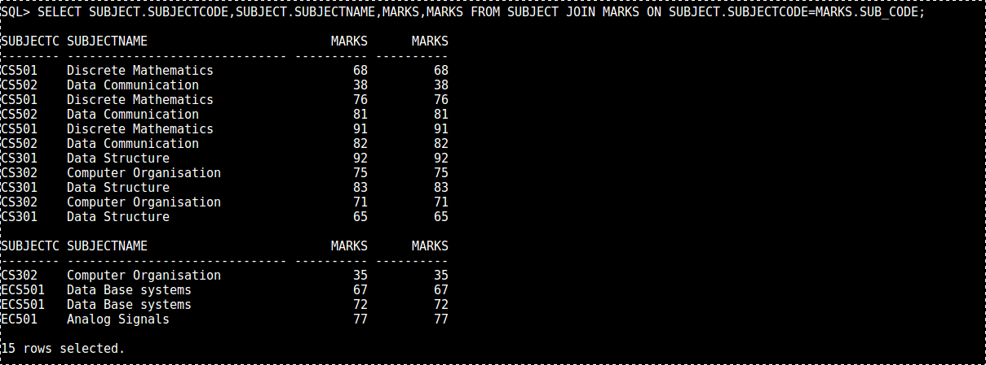

1. **Display students name, subject code, marks. Include all students. [Outer join ]**

