Name: Sneha Tiwari

Roll: 11500119052 | Group: B1

Assignment 7

**1. Write a Shell Script to determine whether given file exist or not, file name is supplied as command line argument, also check for sufficient number of command line argument.**

**Solution:**

**Script**

if [ $# -ne 1 ]

then

echo "Error: Give proper command-line argument"

echo "Syntax: $0 filename"

exit 1

fi

if [ -f $1 ]

then

echo "$1 file exists in this directory."

else

echo "$1 does not exist in this directory."

fi

**Output**

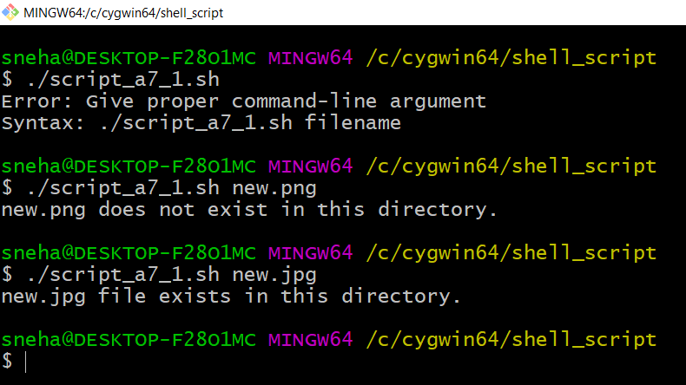

**2. Write Shell Script for Bubble sort.**

**Solution:**

**Script**

echo "Enter size of array: "

read n

echo -e "\nEnter elements in the array to sort: "

for (( i = 0; i < $n; i++ ))

do

read nos[$i]

done

for (( i = 0; i < $n ; i++ ))

do

for (( j = $i; j < $n; j++ ))

do

if [ ${nos[$i]} -gt ${nos[$j]} ];

then

t=${nos[$i]}

nos[$i]=${nos[$j]}

nos[$j]=$t

fi

done

done

echo -e "\nSorted Array using Bubble Sort: "

for (( i=0; i < $n; i++ ))

do

echo ${nos[$i]}

done

**Output**

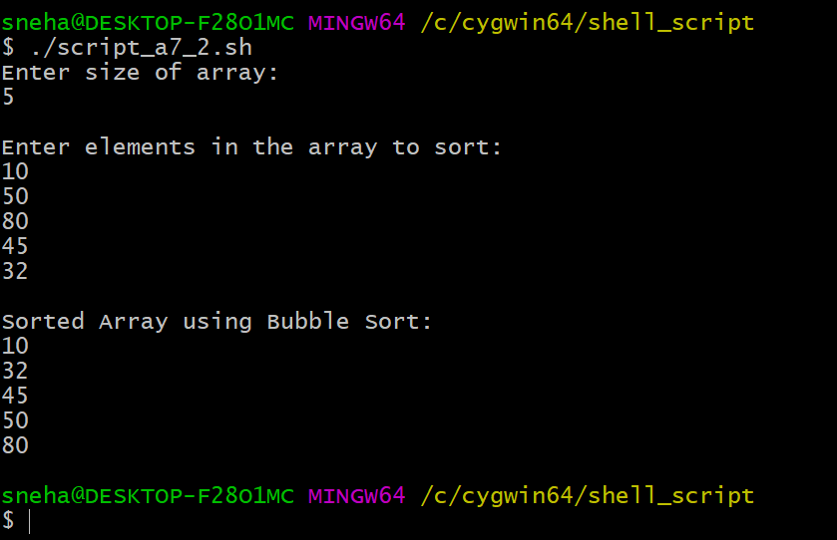

**3. Write a Shell Script to swap two numbers without using third variable.**

**Solution:**

**Script**

echo "Enter a: "

read a

echo "Enter b: "

read b

echo "Before swapping, a = $a and b = $b."

a=$((a+b))

b=$((a-b))

a=$((a-b))

echo "After swapping, a = $a and b = $b."

**Output**

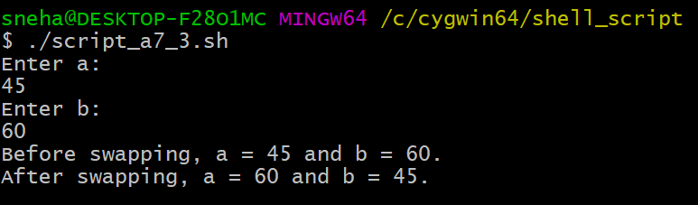

**4. Write a Shell Script to find "a" to the power "b" using function.**

**Solution:**

**Script**

power()

{

num=$1

pow=$2

counter=1

result=1

if((pow==0));

then

result=1

fi

if ((num==0));

then

result=0

fi

if((num>=1&&pow>=1));

then

while((counter<=pow))

do

result=$((result*num))

counter=$((counter + 1))

done

fi

echo -e "\n$1 to the power $2 = $result"

}

read -p "Enter the number: " num

read -p "Enter its power: " pow

#function calling

power $num $pow

**Output**

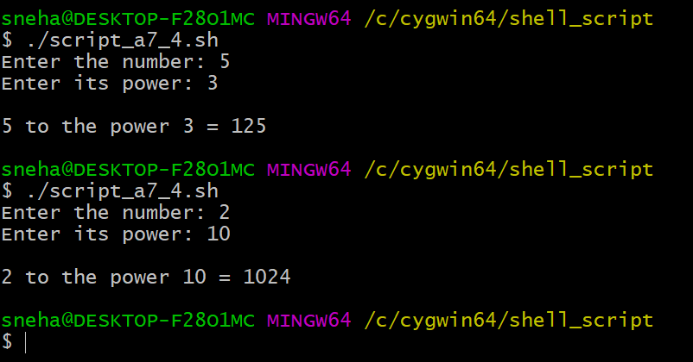

**5. Write a Shell Script to reverse a string.**

**Solution:**

**Script**

read -p "Enter a string: " string

len=${#string}

for (( i=$len-1; i>=0; i-- ))

do

reverse="$reverse${string:$i:1}"

done

echo "Reversed string is:" $reverse

**Output**



