**NAME: SNEHA TIWARI**

**UNIV ROLL NO.: 11500119052**

**ASSIGNMENT 8 – QUERY OUTPUT**

**i. Find the number of students in CSE second year.**

SELECT COUNT(*) AS COUNT_2ND_YR FROM STUDENT WHERE SEMESTER='SEM3' AND DEPTCODE='CSE';

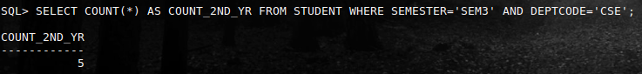

**ii. Find the number of students whose marks of any subject is available.**

SELECT COUNT(MARKS) AS STUD_WITH_MARKS FROM RESULT;



**iii. Find total number of faculty.**

SELECT COUNT(*) AS TOT_FACLT FROM FACULTY;

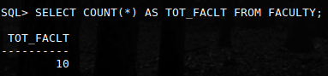

**iv. Find the 5th semester student(s) who got maximum marks in a subject.**

SELECT NAME, MARKS FROM STUDENT   
JOIN RESULT USING(ROLLNO)   
WHERE SEMESTER='SEM5' AND MARKS IN (SELECT MAX(MARKS) AS   
MAX_MARKS FROM RESULT   
GROUP BY SUB_CODE);

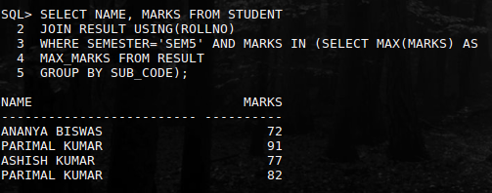

**v. Find the roll number of a student who got maximum marks in CS501.**

SELECT ROLLNO FROM RESULT   
WHERE MARKS=(SELECT MAX(MARKS)   
FROM RESULT WHERE SUB_CODE='CS501');



**vi. Display average marks of CS502.**

SELECT AVG(MARKS) FROM RESULT WHERE SUB_CODE='CS502';

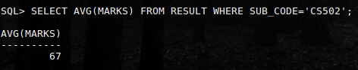

**vii. Find the number of students in each department with their department code.**

SELECT COUNT(*) AS STUD_COUNT, DEPTCODE FROM STUDENT  
GROUP BY DEPTCODE;

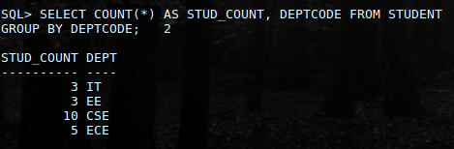

**viii. Find the number of students in each department with their department name.**

SELECT STUD_TOT, DEPTNAME   
FROM (SELECT DEPTCODE, COUNT(ROLLNO) AS STUD_TOT FROM STUDENT   
GROUP BY DEPTCODE)   
JOIN DEPARTMENT USING(DEPTCODE);

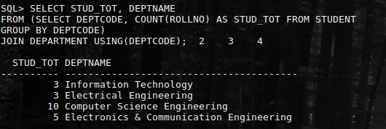

**ix.  Find the Department with more than three faculty.**

SELECT DEPTCODE FROM SUBJECT   
GROUP BY DEPTCODE   
HAVING COUNT(TEACHER) > 3;

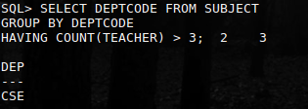

**x.  Find the student name and roll no who get more than 80 in at least two subject.**

SELECT NAME, ROLLNO, MARKS, SUB_CODE FROM STUDENT  
JOIN RESULT USING(ROLLNO)  
WHERE ROLLNO IN (SELECT ROLLNO FROM (SELECT * FROM RESULT WHERE MARKS > 80)   
GROUP BY ROLLNO  
HAVING COUNT(*) >= 2);

**xi. Find the student name and roll no who get more than 70 in average.**

SELECT NAME, ROLLNO, MARKS, SUB_CODE FROM STUDENT  
JOIN RESULT USING(ROLLNO)  
WHERE ROLLNO IN (SELECT ROLLNO FROM (SELECT * FROM RESULT)   
GROUP BY ROLLNO   
HAVING AVG(MARKS) > 70);

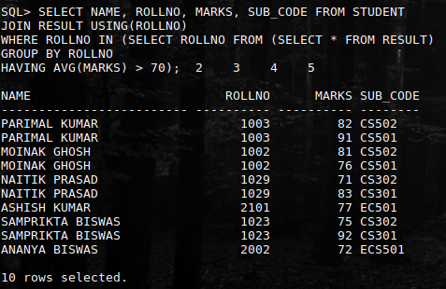

**xii. Display number of subject semester wise in dept CSE.**

SELECT SEMESTER, COUNT(SUBJECTCODE) AS SUBJ_TOT   
FROM SUBJECT   
WHERE DEPTCODE='CSE'   
GROUP BY SEMESTER;

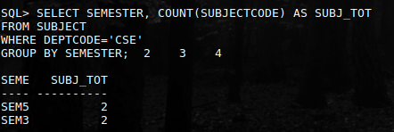

**xiii. Find the department name with maximum number of students.**

SELECT DISTINCT DEPTNAME FROM DEPARTMENT  
JOIN STUDENT USING (DEPTCODE)   
WHERE DEPTCODE=(SELECT DEPTCODE FROM STUDENT   
GROUP BY DEPTCODE   
HAVING COUNT(ROLLNO)=(SELECT MAX(COUNT(ROLLNO))   
FROM STUDENT GROUP BY DEPTCODE));

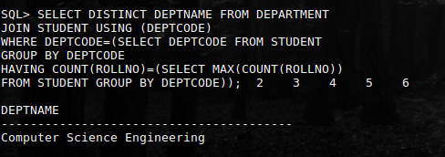

**xiv. Find the second highest marks of the result table.**

SELECT MAX(MARKS) FROM RESULT   
WHERE MARKS NOT IN (SELECT MAX(MARKS) FROM RESULT);



**xv. Find the students name who got highest marks, subjectwise.**

SELECT NAME, MARKS, SUB_CODE FROM STUDENT   
JOIN RESULT USING (ROLLNO)   
WHERE MARKS IN (SELECT MAX(MARKS) FROM RESULT GROUP BY SUB_CODE);



