**NAME: SNEHA TIWARI**

**UNIV. ROLL NO.: 11500119052**

**ASSIGNMENT 9 – OUTPUT**

1. **Create view V_MARKS with roll no, student name, subject code, marks of all CSE students.**

create view V_MARKS as select rollno, name, sub_code,marks from result natural join student where rollno in(select rollno from student where deptcode='CSE');

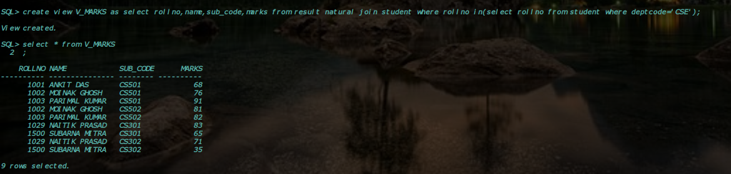

1. **Create view V_CLASSTAKEN with subject code, subject name, Faculty code, faculty name where the subject is taught by that faculty.**

create view V_CLASSTAKEN as select subjectcode, subjectname, fid, name from faculty INNER JOIN subject ON faculty.fid=subject.teacher;

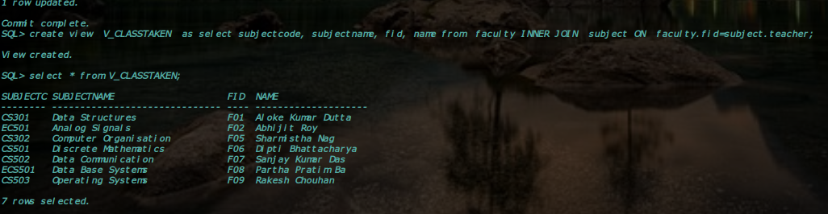

1. **Create view V_SUBJECT with subject_code, subject_name, teacher name where number of student in the subject is more than 1.**

CREATE VIEW V_SUBJECT AS SELECT SubjectCode, SubjectName, Faculty.Name FROM Subject JOIN Faculty ON Subject.Teacher = Faculty.FID WHERE SubjectCode IN (SELECT Sub_Code FROM Result GROUP BY Sub_Code HAVING COUNT(RollNo) > 1);

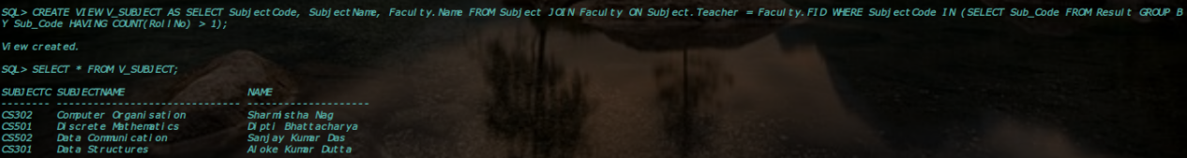

1. **Create view V_STUDENT with student name, roll number, department who appeared  in at least one examination.**

CREATE VIEW V_STUDENT AS SELECT DISTINCT Name, RollNo, DeptCode   
FROM Student INNER JOIN Result USING(RollNo);

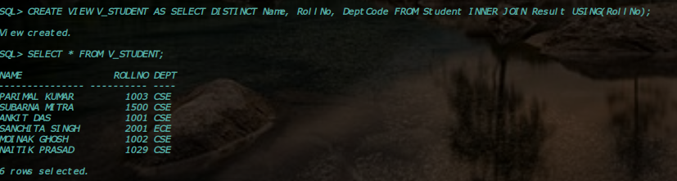

**5. Create view V_DEPT with dept code, semester, number of student with more than 75 marks in at least one subject.**

CREATE VIEW V_DEPT AS SELECT DeptCode, Semester, COUNT(DISTINCT Marks) AS CountStudents FROM Subject JOIN Result ON Subject.SubjectCode = Result.Sub_Code WHERE Marks > 75 GROUP BY DeptCode, Semester;



