**NAME: SHUBHAM MISHRA**

**UNIV. ROLL NO.: 11500119005**

**CSE-B1**

**ASSIGNMENT 10**

**i) Write a PL/SQL program for inverting a number. Take user input. (e.g.  5639 to 9365).**

**Code:**

SET SERVEROUTPUT ON;

DECLARE

num NUMBER;

rev NUMBER;

BEGIN

num:=&num;

rev:=0;

WHILE num>0 LOOP

rev:=(rev*10) + mod(num,10);

num:=floor(num/10);

END LOOP;

DBMS_OUTPUT.PUT_LINE('Reverse of the number is: ' || rev);

END;

**Output:**

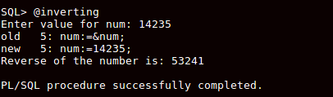

**ii)  Write a PL/SQL program to take Subject name from user and print faculty name who teach the subject also print the student name who got maximum marks in that subject.**

**Code:**

set serveroutput on;

declare

sub varchar2(50);

fname faculty.name%type;

sname student.name%type;

scode subject.subjectcode%type;

sroll student.rollno%type;

begin

sub := '&sub';

select name into fname from subject join faculty on subject.teacher = faculty.fid where subjectname=sub;

select name into sname from student where rollno=(select rollno from result where marks = (select max(marks) from result where sub_code=(select subjectcode from subject where subjectname=sub)));

dbms_output.put_line('Faculty name: ' ||fname);

dbms_output.put_line('Highest scorer: ' ||sname);

end;

set serveroutput off;

**Output:**

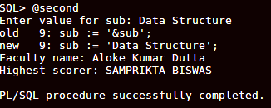

**iii) Write a PL/SQL program to take student name from user and print the department and age of the student. Give appropriate message for non existence of the student name and/or more than one student with same name.**

**Code:**

set serveroutput on;  
  
declare  
stu varchar2(50);  
dname department.deptname%type;  
byear number;  
syear number;  
age number;  
cnt number;  
  
begin  
stu := '&stu';  
select count(*) into cnt from student where name=stu;  
if cnt=0 then  
dbms_output.put_line('No student found');  
elsif cnt>1 then  
dbms_output.put_line('Multiple students found');  
else  
select to_char(birthdate, 'yyyy') into byear from student where name=stu;  
select to_char(sysdate, 'yyyy') into syear from dual;  
dbms_output.put_line(byear);  
dbms_output.put_line(syear);  
age := syear - byear;  
dbms_output.put_line('Age: ' ||age);  
select deptname into dname from student join department using(deptcode) where name=stu;  
dbms_output.put_line('Department: ' ||dname);  
end if;  
end;  
  
set serveroutput off;

**Output:**



