**NAME: SNEHA TIWARI**

**UNIV. ROLL NO.: 11500119052**

**ASSIGNMENT 9A: ADVANCED QUERY**

1. **Display the students name, address, phone who got more than 150 in CS301 and CS302 in order of department code, followed by semester.**

SELECT DISTINCT STUDENT.NAME, STUDENT.ADDRESS, STUDENT.PHONENO, STUDENT.SEMESTER FROM STUDENT

JOIN RESULT ON STUDENT.ROLLNO = RESULT.ROLLNO

WHERE S.ROLLNO IN( SELECT ROLLNO FROM RESULT WHERE SUB_CODE = ‘CS301’ OR SUB_CODE = ‘CS302’

GROUP BY ROLLNO HAVING SUM(MARKS) > 150);

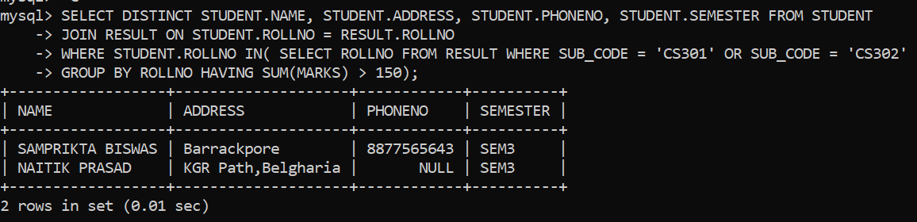

1. **Show name, deptcode, phone number of the students who failed to obtain pass marks in any subject.**

SELECT NAME, DEPTCODE, PHONENO FROM STUDENT

JOIN RESULT ON STUDENT.ROLLNO = RESULT.ROLLNO

WHERE MARKS < 40;

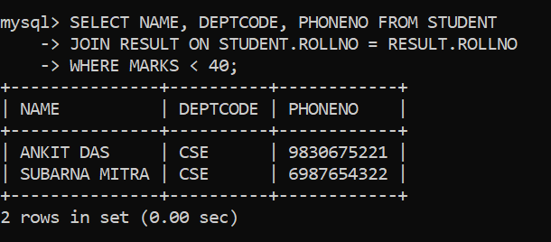

1. **Find the students name and roll number who either got more than 80 in any subject or got more than 70 in average.**

SELECT NAME, ROLLNO FROM STUDENT WHERE ROLLNO IN (SELECT ROLLNO FROM RESULT R WHERE(SELECT MAX(MARKS) FROM RESULT RE WHERE RE.ROLLNO = R.ROLLNO GROUP BY RE.ROLLNO) > 80 OR (SELECT AVG(MARKS) FROM RESULT RE WHERE RE.ROLLNO = R.ROLLNO GROUP BY RE.ROLLNO) > 70);

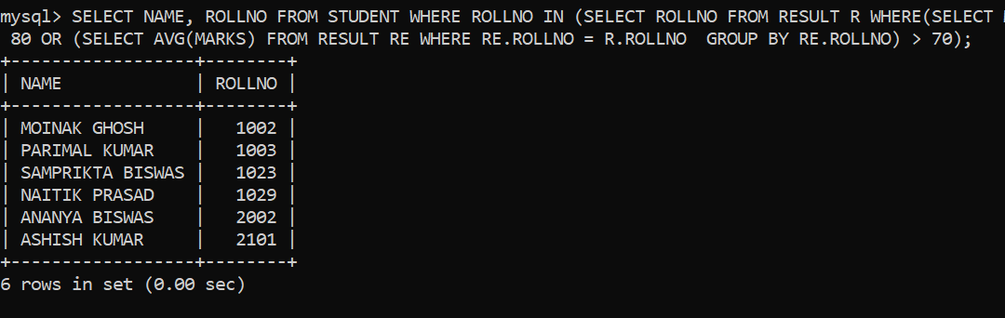

1. **Find the students name and roll number who got more than 75 in average but not get less than 70 in any subject.**

SELECT NAME, ROLLNO FROM STUDENT WHERE ROLLNO IN(SELECT ROLLNO FROM RESULT R WHERE(SELECT AVG(MARKS) FROM RESULT RE WHERE RE.ROLLNO = R.ROLLNO GROUP BY RE.ROLLNO) > 75 AND (SELECT MIN(MARKS) FROM RESULT RE WHERE RE.ROLLNO = R.ROLLNO GROUP BY RE.ROLLNO) > 70);

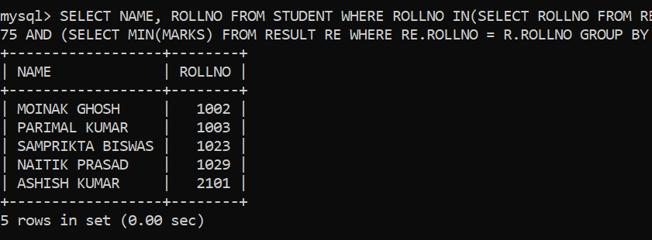

1. **Display first N marks from result table. N is given.**

SELECT * FROM RESULT

LIMIT 5;

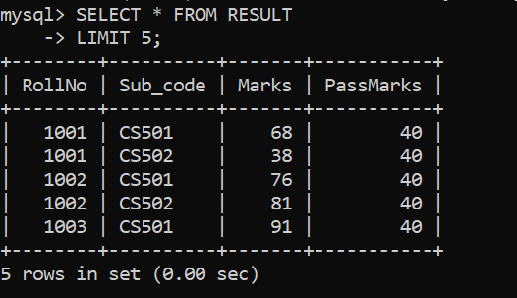

1. **Find the students name who appeared in exactly same subjects as 'Ankit Das'.**

SELECT DISTINCT S.NAME FROM STUDENT S JOIN RESULT R ON S.ROLLNO = R.ROLLNO WHERE S.ROLLNO IN (

SELECT ROLLNO FROM RESULT WHERE SUB_CODE IN (

SELECT SUB_CODE FROM RESULT JOIN STUDENT ON STUDENT.ROLLNO = RESULT.ROLLNO WHERE STUDENT.NAME ='ANKIT DAS'));



