Name: Sneha Tiwari

Roll: 11500119052 | Group: B1

Assignment 9

Problem 1) Solution

*package* com.company;  
*import* java.util.*;  
  
*public class* Lab_Assignment_9_1{  
 *public static void* main(String[] args) {  
 *int*[] marks = *new int*[3];  
 marks[0] = 60;  
 marks[1] = 80;  
 marks[2] = 90;  
 Scanner sc = *new* Scanner(System.***in***);  
  
 *try*{  
 System.***out***.println("Enter array index: ");  
 *int* index = sc.nextInt();  
 System.***out***.println("Enter number to divide: ");  
 *int* num = sc.nextInt();  
 System.***out***.println("\nValue at array index: "+marks[index]);  
 System.***out***.println("Value at array-value/number: "+marks[index]/num);  
 }  
  
 *catch*(ArithmeticException e){  
 System.***out***.println("\nArithmeticException occured!");  
 System.***out***.println(e);  
 }  
  
 *catch*(ArrayIndexOutOfBoundsException e){  
 System.***out***.println("\nArrayIndexOutOfBoundsException occured!");  
 System.***out***.println(e);  
 }  
  
 *catch* (InputMismatchException ie){  
 System.***out***.println("\nThe number should be of type integer.\n"+ie);  
 }  
  
 *catch*(Exception e) {  
 System.***out***.println("\nSome other exception occured!");  
 System.***out***.println(e);  
 }  
 }  
}

Output:

1) Without exception

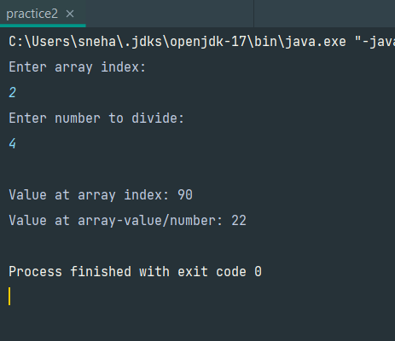

2) With Array Index Out of Bounds Exception

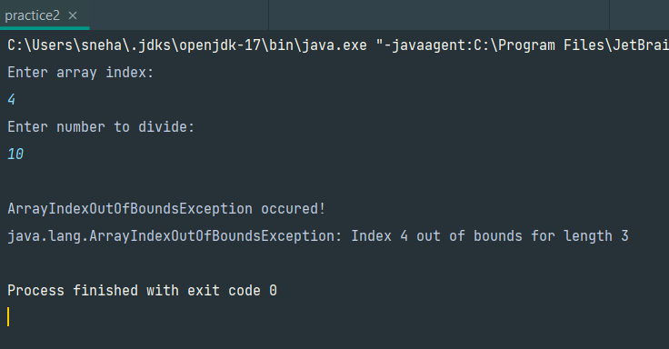

3) With Arithmetic Exception

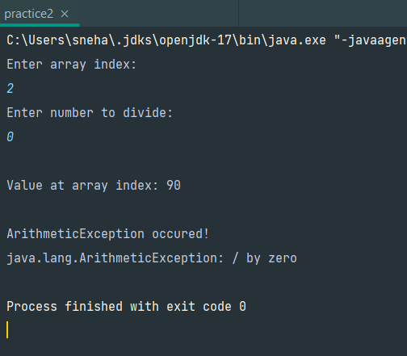

4) With Input Mismatch Exception

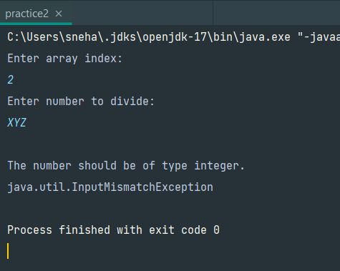

Problem 2) Solution

*package* com.company;  
*import* java.util.Scanner;  
*class* NegativeRadiusException *extends* Exception{ *// user defined Exception* @Override  
 *public* String toString() {  
 *return* "\nRadius cannot be negative!";  
 }  
  
 @Override  
 *public* String getMessage() {  
 *return* "\nRadius cannot be negative!\n";  
 }  
}  
*public class* Lab_Assignment_9_2 {  
 *public static double* area(*int* r) *throws* NegativeRadiusException{ *// use of throws  
 if* (r<0){  
 *throw new* NegativeRadiusException(); *// use of throw* }  
 *double* result = Math.***PI*** * r * r;  
 *return* result;  
 }  
 *public static void* main(String[] args) {  
 Scanner sc = *new* Scanner(System.***in***);  
 *try*{  
 System.***out***.print("Enter radius: ");  
 *int* r = sc.nextInt();  
 *double* ar = *area*(r);  
 System.***out***.print("Area of circle: ");  
 System.***out***.println(ar);  
 }  
 *catch*(Exception e){  
 System.***out***.println("Exception!!"+e.getMessage());  
 }  
 *int* a = 9;  
 *int* b = 3;  
 *while*(*true*){  
 *try*{  
 System.***out***.println("a/b: "+a/b);  
 }  
 *catch*(Exception e){  
 System.***out***.println(e);  
 *break*;  
 }  
 *finally*{ *// use of finally block*  
 System.***out***.println("\nFinally the value of b is: "+b);  
 }  
 b--;  
 }  
 *try*{  
 System.***out***.println("5/0: "+5/0);  
 }  
 *finally*{  
 System.***out***.println("\nThis finally statement will be printed no matter what!!");  
 System.***out***.println("Also try block here does not require catch block because finally block is used.\n");  
 } }  
}

Output:

1) Without exception

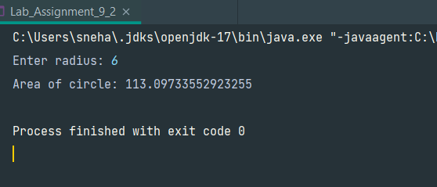

2) With exception



