Assignment No.:1 Topic: User defined class and objects

Name: Sneha Tiwari

Roll No.: 11500119052

1.  Write a Java Program to print Hello World.

Solution:

public class HelloWorld{

public static void main(String []args){

System.out.println("Hello World");

}

}

Output

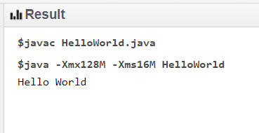

2. Create a class Employee having emp_id,name,salary,designation. Use constructor overloading for designing 3 types of employees--

i) Freshers (name should be user given and other parameters should be fixed)

ii)Executive (Name , salary and designation should be user given)

iii)Temporary member(All the parameter having fixed values)

Create an employee array and create and store 3 Employee objects and print the  detail.

Solution:

class Employee

{

int id,salary,c=1;

String name, designation;

Employee(String name)

{

id=201+c;

c++;

designation="Freshers";

salary=10000;

}

Employee(String name,int salary,String designation)

{

id=501+c;

c++;

designation=designation;

name=name;

salary=salary;

}

Employee(){

id=101+c;

c++;

designation="Temporary";

salary=15000;

}

void print(){

System.out.println("The employee details are: ");

System.out.println("The employee name is: " + this.name);

System.out.println("The employee id is: " + this.id);

System.out.println("The employee salary is: " + this.salary);

System.out.println("The employee designation is: " + this.designation);

}

}

public class Main{

public static void main(String args[]){

Employee emp[] = new Employee[3];

emp[0]=new Employee();

emp[1]=new Employee("Sneha");

emp[2]=new Employee("Sneha",50000,"Managing Director");

emp[0].print();

emp[1].print();

emp[2].print();

}

}

Output

