**NAME: SNEHA TIWARI**

**UNIV. ROLL NO.: 11500119052**

**COLLEGE ROLL NO.: 212297**

**STREAM: CSE (3RD YEAR)**

**OBJECT ORIENTED PROGRAMMING LAB EXAM 2021-22**

**SUBJECT CODE: PCC-CS593**

**DATE OF SUBMISSION: 27-01-2022**

**OUTPUT:**

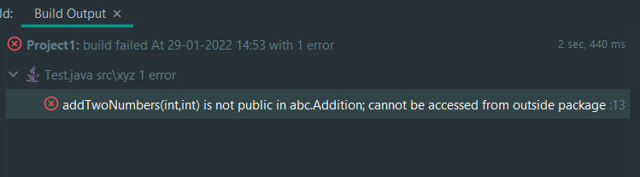

**OUTPUT:**

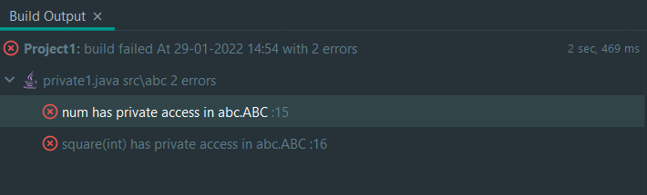

**OUTPUT:**

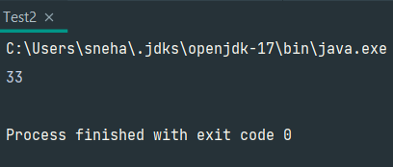

**OUTPUT:**

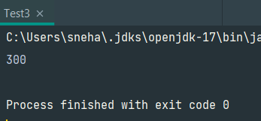

**OUTPUT:**

