**Name: Sneha Tiwari**

**Univ. Roll No.: 11500119052**

**Group B1**

## Question 2) Topic: I/O operations using API classes

## Problem 1) Write a Java Program to illustrate Scanner, BufferReader, BufferedWriter and System class for input and output from terminal and files. (You may write multiple programs as per your wish)

## // Scanner & System class

*package* com.company;  
*import* java.util.*;  
*public class* scanner_and_system {  
 *public static void* main(String[] args) {  
 *//Scanner class* Scanner sc = *new* Scanner(System.***in***);  
 *//System class* System.***out***.print("Enter you name: ");  
 String name = sc.next();  
 System.***out***.print("Enter your roll no.: ");  
 *long* roll = sc.nextLong();  
 System.***out***.print("Enter your grade: ");  
 *char* grade = sc.next().charAt(0);  
 System.***out***.print("Enter your CGPA: ");  
 *double* cgpa = sc.nextDouble();  
 System.***out***.println("\nPrinting student details...");  
 System.***out***.printf("\nName: %s\nRoll number: %d\nGrade: %c\nCGPA: %.2f",name,roll,grade,cgpa);  
 }  
}

**Output**

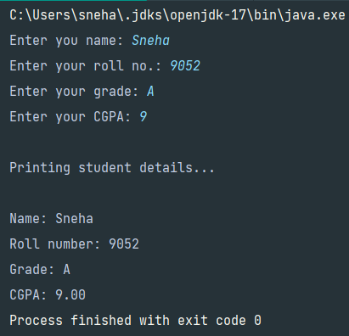

**// BufferedReader**

*package* com.company;  
*import* java.io.*;  
*public class* b_reader {  
 *public static void* main(String[] args)*throws* Exception {  
 System.***out***.println("Enter password to access file: ");  
 *//using BufferedReader to take input by InputStreamReader* BufferedReader br = *new* BufferedReader(*new* InputStreamReader(System.***in***));  
 *int* n = Integer.*parseInt*(br.readLine());  
 *//password is 12345  
 if* (n==12345)  
 System.***out***.printf("Password: %d is correct!\nAccessing file...\n\n",n);  
 *else* System.***out***.println("Wrong password");  
  
 FileReader fr = *new* FileReader("C:\\Users\\sneha\\IdeaProjects\\Project1\\src\\com\\company\\test.txt");  
 *//using BufferedReader to read a test.txt file* BufferedReader br2 = *new* BufferedReader(fr);  
 *int* i;  
 *while*((i=br2.read())!=-1)  
 System.***out***.print((*char*)i);  
 br.close();  
 br2.close();  
 fr.close();  
 }  
}

**Test.txt file contains**

This document has been created for demo purpose,  
for the PCA2 exam today. It demonstrates the working of   
BufferedReader class in Java.

**Output**

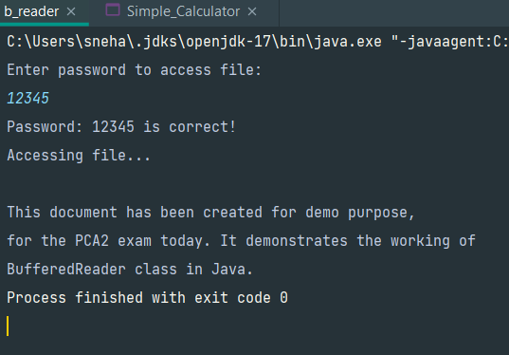

**// BufferedWriter**

*package* com.company;  
*import* java.io.*;  
*public class* b_writer {  
 *public static void* main(String[] args)*throws* Exception {  
 FileWriter fw = *new* FileWriter("C:\\Users\\sneha\\IdeaProjects\\Project1\\src\\com\\company\\test2.txt");  
 BufferedWriter bw = *new* BufferedWriter(fw);  
 *//writing in file* bw.write("This is First Line.");  
 bw.newLine();  
 bw.write("This is Second line.");  
 bw.newLine();  
 bw.write("This is Third line.");  
 bw.newLine();  
 bw.close();  
 fw.close();  
  
 FileReader fr = *new* FileReader("C:\\Users\\sneha\\IdeaProjects\\Project1\\src\\com\\company\\test2.txt");  
 BufferedReader br = *new* BufferedReader(fr);  
 *//reading the file* System.***out***.println(br.readLine());  
 System.***out***.println(br.readLine());  
 System.***out***.println(br.readLine());  
 br.close();  
 fr.close();  
 }  
}

**Output**

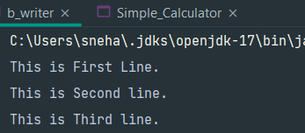

**Test2.txt file has been created as…**

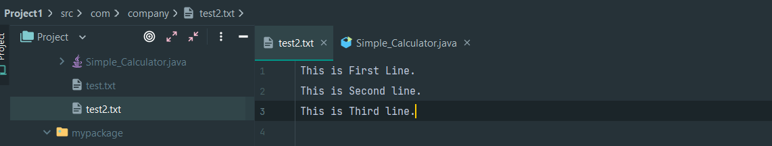

**Problem 2) Write a Java Program to implement simple calculator using command line arguments.**

*package* com.company;  
*import* java.util.*;  
*class* Operations{  
 *float* add(*float* a, *float* b) {*return* a+b;}  
 *float* sub(*float* a, *float* b) {*return* a-b;}  
 *float* mul(*float* a, *float* b) {*return* a*b;}  
 *float* div(*float* a, *float* b) {*return* a/b;}  
 *float* mod(*float* a, *float* b) {*return* a%b;}  
}  
*public class* Simple_Calculator {  
 *public static void* main(String[] args) {  
 *int* ch = 0;  
 Scanner sc = *new* Scanner(System.***in***);  
 Operations cal = *new* Operations();  
 System.***out***.println("\tSIMPLE CALCULATOR");  
 System.***out***.println("\n1. Addition\n2. Subtraction\n3. Multiplication\n4. Division\n5. Modulo\n6. Exit");  
 Task: *//used label to perform continuous operations  
 while*(ch != 6){  
 System.***out***.println("\nChoose an operation: ");  
 ch = sc.nextInt();  
 *float* a, b, ans;  
 *switch*(ch){  
 *case* 1:  
 System.***out***.println("Enter two operands: ");  
 a = sc.nextFloat();  
 b = sc.nextFloat();  
 ans = cal.add(a,b);  
 System.***out***.println("The answer is: "+ans);  
 *break*;  
 *case* 2:  
 System.***out***.println("Enter two operands: ");  
 a = sc.nextFloat();  
 b = sc.nextFloat();  
 ans = cal.sub(a,b);  
 System.***out***.println("The answer is: "+ans);  
 *break*;  
 *case* 3:  
 System.***out***.println("Enter two operands: ");  
 a = sc.nextFloat();  
 b = sc.nextFloat();  
 ans = cal.mul(a,b);  
 System.***out***.println("The answer is: "+ans);  
 *break*;  
 *case* 4:  
 System.***out***.println("Enter two operands: ");  
 a = sc.nextFloat();  
 b = sc.nextFloat();  
 ans = cal.div(a,b);  
 System.***out***.println("The answer is: "+ans);  
 *break*;  
 *case* 5:  
 System.***out***.println("Enter two operands: ");  
 a = sc.nextFloat();  
 b = sc.nextFloat();  
 ans = cal.mod(a,b);  
 System.***out***.println("The answer is: "+ans);  
 *break*;  
 *case* 6:  
 System.***out***.println("Exiting finish!!");  
 *break*;  
 *default*:  
 System.***out***.println("Invalid choice!");  
 }  
 *if*(ch!=6)  
 System.***out***.println("\nContinue performing operations ... \n");  
 *continue* Task;  
 }  
 }  
}

**Output**



