|  |  |
| --- | --- |
| page1image3828864 | **B. P. Poddar Institute of Management and Technology**  **Department of Computer Science & Engineering**  **Software Engineering Lab (ESC-591)**  **AY: 2021-22 ODD Semester**  **End Semester Examination (60 marks)** |

Univ. Roll No.__11500119052_ __

Student Name: ____SNEHA TIWARI___ _______

**Question**

3. The manager of a bookshop wants to have automation software. The shop stocks a set of books. Customers can query whether a book is available and select for purchase. The BAS generates a bill indicating total amount payable and all details of the sales transaction. The BAS should automatically update book stock when a purchase is made or when fresh supply arrives. Customers can provide feedback for books and place demand for a particular book. The shop owner can query on the status of any item anytime and generate sales statistics for any period. Make assumptions wherever necessary. Based on the case study provided, prepare a functional design document showing DFD Level-0.

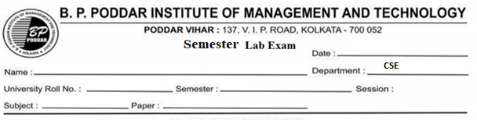

2021-2022

ESC-591

SOFTWARE  
ENGINEERING

11500119052

5TH

SNEHA TIWARI

27-01-2022

SNEHA TIWARI

SNEHA TIWARI

SNEHA TIWARI

**Output**

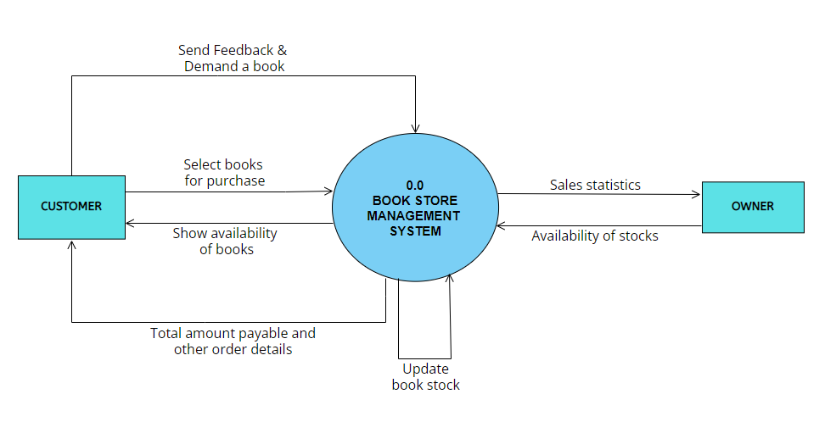

**Tools used and their reference web link (if any)**

*1. Visual Paradigm*

*Link: https://online.visual-paradigm.com/w/knqfpurh/diagrams/#diagram:workspace=knqfpurh&proj=0&id=4*