Member’s Data Form

A project presented to the

Faculty of the College of Computer and Information Sciences, Polytechnic University of the Philippines

In partial fulfillment for the course COMP 20093 - Information Management

***Proponents***

Almeda, Carlance Masarque, Andy Uy, Lord Allain

# Overview of the Project

The Home Development Mutual Fund (HDMF), also known as the Pag-IBIG Fund, was established in response to the need for a national savings program and affordable housing finance for Filipino workers. The Fund was founded on June 11, 1978, by Presidential Decree No. 1530, principally to satisfy these two fundamentals but equally critical demands. The Fund was handled by two agencies under the statute. Pag-IBIG stands for Pagtutulungan sa Kinabukasan: Ikaw, Bangko, Industriya, and Gobyerno, the MDF form might refer to the Home Development Mutual Fund (HDMF), commonly known as the Pag-IBIG Fund. Members of the Pag-IBIG Fund utilize this form to apply for different services including as home loans, multi- purpose loans, and provident savings. The MDF form is a standard document that provides personal and financial information about the member and is necessary to participate in Pag-IBIG Fund activities and services.

This database design is essential in Pag-IBIG Fund since it helps to efficiently manage and process the information of its members and transactions. Also, it allows it to keep and manage its members' personal and financial information, including donations, loans, and savings. This data is used to validate membership eligibility, execute transactions, and guarantee that members receive the benefits and services to which they are entitled. This design helps streamline the loan processing procedures by allowing Pag-IBIG Fund to quickly access and verify the financial records of a member. This helps ensure that loan applications are processed quickly and accurately. In result, a database is an important tool for this project in managing its operations and supporting its members. It enables to handle transactions more effectively, prevent fraud, and guarantee that members receive the benefits and services to which they are entitled.

# Softcopy of the Manual Form

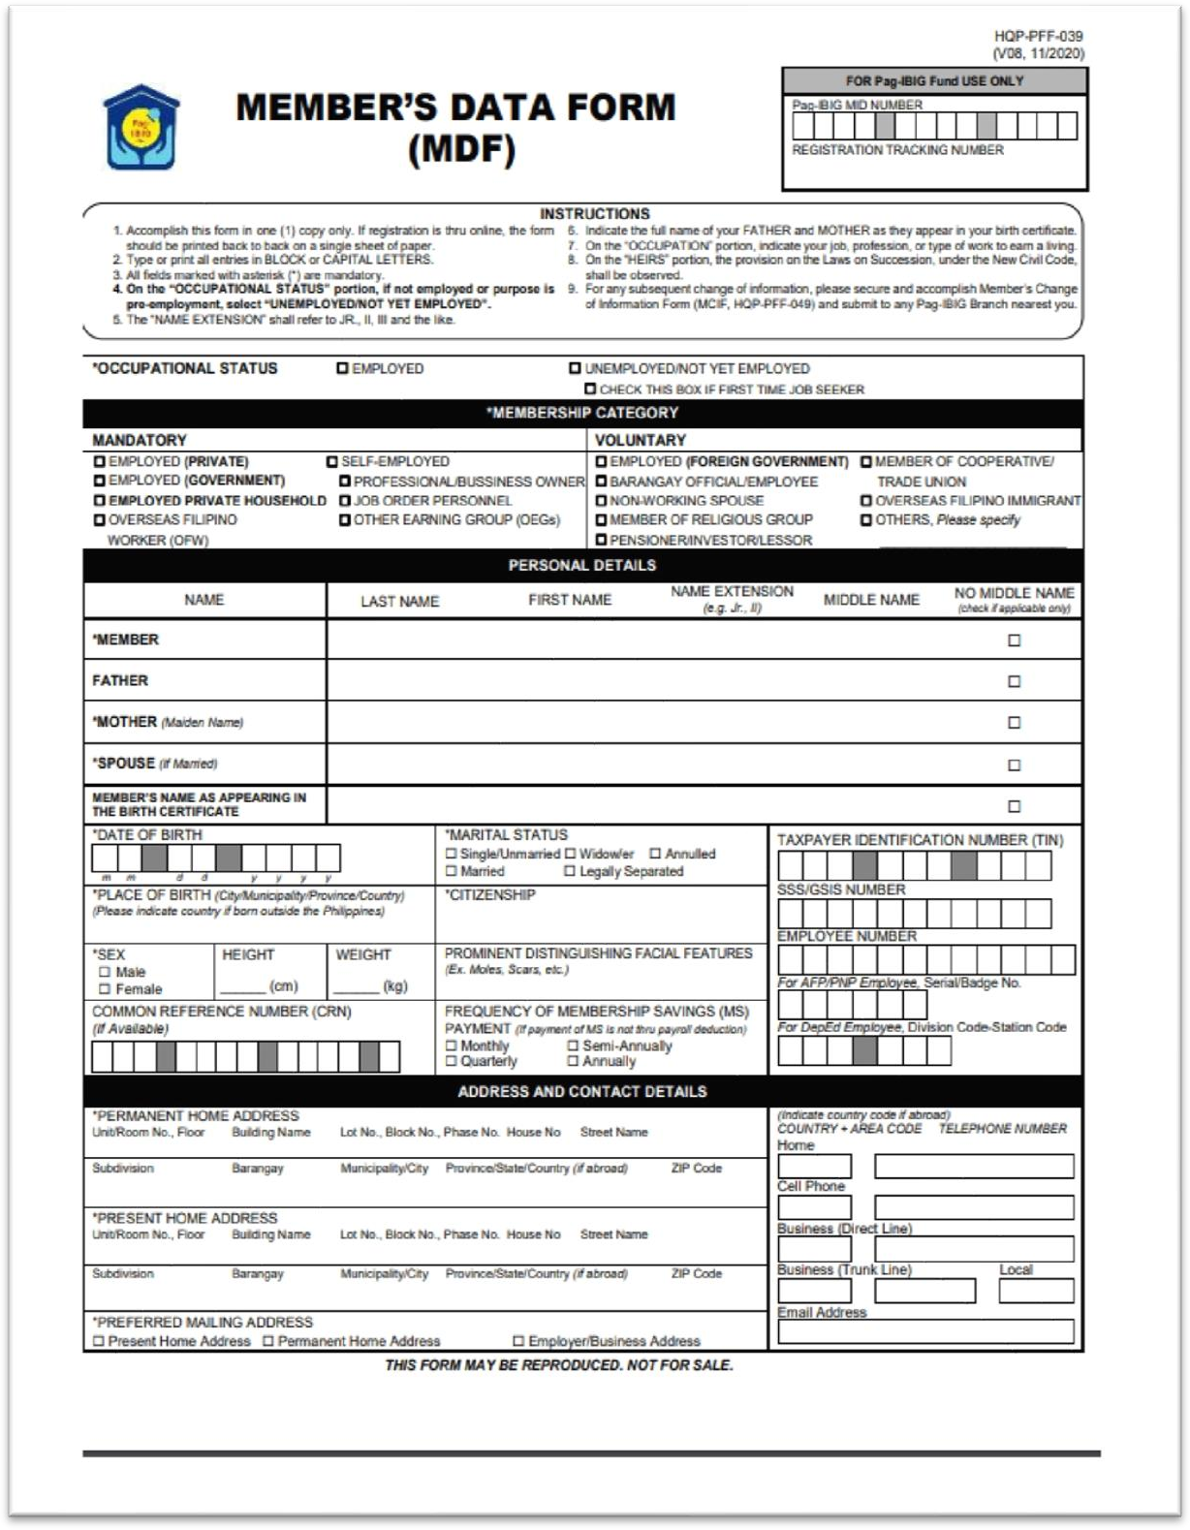

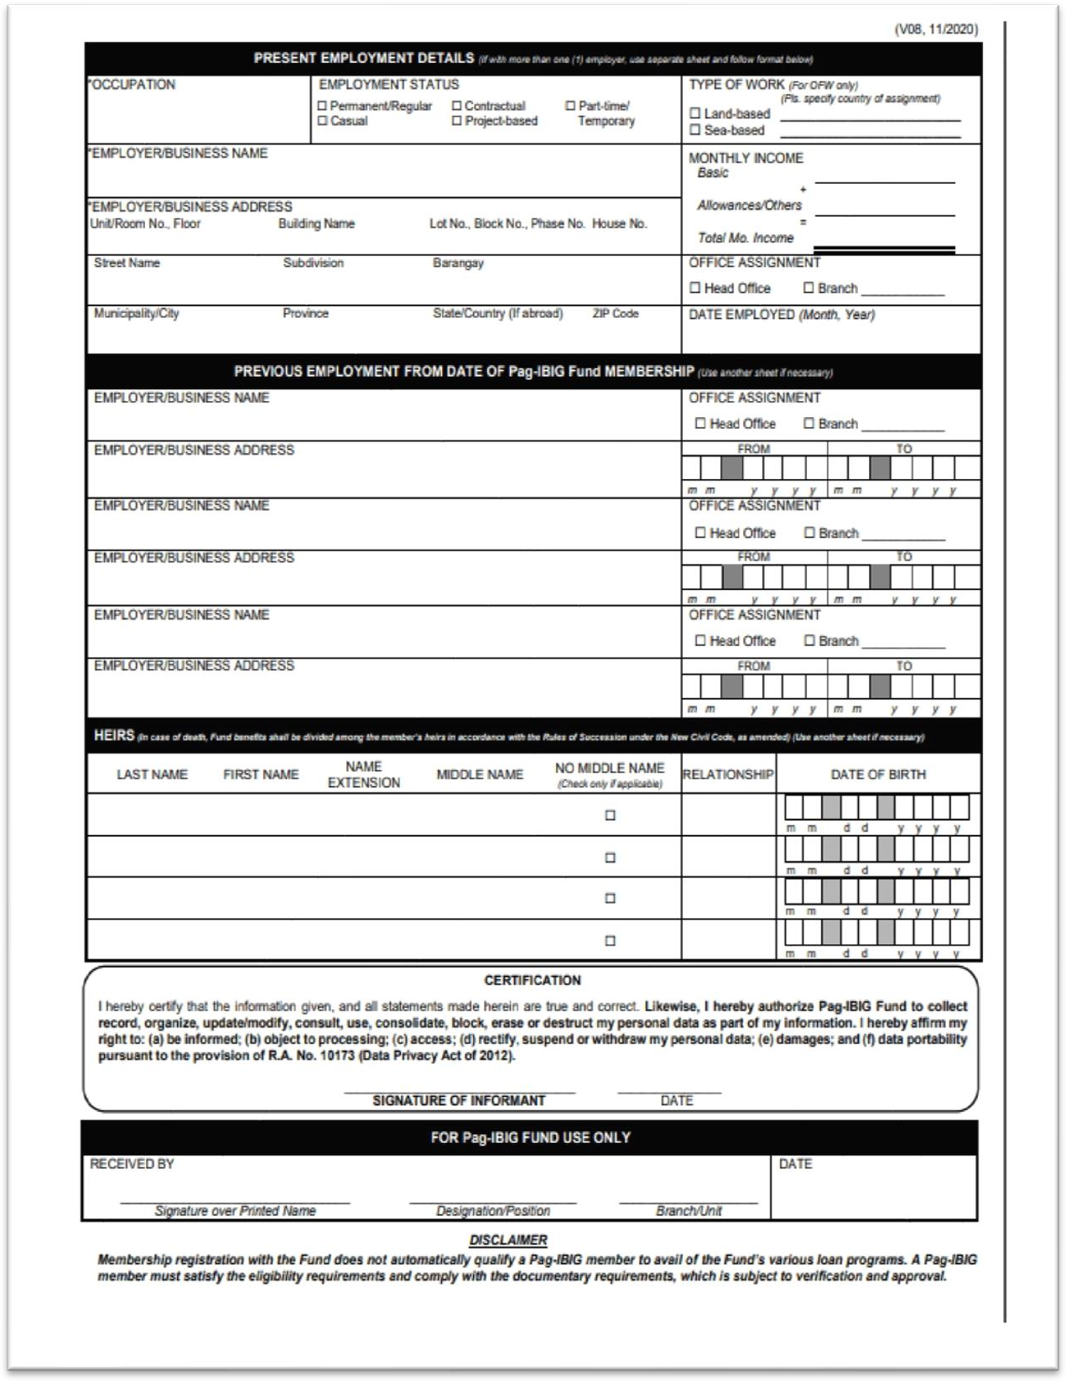

**Normalization**

## UNF

**memberdetails**(MIDNumber, Name, Sex, Father, Mother, Spouse, Birthdate, Birthplace, Status, Citizenship, SSS, TIN, MembershipCategory, MSPayment, HomeAddress, EmailAddress, PhoneNumber, EmployeeNumber,Occupation, EmploymentStatus, Employer, EmployerAddress, MonthlyIncome, DateEmployed, HeirsName, HeirsBirthdate)

## 1NF

**memberdetails**(MIDNumber, Name, Sex, Father, Mother, Spouse, Birthdate, Birthplace, Status, Citizenship, SSS, TIN, MembershipCategory, MSPayment, HomeAddress, EmailAddress, PhoneNumber, {EmployeeNumber,Occupation, EmploymentStatus, Employer, EmployerAddress, MonthlyIncome, DateEmployed, HeirsName, HeirsBirthdate})

## 2NF

**memberdetails**(MIDNumber, Name, Sex, Father, Mother, Spouse, Birthdate, Birthplace, Status, Citizenship, SSS, TIN, MembershipCategory, MSPayment, HomeAddress, EmailAddress, PhoneNumber, HeirsName, HeirsBirthdate)

**workhistory**(EmployeeNumber,Occupation, EmploymentStatus, EmployerID, Employer, EmployerAddress, MonthlyIncome, DateEmployed)

## 3NF

**memberdetails**(MIDNumber, Name, Sex, Father, Mother, Spouse, Birthdate, Birthplace, Status, Citizenship, SSS, TIN, MembershipCategory, MSPayment, HomeAddress, EmailAddress, PhoneNumber, HeirsName, HeirsBirthdate)

**workhistory**(EmployeeNumber,Occupation, EmploymentStatus, MonthlyIncome, DateEmployed, EmployerID)

**payment**(MIDNumber, EmployeeNumber, MembershipCategory, MSPayment)

**employer**(EmployerID, Employer, EmployerAddress)

**Refer to the hyperlink below for the Table of Normalization:**

[Normalization_V2](https://pupedu-my.sharepoint.com/:x:/g/personal/andydmasarque_iskolarngbayan_pup_edu_ph/EaZFOSg1Z89Lq9lN5pRLJLIBmOA_3i9NSwmGODr5ksf3OA)

# ERD

**Data Dictionary**

## memberdetails

|  |  |  |  |  |  |
| --- | --- | --- | --- | --- | --- |
| **Data Name** | **Data Type** | **Data**  **Format** | **Size** | **Allowable**  **Values** | **Constraints** |
| MIDNumber | int |  | 11 |  | Primary key/Composite Key |
| Name | varchar |  | 80 |  | not null |
| Sex | varchar |  | 6 | M, F | not null |
| Father | varchar |  | 80 |  | not null |
| Mother | varchar |  | 80 |  | not null |
| Spouse* | varchar |  | 80 |  | null |
| Birthdate | Date | yyyy/mm/dd |  |  | not null |
| Birthplace | varchar |  | 80 |  | not null |
| Status | varchar |  | 15 |  | not null |
| Citizenship | varchar |  | 15 |  | not null |
| SSS | int |  | 10 |  | null |
| TIN | Int |  | 9 |  | null |
| HomeAddress | Varchar |  | 100 |  | not null |
| EmailAddress | Varchar |  | 45 |  | not null |
| PhoneNumber | varchar |  | 11 |  | not null |
| HeirsName | varchar |  | 80 |  | Not null |
| HeirsBirthdate | Date | yyyy/mm/dd |  |  | not null |

## workhistory

|  |  |  |  |  |  |
| --- | --- | --- | --- | --- | --- |
| **Data Name** | **Data**  **Type** | **Data**  **Format** | **Length** | **Allowable**  **Values** | **Constraints** |
| EmployeeNumber | varchar |  | 45 |  | Primary key/  Composite Key |
| Occupation | varchar |  | 45 |  | not null |
| Employment  Status | varchar |  | 45 |  | not null |
| MonthlyIncome | Decimal |  | (15, 2) |  | not null |
| DateEmployed | Date | yyyy/mm/dd | 20 |  | not null |
| EmployerID | varchar |  | 45 |  |  |

## payment

|  |  |  |  |  |  |
| --- | --- | --- | --- | --- | --- |
| **Data Name** | **Data**  **Type** | **Data**  **Format** | **Length** | **Allowable**  **Values** | **Constraints** |
| MIDNumber | int |  | 45 |  | Primary key/  Composite Key |
| EmployeeNumber | int |  | 45 |  | Primary key/  Composite Key |
| MembershipCategory | varchar |  | 45 |  | not null |
| MSPayment | varchar |  | 45 |  | not null |

## employer

|  |  |  |  |  |  |
| --- | --- | --- | --- | --- | --- |
| **Data Name** | **Data**  **Type** | **Data**  **Format** | **Length** | **Allowable**  **Values** | **Constraints** |
| EmployerID | varchar |  | 45 |  | Foreign |
| Employee | varchar |  | 45 |  | not null |
| EmployerAddress | varchar |  | 45 |  | not null |