7.5 Case study: maintenance scheduling with genetic

algorithms

One of the most successful areas for GA applications includes the problem of scheduling resources. Scheduling problems are complex and difficult to solve. They are usually approached with a combination of search techniques and heuristics.

Why are scheduling problems so difficult?

First, scheduling belongs to NP-complete problems. Such problems are likely to be unmanageable and cannot be solved by combinatorial search techniques. Moreover, heuristics alone cannot guarantee the best solution.

Second, scheduling problems involve a competition for limited resources; as a result, they are complicated by many constraints. The key to the success of the GA lies in defining a fitness function that incorporates all these constraints.

The problem we discuss here is the maintenance scheduling in modern power systems. This task has to be carried out under several constraints and uncertain- ties, such as failures and forced outages of power equipment and delays in obtaining spare parts. The schedule often has to be revised at short notice. Human experts usually work out the maintenance scheduling by hand, and there is no guarantee that the optimum or even near-optimum schedule is produced.

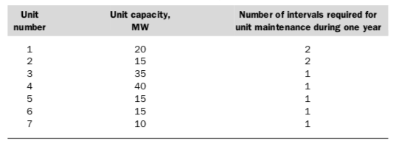

A unit of 20 MW is scheduled for maintenance during the period when the maximum load is predicted to be 100MW, then the net reserve will be 30MW. Maintenance scheduling must ensure that sufficient net reserve is provided for secure power supply during any maintenance period.

Suppose, there are seven power units to be maintained in four equal intervals. The maximum loads expected during these intervals are 80, 90, 65 and 70MW. The unit capacities and their maintenance requirements are presented in Table.

The constraints for this problem can be specified as follows:

* .  Maintenance of any unit starts at the beginning of an interval and finishes at the end of the same or adjacent interval. The main- tenance cannot be aborted or finished earlier than scheduled.
* .  The net reserve of the power system must be greater than or equal to zero at any interval.

The optimum criterion here is that the net reserve must be at the maximum during any maintenance period.

This Repository Consists of two programs – Genetic algorithm to find the optimal solution & another program to translate the optimal solution into Mw (which allows to clarify the solution is valid).