CS 1632 - DELIVERABLE 3: Web Testing with BDD

Members: Christian Boni

Project: Wikipedia Selenium Test Suite

**Conclusions**

I was amazed when I first learned about Selenium and the amount of potential it has during one of this course’s lectures. I had never heard of Selenium prior to this course. Additionally, I had never wondered if there actually was a tool out there that could automate the client-side, user interactions with a web page. As a result, I was extremely excited to educate myself on Selenium not only for this project but also for the many future applications of its functionality.

As recommended in the project description I experimented with the Selenium IDE on several different web pages before beginning the project. I found that in fact a majority of the popular web pages I am familiar with did not interact well with Selenium. Amazon, Facebook, and Twitter were just a few of the websites that were not a good fit for testing. Furthermore, I assumed that creating a “dummy” account for a website under test was out of the scope of this deliverable. For that reason many of the websites I interact with everyday and especially the ones I listed above typically require an account. As a result, I took the time to find a website in which I have experience with, and that would interact well with Selenium. After thinking it over I came to the conclusion of using the website that I consistently go to for information, Wikipedia.

I chose to use Wikipedia as the website that I would test under Selenium for several reasons. Wikipedia is a popular website that is accessed by a vast majority of Internet users. It has a simple motive which is to educate everyone by being “The Free Encyclopedia” of the world. Wikipedia can also be thought of as a central database that stores and displays information on anything and everything. For obvious reasons, I chose to test user interactions with Wikipedia that involved navigating to and searching for various articles. While Wikipedia does have user accounts, they are by no means required to access all of Wikipedia’s content. Furthermore, the sole purpose of a Wikipedia account is to create, update, and modify Wikipedia articles which is out of the scope of testing for this deliverable. For this reason I did not choose to test logged-in user interactions with Wikipedia, but I did chose to test situations in which users have trouble logging-in. Several of these scenarios would be entering an invalid username, entering an invalid password, and forgetting a password. Finally, I chose to test a variety of the featured articles on Wikipedia’s main page.

**Testing Concerns**

In this day and age, a majority of people utilize the Internet on a daily basis. For this reason, the user experience expected from a web page is extremely intuitive. As a result, constructing test cases for this deliverable was rather trivial. On the other hand, learning the Selenium WebDriver and WebElement API was much more of a challenge. It took some time to understand how the WebDriver interacts with a given web page and what commands to call on a given WebElement. Additionally, it was a struggle to try to locate specific elements on a web page. I began by inspecting the elements on a given website and attempting to locate the id of the element under question. However, I found a quick and simple solution to this problem by utilizing the built-in element selector of the Selenium IDE. Another problem I encountered that also involved the elements of a web page, was the difference in structure of similar web pages. I found when testing the page content retrieved from a search query that the structure of the page was different for various queries. This caused problems while creating assertions for each test, since the element on the page containing the content was not consistent.

As you can see below, two tests in my test suite happened to fail. The first failure was found during testing the featured articles on Wikipedia’s main page. I actually discovered this failure by accident. When I ran the test suite on Friday the test actually passed. However, when I ran the test again on Saturday it failed. After looking over the both the test and the website, I discovered the problem. This test case asserts that Wikipedia’s main page has the “From today’s featured list” section. I noticed that when I had created this test case on Friday that section did exist but when observing the page on Saturday this section was absent. I came to the conclusion that either this section was optional for Wikipedia’s main page or Wikipedia made a mistake and forgot to include it. Due to the prominence of Wikipedia I am assuming the former but I cannot completely rule out the latter. The second failure was found when testing the navigation between Wikipedia and its sister project websites. In this case, the failure was a result of my assumptions. I assumed that if you are currently on a given Wikipedia sister project then links would exist to navigate to all the other different Wikipedia sister projects. This assumption turned out to be incorrect as the Wikipedia main page is the only page which has links to all of the Wikipedia sister project web pages.

**Source Code**<https://github.com/thisbechristian/quality-assurance/tree/master/deliverables/d3>

**Unit Tests  
  
All jUnit Test Output from Terminal:**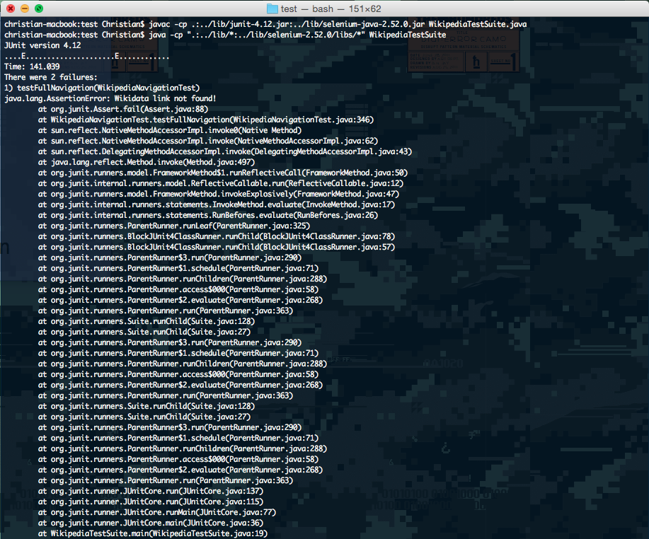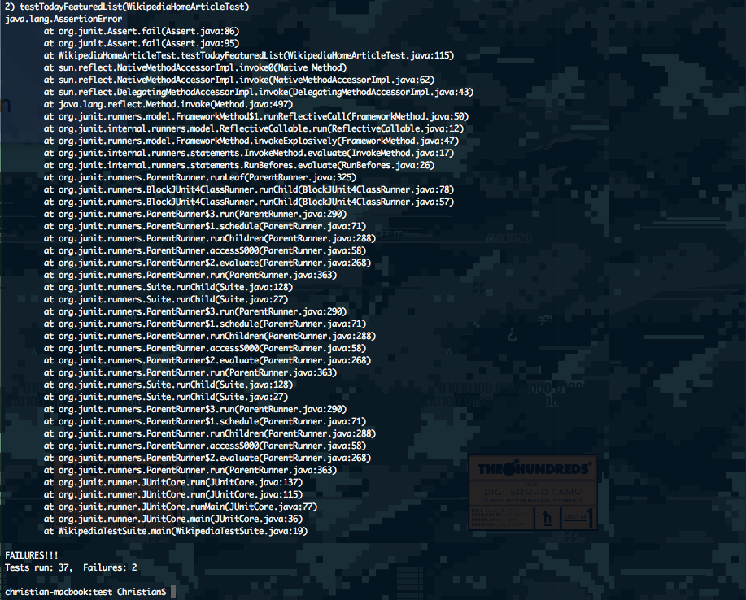

**All jUnit Test Output from Eclipse:**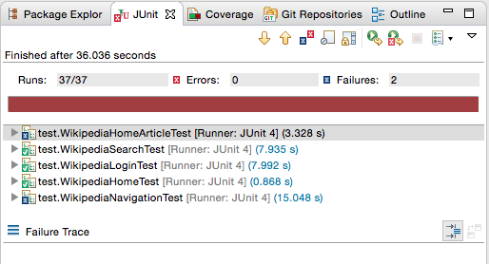

**WikipediaHomeArticleTest jUnit Test Output from Eclipse:**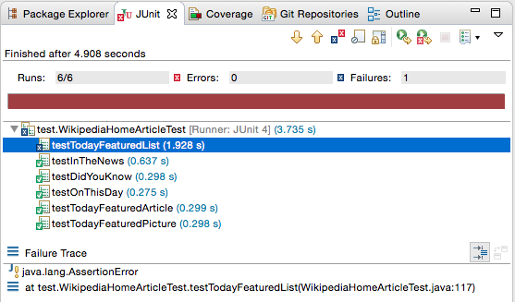

**WikipediaHomeTest jUnit Test Output from Eclipse: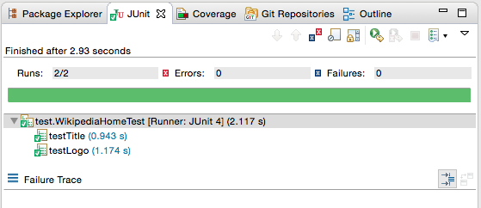 WikipediaLoginTest jUnit Test Output from Eclipse:**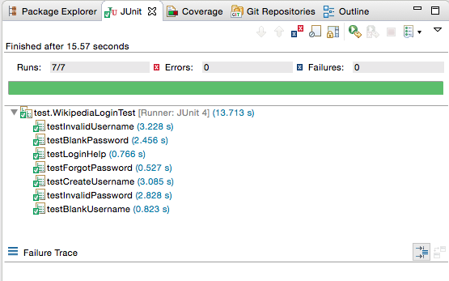

**WikipediaSearchTest jUnit Test Output from Eclipse: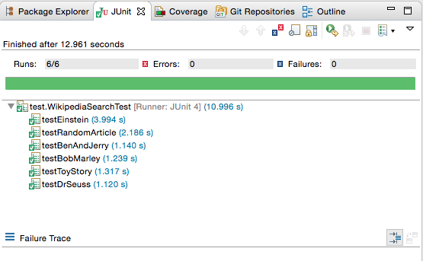 WikipediaNavigationTest jUnit Test Output from Eclipse:**