**Manual Pinning Test Plan**

**IDENTIFIER:** CONTINUOUS-OUTPUT-TEST **TEST CASE:** Ensure that the “Run Continuous” button outputs text to the console to indicate that it is currently running iteration after iteration. **PRECONDITIONS:** The user must currently be at the command line. **INPUT VALUES:** java GameOfLife 7 **EXECUTION STEPS:   
 1.** Type “java GameOfLife 7” on the command line and press enter. (Figure 1)  
 **2**. In the “Game of Life” window click on the “Run Continuous” button. **OUTPUT VALUES:** N/A **POSTCONDITIONS:** The console shall infinitely print out the following text to the user:  
Running…  
 Calculating…  
 Displaying…  
(Figure 2)

**IDENTIFIER:** CONTINUOUS-CONVERGENT-TEST **TEST CASE:** Enter a pattern (initial conditions) for Conway’s Game of Life that will converge to a different, distinct pattern. Pressing the “Run Continuous” button will run iteration after iteration starting from the initial pattern and stopping on the final pattern. **PRECONDITIONS:** The user must currently be at the “Game of Life” window. **INPUT VALUES:** java GameOfLife 7 **EXECUTION STEPS:   
 1.** Type “java GameOfLife 7” on the command line and press enter. (Figure 1) **2.** In the “Game of Life” window enter the pattern seen in Figure 3 below.  
 **3**. In the “Game of Life” window click on the “Run Continuous” button. **OUTPUT VALUES:** N/A **POSTCONDITIONS:** The “Game of Life” window shall converge and stop at the pattern seen in Figure 4 below.

**IDENTIFIER:** CONTINUOUS-INFINTE-TEST **TEST CASE:** Enter a pattern (initial conditions) for Conway’s Game of Life that will be unable to converge to a different, distinct pattern. Rather, for this pattern Conway’s Game of Life will infinitely toggle between two different patterns. Pressing the “Run Continuous” button will run iteration after iteration starting from the initial pattern and toggling between on the final two patterns. **PRECONDITIONS:** The user must currently be at the “Game of Life” window. **INPUT VALUES:** java GameOfLife 7 **EXECUTION STEPS:   
 1.** Type “java GameOfLife 7” on the command line and press enter. (Figure 1) **2.** In the “Game of Life” window enter the pattern seen in Figure 5 below.  
 **3**. In the “Game of Life” window click on the “Run Continuous” button. **OUTPUT VALUES:** N/A **POSTCONDITIONS:** The “Game of Life” window shall infinitely toggle between the patterns seen in Figure 6 below.

**Figures  
  
Figure 1.** Command line input for each of the test cases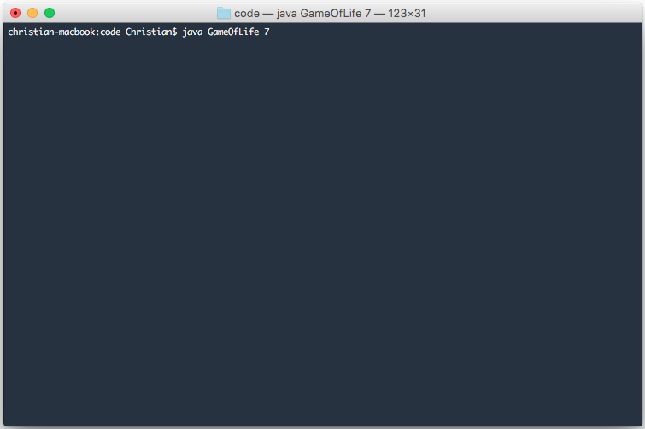

**Figure 2.** Console display output for the “Run Continuous” button press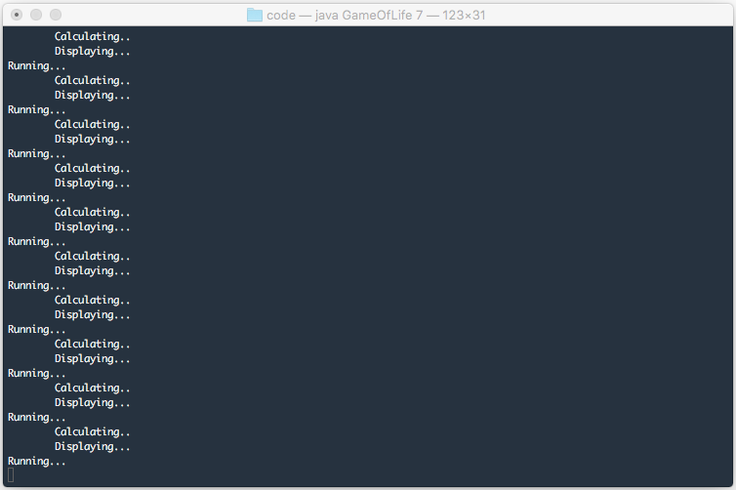

**Figure 3.** Initial pattern for a convergent game of life  
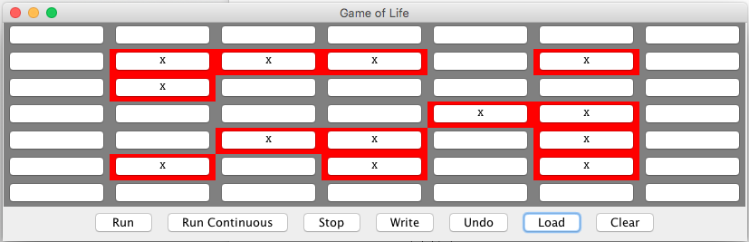  
  
**Figure 4.** Final pattern for the convergent game of life in Figure 3.  
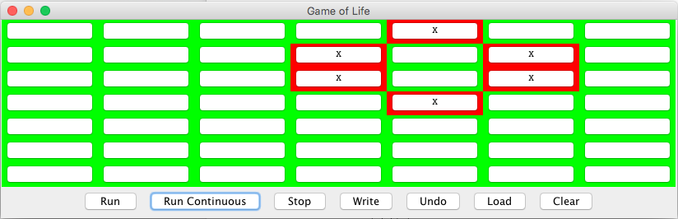

**Figure 5.** Initial pattern for an infinite game of life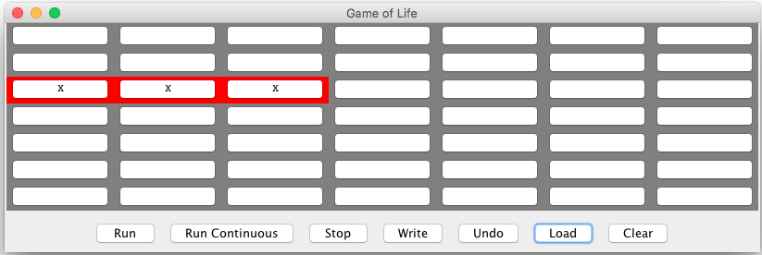  
  
**Figure 6.** The infinite game of life in Figure 5 toggles between these two final patterns  
