**ENSF-381**: **Full Stack Web Development Laboratory**

**Lab03**

**Section: L02**

**Group information:**

Haseeb Tahir (10190846)

Jaskeerat Rai (30186681)

**GitHub Link:**

**https://github.com/thisdontw0rk/ENSF381_Lab3**

**Exercise 1 Output:**

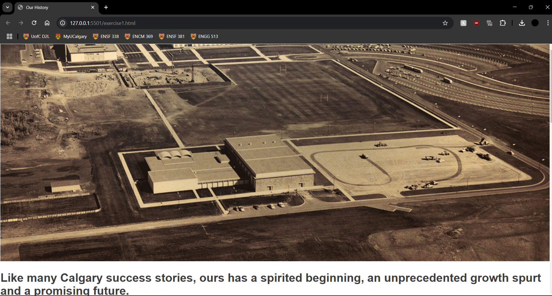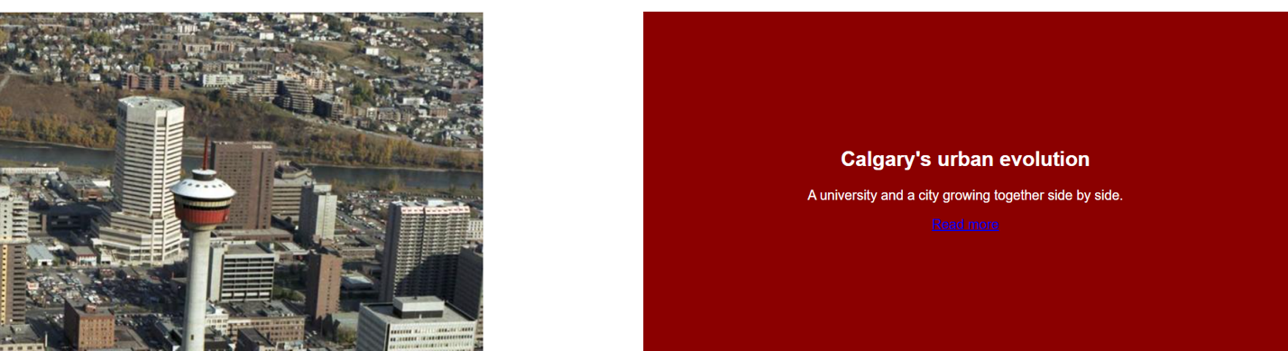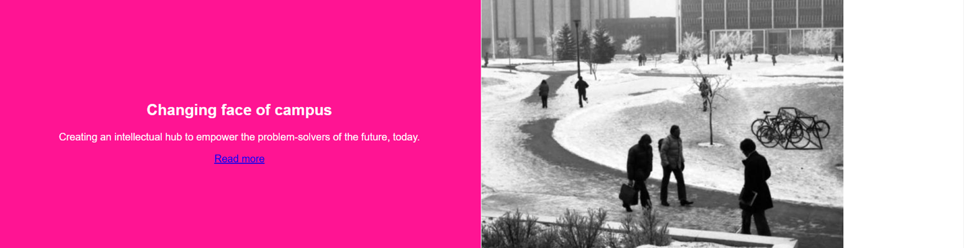

**Exercise 2 Output:**

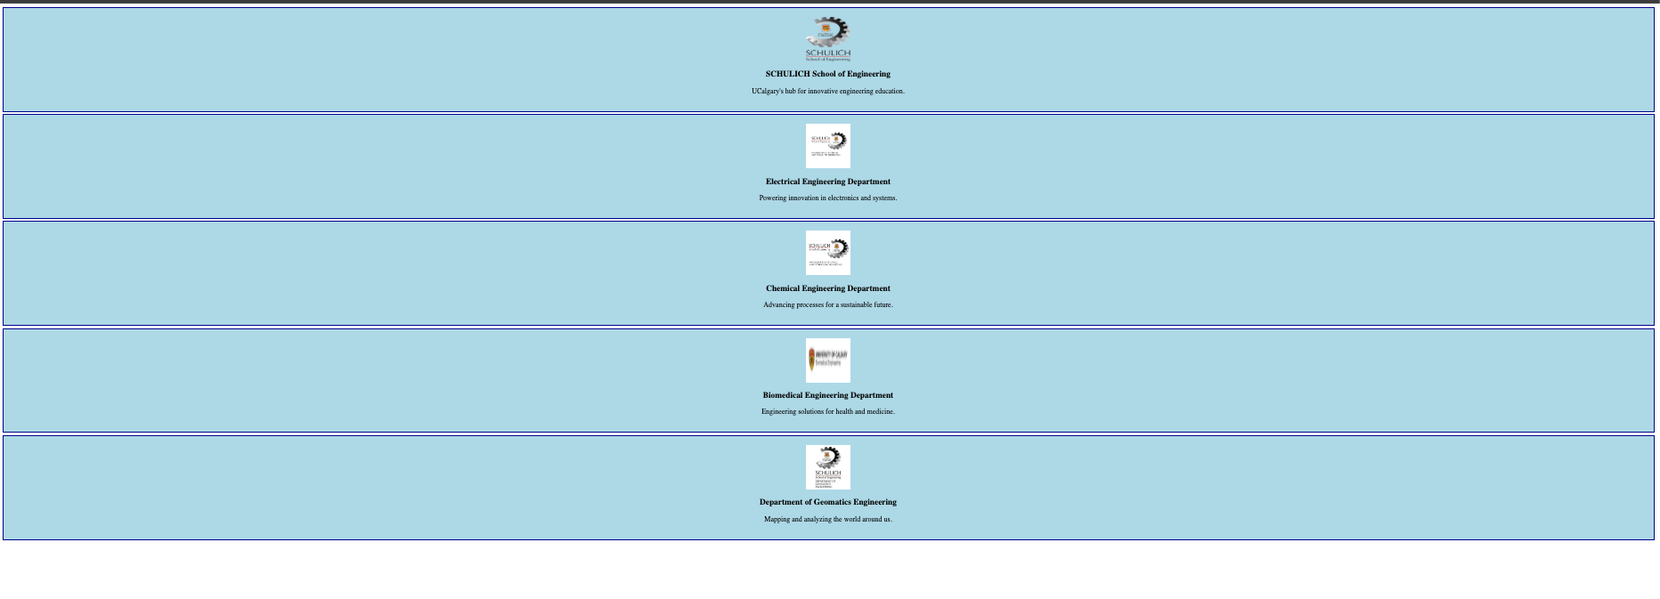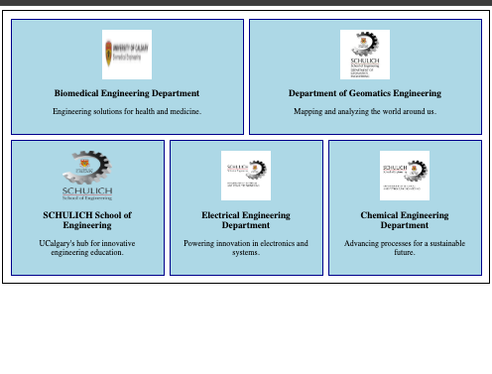

* Item 1 will appear last (order 3).
* Item 2 will appear first (order 1).
* Item 3 will appear second (order 2).

**Exercise 3 Output:**

