## 卷积神经网络实验报告

姓名：靳乐卿 学号：2012159

实验要求：

* 掌握卷积的基本原理
* 学会使用PyTorch搭建简单的CNN实现Cifar10数据集分类
* 学会使用PyTorch搭建简单的ResNet实现Cifar10数据集分类
* 学会使用PyTorch搭建简单的DenseNet实现Cifar10数据集分类
* 学会使用PyTorch搭建简单的SE-ResNet实现Cifar10数据集分类

报告内容：

* 老师提供的原始版本CNN网络结构（可用print(net)打印，复制文字或截图皆可）、在Cifar10验证集上的训练loss曲线、准确度曲线图
* 个人实现的ResNet网络结构在上述验证集上的训练loss曲线、准确度曲线图
* 个人实现的DenseNet网络结构在上述验证集上的训练loss曲线、准确度曲线图
* 个人实现的带有SE模块（Squeeze-and-Excitation Networks）的ResNet网络结构在上述验证集上的训练loss曲线、准确度曲线图
* 解释没有跳跃连接的卷积网络、ResNet、DenseNet、SE-ResNet在训练过程中有什么不同（重点部分）
* 格式不限

作业提交：

* 期末前将报告和代码（可将jupyter notebook里代码复制到一个xxx.py文件中）打包（学号+姓名.zip），提交方式另行通知
* 实验报告内容应工整

# 原始版本CNN

## 网络结构

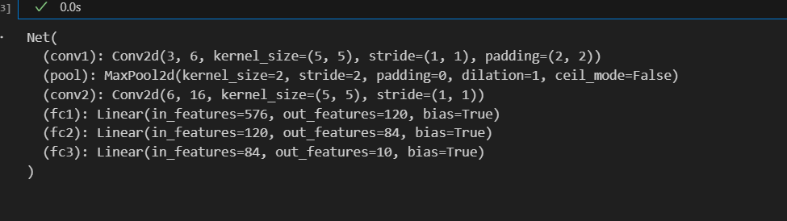

## 训练5轮的曲线

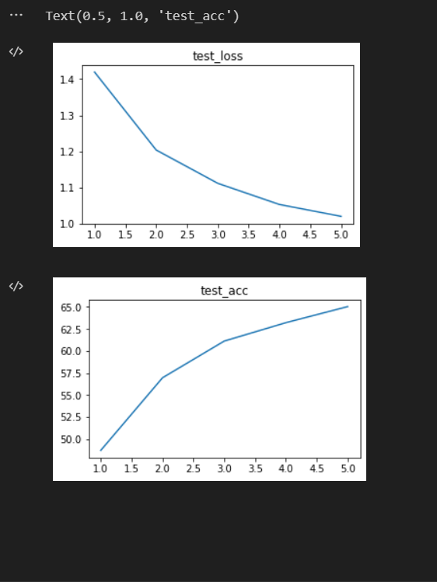

# ResNet

ResNet_normal(

(conv1): Conv2d(3, 64, kernel_size=(7, 7), stride=(2, 2), padding=(3, 3), bias=False)

(bn): BatchNorm2d(64, eps=1e-05, momentum=0.1, affine=True, track_running_stats=True)

(relu): ReLU(inplace=True)

(maxpool): MaxPool2d(kernel_size=3, stride=2, padding=1, dilation=1, ceil_mode=False)

(layer1): Sequential(

(0): BasicBlock(

(conv1): Conv2d(64, 64, kernel_size=(3, 3), stride=(1, 1), padding=(1, 1), bias=False)

(bn1): BatchNorm2d(64, eps=1e-05, momentum=0.1, affine=True, track_running_stats=True)

(relu): ReLU(inplace=True)

(conv2): Conv2d(64, 64, kernel_size=(3, 3), stride=(1, 1), padding=(1, 1), bias=False)

(bn2): BatchNorm2d(64, eps=1e-05, momentum=0.1, affine=True, track_running_stats=True)

)

(1): BasicBlock(

(conv1): Conv2d(64, 64, kernel_size=(3, 3), stride=(1, 1), padding=(1, 1), bias=False)

(bn1): BatchNorm2d(64, eps=1e-05, momentum=0.1, affine=True, track_running_stats=True)

(relu): ReLU(inplace=True)

(conv2): Conv2d(64, 64, kernel_size=(3, 3), stride=(1, 1), padding=(1, 1), bias=False)

(bn2): BatchNorm2d(64, eps=1e-05, momentum=0.1, affine=True, track_running_stats=True)

)

)

(layer2): Sequential(

(0): BasicBlock(

(conv1): Conv2d(64, 128, kernel_size=(3, 3), stride=(2, 2), padding=(1, 1), bias=False)

(bn1): BatchNorm2d(128, eps=1e-05, momentum=0.1, affine=True, track_running_stats=True)

(relu): ReLU(inplace=True)

(conv2): Conv2d(128, 128, kernel_size=(3, 3), stride=(1, 1), padding=(1, 1), bias=False)

(bn2): BatchNorm2d(128, eps=1e-05, momentum=0.1, affine=True, track_running_stats=True)

(downsample): Sequential(

(0): Conv2d(64, 128, kernel_size=(1, 1), stride=(2, 2), bias=False)

(1): BatchNorm2d(128, eps=1e-05, momentum=0.1, affine=True, track_running_stats=True)

)

)

(1): BasicBlock(

(conv1): Conv2d(128, 128, kernel_size=(3, 3), stride=(1, 1), padding=(1, 1), bias=False)

(bn1): BatchNorm2d(128, eps=1e-05, momentum=0.1, affine=True, track_running_stats=True)

(relu): ReLU(inplace=True)

(conv2): Conv2d(128, 128, kernel_size=(3, 3), stride=(1, 1), padding=(1, 1), bias=False)

(bn2): BatchNorm2d(128, eps=1e-05, momentum=0.1, affine=True, track_running_stats=True)

)

)

(layer3): Sequential(

(0): BasicBlock(

(conv1): Conv2d(128, 256, kernel_size=(3, 3), stride=(2, 2), padding=(1, 1), bias=False)

(bn1): BatchNorm2d(256, eps=1e-05, momentum=0.1, affine=True, track_running_stats=True)

(relu): ReLU(inplace=True)

(conv2): Conv2d(256, 256, kernel_size=(3, 3), stride=(1, 1), padding=(1, 1), bias=False)

(bn2): BatchNorm2d(256, eps=1e-05, momentum=0.1, affine=True, track_running_stats=True)

(downsample): Sequential(

(0): Conv2d(128, 256, kernel_size=(1, 1), stride=(2, 2), bias=False)

(1): BatchNorm2d(256, eps=1e-05, momentum=0.1, affine=True, track_running_stats=True)

)

)

(1): BasicBlock(

(conv1): Conv2d(256, 256, kernel_size=(3, 3), stride=(1, 1), padding=(1, 1), bias=False)

(bn1): BatchNorm2d(256, eps=1e-05, momentum=0.1, affine=True, track_running_stats=True)

(relu): ReLU(inplace=True)

(conv2): Conv2d(256, 256, kernel_size=(3, 3), stride=(1, 1), padding=(1, 1), bias=False)

(bn2): BatchNorm2d(256, eps=1e-05, momentum=0.1, affine=True, track_running_stats=True)

)

)

(layer4): Sequential(

(0): BasicBlock(

(conv1): Conv2d(256, 512, kernel_size=(3, 3), stride=(2, 2), padding=(1, 1), bias=False)

(bn1): BatchNorm2d(512, eps=1e-05, momentum=0.1, affine=True, track_running_stats=True)

(relu): ReLU(inplace=True)

(conv2): Conv2d(512, 512, kernel_size=(3, 3), stride=(1, 1), padding=(1, 1), bias=False)

(bn2): BatchNorm2d(512, eps=1e-05, momentum=0.1, affine=True, track_running_stats=True)

(downsample): Sequential(

(0): Conv2d(256, 512, kernel_size=(1, 1), stride=(2, 2), bias=False)

(1): BatchNorm2d(512, eps=1e-05, momentum=0.1, affine=True, track_running_stats=True)

)

)

(1): BasicBlock(

(conv1): Conv2d(512, 512, kernel_size=(3, 3), stride=(1, 1), padding=(1, 1), bias=False)

(bn1): BatchNorm2d(512, eps=1e-05, momentum=0.1, affine=True, track_running_stats=True)

(relu): ReLU(inplace=True)

(conv2): Conv2d(512, 512, kernel_size=(3, 3), stride=(1, 1), padding=(1, 1), bias=False)

(bn2): BatchNorm2d(512, eps=1e-05, momentum=0.1, affine=True, track_running_stats=True)

)

)

(avg_pool): AdaptiveAvgPool2d(output_size=(1, 1))

(fc): Linear(in_features=512, out_features=10, bias=True)

)

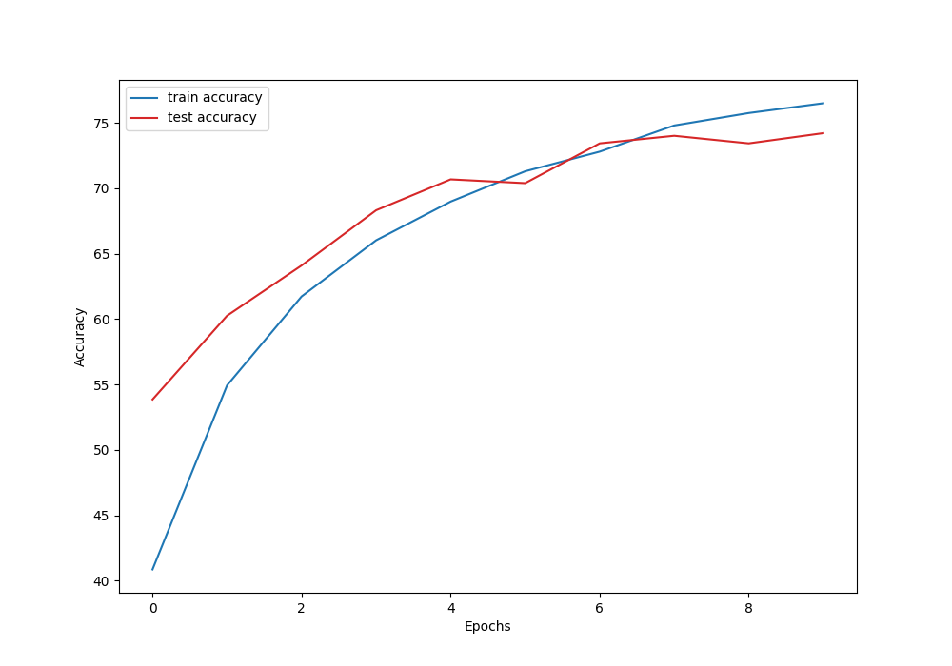

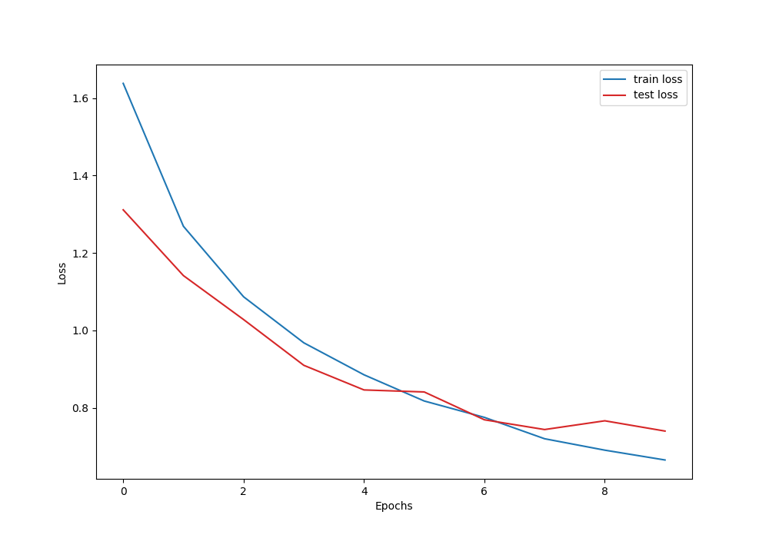

# DenseNet

DenseNet(

(conv): Conv2d(3, 32, kernel_size=(7, 7), stride=(2, 2), padding=(3, 3))

(bn1): BatchNorm2d(32, eps=1e-05, momentum=0.1, affine=True, track_running_stats=True)

(max_pool): MaxPool2d(kernel_size=2, stride=2, padding=0, dilation=1, ceil_mode=False)

(relu): ReLU()

(denseblock1): DenseBlock(

(denseblock): Sequential(

(0): DenseBasic(

(layer): Sequential(

(0): BatchNorm2d(32, eps=1e-05, momentum=0.1, affine=True, track_running_stats=True)

(1): ReLU()

(2): Conv2d(32, 128, kernel_size=(1, 1), stride=(1, 1))

(3): BatchNorm2d(128, eps=1e-05, momentum=0.1, affine=True, track_running_stats=True)

(4): ReLU()

(5): Conv2d(128, 32, kernel_size=(3, 3), stride=(1, 1), padding=(1, 1))

)

)

(1): DenseBasic(

(layer): Sequential(

(0): BatchNorm2d(64, eps=1e-05, momentum=0.1, affine=True, track_running_stats=True)

(1): ReLU()

(2): Conv2d(64, 128, kernel_size=(1, 1), stride=(1, 1))

(3): BatchNorm2d(128, eps=1e-05, momentum=0.1, affine=True, track_running_stats=True)

(4): ReLU()

(5): Conv2d(128, 32, kernel_size=(3, 3), stride=(1, 1), padding=(1, 1))

)

)

(2): DenseBasic(

(layer): Sequential(

(0): BatchNorm2d(96, eps=1e-05, momentum=0.1, affine=True, track_running_stats=True)

(1): ReLU()

(2): Conv2d(96, 128, kernel_size=(1, 1), stride=(1, 1))

(3): BatchNorm2d(128, eps=1e-05, momentum=0.1, affine=True, track_running_stats=True)

(4): ReLU()

(5): Conv2d(128, 32, kernel_size=(3, 3), stride=(1, 1), padding=(1, 1))

)

)

(3): DenseBasic(

(layer): Sequential(

(0): BatchNorm2d(128, eps=1e-05, momentum=0.1, affine=True, track_running_stats=True)

(1): ReLU()

(2): Conv2d(128, 128, kernel_size=(1, 1), stride=(1, 1))

(3): BatchNorm2d(128, eps=1e-05, momentum=0.1, affine=True, track_running_stats=True)

(4): ReLU()

(5): Conv2d(128, 32, kernel_size=(3, 3), stride=(1, 1), padding=(1, 1))

)

)

(4): DenseBasic(

(layer): Sequential(

(0): BatchNorm2d(160, eps=1e-05, momentum=0.1, affine=True, track_running_stats=True)

(1): ReLU()

(2): Conv2d(160, 128, kernel_size=(1, 1), stride=(1, 1))

(3): BatchNorm2d(128, eps=1e-05, momentum=0.1, affine=True, track_running_stats=True)

(4): ReLU()

(5): Conv2d(128, 32, kernel_size=(3, 3), stride=(1, 1), padding=(1, 1))

)

)

(5): DenseBasic(

(layer): Sequential(

(0): BatchNorm2d(192, eps=1e-05, momentum=0.1, affine=True, track_running_stats=True)

(1): ReLU()

(2): Conv2d(192, 128, kernel_size=(1, 1), stride=(1, 1))

(3): BatchNorm2d(128, eps=1e-05, momentum=0.1, affine=True, track_running_stats=True)

(4): ReLU()

(5): Conv2d(128, 32, kernel_size=(3, 3), stride=(1, 1), padding=(1, 1))

)

)

)

)

(bn2): BatchNorm2d(224, eps=1e-05, momentum=0.1, affine=True, track_running_stats=True)

(conv1): Conv2d(224, 64, kernel_size=(3, 3), stride=(1, 1), padding=(1, 1))

(avg1): AvgPool2d(kernel_size=2, stride=2, padding=0)

(denseblock2): DenseBlock(

(denseblock): Sequential(

(0): DenseBasic(

(layer): Sequential(

(0): BatchNorm2d(64, eps=1e-05, momentum=0.1, affine=True, track_running_stats=True)

(1): ReLU()

(2): Conv2d(64, 256, kernel_size=(1, 1), stride=(1, 1))

(3): BatchNorm2d(256, eps=1e-05, momentum=0.1, affine=True, track_running_stats=True)

(4): ReLU()

(5): Conv2d(256, 64, kernel_size=(3, 3), stride=(1, 1), padding=(1, 1))

)

)

(1): DenseBasic(

(layer): Sequential(

(0): BatchNorm2d(128, eps=1e-05, momentum=0.1, affine=True, track_running_stats=True)

(1): ReLU()

(2): Conv2d(128, 256, kernel_size=(1, 1), stride=(1, 1))

(3): BatchNorm2d(256, eps=1e-05, momentum=0.1, affine=True, track_running_stats=True)

(4): ReLU()

(5): Conv2d(256, 64, kernel_size=(3, 3), stride=(1, 1), padding=(1, 1))

)

)

(2): DenseBasic(

(layer): Sequential(

(0): BatchNorm2d(192, eps=1e-05, momentum=0.1, affine=True, track_running_stats=True)

(1): ReLU()

(2): Conv2d(192, 256, kernel_size=(1, 1), stride=(1, 1))

(3): BatchNorm2d(256, eps=1e-05, momentum=0.1, affine=True, track_running_stats=True)

(4): ReLU()

(5): Conv2d(256, 64, kernel_size=(3, 3), stride=(1, 1), padding=(1, 1))

)

)

(3): DenseBasic(

(layer): Sequential(

(0): BatchNorm2d(256, eps=1e-05, momentum=0.1, affine=True, track_running_stats=True)

(1): ReLU()

(2): Conv2d(256, 256, kernel_size=(1, 1), stride=(1, 1))

(3): BatchNorm2d(256, eps=1e-05, momentum=0.1, affine=True, track_running_stats=True)

(4): ReLU()

(5): Conv2d(256, 64, kernel_size=(3, 3), stride=(1, 1), padding=(1, 1))

)

)

(4): DenseBasic(

(layer): Sequential(

(0): BatchNorm2d(320, eps=1e-05, momentum=0.1, affine=True, track_running_stats=True)

(1): ReLU()

(2): Conv2d(320, 256, kernel_size=(1, 1), stride=(1, 1))

(3): BatchNorm2d(256, eps=1e-05, momentum=0.1, affine=True, track_running_stats=True)

(4): ReLU()

(5): Conv2d(256, 64, kernel_size=(3, 3), stride=(1, 1), padding=(1, 1))

)

)

(5): DenseBasic(

(layer): Sequential(

(0): BatchNorm2d(384, eps=1e-05, momentum=0.1, affine=True, track_running_stats=True)

(1): ReLU()

(2): Conv2d(384, 256, kernel_size=(1, 1), stride=(1, 1))

(3): BatchNorm2d(256, eps=1e-05, momentum=0.1, affine=True, track_running_stats=True)

(4): ReLU()

(5): Conv2d(256, 64, kernel_size=(3, 3), stride=(1, 1), padding=(1, 1))

)

)

)

)

(fc1): Linear(in_features=7168, out_features=10, bias=True)

)

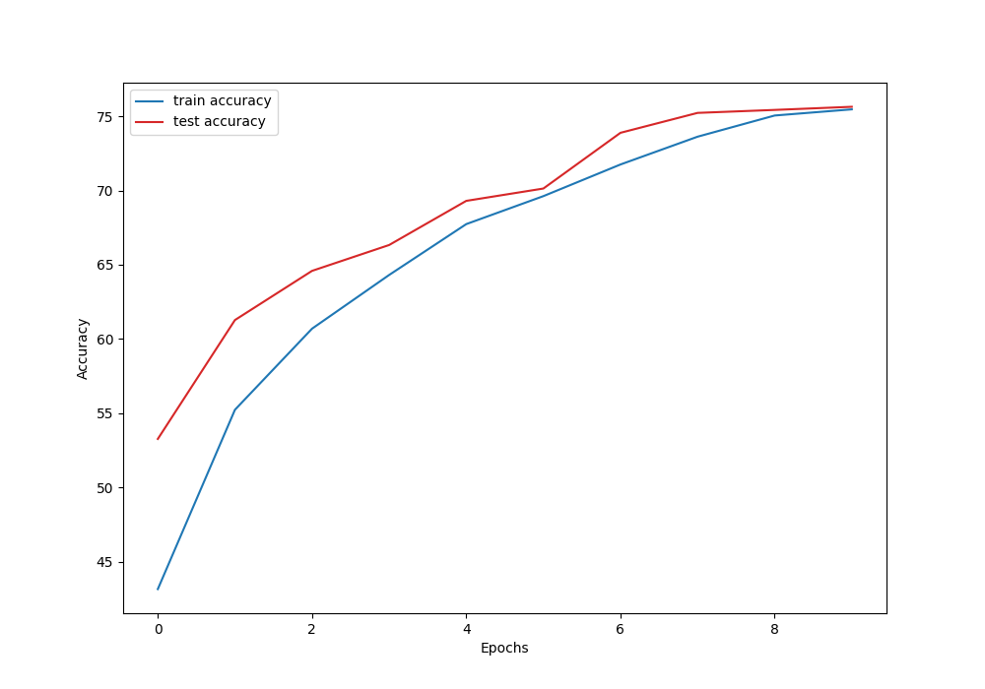

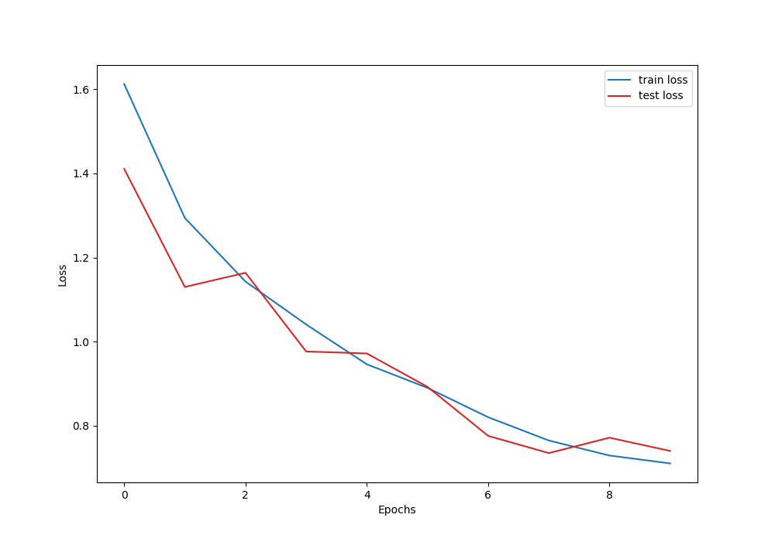

# SE-ResNet

SEResNet(

(conv1): Conv2d(3, 64, kernel_size=(7, 7), stride=(2, 2), padding=(3, 3), bias=False)

(bn): BatchNorm2d(64, eps=1e-05, momentum=0.1, affine=True, track_running_stats=True)

(relu): ReLU(inplace=True)

(layer1): Sequential(

(0): BasicBlock(

(conv1): Conv2d(64, 64, kernel_size=(3, 3), stride=(1, 1), padding=(1, 1), bias=False)

(bn1): BatchNorm2d(64, eps=1e-05, momentum=0.1, affine=True, track_running_stats=True)

(relu): ReLU(inplace=True)

(conv2): Conv2d(64, 64, kernel_size=(3, 3), stride=(1, 1), padding=(1, 1), bias=False)

(bn2): BatchNorm2d(64, eps=1e-05, momentum=0.1, affine=True, track_running_stats=True)

(se): SE(

(avg_pool): AdaptiveAvgPool2d(output_size=(1, 1))

(fc1): Conv2d(64, 4, kernel_size=(1, 1), stride=(1, 1))

(fc2): Conv2d(4, 64, kernel_size=(1, 1), stride=(1, 1))

)

)

(1): BasicBlock(

(conv1): Conv2d(64, 64, kernel_size=(3, 3), stride=(1, 1), padding=(1, 1), bias=False)

(bn1): BatchNorm2d(64, eps=1e-05, momentum=0.1, affine=True, track_running_stats=True)

(relu): ReLU(inplace=True)

(conv2): Conv2d(64, 64, kernel_size=(3, 3), stride=(1, 1), padding=(1, 1), bias=False)

(bn2): BatchNorm2d(64, eps=1e-05, momentum=0.1, affine=True, track_running_stats=True)

(se): SE(

(avg_pool): AdaptiveAvgPool2d(output_size=(1, 1))

(fc1): Conv2d(64, 4, kernel_size=(1, 1), stride=(1, 1))

(fc2): Conv2d(4, 64, kernel_size=(1, 1), stride=(1, 1))

)

)

)

(layer2): Sequential(

(0): BasicBlock(

(conv1): Conv2d(64, 128, kernel_size=(3, 3), stride=(2, 2), padding=(1, 1), bias=False)

(bn1): BatchNorm2d(128, eps=1e-05, momentum=0.1, affine=True, track_running_stats=True)

(relu): ReLU(inplace=True)

(conv2): Conv2d(128, 128, kernel_size=(3, 3), stride=(1, 1), padding=(1, 1), bias=False)

(bn2): BatchNorm2d(128, eps=1e-05, momentum=0.1, affine=True, track_running_stats=True)

(downsample): Sequential(

(0): Conv2d(64, 128, kernel_size=(1, 1), stride=(2, 2), bias=False)

(1): BatchNorm2d(128, eps=1e-05, momentum=0.1, affine=True, track_running_stats=True)

)

(se): SE(

(avg_pool): AdaptiveAvgPool2d(output_size=(1, 1))

(fc1): Conv2d(128, 8, kernel_size=(1, 1), stride=(1, 1))

(fc2): Conv2d(8, 128, kernel_size=(1, 1), stride=(1, 1))

)

)

(1): BasicBlock(

(conv1): Conv2d(128, 128, kernel_size=(3, 3), stride=(1, 1), padding=(1, 1), bias=False)

(bn1): BatchNorm2d(128, eps=1e-05, momentum=0.1, affine=True, track_running_stats=True)

(relu): ReLU(inplace=True)

(conv2): Conv2d(128, 128, kernel_size=(3, 3), stride=(1, 1), padding=(1, 1), bias=False)

(bn2): BatchNorm2d(128, eps=1e-05, momentum=0.1, affine=True, track_running_stats=True)

(se): SE(

(avg_pool): AdaptiveAvgPool2d(output_size=(1, 1))

(fc1): Conv2d(128, 8, kernel_size=(1, 1), stride=(1, 1))

(fc2): Conv2d(8, 128, kernel_size=(1, 1), stride=(1, 1))

)

)

)

(layer3): Sequential(

(0): BasicBlock(

(conv1): Conv2d(128, 256, kernel_size=(3, 3), stride=(2, 2), padding=(1, 1), bias=False)

(bn1): BatchNorm2d(256, eps=1e-05, momentum=0.1, affine=True, track_running_stats=True)

(relu): ReLU(inplace=True)

(conv2): Conv2d(256, 256, kernel_size=(3, 3), stride=(1, 1), padding=(1, 1), bias=False)

(bn2): BatchNorm2d(256, eps=1e-05, momentum=0.1, affine=True, track_running_stats=True)

(downsample): Sequential(

(0): Conv2d(128, 256, kernel_size=(1, 1), stride=(2, 2), bias=False)

(1): BatchNorm2d(256, eps=1e-05, momentum=0.1, affine=True, track_running_stats=True)

)

(se): SE(

(avg_pool): AdaptiveAvgPool2d(output_size=(1, 1))

(fc1): Conv2d(256, 16, kernel_size=(1, 1), stride=(1, 1))

(fc2): Conv2d(16, 256, kernel_size=(1, 1), stride=(1, 1))

)

)

(1): BasicBlock(

(conv1): Conv2d(256, 256, kernel_size=(3, 3), stride=(1, 1), padding=(1, 1), bias=False)

(bn1): BatchNorm2d(256, eps=1e-05, momentum=0.1, affine=True, track_running_stats=True)

(relu): ReLU(inplace=True)

(conv2): Conv2d(256, 256, kernel_size=(3, 3), stride=(1, 1), padding=(1, 1), bias=False)

(bn2): BatchNorm2d(256, eps=1e-05, momentum=0.1, affine=True, track_running_stats=True)

(se): SE(

(avg_pool): AdaptiveAvgPool2d(output_size=(1, 1))

(fc1): Conv2d(256, 16, kernel_size=(1, 1), stride=(1, 1))

(fc2): Conv2d(16, 256, kernel_size=(1, 1), stride=(1, 1))

)

)

)

(layer4): Sequential(

(0): BasicBlock(

(conv1): Conv2d(256, 512, kernel_size=(3, 3), stride=(2, 2), padding=(1, 1), bias=False)

(bn1): BatchNorm2d(512, eps=1e-05, momentum=0.1, affine=True, track_running_stats=True)

(relu): ReLU(inplace=True)

(conv2): Conv2d(512, 512, kernel_size=(3, 3), stride=(1, 1), padding=(1, 1), bias=False)

(bn2): BatchNorm2d(512, eps=1e-05, momentum=0.1, affine=True, track_running_stats=True)

(downsample): Sequential(

(0): Conv2d(256, 512, kernel_size=(1, 1), stride=(2, 2), bias=False)

(1): BatchNorm2d(512, eps=1e-05, momentum=0.1, affine=True, track_running_stats=True)

)

(se): SE(

(avg_pool): AdaptiveAvgPool2d(output_size=(1, 1))

(fc1): Conv2d(512, 32, kernel_size=(1, 1), stride=(1, 1))

(fc2): Conv2d(32, 512, kernel_size=(1, 1), stride=(1, 1))

)

)

(1): BasicBlock(

(conv1): Conv2d(512, 512, kernel_size=(3, 3), stride=(1, 1), padding=(1, 1), bias=False)

(bn1): BatchNorm2d(512, eps=1e-05, momentum=0.1, affine=True, track_running_stats=True)

(relu): ReLU(inplace=True)

(conv2): Conv2d(512, 512, kernel_size=(3, 3), stride=(1, 1), padding=(1, 1), bias=False)

(bn2): BatchNorm2d(512, eps=1e-05, momentum=0.1, affine=True, track_running_stats=True)

(se): SE(

(avg_pool): AdaptiveAvgPool2d(output_size=(1, 1))

(fc1): Conv2d(512, 32, kernel_size=(1, 1), stride=(1, 1))

(fc2): Conv2d(32, 512, kernel_size=(1, 1), stride=(1, 1))

)

)

)

(avg_pool): AdaptiveAvgPool2d(output_size=(1, 1))

(fc): Linear(in_features=512, out_features=10, bias=True)

)

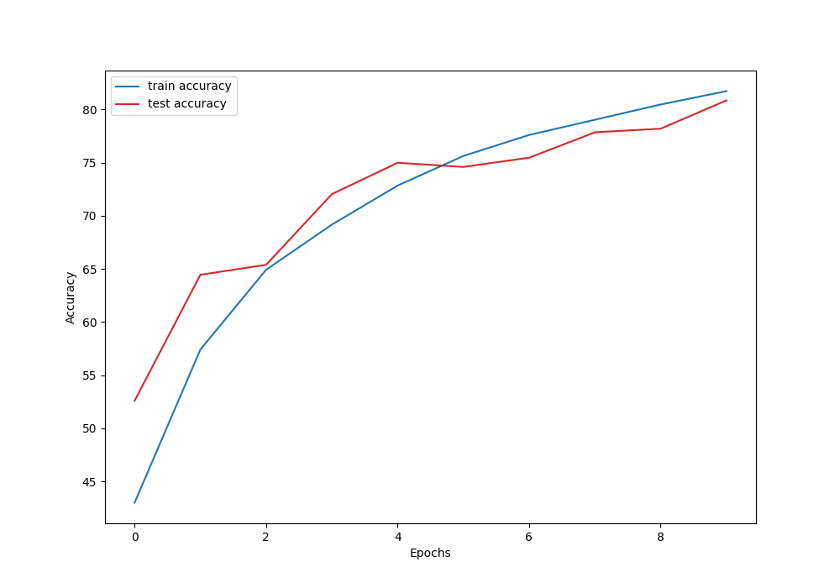

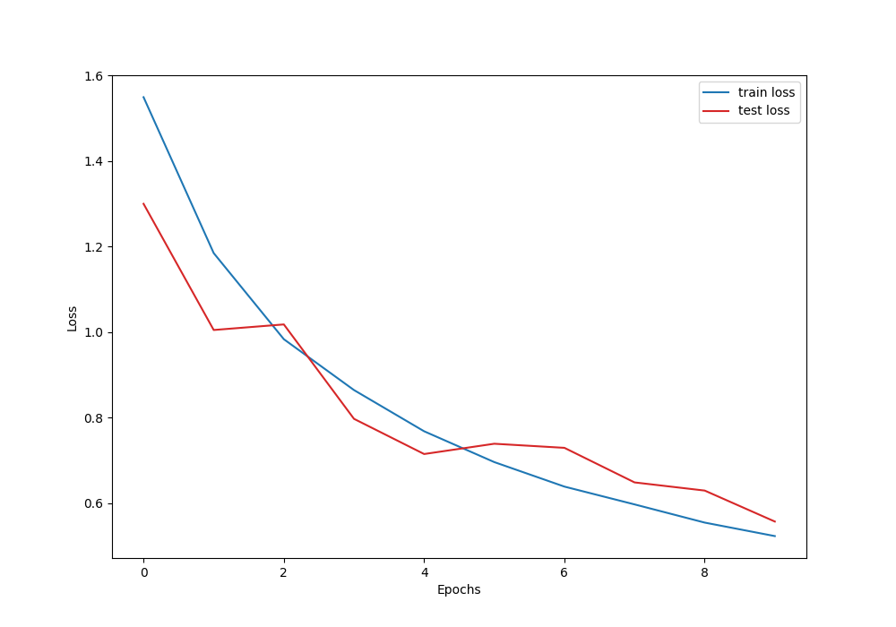

# 解释训练过程中的不同

## resnet

残差网络添加了一个恒等映射的部分，他最终的输出是f(x)+x而非f(x)，他的优势是首先它可以很好的解决梯度消失，因为再如何你还有个x，不至于梯度消失，这样就可以让你的网络层数更深而仍具有学习能力，可以提高网络的效果。而且还可以比较好的解决网络退化的问题，因为新加入一层最差我们也可以让他是一个恒等映射（或极其接近恒等映射的）层，不会对后续效果有影响，那么自然不会比加入之前差，从而解决网络退化问题

## densenet

densenet结构如下图

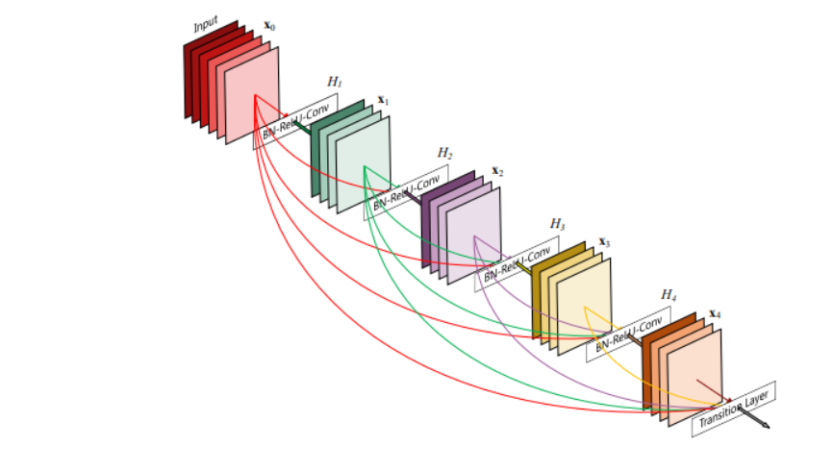

每个层从前面的所有层获得额外的输入，并将自己的特征映射传递到后续的所有层，使用级联方式。他的思想也来自于resnet，同样的他也同resnet一样，能比较好的解决网络退化和梯度消失的问题，不过比起resnet不同，resnet只接受上一层的输入，densenet接受不止上一层的输入，此外，densenet是将输出和残差进行拼接，而非相加。

而且虽然看起来更密集的连接会大大增加参数量，但实际上DenseNet比传统的卷积网络所需要的参数反而更少，因为密集的连接带来了特征重用，不需要重新学习冗余的特征图，而且维度拼接的操作，带来了丰富的特征信息，利用更少的卷积就能获得很多的特征图。

# senet

se模块如下图

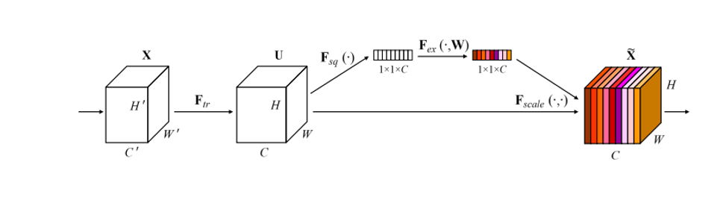

其工作机理如下：

我们把得到的一系列特征图（通道），压缩成1*1大小（使用全局平均池化），然后再通过可学习的参数得到每个特征图（通道）的权重（使用全连接层去训练，也是有一个压缩，解压的过程先把通道数压缩到in\_channel/ratio，然后再给他回到in\_channel通道数），最后和原本的特征图进行相乘，相当于加权运算。

这可以用较少的参数量，显式的构建对各个特征图（通道）的重要性的学习，以期得到对图像的更好的学习效果