 | STORY. ENERGY. SALES.
  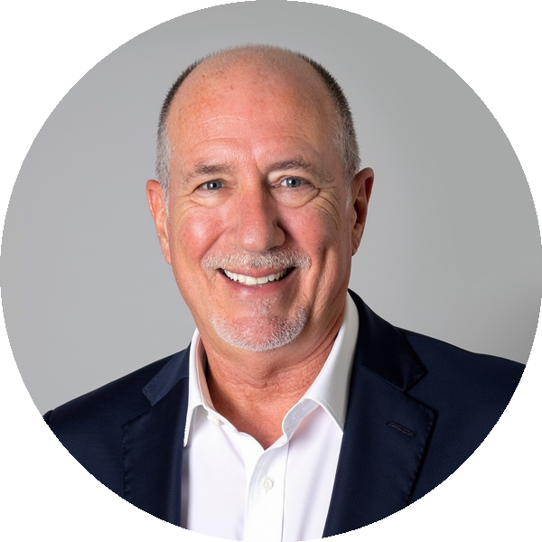 | DON PHIN, ESQ.  KEYNOTE SPEAKER · ENTREPRENEUR · PRIVATE ADVISOR  DONPHIN.COM
Attorney & Former Litigator | 800+ Presentations to Executives | 16 LinkedIn Learning Courses • 1M+ Professionals Reached | 40+ Years Studying Human Potential
SIGNATURE PROGRAM
SALES ON STAGE
How Our Stories and Roles Direct the Sale
Buyer and seller walk onto the sales stage with stories already playing in their heads. Those stories shape the roles they play, the emotions they bring, and what happens next. Change the story, and you can change the sale.

WHAT CHANGES AFTER DON SPEAKS
✓ Awareness of the deep emotional dynamics beneath the sale  ✓ Recognize the stories and roles shaping the sale — understand how Victim, Villain, and Hero stories affect how both buyer and seller show up.  ✓ Build trust faster through curiosity and deeper listening | ✓ Know how you can both be heroes in the sales story  ✓ Have a plan for how you’re going to show up emotionally  ✓ Use the Coax, Encourage, and Inspire formula to help everyone move forward with greater confidence and ownership.
Remember… facts tell, and stories sell!

BUILD THE EXPERIENCE YOUR SALES MEETING NEEDS
SIGNATURE KEYNOTE  Sales on Stage  How Our Stories and Roles Direct the Sale  A highly interactive keynote revealing the hidden roles and stories behind every sale — and how we can both be heroes in the sales process. | INTERACTIVE BREAKOUT  Mastering the Emotional Energy of Partnerships  Go deeper into the stories, assumptions and emotional dynamics that shape customers, teams, channel partners and other critical relationships. | EXECUTIVE SESSION  Sales Commission Agreements That Keep You Out of Court  A practical executive briefing for leaders responsible for commission plans — covering clarity, disputes, changes, termination issues and costly drafting mistakes.

“Don presented his program The 40//40 Solution for Leadership and Engagement for our Fall Summit. Wonderful feedback and survey results. The 40//40 presentation is a unique concept with excellent take-home value that can be implemented immediately! Our membership always thanks us when we have Don speak to them and consistently ask us to have him come back! Book Don for your next event and your members will love you for it!”
PRESTON DIAMOND, MANAGING DIRECTOR, INSTITUTE OF WORKCOMP PROFESSIONALS
“Don has a way of breaking down the complex emotional energy in relationships to basic, common sense, matter-of-fact thinking. It’s a guide on how to take the noise out of how we communicate. The best takeaway from the 40//40 is the space it allows for co-creation. When living in the 40//40, teamwork and sales are fostered.”  DON MADER, CEO, SOUTHEASTERN PRINTING | “It is rare when a speaker can have such a powerful effect simultaneously on doctors, assistants, and office managers. But that is exactly what Don Phin did at our conference. His presentation is talked about almost continually on our social media forums and it has allowed all of us to be more successful in creating team cohesion and strength.”  SANFORD M. FISCH, CEO & CO-FOUNDER, AMERICAN ACADEMY OF ESTATE PLANNING ATTORNEYS
TRUSTED BY


Book Don for Your Next Sales Meeting | KEYNOTE | BREAKOUT | EXECUTIVE SESSION  DONPHIN.COM

