Home Assignment: Product Manager
Question 1.- Google Analytics
Define what kind of events, kpis or funnels we can monitor, so we can extract valuable insights for the Product Team.
What to monitor (events/KPIs/funnel): Track entry points (Gift icon, banners), engagement (time on page, scroll depth, section clicks, search/filter usage), and the core funnel: Offers Page view → Offer click → Offer activation → Game start.
What success looks like: Users can find the page easily, explore multiple offers, and move through the funnel with low drop-off, generating repeat visits and post-offer play.
Additional KPIs to improve decisions: “Time to activation” and “steps to activation” (friction), offer contribution (top offers driving activations), retention uplift (offer users vs non-offer users), and segmentation by platform/region/user type to guide targeting and placement.

Question 2.- Data Analysis & Product Insights
Now, from a more product point of view, we want to evaluate how Sportsbook Missions, one of our most Reports / insights: Conversion peaks in May (~41%), drops in June (~30%), with a clear step-change after May 25. Performance is stronger when mission volume is higher and Private missions are a meaningful share; June shows fewer missions and reduced Private mix, while opt-ins remain solid—suggesting completion-stage friction (not discovery).
Pain points: Growing opt-ins but declining completion efficiency; widening gap between opt-in and completion indicates increased difficulty, complexity, or weaker relevance.
Additional KPIs: Completion time, drop-off by step, completion by mission type/category, reward cost vs incremental engagement, and cohort retention for mission participants.
Improvements / next steps: Restore a balanced Public/Private mix (targeted Private), increase weekly variety, simplify completion requirements, improve progress clarity, and run A/B tests on thresholds and mission mix.
If asked to drop Missions: Recommend not dropping; the mechanic proves strong when configured well (May peak). Treat June as a fixable execution/config issue and iterate before removing a high-engagement lever.
Conversion
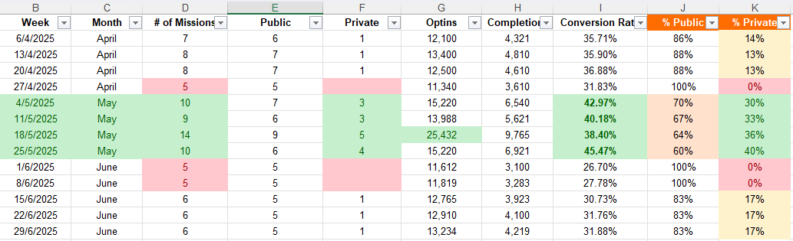

Customer base
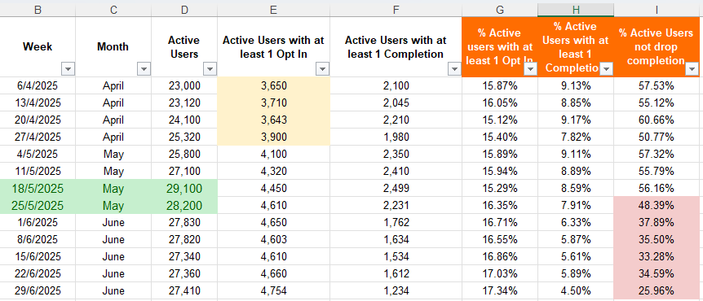
Category
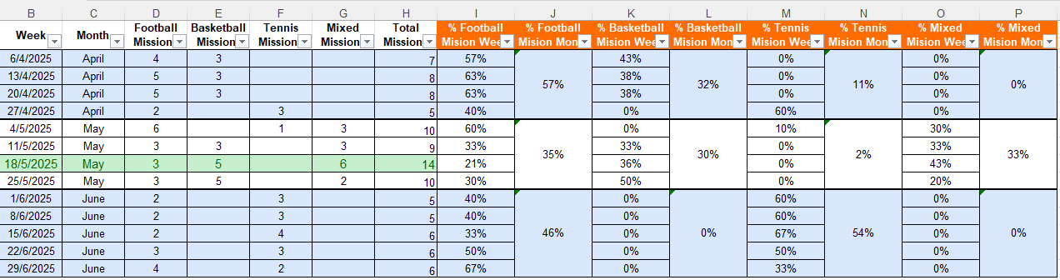

Question 3.- How to?
How to frame analysis: Adoption → progression (Premium→VIP) → redemption behavior → retention impact.
Perimeter: Jan–Aug 2025; active casino users only; segments: new vs existing, Premium completers vs non-completers, VIP vs non-VIP; exclude competitive comparisons and over-focus on coin numerics.
Visuals: Progression funnel (active→earners→Premium→VIP), monthly trends, milestone distribution, retention curve loyalty vs non-loyalty.
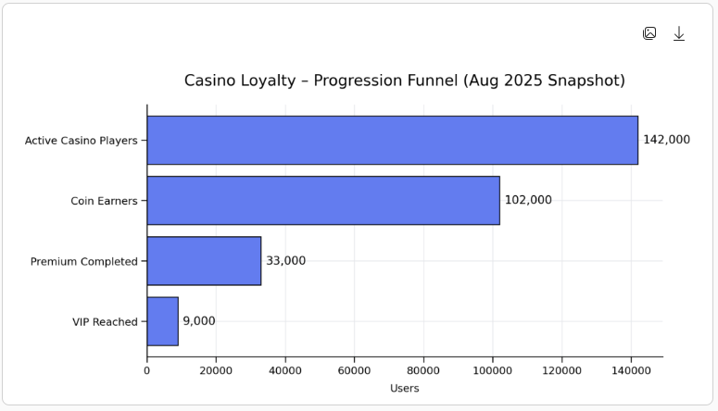
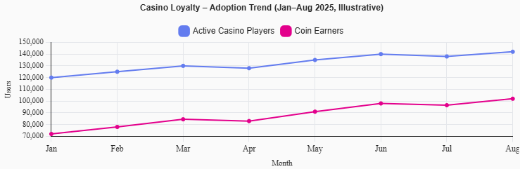
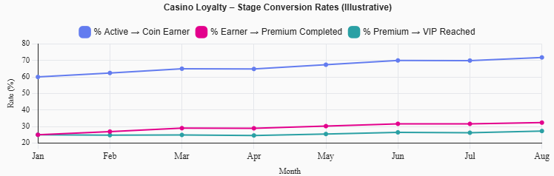
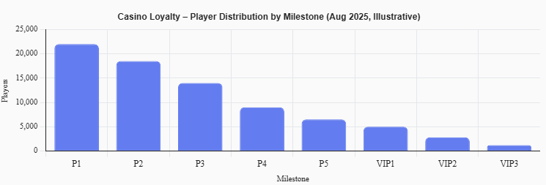

Question 4.- North Star Metric Framework
NSM: Monthly Active Casino Loyalty Users (players earning coins at least once per month).
Rationale: Captures sustained, value-creating engagement in a frictionless, activity-driven program and aligns with Premium→VIP retention design.
Secondary metrics (3–4): Premium completion rate, VIP monthly active users, avg coins per active user, retention lift vs non-loyalty users.
How to use it: Prioritize initiatives by expected NSM lift; diagnose drops via secondary metrics (e.g., low Premium completion → simplify milestones; flat VIP → improve VIP rewards/communication).

