Home Assignment: Product Manager
Question 1.- Google Analytics
Define what kind of events, kpis or funnels we can monitor, so we can extract valuable insights for the Product Team.
Answer
- Traffic & Discovery KPIs
  - Traffic by channel and platform (web, mobile web, app)
  - Entry points to the Offers Page (Gift icon, homepage, banners, deep links)
  - Number of clicks required to reach an offer
  - Peak and low traffic hours
  - Geographic distribution (country and region)
  - New users vs registered / returning users
- Engagement & Interaction Events
  - Time spent on the Offers Page
  - Time spent per screen or section
  - Scroll depth (top, middle, bottom of the landing page)
  - Clicks by section within the Offers Page
  - Clicks on banners and promotional tiles
  - Interactions within the Gift section (most-clicked icons or sections)
  - Use of search and filters to find offers
  - Video interactions (play, pause, completion)
- Offer Discovery & Selection KPIs
  - Click-through rate (CTR) per offer
  - Most viewed and most frequently selected offers
  - Least viewed or least selected offers
  - Search behavior (offers users actively look for)
  - Offer preferences by country or region
- Conversion & Funnel Metrics
  - Example funnel:
    - Landing on Offers Page
    - Clicking on an offer
    - Activating or accepting the offer
    - Starting a game or completing a key action
  - KPIs:
    - Conversion rate at each funnel step
    - Drop-off rate per stage
    - Time to complete the funnel
    - Offer activation rate
- Retention & Behavioral KPIs
  - Frequency of visits to the Offers Page
  - Returning users vs one-time visitors
  - Repeat offer activations
  - Engagement after offer activation
  - Relationship between offer visits and post-offer activity
- Buyer Journey Success Metrics
  - Metrics aligned to each stage of the buyer journey:
    - Awareness: Offers Page visits, entry point usage
    - Consideration: Offer clicks, time spent, scroll depth
    - Conversion: Offer activations, game starts
    - Retention: Return visits, repeat activations, ongoing engagement
- Product Insights Enabled
  - Identify how easily users find the Offers Page
  - Understand how users interact with offers
  - Detect friction points in the user journey
  - Identify top-performing and underperforming offers
  - Optimize offer strategy by platform, country, and region
Provide some reports, for illustrative reasons. (maybe using some random numbers)
Offers Page – Monthly Overview
- Total users: 120,000
- New users: 35%
- Returning users: 65%
- Sessions: 185,000
- Avg. sessions per user: 1.5
Top Entry Points:
- Gift icon: 48%
- Homepage banner: 27%
- Push / email deep links: 15%
- Other navigation paths: 10%
User Interaction on Offers Page
- Avg. time on page: 2m 35s
- Scroll depth:
  - Top section only: 22%
  - Mid-page: 46%
  - Bottom section: 32%
- Clicks per session: 3.4
Section Click Distribution:
- Featured offers: 42%
- Casino offers: 28%
- Sports offers: 18%
- Other promotions: 12%
Top Offers Performance
- Offer A (Free Spins):
  - CTR: 18%
  - Activations: 12,400
- Offer B (Deposit Bonus):
  - CTR: 14%
  - Activations: 9,100
- Offer C (Cashback):
  - CTR: 7%
  - Activations: 3,800
Offers Page Funnel
- Visits to Offers Page: 120,000
- Offer clicks: 54,000 (45% CTR)
- Offer activations: 26,000 (48% of clicks)
- Game starts after activation: 18,500 (71% of activations)
Post-Offer Behavior
- Users returning to Offers Page within 30 days: 41%
- Avg. visits per returning user: 3.2
- Users who activated an offer and returned to play: 68%
- Users who did not interact with offers and returned: 39%

What success looks like for this product? Can you explain?
- Users can easily find the Offers Page
- Users actively engage with available offers
- Offers convert into meaningful actions
- Engagement drives retention
- Product teams can continuously optimize using data
Success for the Offers Page is achieved when users can easily discover the page through key entry points and navigate it with minimal friction, while actively engaging with its content in a meaningful way. This is reflected in strong traffic penetration among active users, healthy time spent on the page, and deep interaction across multiple sections rather than just the top content. A successful Offers Page also demonstrates an efficient conversion funnel, where a significant portion of visitors progress from browsing offers to activating them and ultimately engaging in gameplay, with limited drop-off between each stage. Additionally, success depends on presenting relevant and high-performing offers tailored by user behavior, platform, country, or region, ensuring that the most valuable promotions drive the majority of activations. Finally, the product should contribute to long-term value by increasing retention, repeat visits, and post-offer engagement, while providing the Product Team with clear, measurable, and actionable insights that enable continuous optimization and data-driven decision-making.
Are there additional KPIs that, combined with your suggestions above, enhance our decision making strategy?
Yes, additional KPIs can further strengthen decision-making by adding context around efficiency, value, and long-term impact. Metrics such as time to offer activation and steps to complete activation help identify friction within the user journey. Offer effectiveness KPIs (e.g., activation rate and contribution by top offers) support better prioritization and visibility decisions. Behavioral and retention metrics—including post-offer engagement uplift and retention of offer users vs non-offer users—ensure that offers drive sustained value, not just short-term interaction. Finally, segmentation by platform, region, and user type, along with trend analysis over time, enables more targeted optimization and data-driven product decisions.

Question 2.- Data Analysis & Product Insights
Now, from a more product point of view, we want to evaluate how Sportsbook Missions, one of our most engaging mechanics, is performing.
This product aims to motivate players to place a bet and they will get rewarded regardless if they win or lose.
We bring 13-weeks data from Mexico.
- Create some reports where you can demonstrate your analytical thinking.
- How are Missions performing? Is there any pain point spotted from the data?
- Provide additional KPIs that can be explored to enhance our decision making strategy.
- What success looks like? Can you explain?
- Can you provide any product improvement based on your data?
- If you were responsible to consult the product team for next steps, what would you say?
- How would you respond if you were asked to drop the Missions product?
Answer
Conversion
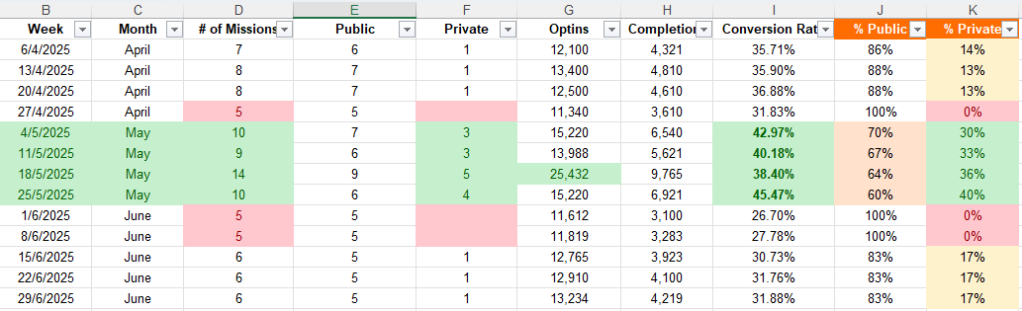
- May is the strongest month in terms of conversion.
May delivers the highest overall (weighted) conversion rate at ~41.3%, clearly outperforming April (~35.2%) and June (~29.9%). This indicates that user progression from Opt-ins → Completions was most efficient in May.
- Higher mission volume and a higher Private mix appear associated with better performance.
May has the highest average mission volume (~10.8 missions/week) and also the highest share of Private missions (about 35% of missions in May vs ~11% in April and June). This suggests that mission variety and/or more targeted Private missions may improve completion outcomes.
- A sharp performance drop happens right after May 25.
The best-performing week is 25/5/2025 with the highest conversion rate (45.47%) and the highest Private share (40% Private). Immediately after that, the week of 1/6/2025 shows the lowest conversion rate (26.70%), coinciding with (1) fewer total missions (5) and (2) zero Private missions (100% Public). This is a strong signal that something changed operationally or in product configuration starting in June.
- June maintains Opt-in volume but fails to convert users into completions at the same rate.
Even though June continues to generate solid Opt-in counts (roughly 11.6K–13.2K weekly), completions do not scale proportionally, keeping conversion low (~26.7%–31.9%). This points to a completion-stage issue (friction, difficulty, reduced perceived reward, or weaker mission relevance), rather than a discovery problem.
- April is stable but less optimized than May.
April conversion stays relatively steady around ~32%–37%, with mostly public missions (typically 86–100% Public). Performance is solid but May clearly show that introducing more missions and more Private missions correlates with stronger conversion.

Customer base
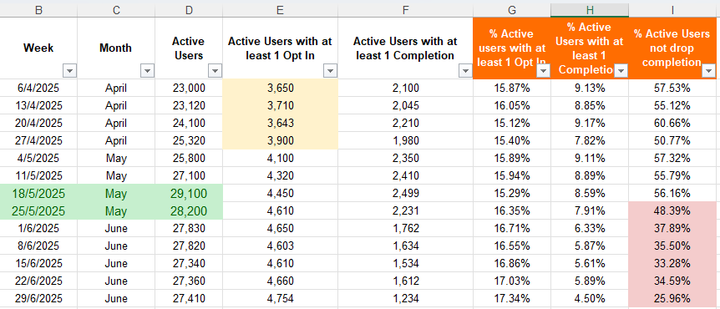
Although the percentage of Active Users with at least one Opt-In shows a steady increase over time, column I clearly indicates a declining trend in the % of Active Users who do not drop before completion. In other words, while more users are opting into Missions, a smaller proportion of them are completing at least one mission.
We can observe the highest peak of active users during the weeks of May 18, 2025 and May 25, 2025. However, starting from the week of May 25, 2025, there appears to be a noticeable shift in behavior, where users begin to drop off more frequently before completing at least one Opt-In, despite Opt-In participation continuing to grow.
An additional interesting insight is that from early June onward, the gap between Opt-In rate and Completion rate widens significantly. While the Opt-In rate increases from ~16% to over 17% by the end of June, the Completion rate drops from ~8–9% in April/May to as low as 4.5% by June 29, 2025. This suggests a potential increase in friction, complexity, or reduced perceived value in the completion stage rather than an issue with initial user motivation.
Overall, the data indicates that discovery and initial engagement remain strong, but there may be a structural or experiential issue introduced after late May that negatively impacts mission completion and should be further investigated.
Category
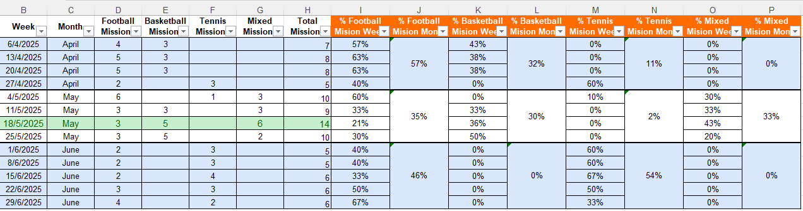
- Football is consistently the backbone of the Missions portfolio.
Across almost every week, Football Missions are present and often represent the largest share of weekly missions (e.g., 57–63% in early/mid April, and up to 67% on 29/6/2025). This suggests Football is the most stable category and likely the safest driver of mission supply and engagement.
- April shows a Football + Basketball-dominant strategy, with limited variety.
In April, missions are heavily concentrated in Football and Basketball (e.g., 6/4: 4 Football + 3 Basketball, 13/4 and 20/4: 5 Football + 3 Basketball). Tennis only appears meaningfully on 27/4/2025 (3 Tennis missions, 60% of that week), indicating Tennis was not consistently part of the weekly mix in April.
- May is the most diverse month and includes the highest weekly mission volume.
May introduces Mixed Missions and shows the broadest variety of mission types. It also includes the highest total missions observed: 14 missions on 18/5/2025 (3 Football, 5 Basketball, 6 Mixed). This week stands out as the peak in mission supply and shows a shift from single-sport missions toward more diversified mechanics.
- Mixed Missions become a major component in May, suggesting an experiment or strategic push.
Mixed Missions represent a significant weekly share in May (e.g., 30% on 4/5, 33% on 11/5, 43% on 18/5). On a monthly basis (as per the table), May appears relatively balanced: Football 35%, Basketball 30%, Mixed 33%, and Tennis only 2%—meaning Tennis is almost absent in May, while Mixed Missions are strategically emphasized.
- June shifts dramatically: Basketball and Mixed Missions drop to zero, and Tennis becomes dominant.
Starting in June, the portfolio becomes much narrower: only Football and Tennis missions remain. Tennis takes the majority share in most weeks (e.g., 1/6: Tennis 60%, 15/6: Tennis 67%, 22/6: Tennis 50%). The monthly split also reflects this: Football 46% vs Tennis 54% in June. This sharp change strongly suggests either a content/seasonality decision, an operational constraint, or a strategic refocus.
- Mission volume declines after May’s peak and stabilizes lower in June.
After the May peak (14 missions on 18/5), total missions in June stabilize at 5–6 per week, which is noticeably lower than mid-May. This could reduce variety and user excitement, especially if engagement depends on having multiple mission options and categories.
General conclusion
Based on the observed data, several product improvements can be proposed:
- Reintroduce and optimize Private Missions
Periods with a higher share of Private Missions (especially in May, reaching up to 40%) consistently show higher conversion rates (peaking at 45.47%). Private Missions appear to be more relevant or achievable for users and should be expanded with clearer targeting and personalization.
- Increase mission variety and weekly volume
Weeks with a higher number of missions (9–14 missions per week) outperform weeks with limited content (5–6 missions). A broader mission catalog likely reduces fatigue and increases the chance that users find a mission that fits their behavior.
- Reduce friction in the completion stage
Opt-in volumes remain strong even when conversion drops (especially in June), suggesting that the main issue is not discovery, but difficulty, complexity, or perceived effort at the completion stage. Simplifying requirements, improving progress visibility, or adjusting reward thresholds could improve completion rates.
- Maintain a balanced Public vs Private mix
A mix closer to 60–70% Public and 30–40% Private appears to be optimal. Weeks with 100% Public missions consistently underperform in conversion.
If responsible for advising the Product Team, I would recommend the following next steps:
- Run controlled experiments (A/B tests)
Test different mission mixes:
  - High vs low Private Mission share
  - High vs low mission volume
  - Simplified vs more complex mission criteria
- Investigate the structural change after May 25
Conversion drops sharply starting June 1. This timing strongly suggests a configuration, content, or operational change. Identifying what changed (reward value, mission difficulty, sport mix, or UI) should be a top priority.
- Segment performance by user type
Analyze new vs returning users, high-value vs casual players, and frequent vs infrequent mission participants to better tailor mission design.
- Align mission strategy with calendar and seasonality
Sports availability, leagues, and major events likely influence mission appeal. Mission planning should better reflect the sports calendar to maintain relevance.
I would not recommend dropping the Missions product based on the data.
Instead, I would respond as follows:
- The product demonstrates strong potential, with conversion rates exceeding 45% at peak performance.
- Poor performance in June is not structural, but correlates strongly with:
  - Reduced mission volume
  - Elimination of Private Missions
  - Lower content diversity
- Missions continue to generate high Opt-in volumes, which confirms that users are interested and motivated to engage.
- The data suggests that execution and configuration, not product relevance, are the root causes of underperformance.
Recommendation:
Rather than dropping the product, Missions should be optimized, simplified, and better balanced, with a renewed focus on Private Missions, mission variety, and completion usability. Dropping the product would risk losing an engagement mechanic that has already proven its value under the right conditions.

Question 3.- How to?
Answer
In Novibet, we launched a Casino Loyalty program in January 2025.
It is a way of rewarding our players, whenever they launch and play a game.
There is no requirement for the player (like opt-in) - he/she instantly receives coins based on their
activity.
The player starts with 0 coins and there is no competition among the players.
These coins can be automatically redeemed based on the below tables.
The “Premium” is a one-off stage; the player receives rewards as soon as a milestone is reached.
The “VIP” is a monthly recurring stage; the player receives rewards by the end of month, based on
his/her highest milestone achieved during each month.
The player will complete the “Premium” stage, before moving to the “VIP” stage.

The Product Analytics team has been requested to assess if the Casino Loyalty program is
successful or not, until now (End of August 2025).
You are responsible to compile a concrete analysis depicting the as is performance of this casino
loyalty.
How would you frame the analysis?
I would frame the analysis around adoption, engagement, progression, and retention, focusing on how players interact with the Casino Loyalty program from launch to maturity.
The analysis would be structured in four main dimensions:
- Program Adoption
  - How many players are participating in the loyalty program?
  - How quickly do players start earning coins after launch?
  - Share of active casino players earning coins vs total casino player base.
- Engagement & Progression
  - Average coins earned per user over time.
  - Distribution of players across milestones.
  - Time required to complete the Premium stage.
  - Progression rate from Premium to VIP.
- Reward Effectiveness
  - Redemption rate of coins.
  - Time between coin earning and redemption.
  - Comparison of behavior before and after reward milestones.
- Retention & Behavioral Impact
  - Retention of loyalty users vs non‑loyalty users.
  - Increase in play frequency and session depth after entering the program.
  - Monthly engagement consistency within the VIP stage.
This structure allows us to assess not only whether the program is being used, but also whether it is driving meaningful and sustained player behavior.
Explain the perimeter of your analysis e.g. time period, customer segment, etc
The perimeter of the analysis would be clearly defined to ensure consistency and relevance:
- Time period
  - January 2025 (program launch) through end of August 2025.
  - Monthly and cumulative views to capture early adoption and medium-term trends.
- Customer segments
  - Active Casino players during the analysis period.
  - Segmentation by:
    - New vs existing players at the time of program launch.
    - Players who completed Premium vs those who did not.
    - Players who reached VIP vs those who remained in earlier stages.
- Scope
  - Casino activity only (excluding sportsbook).
  - Loyalty interactions including:
    - Coin earning
    - Milestone progression
    - Reward redemption
- Exclusions
  - No competitive comparison between players (as the program is non-competitive).
  - No deep focus on exact coin values, per the assignment guidance.

This perimeter ensures the analysis reflects the real behavioral impact of the loyalty program within its intended ecosystem.
Feel free to provide any visuals, if necessary.
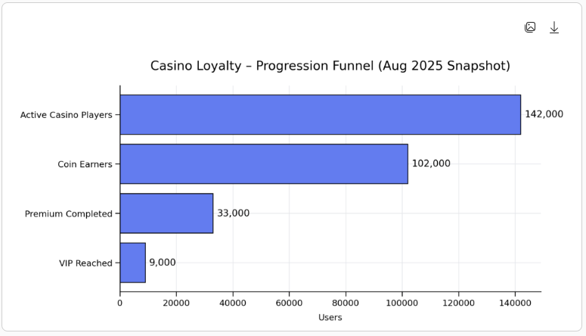
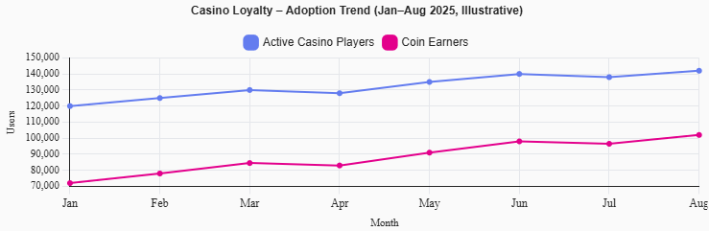
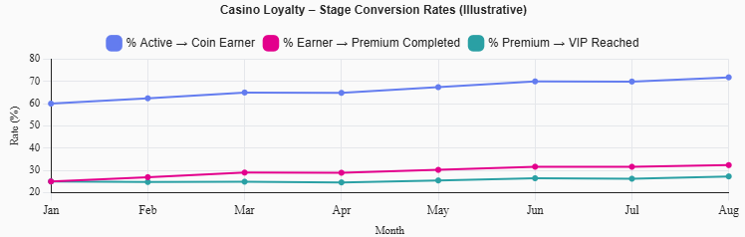
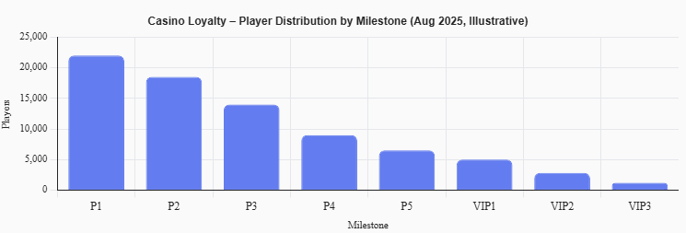

Question 4.- North Star Metric Framework
The way we evaluate the performance of our products is through the NSM framework.
NSM stands for North Star Metric; we can have multiple metrics to evaluate a product, but you need to
choose one metric that best reflects whether the product is truly growing and delivering value.
- Propose a NSM for one of the above mentioned products (Offers Page, Sportsbook Missions,
Casino Loyalty)
- Explain your rationale and for choosing this metric
- Identify 3-4 additional, secondary metrics that can either influence the NSM or cover another
dimension of success for the product
- Describe the way you can actually use this NSM framework to guide product decisions and
prioritize initiatives.

Monthly Active Casino Loyalty Users (players earning coins in a given month)
Rationale for Choosing This Metric
Monthly Active Loyalty Users is the most appropriate North Star Metric for the Casino Loyalty program because it directly reflects whether the product is delivering continuous value and driving habitual engagement, which are the core objectives of any loyalty system.
The Casino Loyalty program is intentionally designed to be:
- Frictionless (no opt‑in required),
- Activity‑driven (coins earned automatically through gameplay),
- Progressive (clear journey from Premium to VIP),
- Retention‑focused (recurring monthly rewards in the VIP stage).

Tracking how many players actively earn coins each month confirms that users understand the program, consistently engage with casino games, and are motivated to return over time. Unlike vanity metrics such as total registered users, this NSM captures ongoing, value‑creating usage, making it a reliable indicator of real and sustainable product growth.

Secondary Metrics Supporting the NSM
To complement the North Star Metric and provide a broader view of success, the following secondary metrics should be tracked:
- Premium Completion Rate
Measures how many coin earners complete the initial Premium stage, indicating whether early progression is achievable, motivating, and well‑designed. This metric strongly influences long‑term retention and transition into VIP.
- VIP Monthly Active Users
Tracks the number of players actively participating in the VIP stage, reflecting depth of loyalty and validating the recurring value of the program.
- Average Coins Earned per Active Loyalty User
Indicates engagement intensity and gameplay frequency, helping distinguish between passive participation and meaningful progression.
- Retention Lift (Loyalty vs Non‑Loyalty Users)
Compares retention rates between loyalty participants and non‑participants to demonstrate the incremental value generated by the program.
These metrics either directly influence the NSM or explain the drivers behind its movement.

How the NSM Framework Guides Product Decisions
The NSM framework enables the Product Team to make focused, data‑driven decisions by evaluating every initiative against a single guiding question:
“Will this increase Monthly Active Loyalty Users?”
- If the NSM declines, the team investigates discovery, reward clarity, or perceived value.
- If Premium completion is low, milestones can be simplified or thresholds rebalanced.
- If VIP participation stagnates, reward attractiveness or communication cadence can be optimized.
- If engagement intensity drops, incentives or progression boosters can be introduced.
This approach ensures that roadmap prioritization, experimentation, and UX improvements are consistently aligned with long‑term player value.

