**ATM – Automated Teller Machine**



***IN THE PARTIAL FULFILLMENT FOR THE AWARD***

***OF THE DEGREE OF***

***BACHELOR’S OF COMPUTER APPLICATIONS***

***(2019-2020)***

**SHRI GURU GOBIND SINGH COLLEGE**

**SECTOR 26, CHANDIGARH**

 

**SUBMITTED TO: SUBMITTED BY:**

**Mrs. Garima Atul Joshi (17048593)**

**Mrs. Vikramjeet Kaur**

**Acknowledgement**

It is a great pleasure for me to acknowledge all those who have contributed towards the conception, origin and nurturing of this project that is on System analysis the **“ATM-Automated Teller Machine”**.

The way can’t walk itself. We have to walk on it. For that we must have a guide. Here, I would like to place on record my grateful thanks to each one of them who help us in this project.

Before I get into thick of the thing, I would like to add a few heartfelt words for the people who gave me unending time support whichever and whenever necessary.

My grateful thanks go to our Dept., which provides us an opportunity as a project subject in **6­th­ Semester** to develop a report work skill in this System analysing.

I would like to thank my parents & friends for giving me full feedback when I was in trouble. My special thanks go to **Mr. Chaman Bhardwaj** to give their expert guidance to me whenever necessary.

Last but not the least; I heartily thanks to my teachers **Mrs. Garima** & **Mrs. Vikramjeet Kaur**.

**SHRI GURU GOBIND SINGH COLLEGE**

**SECTOR 26, CHANDIGARH**

**CERTIFICATE**

This is to certify that the project has been submitted by **Mr. Atul Joshi (17048593)** pursuing BCA (6th semester) at SGGS-26 Chandigarh, under took a project entitled “ATM-Automated Teller Machine” which is a record of Bonafide work carried out by him under my supervision. In my knowledge, this work has not been submitted, either in part or in full, to any other University or Institute for the award of degree. He had submitted the report in time. He had done good work and have fulfilled all the requirements.

Date: Dept. of Computer Science

**Mrs. Garima**

**Mrs. Vikramjeet Kaur**

**Index of ATM**

|  |  |  |  |
| --- | --- | --- | --- |
| S. No. | Topic | Page No. | Signature |
| 1 | Introduction | 5 |  |
| 2 | Requirement | 6 |  |
| 3 | Implementation | 7-9 |  |
| 4 | Advantages & Disadvantages | 10 |  |
| 5 | Features | 11 |  |
| 6 | Working | 11-12 |  |
| 7 | Diagrams | 12-13 |  |
| 8 | Outputs | 14-18 |  |

**Introduction**

An ATM (Automated Teller Machine) is a computerized telecommunications device that provides the clients of a financial institution with access to financial transactions in a public space without the need for a cashier, human clerk or bank teller. On most modern ATMs, the customer is identified by inserting a plastic ATM card with a magnetic stripe or a plastic smart card with a chip that contains a unique card number and some security information such as an expiration date. Authentication is provided by the customer entering a personal identification number (PIN). Using an ATM, customers can access their bank accounts:

1. To make cash withdrawals

2. Check their account balances

3. Exchange rate for foreign travellers.

**Example**- If the currency being withdrawn from the ATM is different from that which the bank account is denominated in (e.g.: Withdrawing Japanese Yen from a bank account containing US Dollars), the money will be converted at a wholesale exchange rate. Thus, ATMs often provide the best possible exchange rate for foreign travellers and are heavily used for this purpose as well.

**Requirement**

**Software Requirement:**

* **Operating System:** MicrosoftWindows 10 (64-Bits, With .Net Framework v4.7.2)
* **Front End:** Visual Studio 2019
* **Back End:** Microsoft Access 2019

**Hardware Requirement:**

* **Minimum:**

1. **Processor:** 1.8 GHz Quad-Core
2. **Ram:** 2 GB
3. **HDD or SSD­­*­­­­­­­­­:** 800 MB

* **Maximum:**

1. **Processor:** More than 1.8 GHz Quad-Core
2. **Ram:** Upto 8 GB
3. **HDD or SSD­­­­­­*­­­­­­­­:** Upto 20-30 GB
4. **Video Card:** 720p

SDD­*­­­­­­­: For better performance.

**Implementation**

**Form 1 (Welcome):**

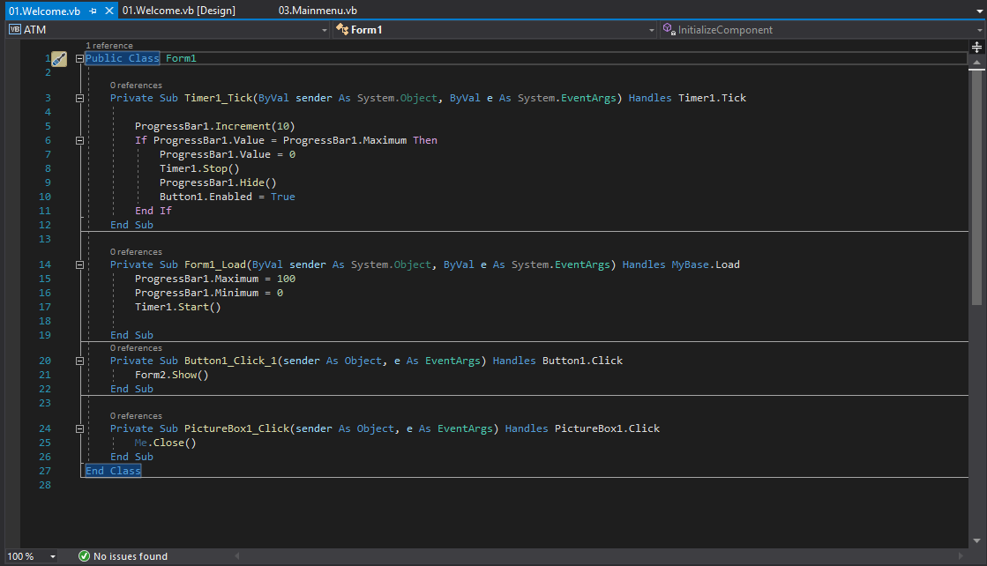

**Form2 (EnterPin):**

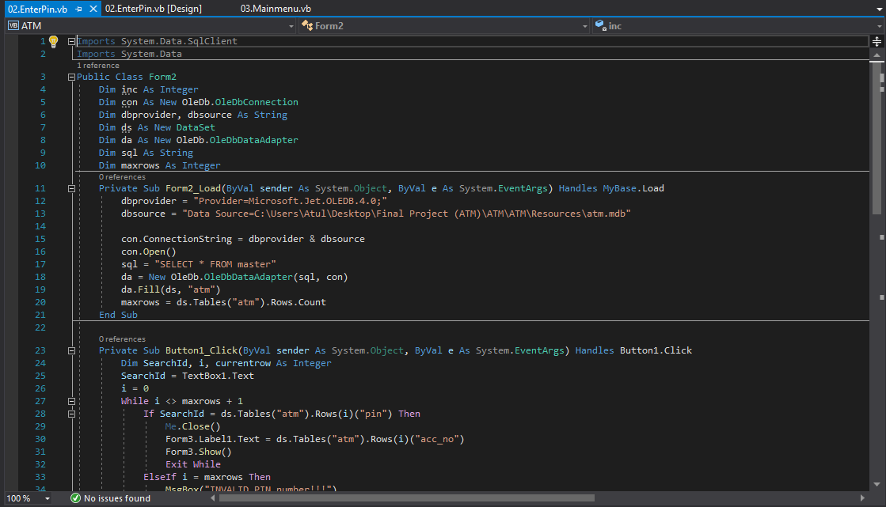

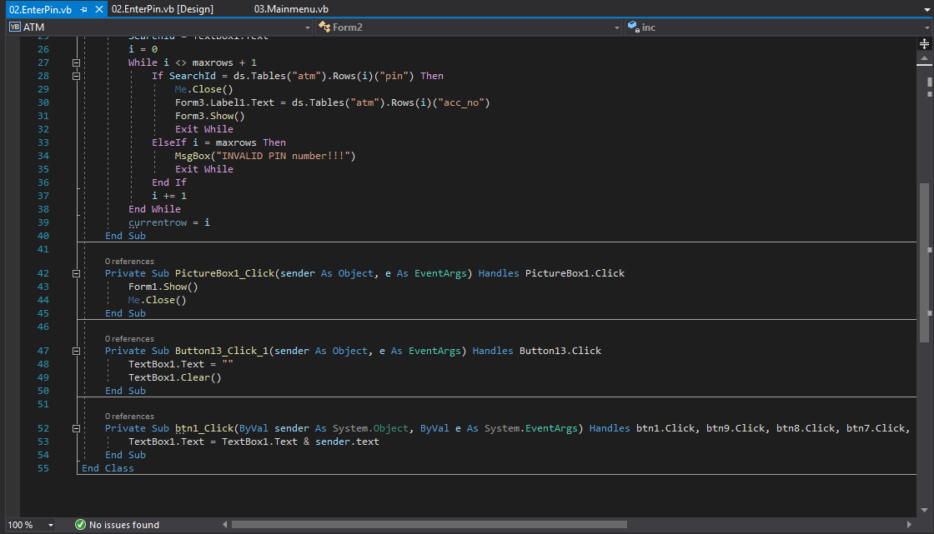

**Form3 (Main-Menu):**

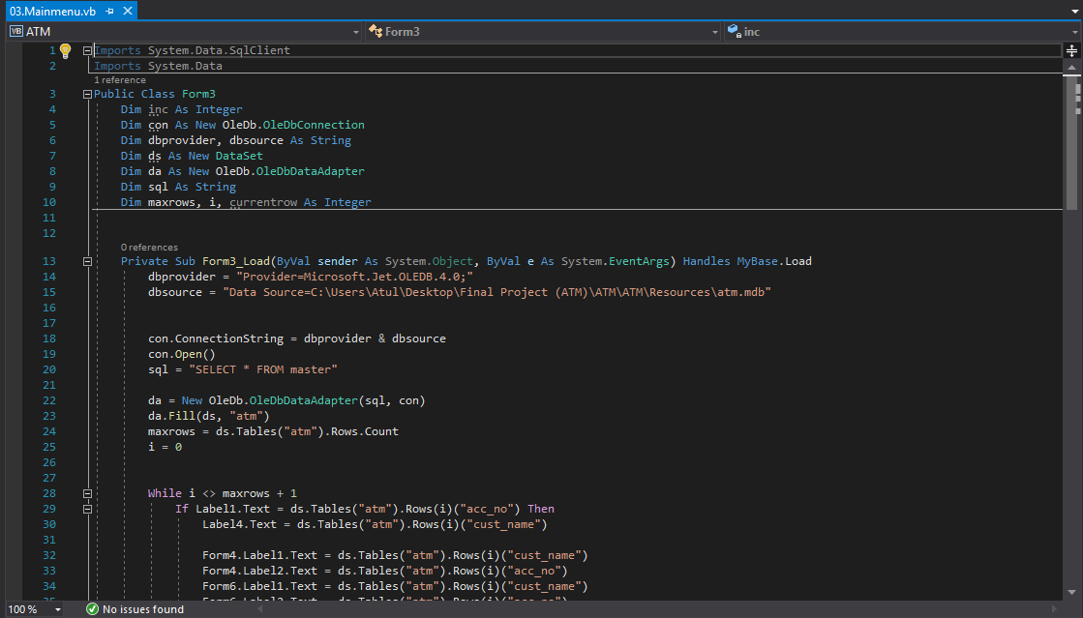

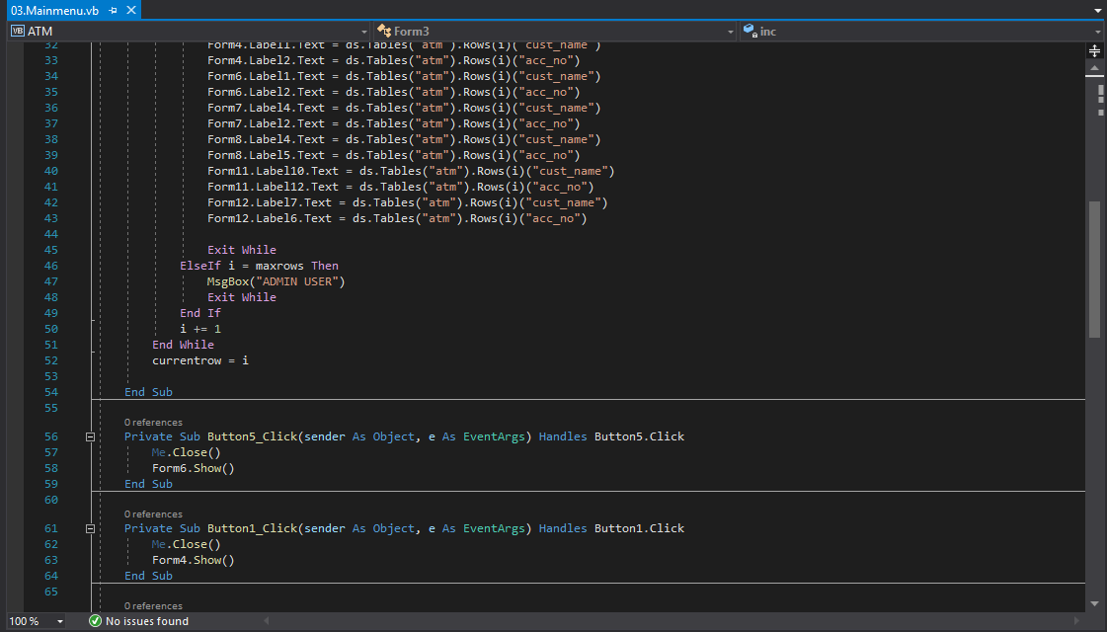

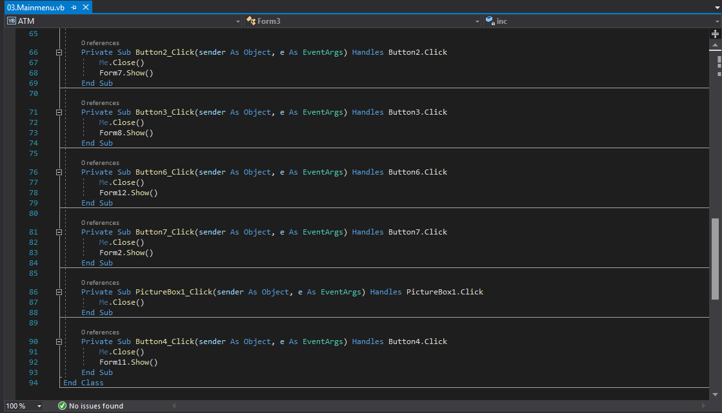

**Advantages & Disadvantages**

**Advantage:**

* You don’t have to carry cash around with you.
* You can withdraw cash at any time, day or night. The banks don’t need to be open.
* ATMs offer the convenience of multiple locations. You can withdraw cash at any bank that is part of the system to which your ATM card is linked.
* Your ATM card is protected by a PIN, keeping your money safe.
* You don’t need to fill out withdrawal and deposit slips as is required at the bank.
* ATMs are faster than going to the bank—no long lines.
* You can withdraw cash at ATMs in foreign countries.

**Disadvantage:**

* ATM may be off-line (system down).
* If you forget your PIN number you cannot use the card.
* Risk of robbery when you leave the ATM.
* The ATM can break down or run out of cash.
* Fees charged to use ATMs of other banks can become expensive.

**Features**

* Transfer funds between linked bank accounts
* Receive account balance
* Prints recent transactions list
* Change your pin
* Deposit your cash
* Prepaid mobile recharge
* Bill payments
* Cash withdrawal
* Perform a range of features in your foreign language.

**Working**

The automated teller machine is simply a data terminal with two inputs and four output devices. These devices are interfaced with the processor. The processor is the heart of the ATM. All the ATMs working around the world are based on a centralized database system. The ATM has to connect and communicate with the host processor (server). The host processor is communicating with the internet service provider (ISP). It is the gateway through all the ATM networks available to the cardholder.

When a cardholder wants does an ATM transaction, the user provides necessary information through card reader and keypad. The ATM forwards this information to the host processor. The host processor enters the transaction request to the cardholder bank. If the cardholder requests the cash, the host processor takes the cash from the

cardholder account. Once the funds are transferred from the customer account to the host processor bank account, the processor sends the approval code to the ATM and the authorized machine to dispense the cash. This is the way to get the amount on ATMs. The ATM network is fully based on a centralized database environment. This will make life easier and secure the cash.

**Diagrams**

**Block Diagram:**

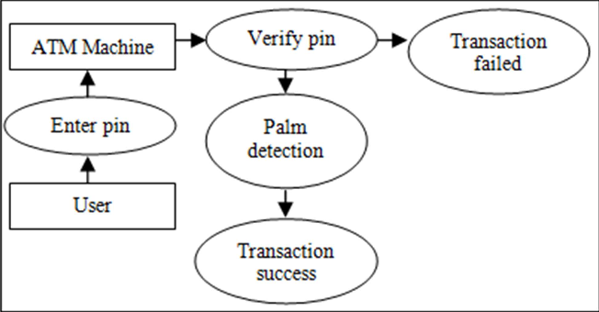

**Flow Chart:**

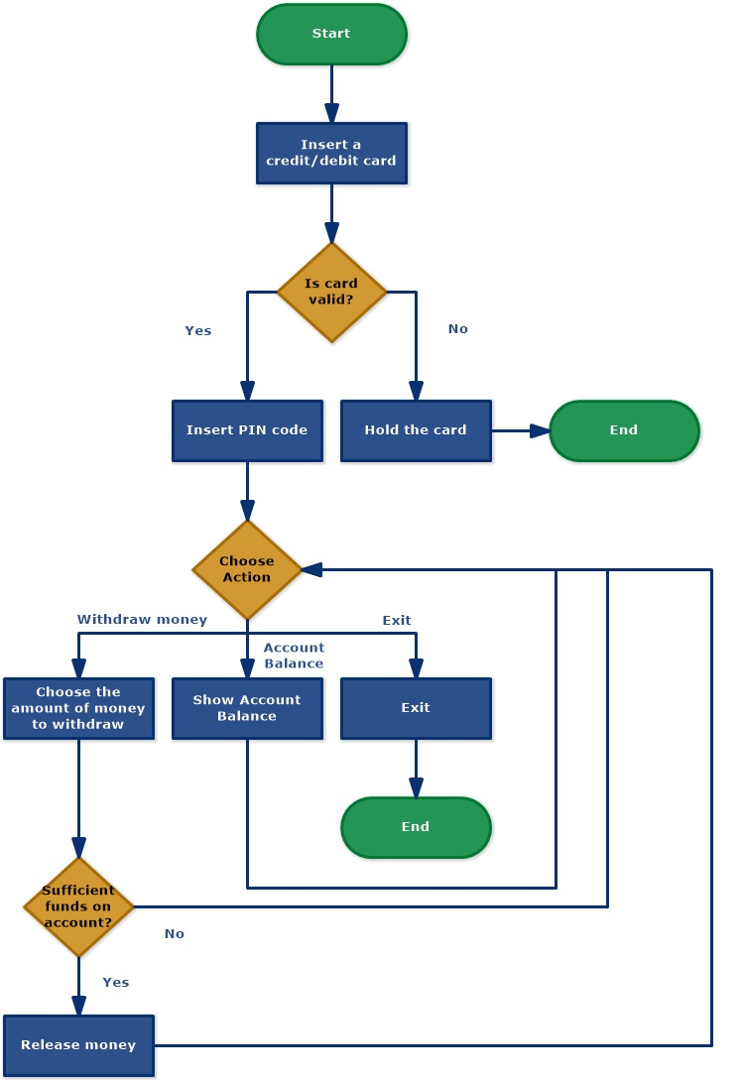

**Front-End Outputs**

**Form 1 (Welcome):**

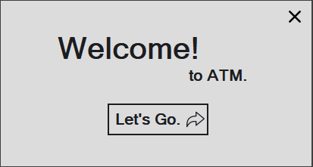

**Form 2 (Enter Pin):**

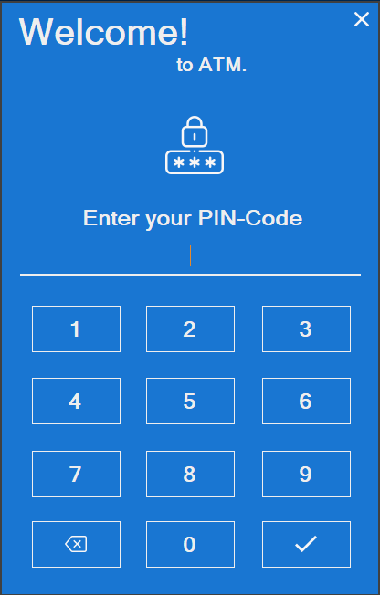

**Form 3 (Main-Menu):**

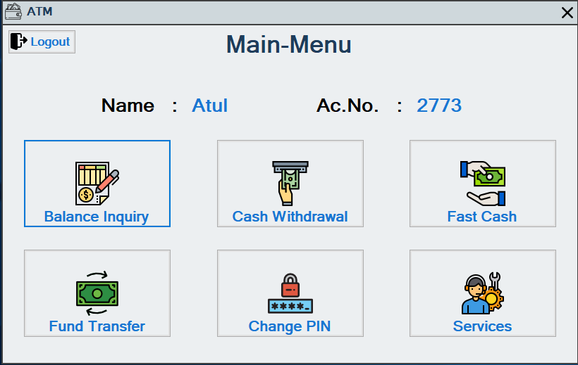

**Form 11 (Balance Enquiry):**

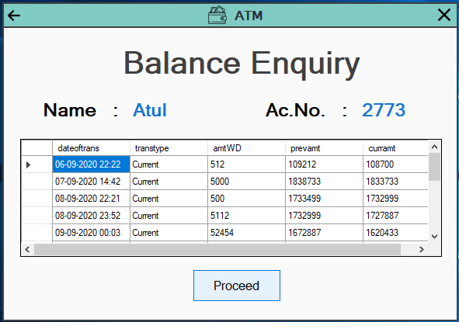

**Form 5 (Cash Withdrawal):**

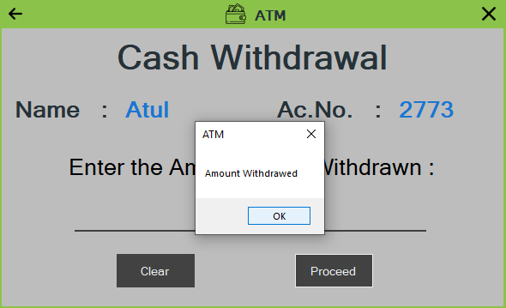

**Form 7 (Fast Cash):**

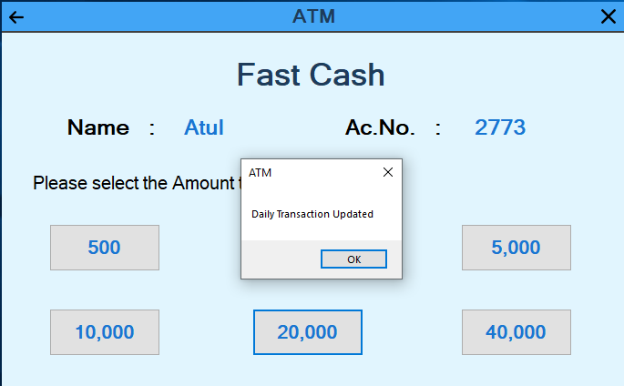

**Form 10 (Fund Transfer):**

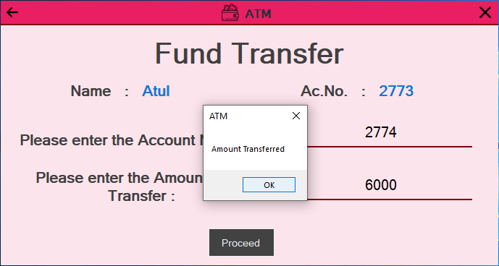

**Form 6 (Change PIN):**

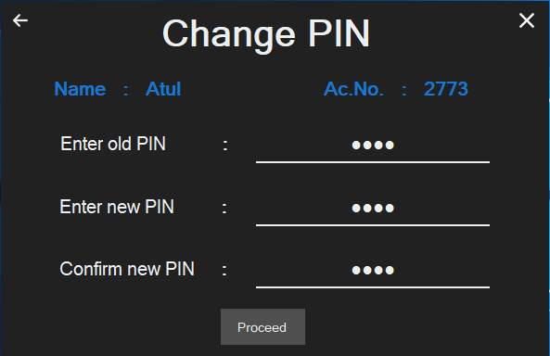

**Form 12 (Services):**

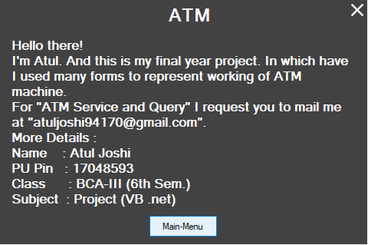

**Back-End Outputs**

**Database 1 (Dailytrans):**

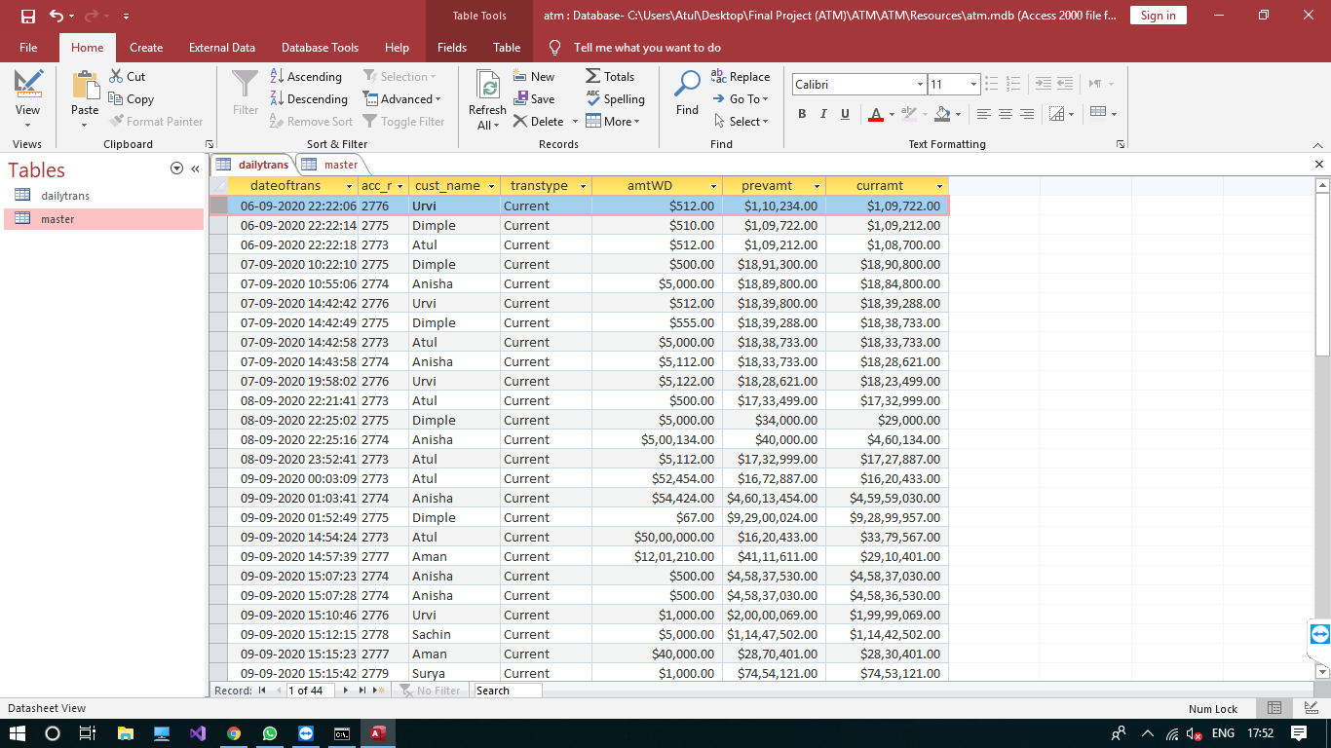

**Database 2 (Master):**

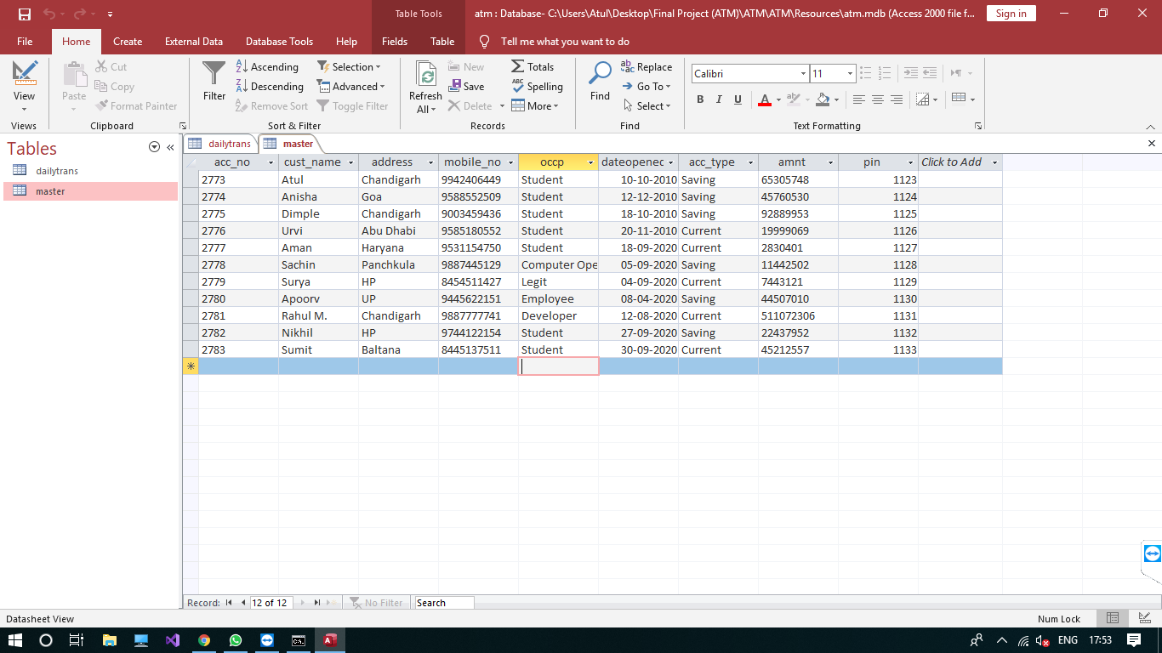

**THANK YOU**