**AN INTERNSHIP REPORT**

**submitted in partial fulfilment of the requirements for the Award of Degree of**

**BACHELOR OF TECHNOLOGY**

**in**

**ELECTRONICS AND COMMUNICATION ENGINEERING**

**on**

**VLSI SoC DESIGN USING VERILOG HDL**

**at**

**MAVEN SILICON**

**SUBMITTED BY:** AMISH VERMA

(ROLL NO. 2000910310033 )

**MENTOR:** Dr. B. P. MISHRA

***Internship Duration: 14 October, 2022 - 10 November, 2022***



**DEPARTMENT OF ELECTRONICS AND COMMUNICATION**

**ENGINEERING**

JSS ACADEMY OF TECHNICAL EDUCATION

C-20/1 SECTOR-62, NOIDA 2021- 2022

# CERTIFICATE

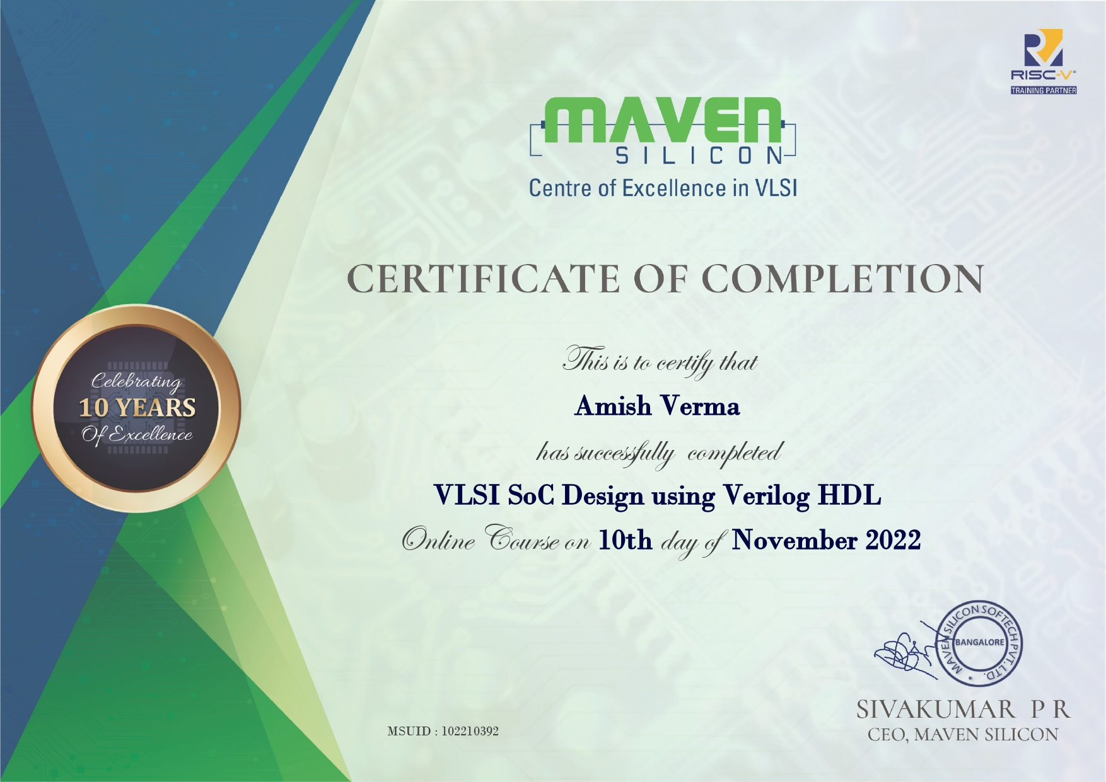

**TABLE OF CONTENTS**

PAGE NO.

INTERNSHIP CERTIFICATE 2

ACKNOWLEDGEMENT 4

LIST OF FIGURES AND TABLES 5

ABSTRACT 6

CHAPTER 1: INTRODUCTION 7 - 12

CHAPTER 2: ABOUT THE INTERNSHIP 13 - 20

CHAPTER 3: WHAT I HAVE LEARNED 21 - 24

CHAPTER 4: CONCLUSION 25

REFERENCES 26 - 27

# ACKNOWLEDGEMENT

Firstly, I would like to thank Dr. BP Mishra Sir for being a great mentor throughout this internship duration. It is because of him that I got the chance to complete this internship. He introduced me to Utpal Sir, who is a pass-out from the IT branch of our college, JSSATE, Noida. Utpal Sir directed me towards the Forage website where I found this virtual

internship, and for that I am forever grateful.

I would also like to thank my brother, Anshul Verma for his continued support throughout the period of my internship and helping me every time I got stuck at a task (which was quite

often).

Next up, I would like to thank Akruti Agarwal, our team leader, for her constant support

throughout the internship and being a fantastic team leader.

AMISH VERMA

(2000910310033)

# LIST OF FIGURES AND TABLES

**FIGURES:**

|  |  |  |
| --- | --- | --- |
| **S. No.** | **Title of the figure** | **Page No.** |
| 1. | Fig. 1.1 - The six-step Data Analysis process taught by Google | 12 |
| 2. | Fig. 2.1 - Logo of The Forage | 14 |
| 3. | Fig. 2.2 - Logo of KPMG | 14 |
| 4. | Fig. 2.3 - Customer tiers based on RFM Class | 18 |
| 5. | Fig. 2.4 - Breakup of Top 1000 Customers | 20 |

**TABLES:**

|  |  |  |
| --- | --- | --- |
| **S. No.** | **Title of the table** | **Page No.** |
| 1. | Table 1.1 - Skills required for a data analyst and a data scientist | 8 |
| 2. | Table 1.2 - Overlaps and distinctions between three job titles | 10 |
| 3. | Table 2.1 - Data quality issues found in the first task | 16 |
| 4. | Table 2.2 - Customer Segments on the basis of RFM Score | 19 |

# ABSTRACT

Data is everywhere. With the technological advancements and better connectivity in the whole world, the amount of data being generated is huge. To make sense of this data and

draw conclusions that lead to better decision making is what data analytics is all about.

KPMG Data Analytics Virtual Experience Program is created by KPMG and provided for free via The Forage. It’s main goal is to provide a virtual experience of how the data analytics division of KPMG works, by giving a real task handled by the personnel at KPMG. Anyone can complete the program and enhance their data analytics skills and get a look at the

work done in KPMG.

This report outlines the tasks completed by me from 6 October, 2021 to 17 January, 2022, as a part of KPMG Data Analytics Virtual Experience Program provided by The Forage. I will give a brief overview of the Data Analytics process and the jobs associated with this field before moving on to the detailed description of the three tasks that I completed - 1. Data Quality Assessment, 2. Data Insights, and 3. Data Insights and Presentation,

followed by an overview of everything that I learned during this period.

This program was a great opportunity for me to explore the vast world of data and its manipulation to get valuable insights. I would highly recommend this program to anyone

interested in the field of data analytics.

**Chapter 1**

## INTRODUCTION

Every day, the amount of data out there gets bigger and bigger. So the ability to interpret it effectively is more important than ever before. Data analytics is becoming one of the fastest-growing and most rewarding career choices in the world. In the next decade, the demand for business analytics skills will probably be higher than the demand for any other career (10.9% vs. 5.2%) (Source: Bureau of Labor Statistics). All kinds of companies all over the world need qualified data analysts to solve problems and help them make the best

possible business decisions. And right now, fifty-nine percent of companies have plans to add

even more positions requiring data analysis skills (Source: SHRM).

**1.1 WHAT IS DATA ANALYTICS?**

Data analytics is the process of exploring and analyzing large datasets to find hidden patterns, unseen trends, discover correlations, and derive valuable insights to make business

predictions [1].

**1.2 HOW IS DATA ANALYTICS DIFFERENT FROM DATA ANALYSIS?**

It is very confusing to spot the difference between both the terms, “data analytics” and “data analysis” because they almost sound as if they are the same thing. But there is a

difference.

Data analysis can be thought of as a slice of big pie which is Data analytics. The main goal of data analytics is to explore datasets to derive informed decision-making. That process may involve various steps - from asking the right questions to finally presenting a solution. Sometimes, there might not even be a solution. The path to reach that end-point, whether we conclude with the fact that we have the solution or not, involves data analysis. In Data analysis, we try to make sense of the data that is given to us by modelling it to our needs. Now, it must be said that both the terms do not have a fixed definition as are sometimes used interchangeably, even by industry professionals. Also, different organizations have different needs for different data so it is hard to provide the exact difference between these two terms. Sometimes, they might even overlap. The main thing though, is to understand the process through which data goes to give us a meaning. Throughout this report, I have used the term “data analysis” even where “data analytics” could have been more appropriate. This is because data analysis is a much more familiar term and is used more commonly than data

analytics.

### 1.3 DATA ANALYTICS AND DATA SCIENCE

We can differentiate between data analytics and data science by examining what the industry professionals related to these two fields, namely data analysts and data scientists, do

with data. It must be noted here that there might also be some deviations as to what a data analyst and a data scientist’s job is. Usually these deviations are dependent on the organization these professionals are working for. Thus, we are talking in general terms when

we say data analyst and a data scientist.

Data analysts typically work with structured data to solve tangible business problems using tools like SQL, R or Python programming languages, data visualization software, and

statistical analysis [2].

Data scientists often deal with the unknown by using more advanced data techniques to make predictions about the future. They might automate their own machine learning algorithms or design predictive modeling processes that can handle both structured and

unstructured data [2].

Table 1.1 - Skills required for a data analyst and a data scientist [2]

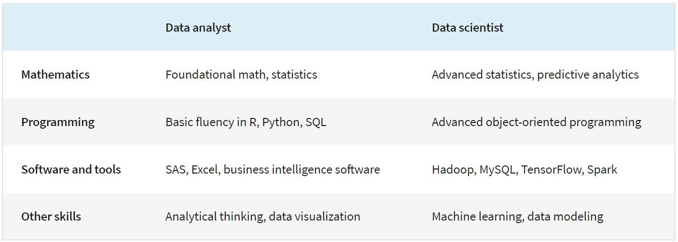

### 1.2 VARIOUS JOB ROLES ASSOCIATED WITH DATA ANALYSIS

The data analyst role is one of many job titles that contain the word “analyst.” To name a few

others that sound similar but may not be the same role [3]:

* **Business analyst** — analyzes data to help businesses improve processes,

products, or services

* **Data analytics consultant** — analyzes the systems and models for using data
* **Data engineer** — prepares and integrates data from different sources for

analytical use

* **Data scientist** — uses expert skills in technology and social science to find

trends through data analysis

* **Data specialist** — organizes or converts data for use in databases or software

systems

* **Operations analyst** — analyzes data to assess the performance of business

operations and workflows

Data analysts, data scientists, and data specialists sound very similar but focus on different tasks. In fact, sometimes companies’ job descriptions seem to combine these roles or look for candidates who may have overlapping skills. Thus, it is very important to look closely at the job description even if we’re familiar with the job title, to see if our skills match the ones

required for the job.

Table 1.2 [3] illustrates some of the overlap and distinctions between three job titles*.

*In Table 1.2 [3], we used the role of data specialist as one example of many specializations within data analytics, but specializations can take a number of different turns. For example,

one can specialize in developing data visualizations and likewise go very deep into that area.

#### Job specializations by industry

We saw that the data specialist role concentrates on in-depth knowledge of databases. In similar fashion, other specialist roles for data analysts can focus on in-depth knowledge of specific industries. For example, in a job as a business analyst one might wear some different hats than in a more general position as a data analyst. As a business analyst, one would likely collaborate with managers, share one’s data findings, and maybe explain how a small change in the company’s project management system could save the company 3% each quarter. Although one would still be working with data all the time, you would focus on using the

data to improve business operations, efficiencies, or the bottom line.

Table 1.2 - Overlaps and distinctions between three job titles [3]

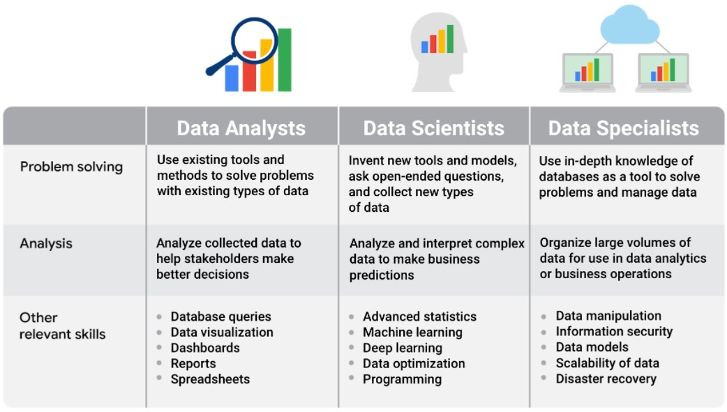

Other industry-specific specialist positions that we might come across in our data analyst job

search include [3]:

* **Marketing analyst** — analyzes market conditions to assess the potential sales of

products and services

* **HR/payroll analyst** — analyzes payroll data for inefficiencies and errors
* **Financial analyst** — analyzes financial status by collecting, monitoring, and

reviewing data

* **Risk analyst** — analyzes financial documents, economic conditions, and client data to help companies determine the level of risk involved in making a

particular business decision

* **Healthcare analyst** — analyzes medical data to improve the business aspect of

hospitals and medical facilities

Key takeaway from all of this is that the job of a data analyst varies widely with industry and

organization needs. So one must clearly read the job description before applying for a job.

### 1.3 PHASES OF DATA ANALYSIS

While the data analysis process is well known among experts, there isn't a single defined structure of those phases. There might not be one single architecture that’s uniformly followed by every data analysis expert, but there are some shared fundamentals in every data

analysis process. Generally, all the data analysis processes involve roughly four steps -

1. Data Collection
2. Data Cleaning
3. Data Analysis, and
4. Data Visualization

From our journey to the pyramids and data in ancient Egypt to now, the way we

analyze data has evolved (and continues to do so). The data analysis process is like real life architecture, there are different ways to do things but the same core ideas still appear in each

model of the process.

The key takeaway from all of that is this - even though the exact path taken in the data analysis process might be different, all of them go through some of the same general steps,

and the ultimate goal of data analysis is to help organizations make better business decisions.

Analysts use data-driven decision-making and follow a step-by-step process. Here is a

six-step path that Google teaches in its Data Analytics course on Coursera:

1. **Ask questions** and define the problem.
2. **Prepare data** by collecting and storing the information.
3. **Process data** by cleaning and checking the information.
4. **Analyze data** to find patterns, relationships, and trends.
5. **Share data** with your audience.
6. **Act on the data** and use the analysis results.

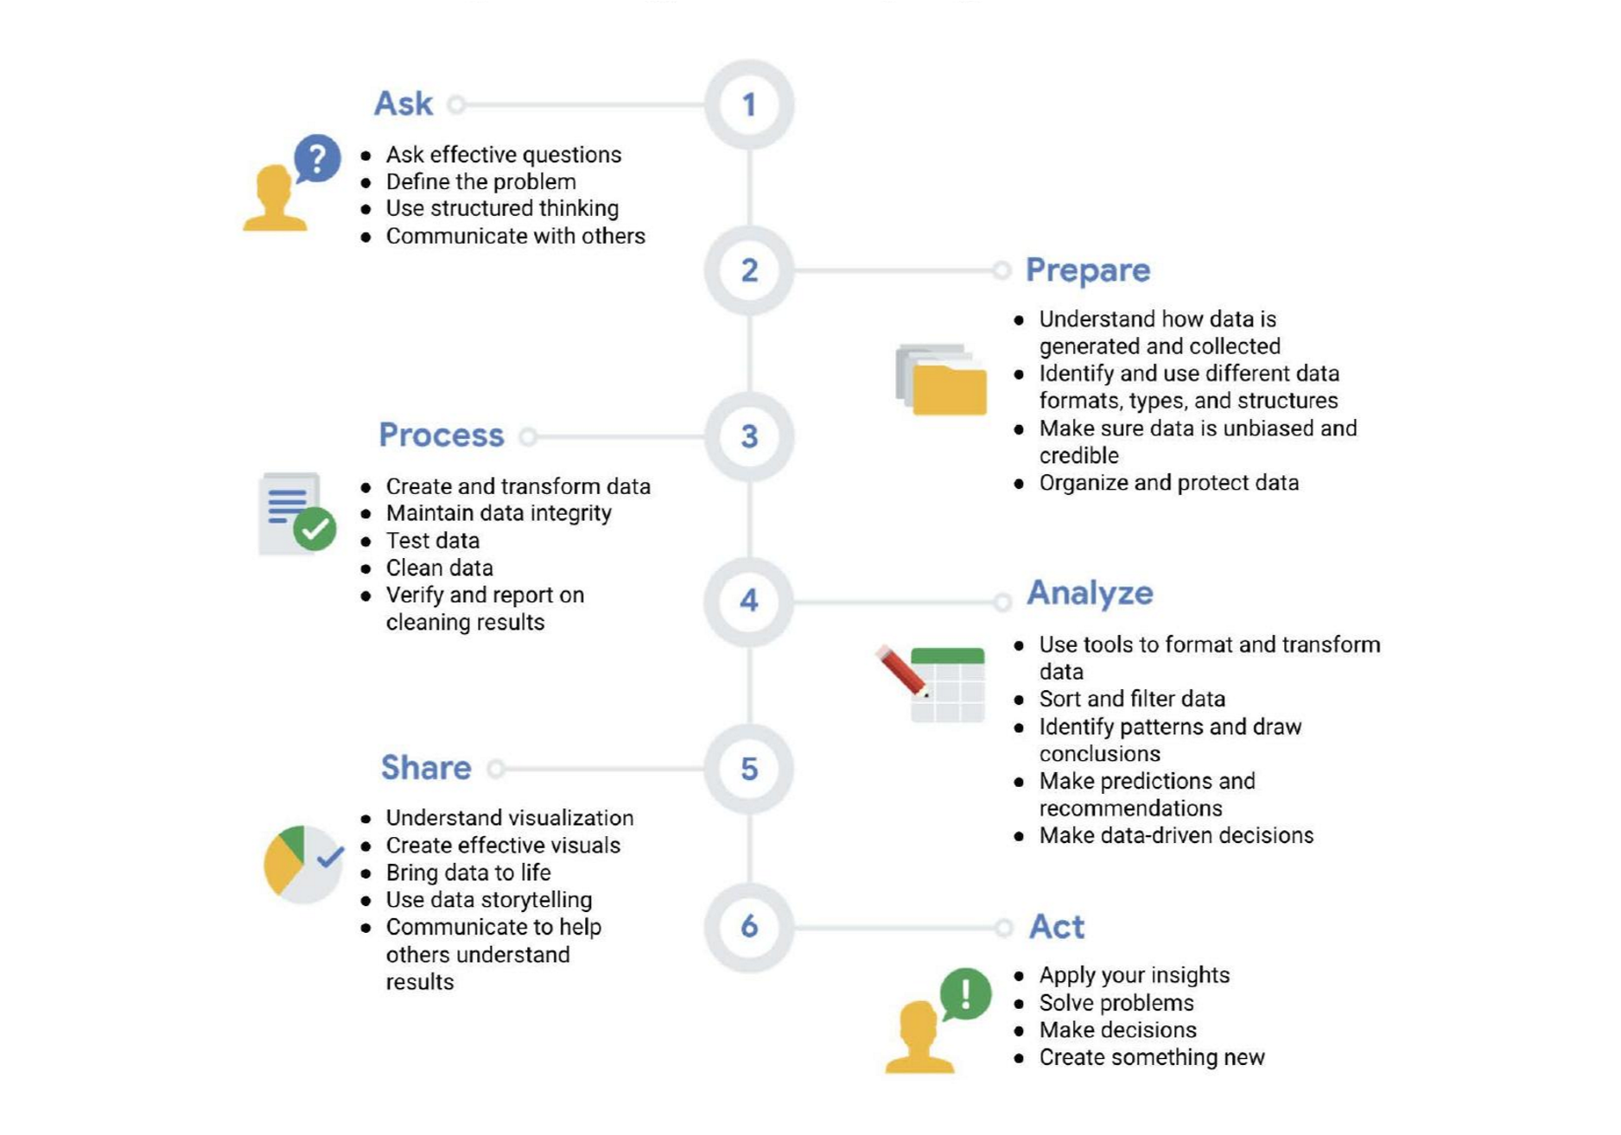

Fig. 1.1 - The six-step Data Analysis process taught by Google [4]

# Chapter 2

## ABOUT THE INTERNSHIP

### 2.1 KPMG DATA ANALYTICS VIRTUAL EXPERIENCE PROGRAM

KPMG Data Analytics Virtual Internship Program is provided by KPMG via

www.theforage.com (more about KPMG and www.theforage.com is given in later sections of this chapter). It is a free online program, where one can get to complete work similar to what

graduates do at KPMG. One can get a feel of the work done at KPMG’s Data Analytics

division, and build skills required to excel as an analytics consultant.

The process to complete the program is pretty simple - one can enroll in the program after signing up on www.theforage.com, then one can start a module where they’ll get video instructions about the task from the KPMG supervisor along with some hints and resources to guide in the task completion process. After completing the module, one can upload it on the platform and unlock KPMG model answers, with which one can compare their own work. In this way one can complete all the modules of the program after which a completion

certificate will be issued to the person. One can also submit the tasks as many times as they want making their solutions better and better after comparing them with the model work

unlocked earlier.

It is not the intention for KPMG to hire students based on their performance in this virtual internship and completing the program is not a prerequisite when applying for their current vacancies. This virtual internship is an opportunity for one to demonstrate one’s

interest in KPMG and they will consider students favourably who complete the program [5].

Due to the number of participants potentially completing this program, KPMG will not be able to assess one’s individual work or provide one with specific feedback. However, after submitting their completed work, one will be able to access model work prepared by KPMG’s consultants so one can see how someone from KPMG would approach the task [5].

#### 2.1.1 ABOUT THE FORAGE

Forage started as a mentoring startup in 2017, whose goal was to help students from all backgrounds discover careers and land jobs. Currently, they have “helped over 1.7 million students, worked with over 100 companies, and helped students become up to 5 times more

employable” [6].

Forage is an open platform which is 100% free and focuses on giving students a chance to learn and experience what it is like to work at a Fortune 500 company. They provide

virtual experiences (KPMG Virtual Internship is one of them) from Fortune 500 companies that simulate actual work done at those companies. Fig. 2.1 - Logo of The Forage [7]

Moreover, Forage’s programs are completely online and self-paced so there is no hassle. This gives students a unique opportunity to upskill themselves at the comfort of their

homes at a Fortune 500 company. There is also no interview or selection process to go through. You just sign up on Forage and join any of their programs for free. That is what

makes Forage such an interesting and unique website.

#### 2.1.2 ABOUT KPMG

 KPMG International Limited is a

British-Dutch multinational professional services

network, and one of the Big Four accounting

organizations (the other three being Deloitte, Ernst &

Young and PwC). They provide Audit, Tax and

Advisory services. Fig. 2.2 - Logo of KPMG [8]

One of KPMG’s many divisions include the Data Analytics division whose main

purpose is to help organizations make better decisions by using data, i.e. data-driven decision making. They help organizations make sense of their data, enabling them to learn from and use it to make better business decisions, grow revenue, enhance operational capabilities, and manage enterprise risks and compliance mandates.

### 2.2 TASKS INVOLVED IN THE INTERNSHIP

There were 3 tasks in total to complete the internship. The details of each task is given below.

#### 2.2.1 DATA QUALITY ASSESSMENT

This task required the assessment of data quality and completeness of the dataset provided in

preparation for the analysis.

**The task:**

Draft an email to the client identifying the data quality issues and strategies to mitigate these

issues.

**Background information on the task:**

Sprocket Central Pty Ltd is a medium size bikes & cycling accessories. They need help with their customer and transactions data. The organisation has a large dataset relating to its

customers, but their team is unsure how to effectively analyse it to help its marketing strategy.

The client has provided 3 datasets to us:

* Customer Demographic
* Customer Address
* Transactions data in the past 3 months

As a data analyst intern, I need to start the preliminary data exploration and identify ways to

improve the quality of Sprocket Central Pty Ltd’s data.

**My approach to solve the task:**

I first used Microsoft Excel to get a general understanding of the dataset and its rows and columns. Then I used pandas, numpy, matplotlib and seaborn libraries of the Python programming language to further explore the data, noting down every data quality issue with the data along with possible ways to mitigate these issues. I used Jupyter Notebook to do the data exploration. Finally, I wrote an email to the client, Sprocket Central Pty Ltd, highlighting the data quality issues and the possible ways to mitigate them. Given below is a link to a GitHub repository where I have uploaded my solution of the task. I have also attached a table

of the data quality issues that I found, just for a reference.

**Solution:** [**https://github.com/thisisamish/kpmg-data-analytics-virtual-internship.git**](https://github.com/thisisamish/kpmg-data-analytics-virtual-internship.git)

Table 2.1 - Data quality issues found in the first task

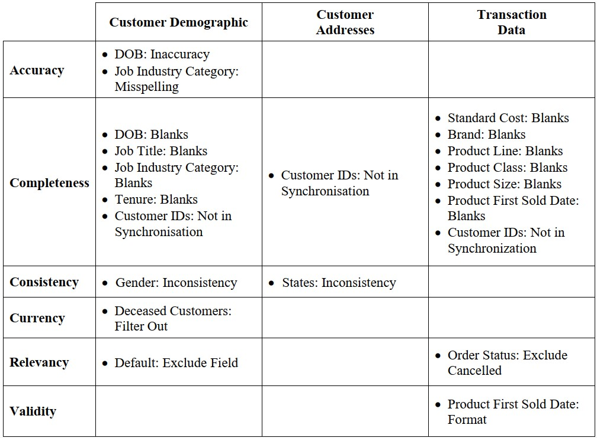

#### 2.2.2 DATA INSIGHTS

In this task, targeting of high value customers based on customer demographics and attributes

was to be done.

**The task:**

Prepare a detailed approach for completing the analysis of the newly acquired data along with the previous data including activities - understanding data distributions, feature engineering, data transformations, modelling, results interpretation and reporting. This detailed plan needs

to be presented to the client to get a sign-off. Please advise steps you would take.

**Background information on the task:**

Sprocket Central Pty Ltd has given us a new list of 1000 potential customers with their demographics and attributes. However, these customers do not have prior transaction history

with the organisation.

The marketing team at Sprocket Central Pty is sure that, if correctly analysed, the data would reveal useful customer insights and which could help resource allocation for targeted

marketing.

As a data analyst intern, I need to start with a PowerPoint presentation which outlines the approach which I will be taking. The client has agreed on a 3 week scope with the following 3 phases as follows - Data Exploration, Model Development and Interpretation.

**My approach to solve the task:**

**Data Exploration:**

I first used Microsoft Excel to get a general understanding of the newly acquired dataset and its rows and columns. Then I used pandas, numpy, matplotlib and seaborn libraries of the Python programming language to further explore the data and note down the data quality

issues.

After this, I started cleaning the new and the old customers' data. Here are the steps I took -

* Records with missing fields were dropped.
* Join keys between tables were considered and conflicting records were dropped.
* Age, Last Purchase (Days Ago) and Profit fields were added.
* Records pertaining to deceased customers were dropped.
* Transactions more than a year old were dropped.

Then with the use of the aforementioned libraries of Python, I plotted graphs and found similarities between the new and old data. After this, Data Exploration was done and I moved to Model Development.

**Model Development:**

I used RFM Analysis for customer segmentation. Based on RFM Analysis, four customer

tiers were identified.

1. Gold Class: These customers Fig. 2.3 - Customer tiers based on RFM Class

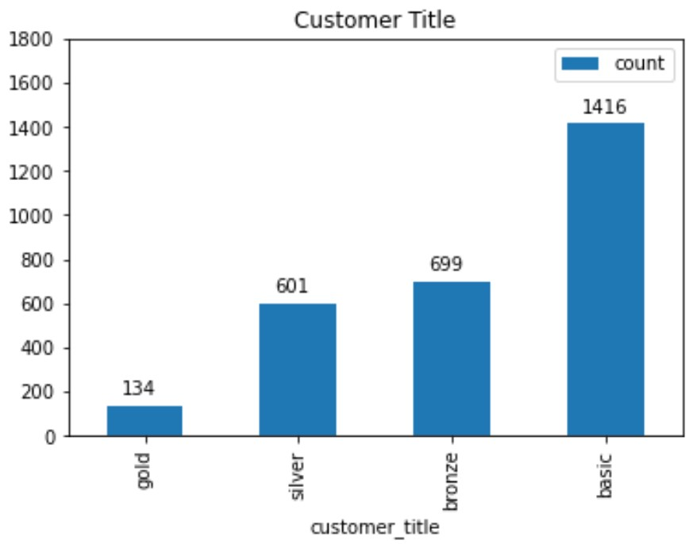 have recently made a

purchase, are frequent and

are most profitable.

1. Silver Class
2. Bronze Class
3. Basic Class: These customers

have not made any recent

purchase, are not frequent

and do not contribute

majorly.

**Interpretation:**

Based on the RFM Analysis, customer segments were divided (as shown in the table on the next page). Thus, customers having high RFM scores can be filtered and targeted to boost.

These customers have made recent purchases, are frequent, and provide the most profits. The full presentation is uploaded on a GitHub repository and the link is given below.

**Solution:** [**https://github.com/thisisamish/kpmg-data-analytics-virtual-internship.git**](https://github.com/thisisamish/kpmg-data-analytics-virtual-internship.git)

Table 2.2 - Customer Segments on the basis of RFM Score

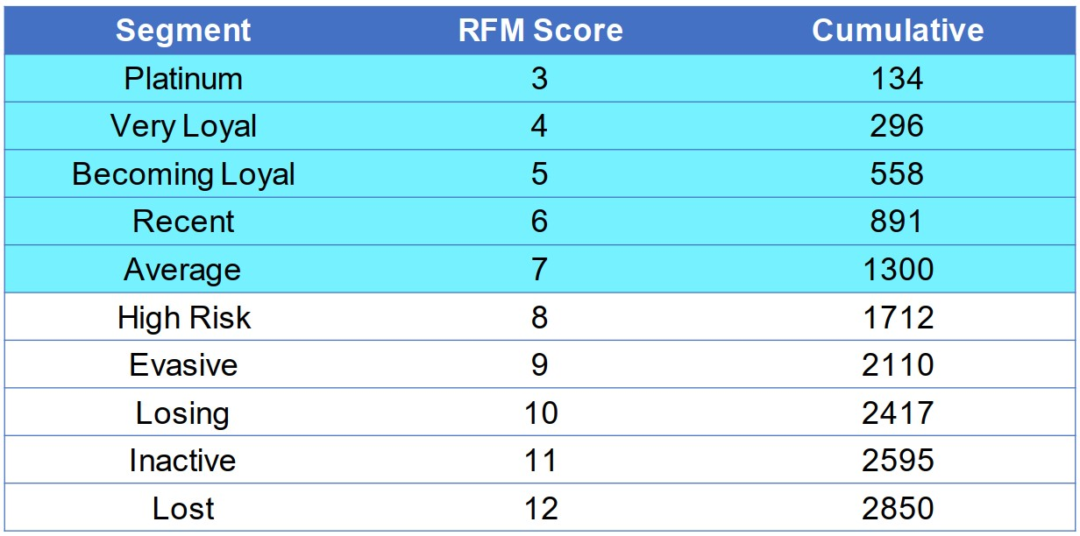

#### 2.2.3 DATA INSIGHTS AND PRESENTATION

This task required using visualizations to present insights.

**The task:**

Develop a dashboard that we can present to the client at our next meeting. Display your data summary and results of the analysis in a dashboard. Maximum of 3 dashboard views/tabs,

creativity in layout and presentation is welcome.

**Background information on the task:**

The client is happy with the analysis plan and would like us to proceed. After building the model, we need to present our results back to the client. Visualisations such as interactive dashboards often help us highlight key findings and convey our ideas in a more succinct

manner.

It is important to keep in mind the business context when presenting our findings. We need to look at the underlying trends in the data and customer segments and propose a proper marketing and growth strategy to Sprocket Central Pty Ltd. Specifically, our presentation should specify who Sprocket Central Pty Ltd’s marketing team should be targeting out of the

new 1000 customer list.

**My approach to solve the task:**

I used Power BI software to develop interactive dashboards out of all the analysis results in the last module. First I plotted 4 charts - Customer Segments by Wealth Segments, Avg Profit by State and Industry, Avg Profit by Age and Gender, and Avg Sales per month of the various customer segments. Then in the next dashboard, I tabulated the Top 1000 customers that the client must target to maximise revenue. Alon with the table, I also included a breakup of

these Top 1000 customers on the basis of the customer segments derived earlier.

I am including the link to the final dashboard uploaded on a GitHub repository. Also included in the report itself is the customer segment wise breakup of The Top 1000 Customers table,

for reference.

**Solution:** [**https://github.com/thisisamish/kpmg-data-analytics-virtual-internship.git**](https://github.com/thisisamish/kpmg-data-analytics-virtual-internship.git)

Fig. 2.4 - Breakup of Top 1000 Customers

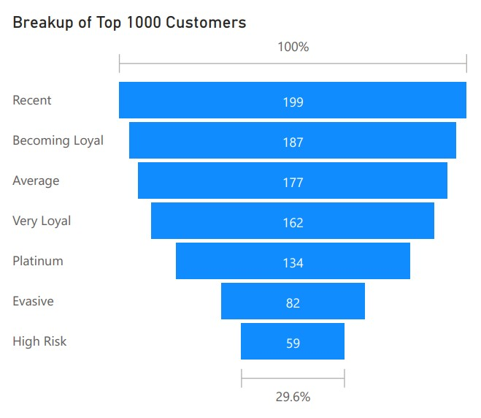

**Chapter 3**

## WHAT I HAVE LEARNED

While completing the KPMG Data Analytics Virtual Experience Program, I learnt a great deal about the fascinating world of data science, all of the various jobs related to this field, the cutting edge softwares used to create beautiful visualisations, the sheer power of Python language when used with all of its libraries, and extremely valuable soft skills like email writing, creating presentations and last but not the least, being a detective and uncovering the mystery behind a spreadsheet of data.I have listed all of these invaluable

learnings down below and explained them in detail.

### 3.1 ABOUT DATA SCIENCE AND THE JOBS ASSOCIATED WITH IT

Data Science is a vast field with many sub-branches that often get confused with each other. It is also a relatively new field with numerous ongoing research. I got to understand what all comes under the umbrella of Data Science and how to distinguish its various

sub-fields.

I also got to learn about the various jobs associated with Data Science. This knowledge about the various job fields will immensely help me in forging a career in the world of Data Science. I have listed all of the terms frequently used in Data Science and how to distinguish between them, along with the job fields associated with them in the

introduction of this report.

### 3.2 TOOLS/SOFTWARES USED

I used a lot of softwares and technologies to successfully complete this internship. I have

given a brief description of all of them below.

#### 3.2.1 MICROSOFT EXCEL

Microsoft Excel is a spreadsheet tool developed by Microsoft. It uses rows and columns to store data, like all spreadsheets. It also provides handy features to do data

cleaning and data analysis, along with some functionality to do data visualization.

I used Microsoft Excel to do the initial data exploration. I got a feel of what the datasets contained before moving forward with pandas and matplotlib to do the actual data

cleaning.

#### 3.2.2 JUPYTER NOTEBOOK

It is essentially a web-based interactive computational environment for creating

notebook documents. A Jupyter Notebook document is a browser-based REPL

(read-eval-print loop) containing an ordered list of input/output cells which can contain code, text (using Markdown), mathematics, plots and rich media. Underneath the interface, a notebook is a JSON document, following a versioned schema, usually ending with the

".ipynb" extension [9].

I used Jupyter Notebook to pretty much do all the data exploration, data cleaning, data

analysis and preliminary data visualization.

#### 3.2.3 PYTHON PROGRAMMING LANGUAGE AND IT’S LIBRARIES

Python is an interpreted high-level general-purpose programming language. Its language constructs as well as its object-oriented approach aim to help programmers write clear, logical code for small and large-scale projects. Python is dynamically-typed and garbage-collected. It supports multiple programming paradigms, including structured (particularly, procedural), object-oriented and functional programming [10], [11].

I used Python, along with its libraries - NumPy, pandas, Matplotlib and Seaborn to do data exploration, data cleaning, data analysis and preliminary data visualization. Brief

description of these libraries is given below.

* **NumPy** is the fundamental package for scientific computing in Python. It is a Python library that provides a multidimensional array object, various derived objects (such as masked arrays and matrices), and an assortment of routines for fast operations on arrays, including mathematical, logical, shape manipulation, sorting, selecting, I/O, discrete Fourier transforms, basic linear algebra, basic statistical operations, random

simulation and much more [12]. NumPy is open-source.

* **pandas** is an open source, BSD-licensed library providing high-performance, easy-to-use data structures and data analysis tools for the [Python](https://www.python.org/) programming

language [13].

* **Matplotlib** is a comprehensive library for creating static, animated, and interactive

visualizations in Python [14]. It is open-source.

* **Seaborn** is a library for making statistical graphics in Python. It builds on top of [matplotlib](https://matplotlib.org/) and integrates closely with [pandas](https://pandas.pydata.org/) data structures. Its plotting functions operate on dataframes and arrays containing whole datasets and internally perform the necessary semantic mapping and statistical aggregation to produce informative plots. Its dataset-oriented, declarative API lets you focus on what the different elements of

your plots mean, rather than on the details of how to draw them [15]. Seaborn is

open-source.

#### 3.2.5 POWER BI DESKTOP

**Power BI Desktop** is a free application you install on your local computer that lets you connect to, transform, and visualize your data. With Power BI Desktop, you can connect to multiple different sources of data, and combine them (often called *modeling*) into a data model. This data model lets you build visuals, and collections of visuals you can share as reports, with other people inside your organization [16]. Power BI Desktop is a part of Power BI software by Microsoft.

I used Power BI to create the interactive dashboard required for module-3 of the

internship.

### 3.3 DATA ANALYTICS IN THE ELECTRONICS INDUSTRY

Data Analytics is the science of data. When properly analysed, raw data can give meaningful information which can be taken into consideration while making business decisions. Electronics industry, too, can benefit from incorporating data-driven decision making in their various areas of business like supply chain management, customer analytics,

marketing etc.

In even the most simple decisions, having solid data is always beneficial. Hence be it any industry, data analysis is always important. But especially in the electronics industry in this age of **Industry 4.0 or the Fourth Industrial Revolution**, data can be used to create better **AI** models and better **automation** and **robotics** systems that move the industry forward. The term Industry 4.0 encompasses a promise of a new industrial revolution - one that marries advanced manufacturing techniques with the **Internet of Things (IoT)** to create manufacturing systems that are not only interconnected, but communicate, analyze, and use

information to drive further intelligent action back in the physical world [17].

We can use data analytics to better target customer demographics, create better workplace conditions for employees, predict trends in the demand and supply of electronic

components and so much more. The possibilities are endless.

# Chapter 4 CONCLUSION

As technology continues to advance, being able to collect and analyze the data from that new technology has become a huge competitive advantage for a lot of businesses. Everything from websites to social media feeds are filled with fascinating data that, when analyzed and used correctly, can help inform business decisions. A company’s ability to thrive now often depends on how well it can leverage data, apply analytics, and implement new technologies. This is why skilled data analysts are some of the most sought-after

professionals in the world.

Data Analytics helps organizations (and individuals, for that matter) make sense of their data and thus make business decisions based on that. As the amount of data is growing day-by-day, the demand for data analysts (and other jobs associated with data science in

general) is bigger than ever.

This KPMG Data Analytics Virtual Experience Program helped me gain an insight

into:

1. what data analytics, one of the hottest fields in the present day, encompasses in

a professional environment, and

1. how one of the biggest consulting companies, KPMG, works in this field.

I learnt a lot over the duration of completing all the tasks of this virtual experience program. I am grateful to The Forage for offering these kinds of programs, and that too, for

free.

I am still learning a lot about the vast field of data analytics and data science. I am also exploring many ways in which data analytics could be used in the core electronics

industry.

# REFERENCES

1. Simplilearn, “What is Data Analytics and its Future Scope in 2021,” Sept 13, 2021.

[Online]. Available: <https://www.simplilearn.com/tutorials/data-analytics-tutorial/what-is-data-analytics>.

[Accessed Jan 18, 2022].

1. Coursera, “Data Analyst vs. Data Scientist: What’s the difference? | Coursera,” Dec 16,

2021. [Online]. Available:

<https://www.coursera.org/articles/data-analyst-vs-data-scientist-whats-the-difference>.

[Accessed Jan 18, 2022].

1. Google, “Data analyst roles and job descriptions” in “Week 5” of “Foundations: Data,

Data, Everywhere” course on Coursera. [Online]. Available: [https://www.coursera.org/learn/foundations-data/supplement/VUMX2/data-analyst-roles-andjob-descriptions](https://www.coursera.org/learn/foundations-data/supplement/VUMX2/data-analyst-roles-and-job-descriptions). [Accessed Nov 10, 2021].

1. Google, “The data analysis process and this program” in “Week 3” of “Foundations: Data,Data, Everywhere” course on Coursera. [Online]. Available:

[https://www.coursera.org/learn/foundations-data/supplement/Yo3Cn/the-data-analysis-proces s-and-this-program](https://www.coursera.org/learn/foundations-data/supplement/Yo3Cn/the-data-analysis-process-and-this-program). [Accessed Nov 2, 2021].

1. “The purpose of the KPMG Virtual Internship” on The Forage. [Online]. Available:

[https://www.theforage.com/virtual-internships/theme/m7W4GMqeT3bh9Nb2c/KPMG-DataAnalytics-Virtual-Internship?ref=nFuQpyX9AjWPnrvdk](https://www.theforage.com/virtual-internships/theme/m7W4GMqeT3bh9Nb2c/KPMG-Data-Analytics-Virtual-Internship?ref=nFuQpyX9AjWPnrvdk). [Accessed Oct 7, 2021].

1. “About us” on The Forage. [Online]. Available: <https://www.theforage.com/>. [Accessed Jan 20, 2022].
2. Snapshot of the logo of “The Forage”. [Online]. Available: <https://www.theforage.com/>.

[Accessed Jan 20, 2022].

1. Logo of “KPMG”. [Online]. Available:

<https://assets.kpmg/content/dam/kpmg/images/platform/KPMG.png>. [Accessed Jan 20, 2022].

1. About the Jupyter Notebook. [Online]. Available: <https://jupyter.org/>. [Accessed Jan 22, 2022].
2. Kuhlman, Dave, “A Python Book: Beginning Python, Advanced Python, and PythonExercises,” Section 1.1, 22 April, 2012. [Online]. Available:

[https://web.archive.org/web/20120623165941/http://cutter.rexx.com/~dkuhlman/python_boo k_01.html](https://web.archive.org/web/20120623165941/http://cutter.rexx.com/~dkuhlman/python_book_01.html). [Accessed Jan 31, 2022].

1. “PEP 206 – Python Advanced Library,” Archived on 5 May, 2021. [Online]. Available: <https://web.archive.org/web/20210505003659/https://www.python.org/dev/peps/pep-0206/>.

[Accessed Jan 31, 2022].

1. NumPy documentation of version 1.22. [Online]. Available:

<https://numpy.org/doc/stable/>. [Accessed Jan 31, 2022].

1. pandas documentation of version 1.4.0. [Online]. Available: <https://pandas.pydata.org/docs/>. [Accessed Jan 31, 2022].
2. Matplotlib 3.5.1 documentation. [Online]. Available: <https://matplotlib.org/stable/>.

[Accessed Jan 31, 2022].

1. An introduction to seaborn. [Online]. Available: <https://seaborn.pydata.org/introduction.html>. [Accessed Jan 31, 2022].
2. “What is Power BI Desktop?” in Power BI documentation. [Online]. Available:

<https://docs.microsoft.com/en-us/power-bi/fundamentals/desktop-what-is-desktop>. [Accessed Jan 31, 2022].

1. “Industry 4.0” on Deloitte Insights. [Online]. Available:

<https://www2.deloitte.com/us/en/insights/focus/industry-4-0.html>. [Accessed Jan 28, 2022]