**A MINI PROJECT/INTERNSHIP REPORT**

**submitted in partial fulfilment of the requirements for the Award of Degree of**

**BACHELOR OF TECHNOLOGY**

**in**

**ELECTRONICS AND COMMUNICATION ENGINEERING**

**on**

**VLSI SoC Design Using Verilog HDL**

**in**

**Maven Silicon**

**SUBMITTED BY:** AMISH VERMA

(ROLL NO. 2000910310033 )

**MENTOR:** MR. SAMPATH KUMAR V.

***Duration: 14 October, 2022 - 10 November, 2022***



**DEPARTMENT OF ELECTRONICS AND COMMUNICATION ENGINEERING**

JSS ACADEMY OF TECHNICAL EDUCATION

C-20/1 SECTOR-62, NOIDA

2021- 2022

**CERTIFICATE**

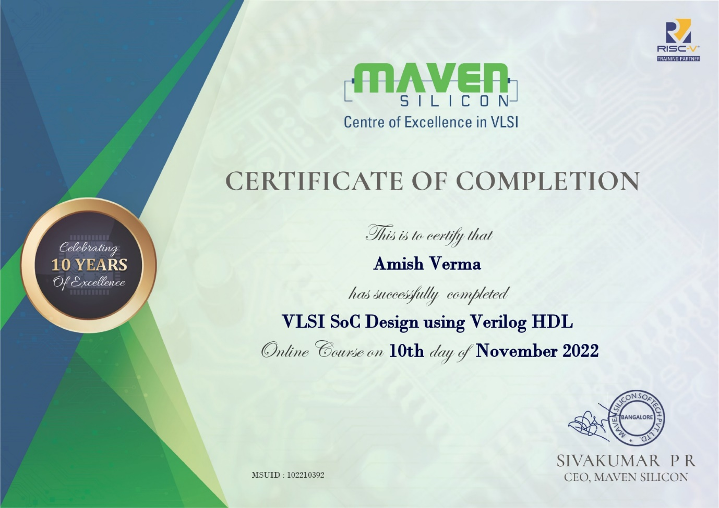

**TABLE OF CONTENTS**

Page

ACKNOWLEDGEMENT

INTERNSHIP CERTIFICATE

ABSTRACT i

LIST OF FIGURES ii

LIST OF TABLES iii

LIST OF ABBREVIATIONS iv

CHAPTER 1 (INTRODUCTION) 1

CHAPTER 2 ABOUT THE PROJECT IMPLEMENTED

CHAPTER 2 WHAT I HAVE LEARNED 6

CHAPTER 3 RESULT ANALYSES 7

CHAPTER 4 (CONCLUSIONS) 23

REFERENCES 24

* **It is expected to present the subject matter in an organized way. Avoid copying the subject matter directly from the internet/ Book / website as it is.**
* **Divide the matter into different sections/ chapters.**
* **A spiral bound copy of the report is to be submitted at the time of presentation. (Printed on single side on a good quality paper-total 20-25 pages -not to exceed 50 pages)**
* **Get a soft copy verified from the faculty mentor prior to the presentation so that you can proceed for printout.**
* **Faculty mentor has full right to reject your report if it is not prepared as per the guidelines.**

**All headings -font size 16- Times New Roman- Double spacing after the Page heading**

**Sub-headings font size -14 and (Proper numbering of subheading is essential) the text is to be properly justified.**

**Text -font sixe-12 spaced at 1.5 line spacing.**

* **Each figure and table must be labelled as figure -1- at the bottom and table-1 at the top. (Font size 10 , bold, alignment-centre)**
* **Page margins- Top – bottom 2.5cm. Left 3.5 cm (Gutter-0), right 2 cm**
* **Page numbering – table of contents, acknowledgement etc to have roam page numbers (I,ii,iii….) followed by numeric (1,2,3,4..)at the bottom of the page aligned at the centre.**
* **For any query, please contact the internship coordinators or faculty mentor.**

**ACKNOWLEDGEMENT**

First, I would like to thank Maven Silicon, Bangalore, for providing me their online training course title “VSLI SoC Design Using Verilog HDL” without any cost. It is really generous of them. I would also like to thank Dr. Arun Kumar G., HoD, ECE Department, JSS Academy of Technical Education, Noida, for communicating with Maven Silicon, Banglore and helping me get the online training. I would forever be grateful for this opportunity.

Next, I would like to thank, Mr. Sampath Kumar V, for his guidance during and after this online training. He is a great guide and mentor and I am grateful to him.

I am also thankful to my friends Udbhav Patel and Mridul Sahu for their constant support throughout the online training duration. They were always there to help me whenever I got stuck in some concept and I am thankful for that.

AMISH VERMA

(2000910310033)

# LIST OF FIGURES AND TABLES

**FIGURES:**

|  |  |  |
| --- | --- | --- |
| **S. No.** | **Title of the figure** | **Page No.** |
| 1. | Fig. 1.1 - The six-step Data Analysis process taught by Google | 12 |
| 2. | Fig. 2.1 - Logo of The Forage | 14 |
| 3. | Fig. 2.2 - Logo of KPMG | 14 |
| 4. | Fig. 2.3 - Customer tiers based on RFM Class | 18 |
| 5. | Fig. 2.4 - Breakup of Top 1000 Customers | 20 |

**TABLES:**

|  |  |  |
| --- | --- | --- |
| **S. No.** | **Title of the table** | **Page No.** |
| 1. | Table 1.1 - Skills required for a data analyst and a data scientist | 8 |
| 2. | Table 1.2 - Overlaps and distinctions between three job titles | 10 |
| 3. | Table 2.1 - Data quality issues found in the first task | 16 |
| 4. | Table 2.2 - Customer Segments on the basis of RFM Score | 19 |

**ABSTRACT**

Very Large Scale Integration (VLSI) is the process of creating an integrated circuit (IC) by combining millions or billions of MOS transistors onto a single chip. Before the introduction of VLSI technology, most ICs had a limited set of functions they could perform. An electronic circuit might consist of a CPU, ROM, RAM and other glue logic. VLSI enables IC designers to add all of these into one chip.

“VLSI SoC Design Using Verilog HDL” is an online training program by Maven Silicon – a VLSI training company based in Bangalore, India. This training program is beginner-friendly and introduces students to VLSI design and usage of Hardware Description Languages (HDL), particularly Verilog HDL. The program is hands-on and provides complete tutorials of writing, compiling and simulating VLSI designs with Verilog in Intel’s Quartus Prime and ModelSim.

**Chapter 1**

**INTRODUCTION**

**1.1 IC AND ITS HISTORY**

The integrated circuit is nothing more than a very advanced electric circuit. An electric circuit is made from different electrical components such as transistors, resistors, capacitors and diodes that are connected to each other in different ways. These components have different behaviors.

* The transistor acts like a switch. It can turn electricity on or off, or it can amplify current. It is used for example in computers to store information, or in stereo amplifiers to make the sound signal stronger.
* The resistor limits the flow of electricity and gives us the possibility to control the amount of current that is allowed to pass. Resistors are used, among other things, to control the volume in television sets or radios.
* The capacitor collects electricity and releases it all in one quick burst; like for instance in cameras where a tiny battery can provide enough energy to fire the flashbulb.
* The diode stops electricity under some conditions and allows it to pass only when these conditions change. This is used in, for example, photocells where a light beam that is broken triggers the diode to stop electricity from flowing through it.

These components are like the building blocks in an electrical construction kit. Depending on how the components are put together when building the circuit, everything from a burglar alarm to a computer microprocessor can be constructed.

Of the components mentioned above, the transistor is the most important one for the development of modern computers. Before the transistor, engineers had to use vacuum tubes. Just as the transistor, the vacuum tube can switch electricity on or off, or amplify a current. So why was the vacuum tube replaced by the transistor? There are several reasons.

The vacuum tube looks and behaves very much like a light bulb; it generates a lot of heat and has a tendency to burn out. Also, compared to the transistor it is slow, big and bulky.

When engineers tried to build complex circuits using the vacuum tube, they quickly became aware of its limitations. The first digital computer ENIAC, for example, was a huge monster that weighed over thirty tons, and consumed 200 kilowatts of electrical power. It had around 18,000 vacuum tubes that constantly burned out, making it very unreliable.

When the transistor was invented in 1947 it was considered a revolution. Small, fast, reliable and effective, it quickly replaced the vacuum tube. Freed from the limitations of the vacuum tube, engineers finally could begin to realize the electrical constructions of their dreams, or could they?

With the small and effective transistor at their hands, electrical engineers of the 50s saw the possibilities of constructing far more advanced circuits than before. However, as the complexity of the circuits grew, problems started arising.

When building a circuit, it is very important that all connections are intact. If not, the electrical current will be stopped on its way through the circuit, making the circuit fail. Before the integrated circuit, assembly workers had to construct circuits by hand, soldering each component in place and connecting them with metal wires. Engineers soon realized that manually assembling the vast number of tiny components needed in, for example, a computer would be impossible, especially without generating a single faulty connection.

Another problem was the size of the circuits. A complex circuit, like a computer, was dependent on speed. If the components of the computer were too large or the wires interconnecting them too long, the electric signals couldn't travel fast enough through the circuit, thus making the computer too slow to be effective.

So there was a problem of numbers. Advanced circuits contained so many components and connections that they were virtually impossible to build. This problem was known as the tyranny of numbers.

In the summer of 1958 Jack Kilby at Texas Instruments found a solution to this problem. He was newly employed and had been set to work on a project to build smaller electrical circuits. However, the path that Texas Instruments had chosen for its miniaturization project didn't seem to be the right one to Kilby.

Because he was newly employed, Kilby had no vacation like the rest of the staff. Working alone in the lab, he saw an opportunity to find a solution of his own to the miniaturization problem. Kilby's idea was to make all the components and the chip out of the same block (monolith) of semiconductor material. When the rest of the workers returned from vacation, Kilby presented his new idea to his superiors. He was allowed to build a test version of his circuit. In September 1958, he had his first integrated circuit ready. It was tested and it worked perfectly!

Although the first integrated circuit was pretty crude and had some problems, the idea was groundbreaking. By making all the parts out of the same block of material and adding the metal needed to connect them as a layer on top of it, there was no more need for individual discrete components. No more wires and components had to be assembled manually. The circuits could be made smaller and the manufacturing process could be automated.

Jack Kilby is probably most famous for his invention of the integrated circuit, for which he received the Nobel Prize in Physics in the year 2000. After his success with the integrated circuit Kilby stayed with Texas Instruments and, among other things, he led the team that invented the hand-held calculator.

Robert Noyce came up with his own idea for the integrated circuit. He did it half a year later than Jack Kilby. Noyce's circuit solved several practical problems that Kilby's circuit had, mainly the problem of interconnecting all the components on the chip. This was done by adding the metal as a final layer and then removing some of it so that the wires needed to connect the components were formed. This made the integrated circuit more suitable for mass production. Besides being one of the early pioneers of the integrated circuit, Robert Noyce also was one of the co-founders of Intel. Intel is one of the largest manufacturers of integrated circuits in the world.

**1.2 CHIP PRODUCTION TODAY**

Building an integrated circuit like a computer chip is a very complex process. It is divided into two major parts, front end and back end. In the front end, you make the components of the circuit. In the back end, you add metal to connect the components and then you test and package the chip. Below is a simplified description of the steps.

**1.2.1 FRONT END - CONSTRUCTION OF THE COMPONENTS**

1. Just as in building a house, you need a construction plan to construct a chip. The construction plans for the chip are made and tested with a computer.
2. From the construction plans, masks with the circuit patterns are made.
3. Under precisely monitored conditions, a pure silicon crystal is grown. Circuit manufacturing demands the use of crystals with an extremely high grade of perfection.
4. The silicon is sawed into thin wafers with a diamond saw. The wafers are then polished in a number of steps until their surface has a perfect mirror-like finish.
5. The silicon wafer is covered with a layer of insulating silicon oxide.
6. A covering film of protective material is put on top of the insulating silicon oxide. This material, a bit like the film in any ordinary camera, is sensitive to light.
7. UV-light is shone through a mask and onto the chip. On the parts of the chip that are hit by light, the protective material breaks apart.
8. The wafer is developed, rinsed and baked. The development process removes the parts of the protective material exposed to light.
9. The wafer is treated with chemicals in a process called "etching." This removes the unprotected insulating material, creating a pattern of non-protected silicon wafer parts surrounded by areas protected by silicon oxide.
10. The wafer is run through a process that alters the electrical properties of the unprotected areas of the wafer. This process is called "doping." Steps 5-10 are repeated to build the integrated circuit, layer by layer. Other layers of conducting or isolating layers may also be added to make the components.

**1.3 CAN (CONTROLLER AREA NETWORK)**

CAN is a hardware and software communication protocol originally developed by Robert Bosch GmbH in 1986 for in-vehicle networks in cars. CAN buses employing twisted wire pairs were specifically designed to be robust in electromagnetically noisy environments. The applications of CAN in automobiles include engine control communications, body control, and on-board diagnostics. CAN buses can also be found in other embedded control applications such as factory automation, building automation, and aerospace systems.

A CAN bus enables microcontrollers in a car to talk to each other without the need for a network host. A typical automobile today has dozens of microcontrollers that communicate with each other via various CAN buses.

**Key Features**

* Maximum Data Rates: 1Mbps at 40m, 125Kbps at 500m, 50kbps at 1000m
* Circuit Type: Differential
* Physical Layer: Twisted Wire Pair, 9 pin D-Sub
* Transmission Format: Asynchronous
* Drive Voltage: High: 2.75v ~ 4.5v; Low: 0.5v ~ 2.25v; Differential: 1.5v ~ 3.0v
* Network Topology: Point to Point
* Standards: ISO 11898/11519

**1.4 EMBEDDED SYSTEMS IN A CAR**



**Figure 1.1 Basic Block diagram**

A typical automobile on the road today has dozens of computer controlled electronic systems. This paper will review some of commonly used embedded system in vehicles.

**CHAPTER 2**

**APPLICATIONS**

**2.1 AIRBAG DEPLOYMENT SYSTEMS**

Airbags are passive safety devices that are mandatory on all vehicles sold in the United States. Airbags are a critical part of the Supplemental Restraint System (SRS) in most vehicles. The objective of the airbag, which is deployed when the vehicle suddenly decelerates (as in a collision), is to prevent the vehicle occupants from hitting any rigid surfaces and cushion the forces on their heads and upper or lower bodies. Airbags are typically made of nylon fabric and are hidden behind panels at various locations in the vehicle, including the steering wheel.

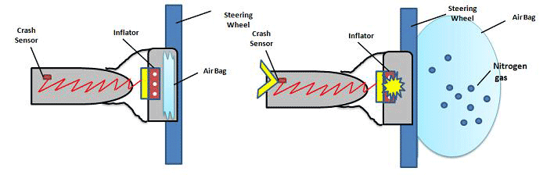

**Figure 2.1 Air Bags System**

Depending on the crash severity, the rate at which the airbags are deployed is decided by the airbag control unit. In the event of a crash, the crash sensor (an accelerometer) sends a signal to the airbag control unit. This control unit triggers the inflation device, which generates nitrogen gas by igniting a mixture of sodium azide (NaN3) and potassium nitrate (KNO3). The time between crash detection and complete deployment of the airbag is approximately 0.05 seconds. The airbag speed is about 200 mph, which itself can be harmful in certain cases. This has given rise to adaptive airbag systems that employ multiple inflators to produce either low-level or high-level deployments. These systems can adjust the airbag pressure depending on factors such as seat position, size of passenger, crash severity and seat belt use.

Most systems use a weight sensor in the front passenger seat to determine if the seat is unoccupied. If it is, the passenger airbag will not deploy. The weight sensor can also discriminate between children and adults who may be occupying the seat. The U.S. Federal Motor Vehicle Safety Standard 208 requires airbag deployment systems to detect whether a child is seated in the front passenger seat. Typically, airbag deployment will be suppressed if a sensor identifies a low-weight condition. Additionally some systems can detect child's safety seats that are equipped with special sensors as defined by the technical specification ISO/TS 22239.

In 2012, Volvo became the first automotive manufacturer to introduce a Pedestrian Airbag System in its V40 model. It uses a pedestrian contact sensing system. When impact with a pedestrian is sensed, the hood opens from the back and an airbag is inflated over the windshield-wiper area.

In 2013, GM announced a new airbag for side impact crashes. It inflates near the center console and provides padding between the front passengers or support for the solo driver. GM has also modified the front airbag to include a vent which opens when the passenger compresses the bag. This provides a similar effect to the more expensive dual stage airbags without the increased cost. Due to the vent being closed during initial deployment, it can inflate with lower pressure. This will reduce some inflation-related injuries with smaller drivers who sit closer to the steering wheel and benefit drivers who sit further back due to reduced premature deflation.

**Sensors**

Accelerometers, wheel speed sensors, brake pressure sensors, seat occupancy sensor

**Actuators**

Airbag inflation device, passenger airbag ON/OFF indicator

**Data Communications**

Typically **CAN**

**2.2 EVENT DATA RECORDERS**

Event data recorders (EDRs), sometimes referred to as automotive "black boxes", are systems that constantly record information related to the vehicle operation. In the event of an accident, the recorder saves the information that was recorded several seconds just before and/or just after the collision. EDRs may be independent electronic control units or they may reside within other control modules such as the engine control (ECM) or airbag control module.

Unlike Accident Recorders, which are after-market systems that usually record video and GPS location data, EDRs are installed by the vehicle manufacturer and integrated with existing systems and sensors. Although automotive EDRs have existed in one form or another since the mid-1970s, they have only recently become standard equipment in most vehicles. The National Highway Traffic Safety Administration (NHTSA) estimates that about 96% of model year 2013 cars and light trucks are equipped with EDRs. Modern EDRs record various vehicle operation parameters such as vehicle speed, pedal positions, steering wheel position and other information that may be relevant to a crash investigation. There is some consumer resistance to vehicle black boxes due to privacy concerns, and the fear that information recorded by a black box could be used against the vehicle owner in a lawsuit resulting from an accident.

In 2006, the National Highway Traffic Safety Administration (NHTSA) published standards for EDR practices, but did not require EDRs as standard equipment [6]. It only specified which data EDRs should collect and how it should be stored. The NHTSA standard would require all cars with EDRs to record the following information:

* Change in forward crash speed
* Maximum change in forward crash speed
* Time from beginning of crash at which the maximum change in forward crash speed occurs
* Speed vehicle was traveling
* Percentage of engine throttle, percentage full (how far the accelerator pedal was pressed)
* Whether or not brake was applied and the anti-lock brakes were activated
* Ignition cycle (number of power cycles applied to the EDR) at the time of the crash
* Ignition cycle (number of power cycles applied to the EDR) when the EDR data is downloaded
* Whether or not driver was using a safety belt
* Whether or not frontal airbag warning lamp was on
* Driver frontal airbag deployment: time to deploy for a single stage airbag, or time to first stage deployment for a multistage airbag
* Right front passenger frontal airbag deployment: time to deploy for a single stage airbag, or time to first stage deployment for a multistage airbag
* Number of crash events
* Steering wheel angle
* Vehicle roll angle, in case of a rollover
* Front seat positions
* Time between first two crash events, if applicable
* Whether or not stability control was engaged
* Whether or not EDR completed recording

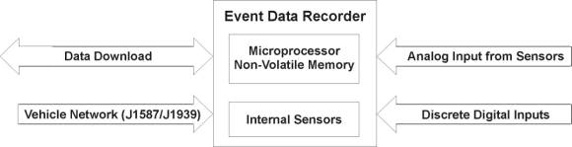

**Figure 2.2 EDR System Connectivity Block Diagram**

As shown in Figure, five types of data measurement connections or sensors make up the entire EDR measuring chain:

1. **Internal Sensors** – Internal sensors are located inside an EDR when data is not available to be read directly from other sources on the truck. These sensors typically include: longitudinal, lateral, and vertical accelerometers; yaw, pitch, and roll angular sensors; and a GPS receiver, if the vehicle does not have a GPS receiver on its in-vehicle data network.

2**. Analog Input from Sensors** – Analog input from sensors refers to the electrical output of analog (i.e., continuous, 1 to 5 Volts Direct Current (VDC)) sensors that can be located in various locations on the vehicle. An example of an analog sensor is the throttle position sensor.

Any analog inputs from the vehicle directly into an EDR are undesirable, because the analog signal may degrade due to long wire lengths, which will reduce the signal strength, place an additional load on the sensor which may alter its reading, and increase noise on the line. Most analog sensors used for engine control have data placed on the in-vehicle data network.

3. **Discrete Digital Inputs** – Discrete digital inputs refer to connections throughout the vehicle to on/off devices. Brake lights, turn signals, horn, running lights, and headlights are examples of this type of signal. Determining the state of discrete digital inputs is cost effective and will not affect the operation of the device. The wiring required to tap into the signals is simple, and the physical connection can be made by the use of a simple crimp-style wire splice.

4. **Vehicle Network** – Another cost effective method of obtaining vehicle data is via the vehicle network. Two in-vehicle data networks commonly found in large trucks: 1) a low-speed network (SAE J1708/J1587) and 2) a high-speed network (SAE J1939). When both networks are present, the low-speed network conveys general vehicle operating data, and the high-speed network carries engine control data.

Obtaining vehicle data via the vehicle networks is cost efficient, because one network interface allows all operating data available on the network to be accessed by an EDR. Since the network protocols are well-defined and standardized, the same network messages will exist across many types of vehicles.

5. **Data Download** – Data download is the process of transferring data stored in an EDR to another device, which serves as the only two-way connection interface. Using a data download connection, an EDR receives commands from a device (e.g., a laptop), and transmits data to it. Checksums are transferred by an EDR and analyzed by the off-loading device to ensure there are no errors in data transmission. In addition, this link can be used to upload new operating software to an EDR. This connection is a type of serial link (e.g., RS-232, USB, Firewire, etc.), which could be a wireless link.

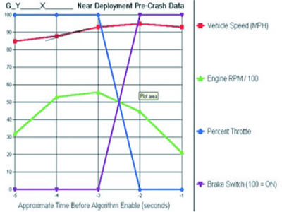

**Figure 2.3 EDR Data Retrieval**

**2.3 ANTI-LOCK BRAKE SYSTEM (ABS)**

Anti-lock Braking Systems (ABS) prevent wheel lockup by modulating the braking pressure. These systems play a significant role in improving the safety of modern vehicles. In slippery road conditions on smooth surfaces, a driver may hit the brake so hard that one or more wheels locks and begins to skid over the surface. This results in longer stopping distances, a loss of steer-ability, and vehicle instability. ABS systems monitor the wheel speed in real time and regulate the brake pressure automatically in order to prevent wheel lockup and improve the driver's control of the vehicle. They are now often paired with other systems such as Electronic Stability Control (ESC) and Traction Control to further increase vehicle control and driver safety. The main components of these systems include regular brake parts (such as the brake pedal, hydraulic cylinders and lines), wheel speed sensors, and a hydraulic modulator operated by an electronic control unit. The architecture of the ABS system (including the hydraulic modulator) is illustrated in the figure below.

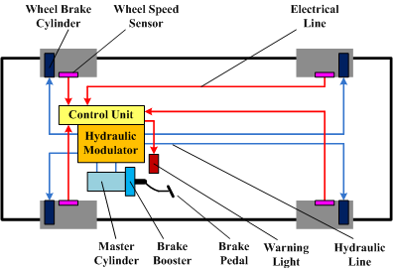

**Figure 2.4 Block Diagram of ABS**

When operating in normal conditions, the outlet valve (C) of the hydraulic modulator is closed and the inlet valve (A) stays open until the pressure reaches the desired value. Then both the inlet and outlet valves remain closed to hold this pressure and provide sufficient brake torque for wheel brake cylinders. Once the control unit detects any excessive wheel slip, the corresponding outlet valve is opened to release the pressure to the accumulator (D) and prevent possible wheel lockup. The excess brake fluid is returned to the master cylinder through the return pump (E). After the wheel slip returns to normal, the valve solenoids are de-energized and the hydraulic modulator resumes the regular braking process.

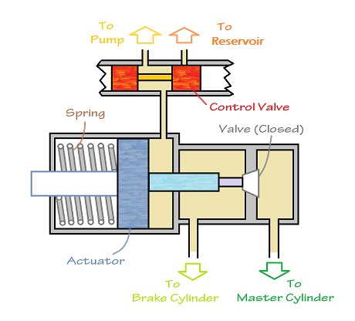

**Figure 2.5 Functioning Block Diagram of ABS**

Anti-lock braking systems can be classified based on the number of channels and number of sensors employed.

**Four Channel, Four Sensor ABS** - This type of ABS uses a speed sensor and separate valves for each of the four wheels. Maximum braking force is achieved with this type.

**Three Channel, Three Sensor ABS** - The front wheels each have a sensor and a valve. There is one valve and one sensor for both the rear wheels.

**One Channel, One Sensor ABS** - One valve and speed sensor located on the rear axle monitor both the rear wheels. This type of ABS is commonly seen in pickup trucks.

**Slip Ratio**

Slip ratio is a means of calculating and expressing the locking status of a wheel. It is the ratio of the difference between the vehicle speed and the wheel speed to the vehicle speed. For example, when the vehicle is running normally on an ideal road surface, the slip ratio is 0; when the wheels are locked, the slip ratio is 1. During braking, as the slip ratio rises, the ABS system maintains an ideal slip ratio of 0.10 to 0.30 based on the road-tire friction characteristics. In this way, the vehicle maintains a maximum deceleration without a total loss of steering capability.

**Sensors**

Wheel speed sensor

**Actuators**

Hydraulic modulator, master cylinder, wheel brake cylinders, warning light

**Data Communications**

High-speed CAN bus

**2.4 ELECTRONIC STABILITY CONTROL SYSTEM**

Electronic Stability Control (ESC), also called Vehicle Dynamic Control (VDC), Dynamic Stability Control (DSC), Electronic Stability Program (ESP), Vehicle Stability Control (VSC) or Vehicle Stability Assist (VSA), is one of the most significant active safety systems in modern automobiles. The main function of this system is to improve the handling performance of the vehicle and prevent possible accidents during severe driving maneuvers (e.g. fast cornering or lane changing with emergency braking). Generally, these systems stabilize the vehicle by applying the necessary yaw moment (generated by individual braking force on each wheel) and regulating the side slip angle of the vehicle based on a comparison between the vehicle state and the driver's demand. Some ESC systems .A vehicle may go in a direction different from the one the steering wheel position indicates when the driver tries to turn very hard or turn on a slippery road. In these situations, the vehicle may understeer or oversteer. In an oversteer situation, the vehicle turns more than the driver intended because the rear end loses traction and slides out. Understeer occurs when the front wheels lose traction and the vehicle turns less than the driver intended.

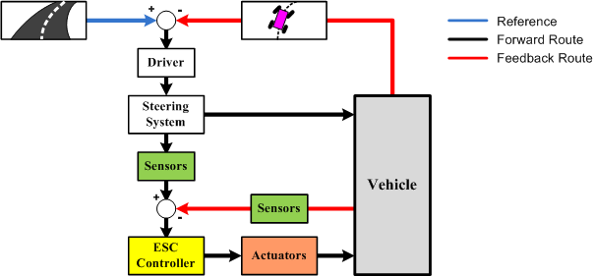

**Figure 2.6 Block Diagram of ECU**

The figure above shows the architecture of a typical stability control system, incorporating three fundamental elements: the driver, the vehicle and the environment. In the normal control loop, the driver detects the deviation of the vehicle from the current road trajectory and corrects it through the steering system. When the electronic stability control system senses that the driver is about to lose control of the vehicle, it generates the necessary yaw moment automatically based on the difference between the driver's demand and actual vehicle state and helps to pull the vehicle back to the desired trajectory.

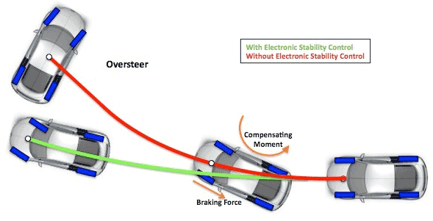

**Figure 2.7 Impact of ECU**

**Sensors**

*Steering wheel angle sensor*: detects the steering wheel position and provides a reference input for the ESC controller.

*Lateral acceleration sensor*: measures the lateral acceleration of the vehicle (also called a G-force sensor).

*Wheel speed sensor*: measures the spin speed of each wheel for individual braking control.

**Actuators**

The main actuator of the stability control system is the application of the anti-lock brakes to each wheel individually. Electronic throttle, fuel injector and spark plugs may also be actuated in order to control the engine output.

**Data Communications**

High-speed CAN or FlexRay bus.

**2.5 ADAPTIVE CRUISE CONTROL SYSTEMS**

Adaptive Cruise Control (ACC) extends existing cruise control systems to include a headway sensor that monitors the distance between your vehicle and the vehicle ahead. The system is also sometimes called Active Cruise Control (ACC) or Intelligent Cruise Control (ICC).

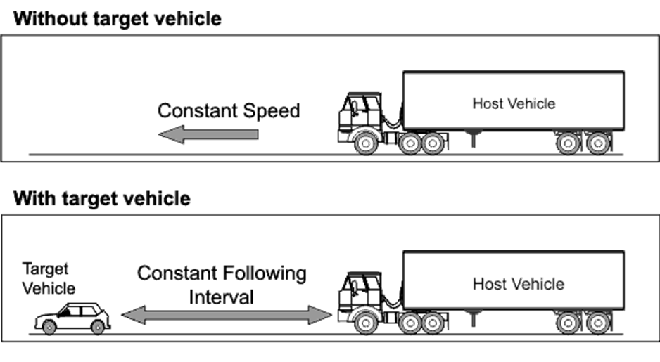

**Figure 2.8 Application of ACC**

**Principle of Operation of Adaptive Cruise Control**

There are two key types of headway sensors. Radar sensors employ microwave signals (typically at 35 or 76 GHz). Lidar sensors employ a laser diode to produce infrared light signals. Both types of sensors send a signal and monitor the time required for the signal to reflect off the object ahead. Optical or infrared image sensors are also being introduced for the purpose of detecting vehicles in the road ahead. These sensors can replace or supplement the information from radar or lidar sensors.

When ACC systems determine there is a need to slow the vehicle, they may use the engine, transmission and/or brakes to decrease the vehicle's speed and maintain a safe following distance. Many systems limit the maximum deceleration to no more than 3 m/s2 (10 ft/s2), although systems are beginning to appear that allow more aggressive braking (see Automatic Braking). The ACC user interface typically has both visual and audible indications that are provided to the driver depending on the severity of the situation. ACC systems can always be disengaged through the use of the brake pedal or the primary ACC user interface. In addition, certain stability systems such as traction control, and electronic stability control may also turn the ACC system off. ACC systems are evolving rapidly and are currently available on many mid- to high-end passenger cars as well as many heavy duty commercial trucks.

**Cruise control system**

The cruise control system controls the speed of the car by adjusting the throttle position, so it needs sensors to tell it the speed and throttle position.

It also needs to monitor the controls so it can tell what the desired speed is and when to disengage.

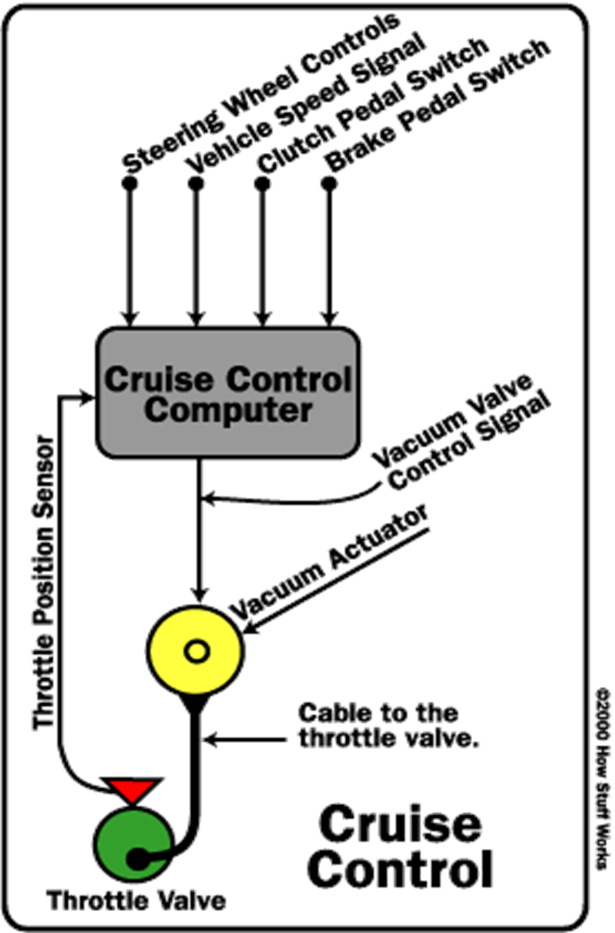

**Figure 2.9 Basic structure of CCS**

**Sensors**

Headway sensor (radar, lidar or image), vehicle speed sensor, accelerator pedal position, brake pedal position

**Actuators**

Throttle, brakes

**Data Communications**

Control Unit Communication: Typically Control Area Network (CAN) Bus System

**2.6 COOPERATIVE ADAPTIVE CRUISE CONTROL - CACC**

The CACC system is an embedded control system for automobiles which automatically monitors and adjusts a vehicle speed according to the traffic conditions in its immediate vicinity. The CACC system on a vehicle will receive the necessary data from sensors on the vehicle, will maintain communication with the CACC system in another vehicle directly in front of it and communication with a central Street Monitoring Data Center. In order to effect a change in the vehicle speed, the system issues commands to the throttle device as well as to the brake pedal. It includes all related components of a generic embedded system.

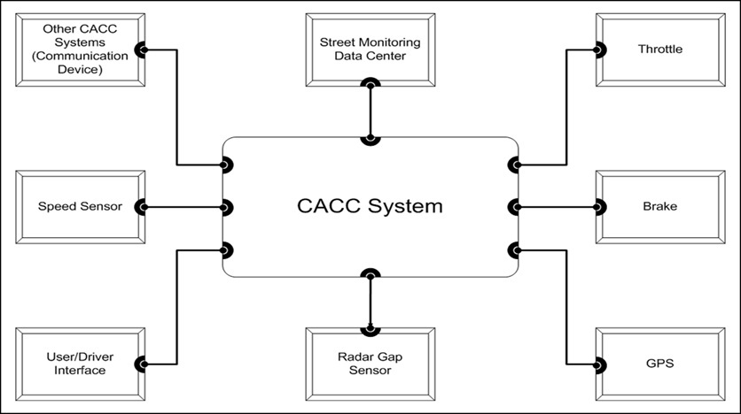

**Figure 2.10 General View of a Cooperative Adaptive Cruise Control (CACC) System and Its Interfaces.**

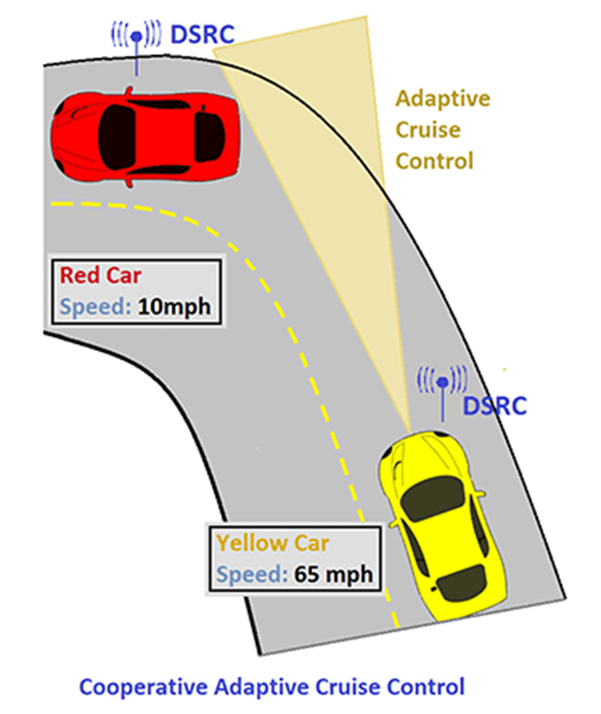

**Figure 2.11 Implementation of CACC**

**2.7 DEDICATED SHORT RANGE COMMUNICATIONS**

Dedicated Short Range Communications (DSRC) is a data-only automotive communication protocol. There are two broad categories of DSRC: Vehicle-to-Vehicle (V2V) communication and the Vehicle-to-Infrastructure (V2I) communication. Typical or potential applications of DSRC include:

* Electronic toll collection
* Cooperative adaptive cruise control
* Intersection collision avoidance
* Approaching emergency vehicle warning
* Automatic vehicle safety inspection
* Transit or emergency vehicle signal priority
* Electronic parking payments
* Commercial vehicle clearance
* In-vehicle display of road signs and billboards
* Traffic data collection
* Rail intersection warning

DSRC is widely used for electronic toll collection (a V2I application) today. V2V applications will not be fully functional until a significant percentage of cars on the road are equipped with DSRC systems.

**2.8 DRIVE BY WIRE**

There is a trend in the automotive industry towards eliminating mechanical and hydraulic control systems and replacing them with electronic controls. Many traditional mechanical components can be eliminated such as shafts, pumps, hoses, fluids, coolers, cylinders, etc., which reduces the weight of the vehicle and improves efficiency. Electronic controls can also improve safety by facilitating more automated control functions like stability control. They also enhance the flexibility of automotive systems, making it easier to modify or upgrade vehicles. Electronic controls improve handling, enable better fuel efficiency and exhibit shorter response times in emergency situations.

The complexity of the system control functions enabled by electronic systems can make vehicle performance more difficult to model. Integrating these complex systems, while achieving predictable, fail-safe performance represents a significant challenge for the automotive industry.

Drive by wire involves 3 main systems:

1. Steer by Wire
2. Throttle by Wire
3. Brake by Wire

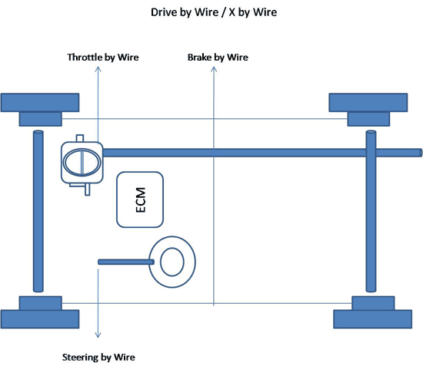

**Figure 2.12 Block Diagram of Drive by Wire**

**STEER BY WIRE**

Steer-by-Wire systems do not have a direct mechanical connection between the steering wheel and the wheels of the vehicle. Instead, turning the steering wheel sends instructions to an electronic control unit, the control unit actuates an electric motor that controls the steering angle of the wheels. Steer-by-Wire systems have the following advantages:

* Interior styling is easier and more versatile due to the absence of the steering column
* There is more space available in the engine compartment
* This system can be modeled and installed as a modular system
* Allows designs that prevent the steering wheel from rigidly impacting the driver during a frontal crash
* Driving characteristics can be monitored and the steering response can be easily adjusted
* Simplifies designs and lowers manufacturing costs

There are different models for steer-by-wire systems. Below is an illustration of one such system:

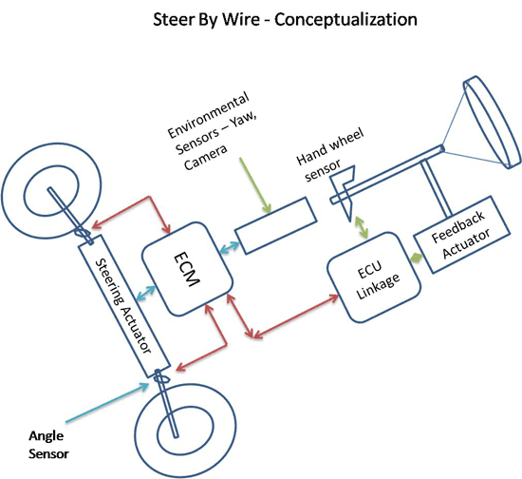

**Figure 2.13 Steer By Wire - Conceptualization**

Steering wheel position and angle is measured by hand wheel sensor which is linked to ECM through an ECU linkage which generates torque. Environmental sensors analyze environmental factors like Yaw, roll over position and positions using cameras which are translated into the engine control module. Using all these inputs tires are actuated using steering sensors and the angle of the steering rod is controlled and monitored by the ECM.

**Sensors**

Torque sensor, steering angle sensors, yaw sensor, wheel speed sensor, and wheel angle sensor

**Actuators**

Steering actuator, feedback actuator, pinion actuator

**CHAPTER ….**

**CONCLUSION**

In the recent years, more and more equipment in automotive are changing from mechanical systems to electronic systems. Embedded system is a core of vehicle electronic systems because of its flexibility and versatility. The electronics revolution has influenced almost every aspect of automotive design including the powertrain, fuel combustion, crash protection and the creation of a comfortable cabin and nearly wireless environment. It is necessary to pay more attention to the fields of environments, safety and security, which are the most significant and challenge field of automotive embedded system design.

Embedded systems, especially in-vehicle embedded systems, are ubiquitously related to our everyday life. The development of embedded systems greatly facilitates the comfort of people’s life, changes our view of things, and has a significant impact on society. On the other hand, even though embedded systems technologies are becoming more and more mature, currently there still exist many challenges in technique and will be more with the ever growing speed and reliability demand from market. We expect more enlightening researches in this area.

**REFERNCES**

1. Usage of In-Vehicle Information and Communication Devices Survey, http://www.nuanoe.com/ads/automotive/survey,
2. J. Kotzian, V. Srovnal Jr.: Distributed embedded system for ultialight airplane monitoring. ICINCO 2007, Intelligent Control Systems and Optimization, Anger, France, 2007
3. Kun A.L., Miller W.T. III, Pelhe A., Lynch R.L., A Software Architecture Supporting In-Car Speech Interaction, Proc of IEEE Intelligent Vehicles Symposium, pp. 471-476, June 2004
4. Islam,S.Ajmal,F.Ali,S.Zahid,J.Rashdi,A..: 'Secure end-to-end communication over GSM and PSTN networks', IEEE International Conference on Electro/Information Technology, 2009, pp-323
5. http://dspace.wul.waseda.ac.jp/dspace/bitstream/2065/28391/3/Honbun-4286.pdf
6. http://www.eng.auburn.edu/~wilambm/pap/2011/Recent%20advances%20in%20in-vehicle%20embedded%20systems.pdf