**Prerequisite:**

* conda install -c conda-forge keras
* conda install tensorflow
* pip install opencv-python

Also install waitress to better support flask

* conda install -c conda-forge waitress

**Steps to run the web app:**

Run the web app from the command prompt: python runit.py



Command prompt shows flask app is running as displayed below:

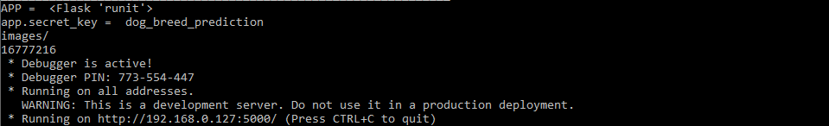

Open the browser and go to <http://192.168.0.127:5000/>. Below page opens up.

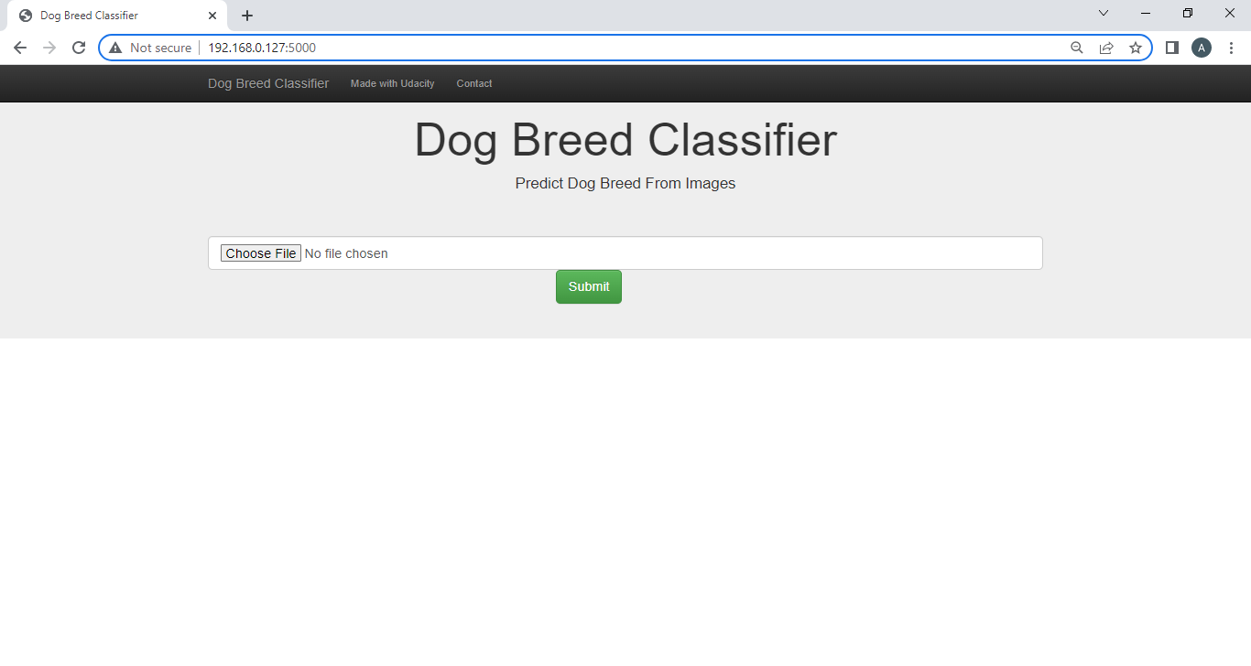

Click on “Choose File” and select “Brittany_02614.jpg” and click on open.

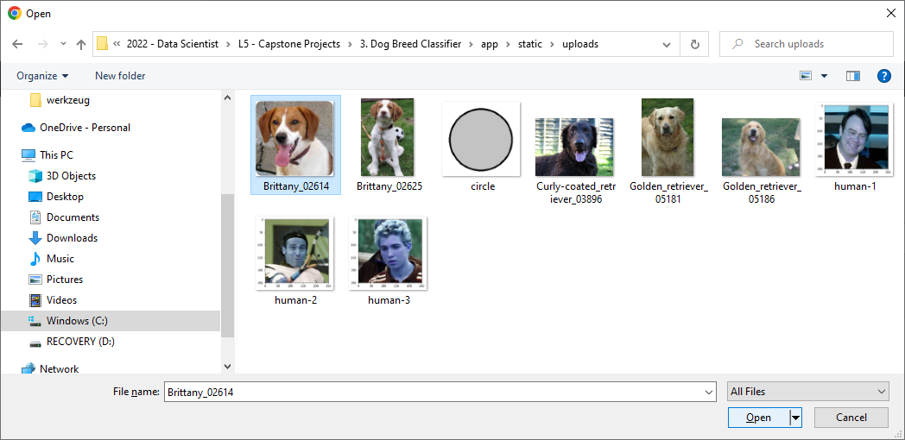

File name gets displayed on the screen.

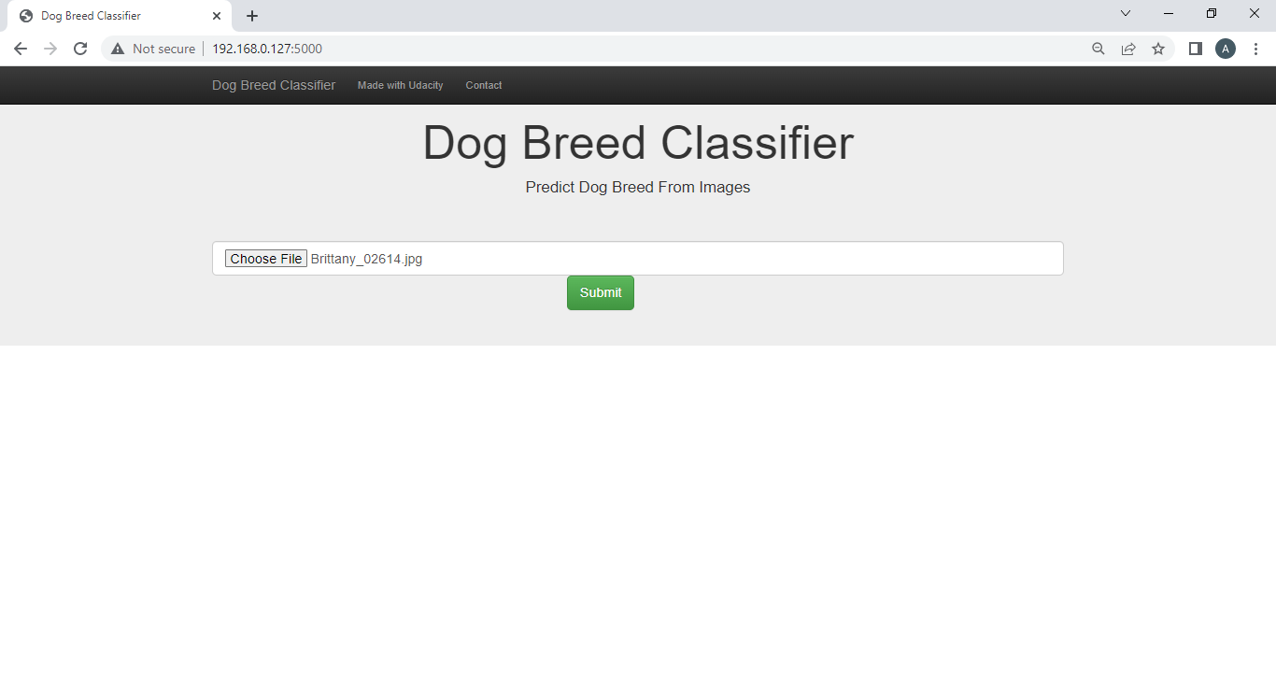

Click on submit.

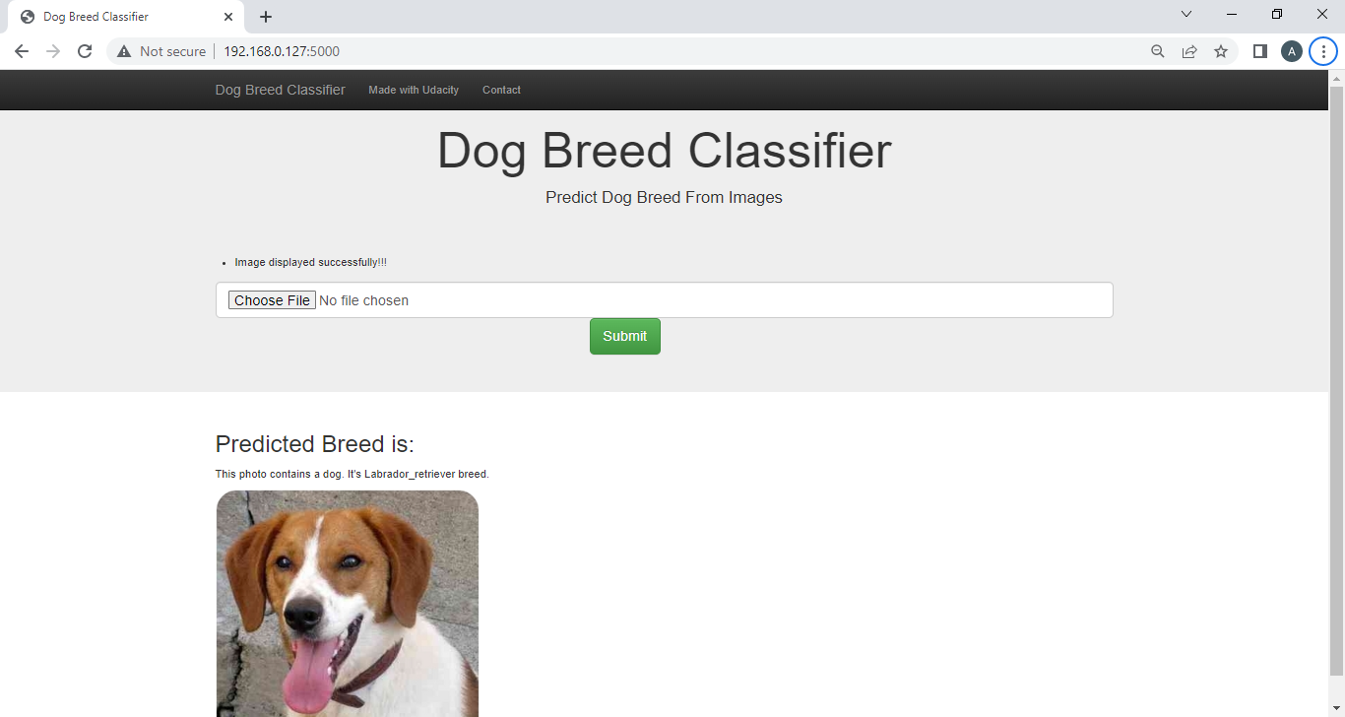

Picture of the dog and the prediction displayed on the page. Now select a different dog image say – “Brittany_02625.jpg”

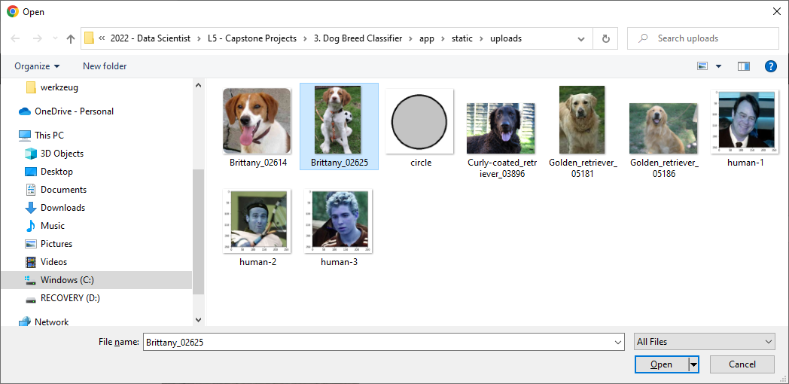

Picture of the dog and the prediction displayed on the page.

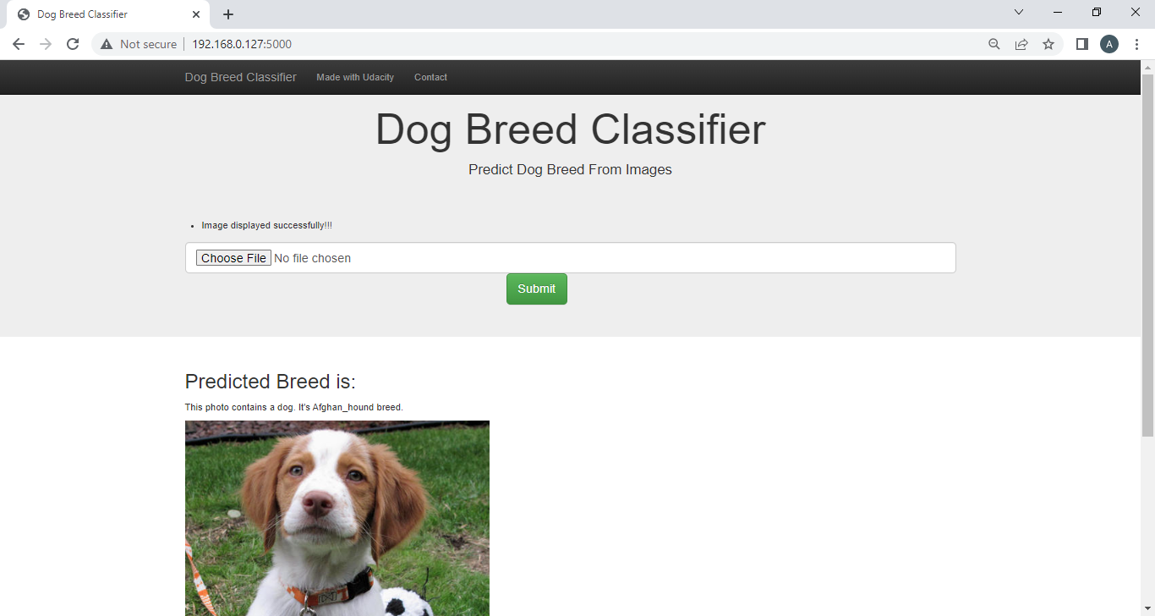

Now select a different dog image say – “Golden_retriever_05186.jpg”. Click on Open and them submit.

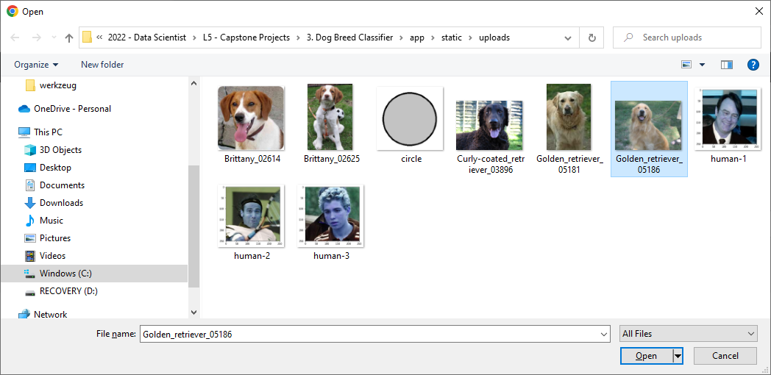

Picture of the dog is and the prediction displayed on the page.

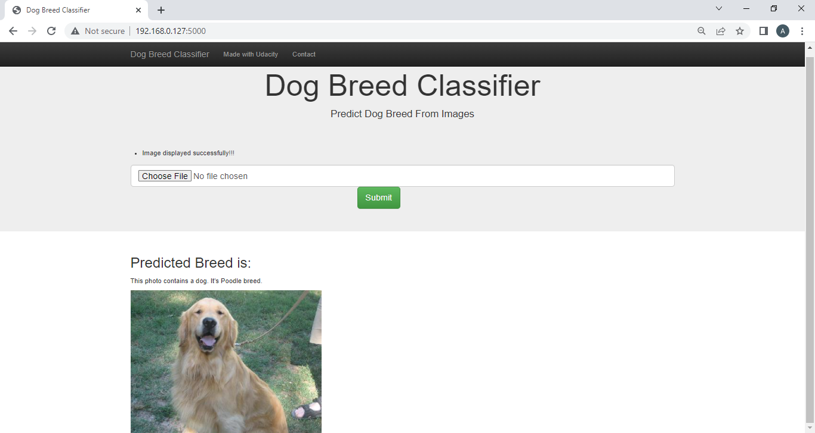

Now select an image of a human, say “human-3.jpg” and then click open and submit.

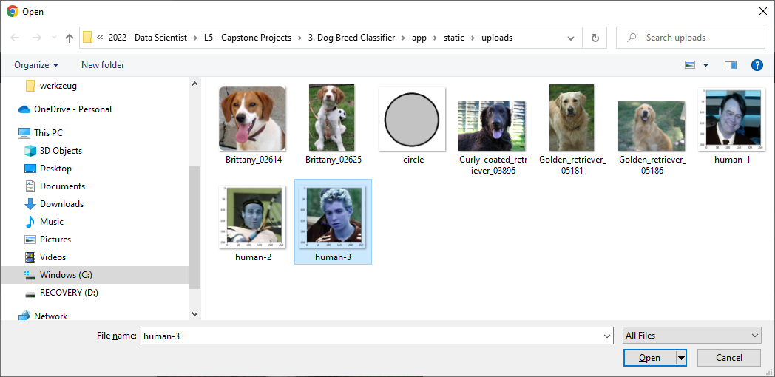

The app identifies as a human face and predicts then predicts the corresponding dog breed.

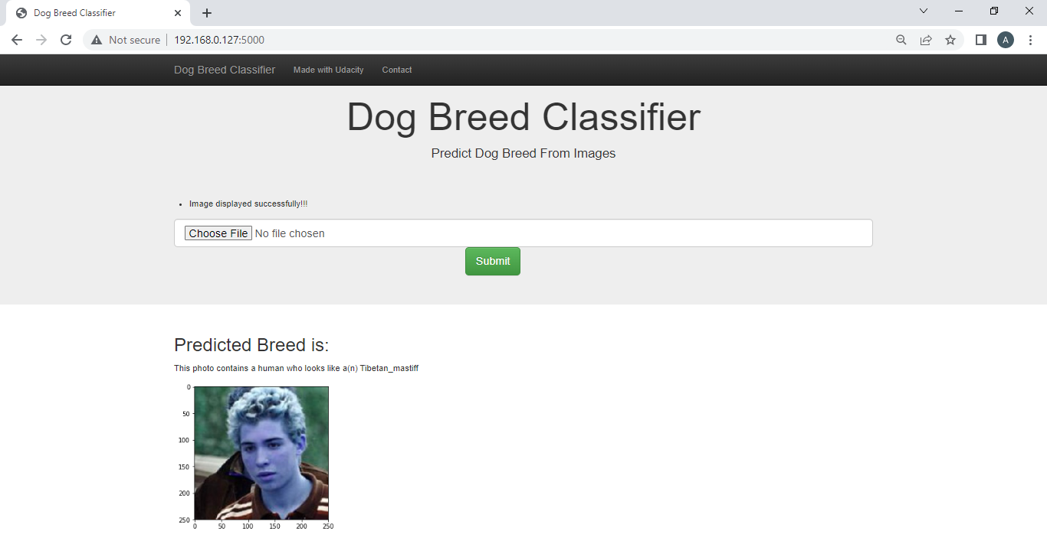

Now finally select an image which is neither of dog or of a human say - “circle.jpg”. Then click on open and submit.

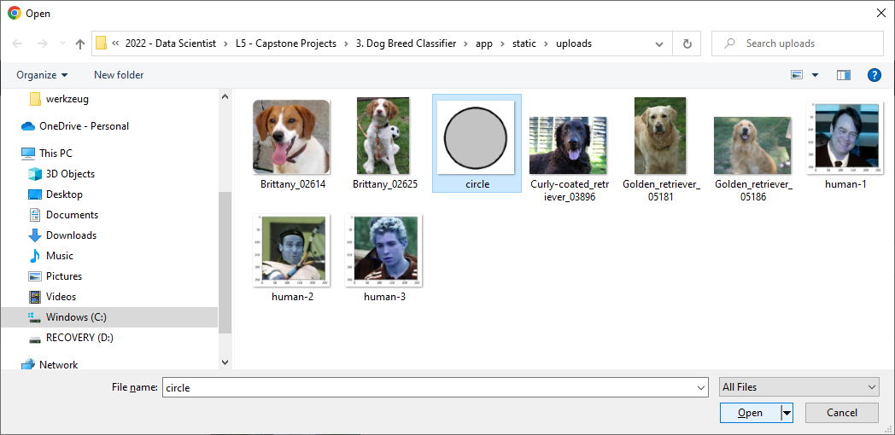

The app correctly suggests that - “This photo contains neither a human nor a dog."

