Assignment — Batch 11 | Bhumeet Selokar
Olist dataset | 8 sources → ADLS raw → metadata-driven ADF (Parquet) → ADLS src → Databricks SCD1/SCD2 → Delta curated → Power BI (Dashboard)

1. Project Overview
Azure E2E ETL Project with Eight e-commerce sources (SQL Server on-prem, SFTP, Snowflake, Excel, CSV, JSON, bulk, REST API) land in a raw ADLS Gen2 zone. Azure Data Factory routes each load dynamically through a 3-level Switch hierarchy driven by an Azure SQL metadata database, converting everything to snappy Parquet partitioned type/yyyy/MM/dd in the src zone. Azure Databricks consumes the latest partition and merges into Delta tables in the curated (std) zone using SCD Type 1 (fact) and SCD Type 2 (dimension) patterns. Execution is fully audited in a log table via stored procedures.

Architecture

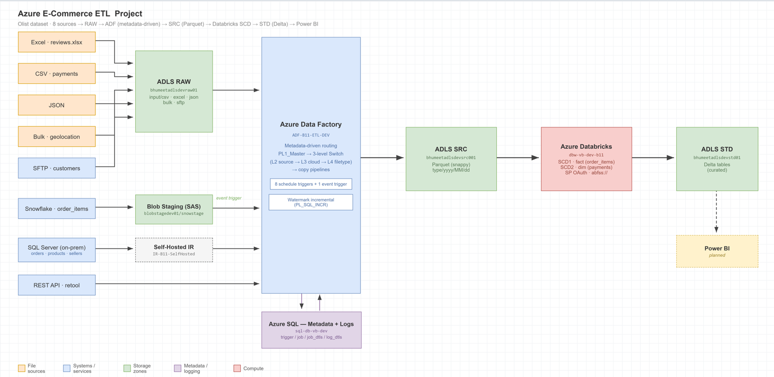

2. Azure Objects

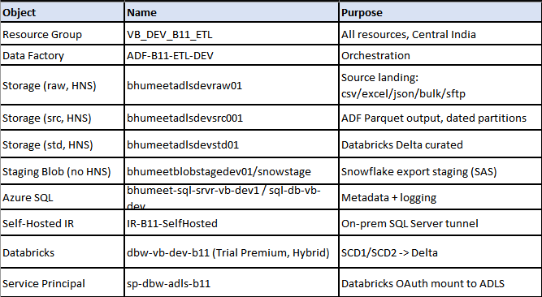

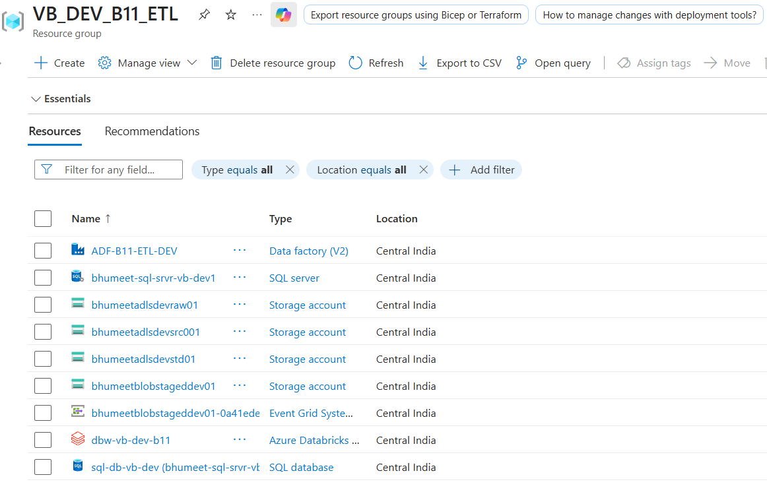

3. Data Sources

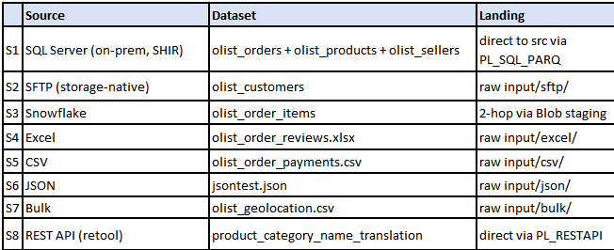

SSMS — vbproject DB w/ all 3 tables

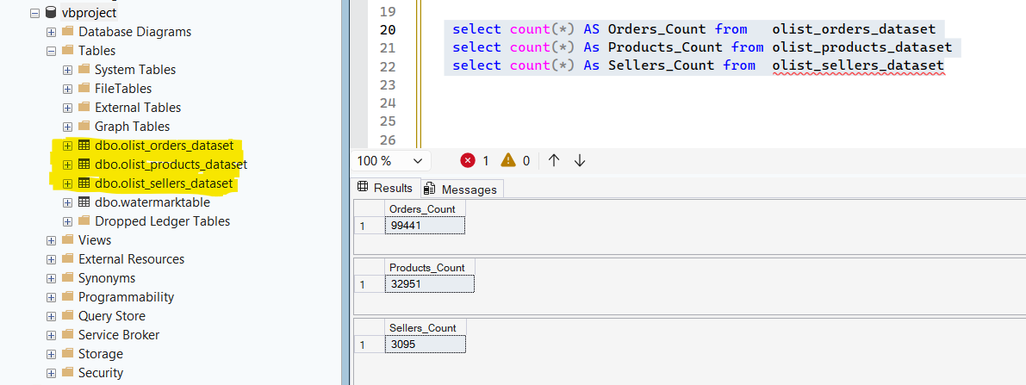

WinSCP session connected + customers csv in input/sftp/ (portal)

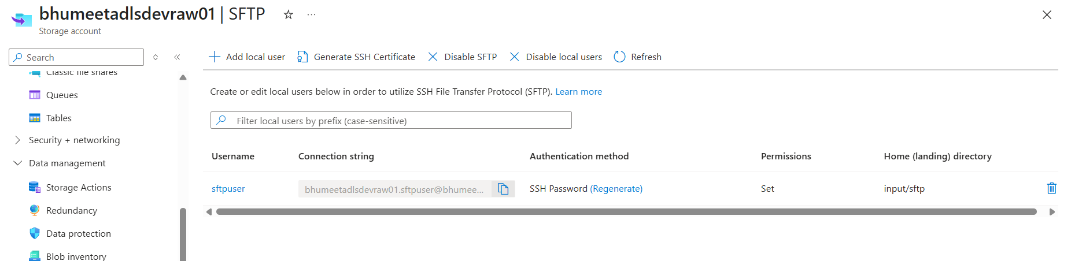

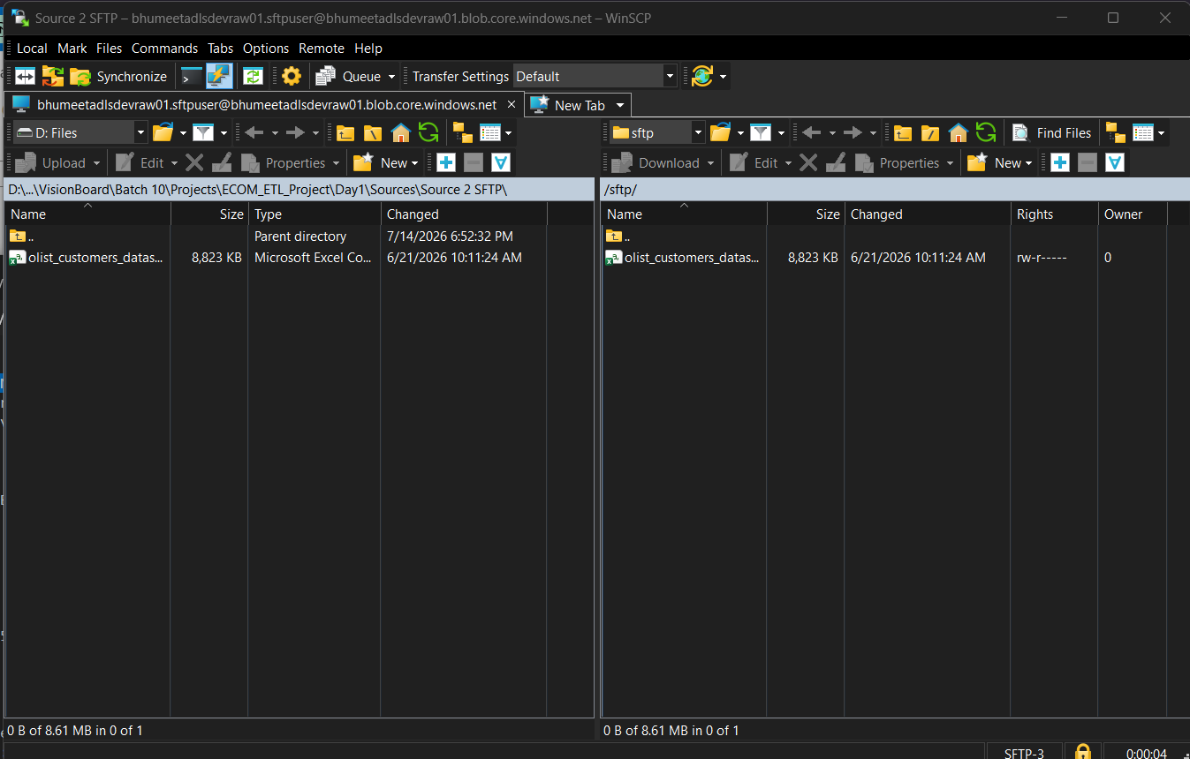

Snowflake worksheet — order_items_dataset (112,650 w/ full CSV load)

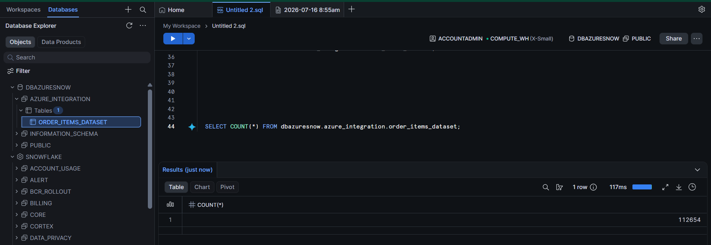

Raw And Source(Parquet) container input/ folder listing showing csv/excel/json/bulk/sftp]

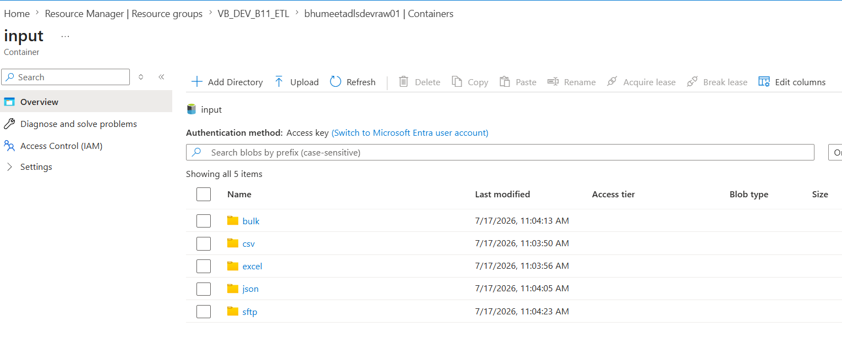

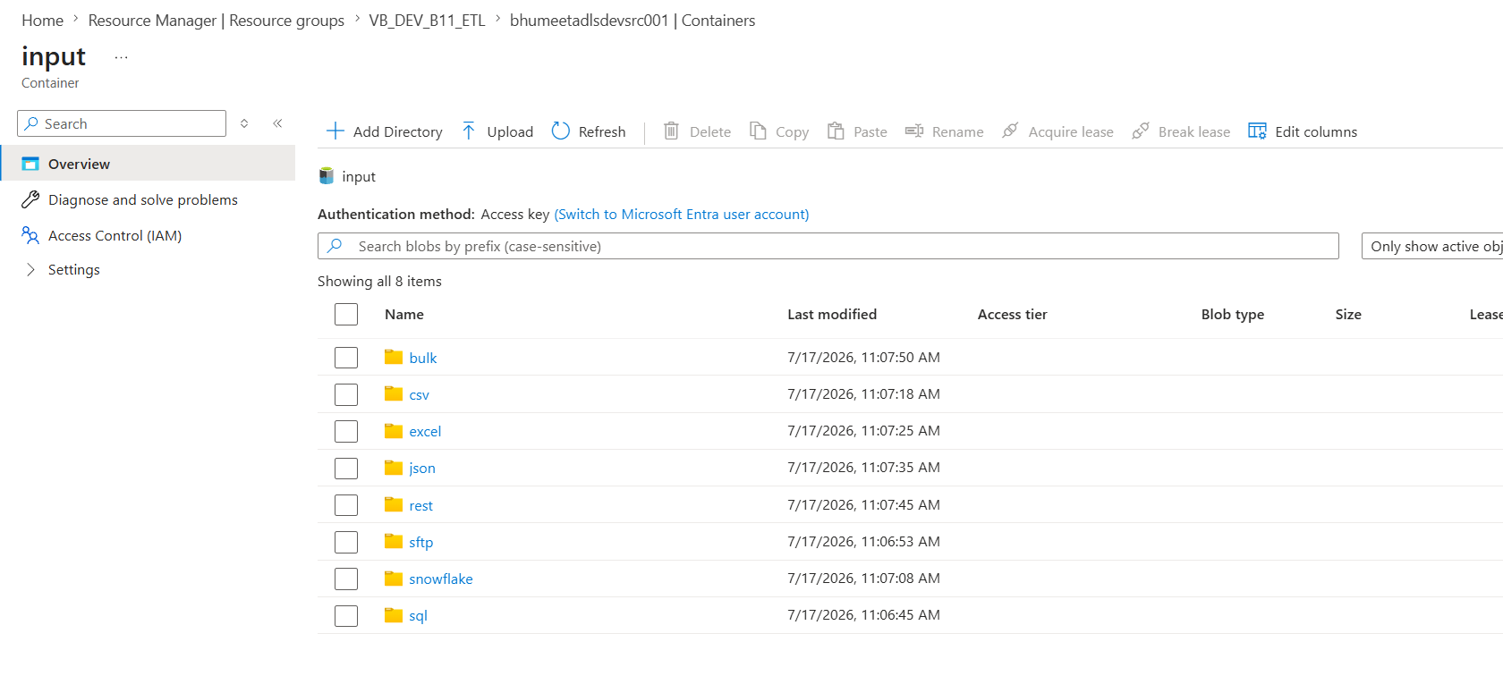

Retool API response (JSON array)

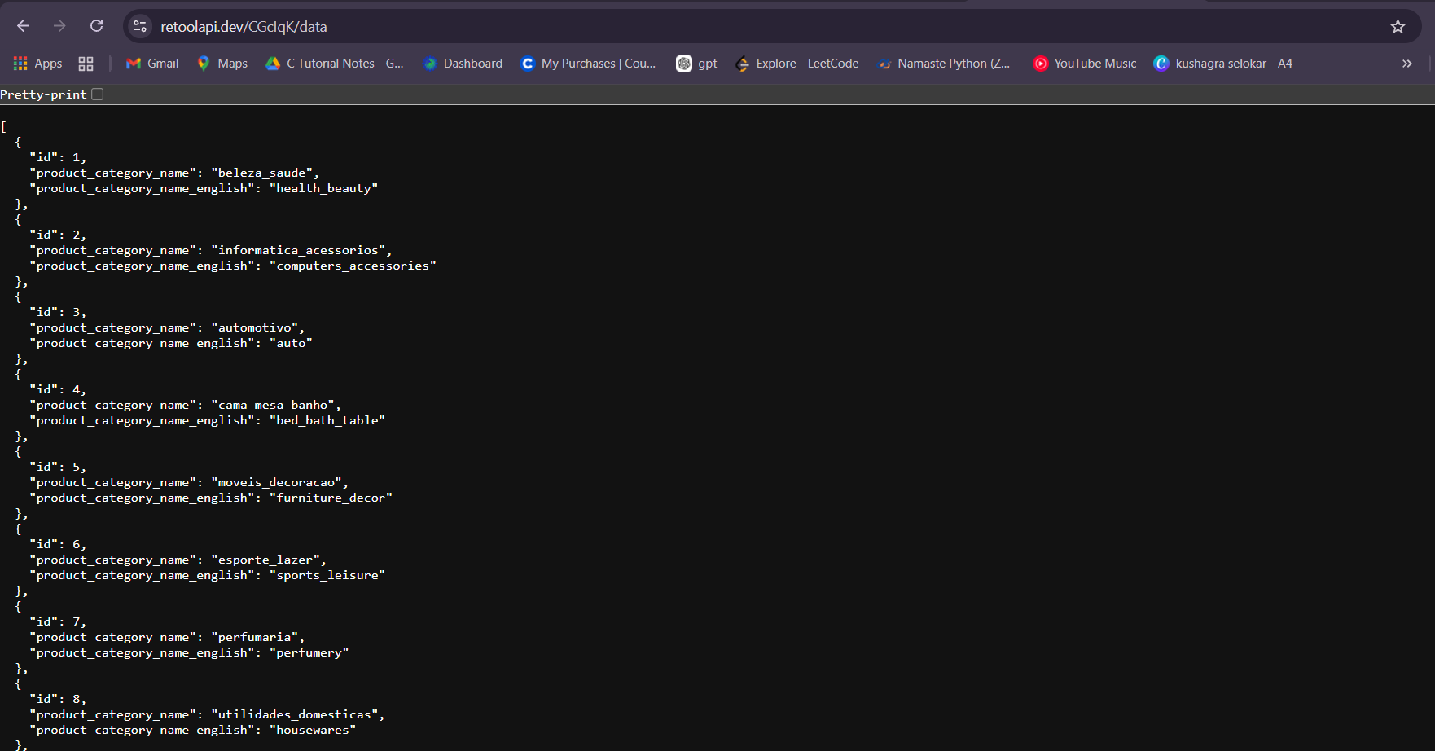

4. Metadata (Azure SQL DB)
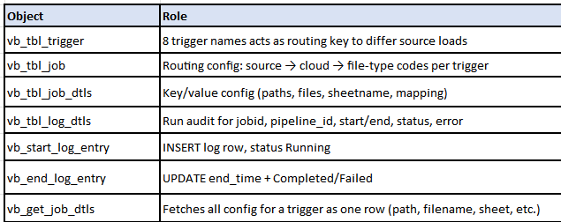

vb_tbl_log_dtls rows showing Completed entries

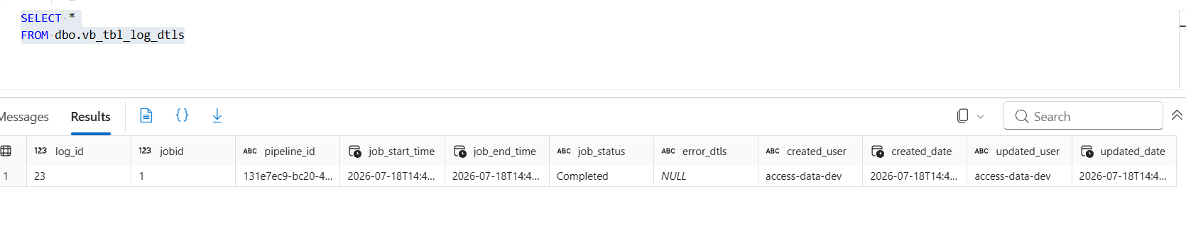

Before running any pipeline, we need to check the metadata:

All 8 rows are there, one per trigger (Tr_sample_csv through Tr_sample_bulk).

L2 is the first decision the pipeline makes — it tells the source category.

L3 and L4 switches are populated only for csv and excel, blank for the rest. Only the CloudStorage branch needs those extra decisions (which cloud, which file format).

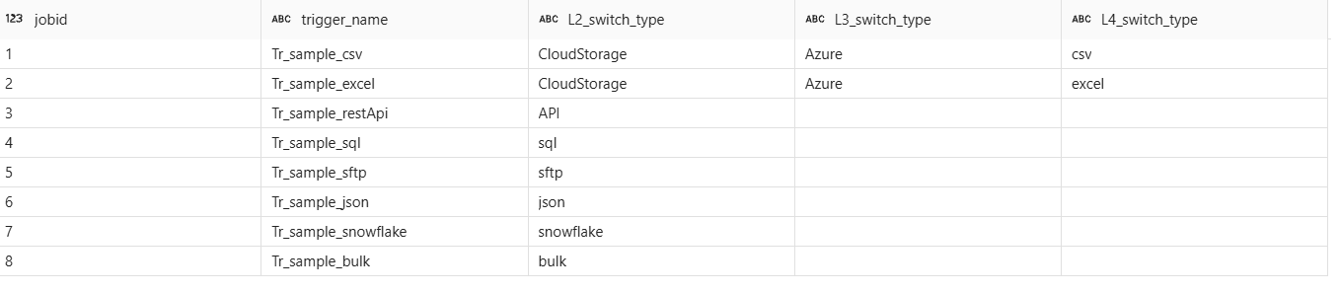

5. Integration Runtimes
AutoResolveIntegrationRuntime (cloud copies)
IR-B11-SelfHosted (on-prem SQL Server).
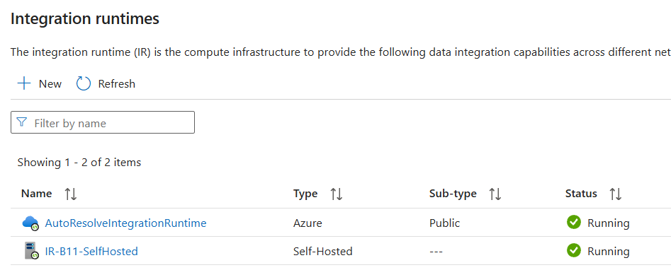

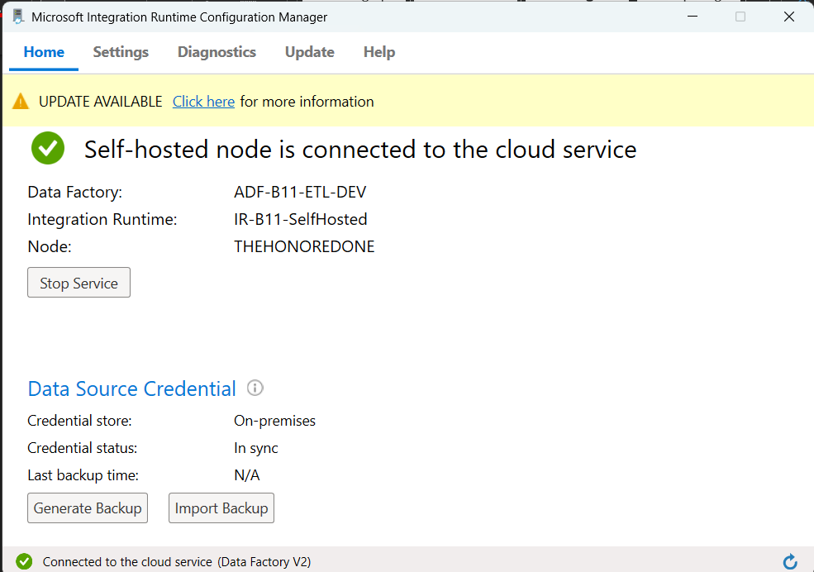

6. Linked Services (12)

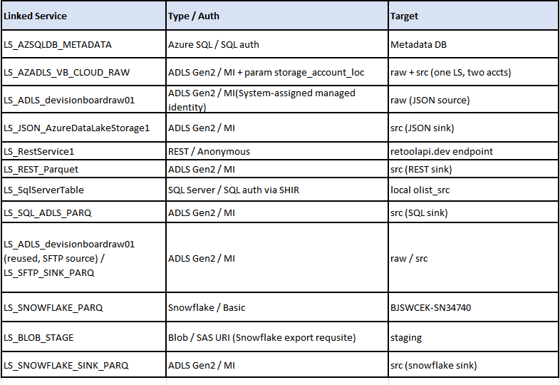

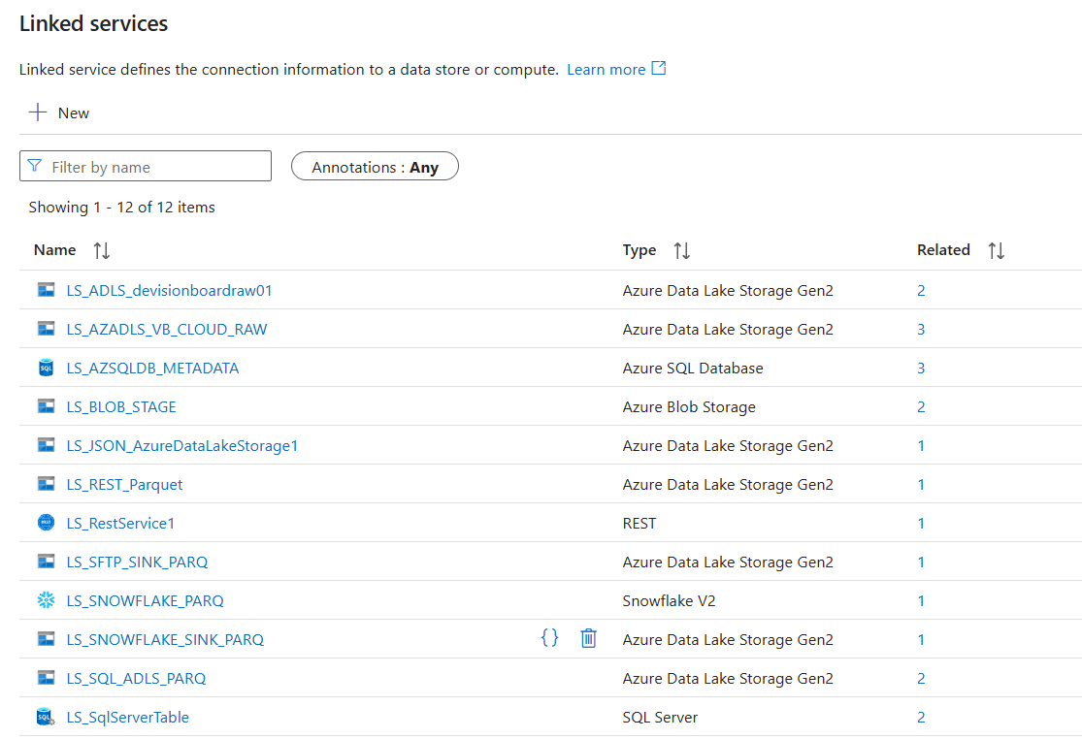
Parameterized LS URL expression:
https://@{linkedService().storage_account_loc}.dfs.core.windows.net

Test connection Successful on LS_AZADLS_VB_CLOUD_RAW without param prompt filled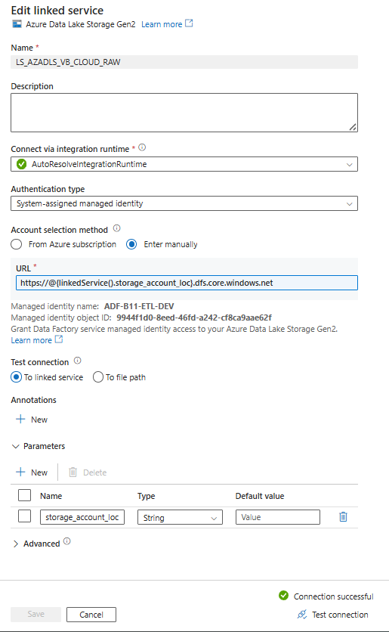

7. Datasets (15)
Datasets Two Design Patterns

Chosen by whether the dataset is reused across triggers or owned by a single pipeline.

Pattern 1 — Param-driven (reused by multiple triggers; values resolved at runtime from metadata):
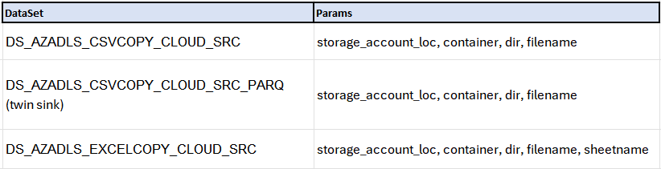

The Connection tab doesn't hold real paths — it holds placeholders (@dataset().container, @dataset().filename, etc.) that get filled in fresh every time the pipeline runs, with values pulled from LKUP_JOB_DETAILS (the metadata lookup). That's why the same dataset works for both PL4_1_CSV (payments) and PL4_2_EXCEL (reviews) — it isn't tied to one file, it just reads whatever the current run's metadata says. Adding a CSV or Excel source later means adding one row to the metadata table — no new dataset, no ADF redeploy.

Pattern 2 — Fixed-expr (single-owner pipeline; no reuse, so no parameters)
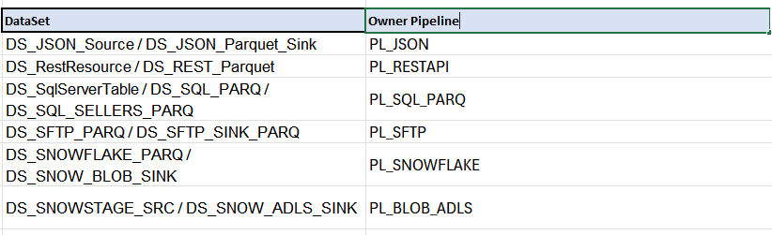

Sink Directory is a hardcoded date expression instead of a metadata lookup:
@concat('csv/',formatDateTime(utcNow(),'yyyy'),'/',formatDateTime(utcNow(),'MM'),'/',formatDateTime(utcNow(),'dd'))

Sample Datasets

DS_AZADLS_CSVCOPY_CLOUD_SRC
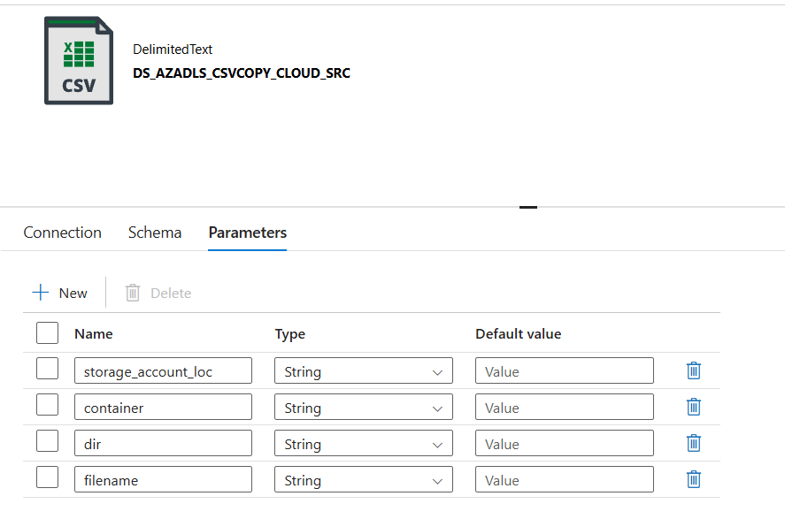

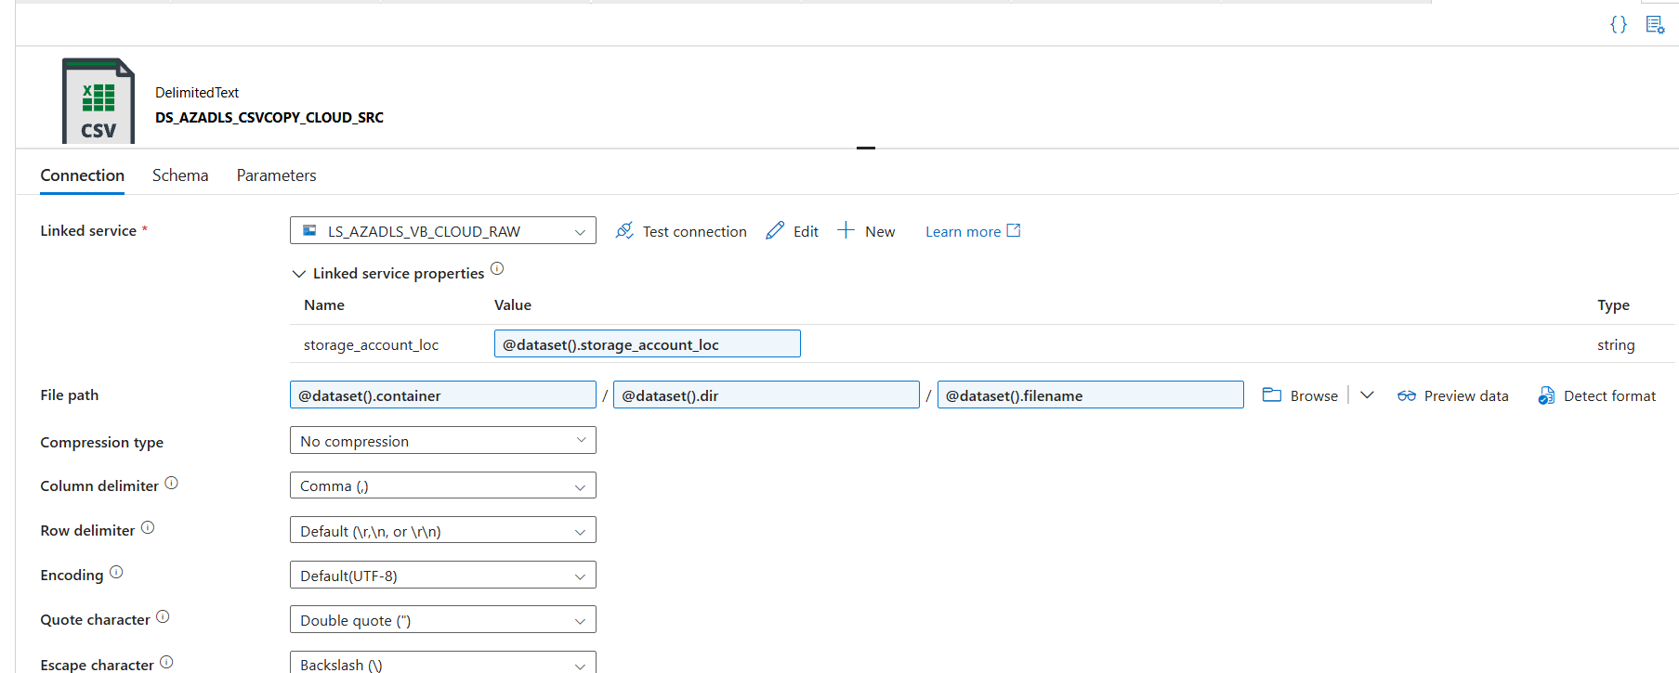

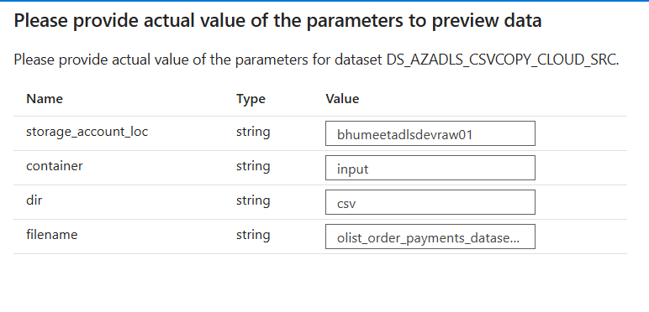

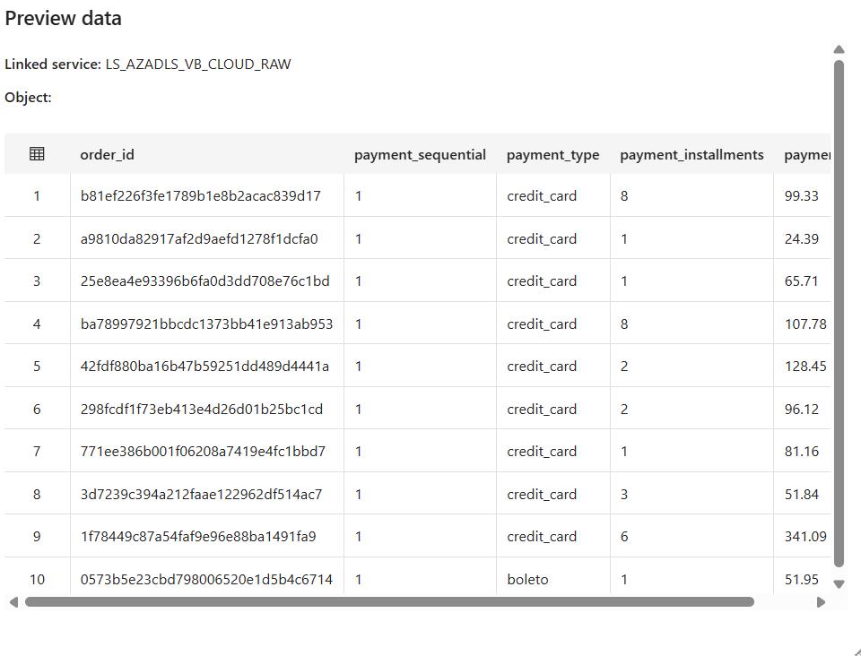

DS_AZADLS_EXCELCOPY_CLOUD_SRC

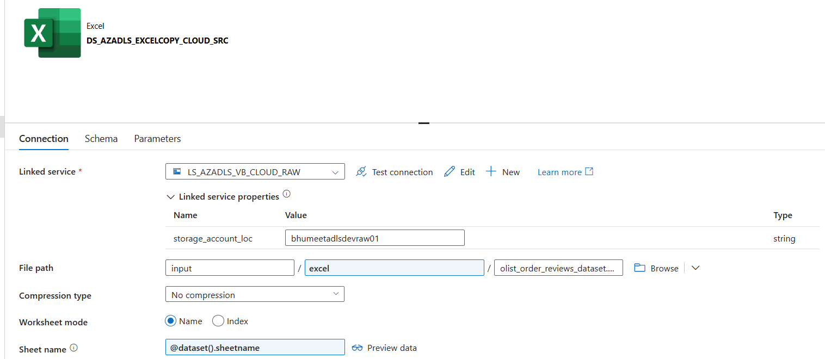

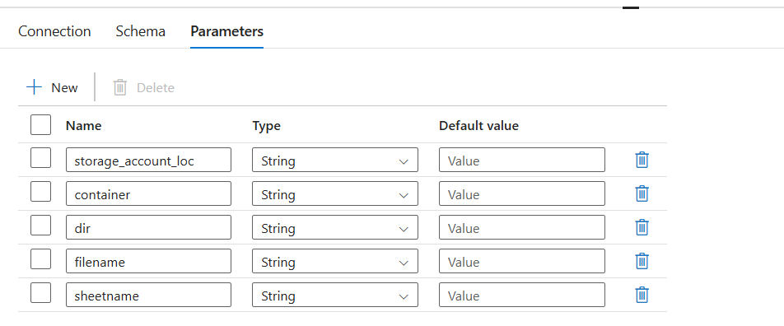

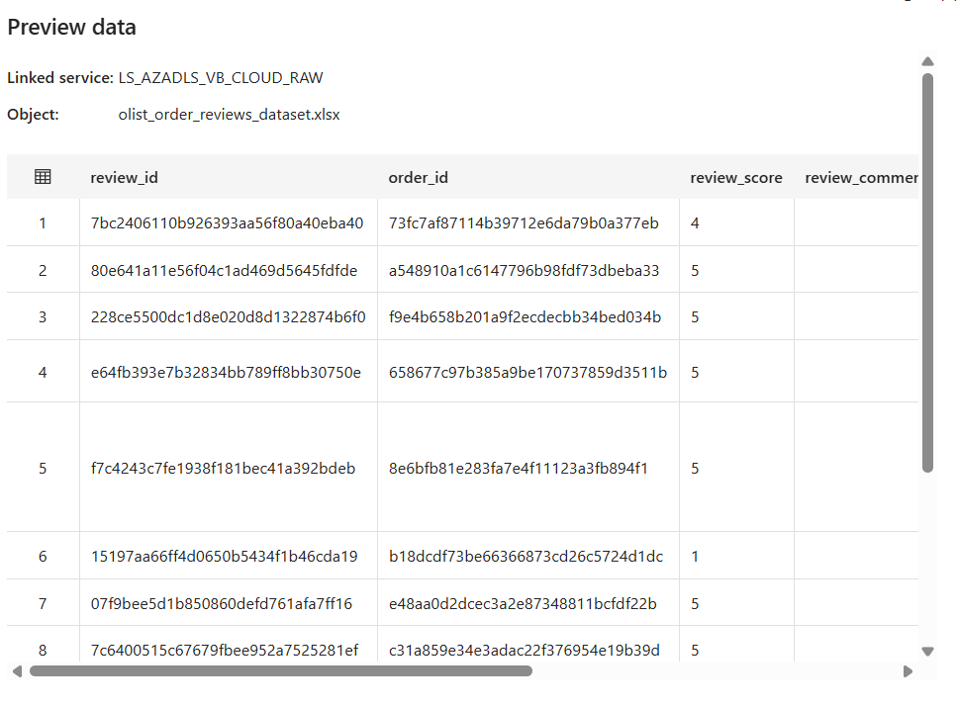

8. Pipelines — Metadata-Driven Routing Chain

8.1 PL1_Master (entry orchestrator)
SET_VAR_TRIGGER resolves trigger name (param wins, else TriggerName):

@if(or(equals(pipeline().parameters.Trigger, null), equals(pipeline().parameters.Trigger, '')), pipeline().TriggerName, pipeline().parameters.Trigger)

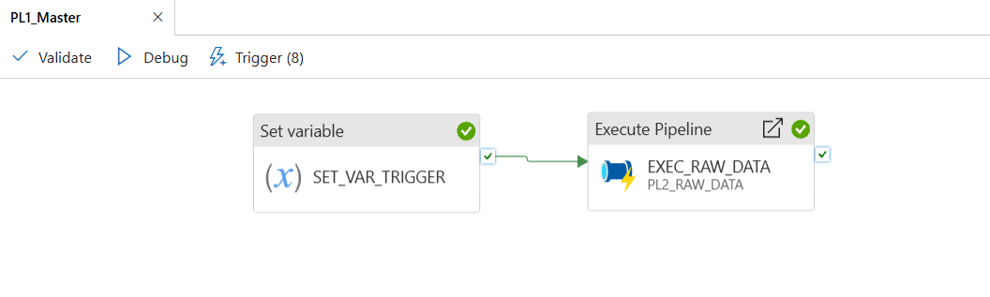

8.2 PL2_RAW_DATA (L2 router)
SELECT DISTINCT L2_switch_type FROM dbo.vb_tbl_job a JOIN dbo.vb_tbl_trigger b ON a.trigger_id=b.trigger_id WHERE b.trigger_name='@{pipeline().parameters.Trigger}'

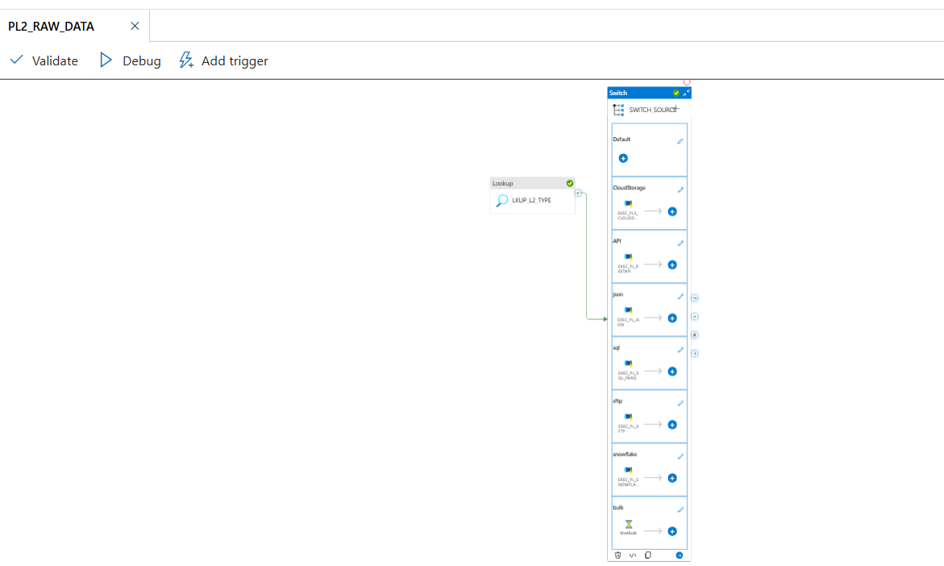

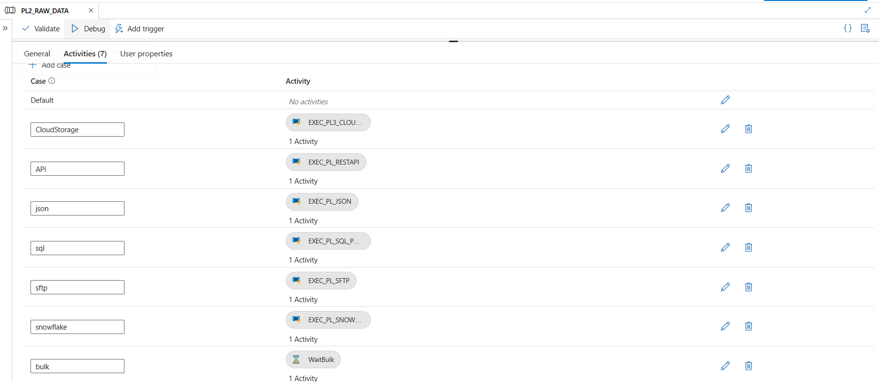

8.3 PL3_CLOUDSG_CSV_EXCEL (L3) + PL4_FILETYPE_CSV_EXCEL (L4)

L3 Switch: routes to file-type router

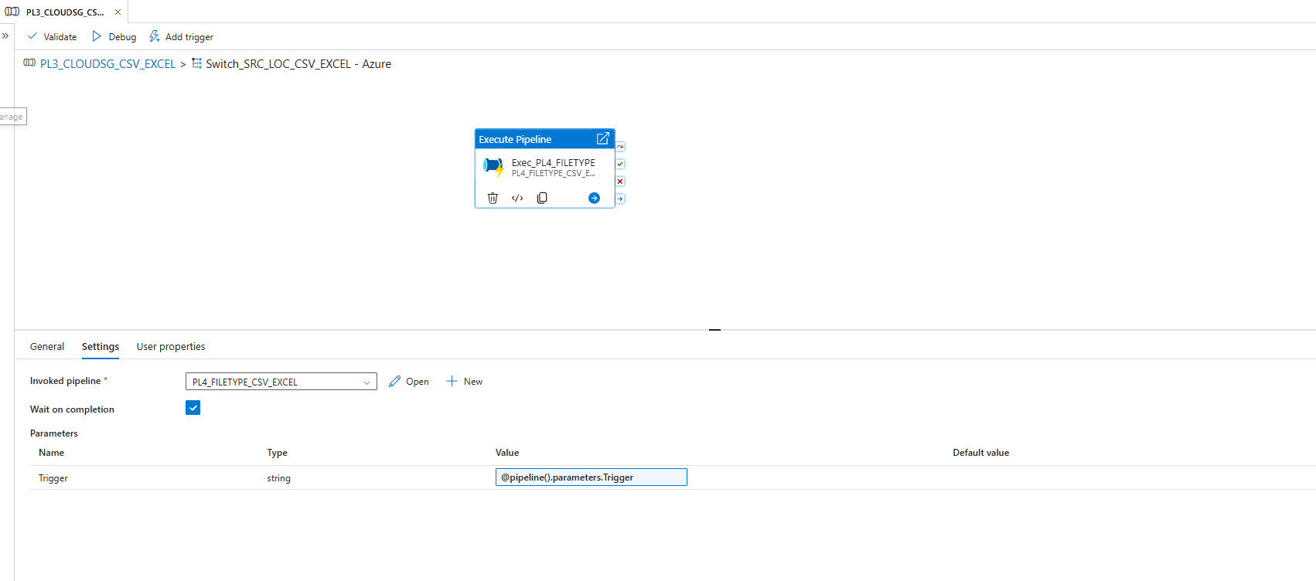

L4 Switch: routes to grain copy pipeline

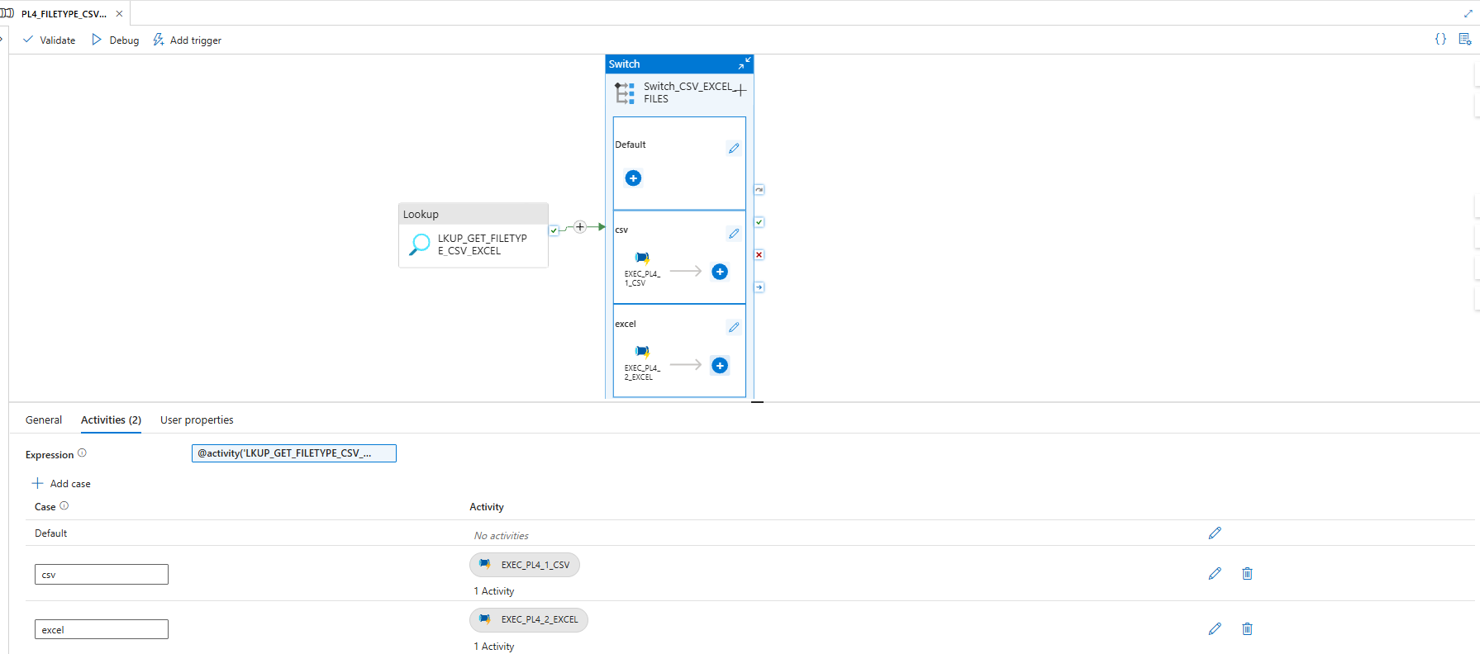

8.4 PL4_1_CSV ( CSV ingestion w/ logging)
Chain: LKUP_JOB_DETAILS -> SP-START-LOG-ENTRY (vb_start_log_entry) -> SET_VAR_MAPPING (TabularTranslator) -> COPY-CSV (raw CSV -> src Parquet, Mapping=@json(variables(mapping))) -> SP-SUCESS-LOG-ENTRY (sic — matches ADF object name) (green) / SP-FAIL-LOG-ENTRY (red, error=@activity(COPY-CSV).error.message).

PL4_1_CSV full canvas — 6 activities w/ green + red arrows

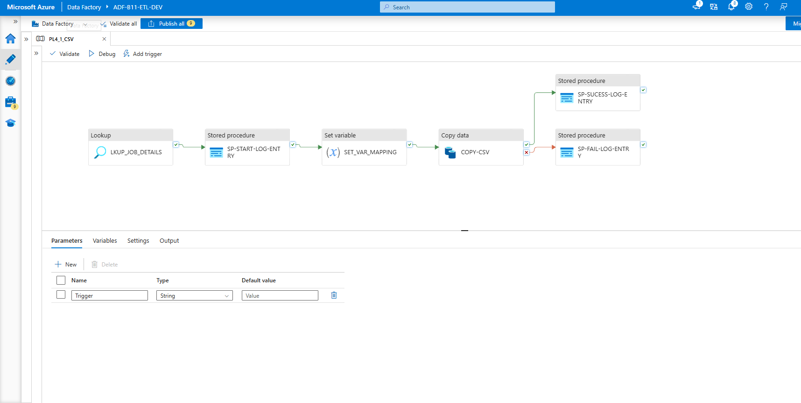

SP-START-LOG-ENTRY Settings
jobid = @activity('LKUP_JOB_DETAILS').output.firstRow.jobid
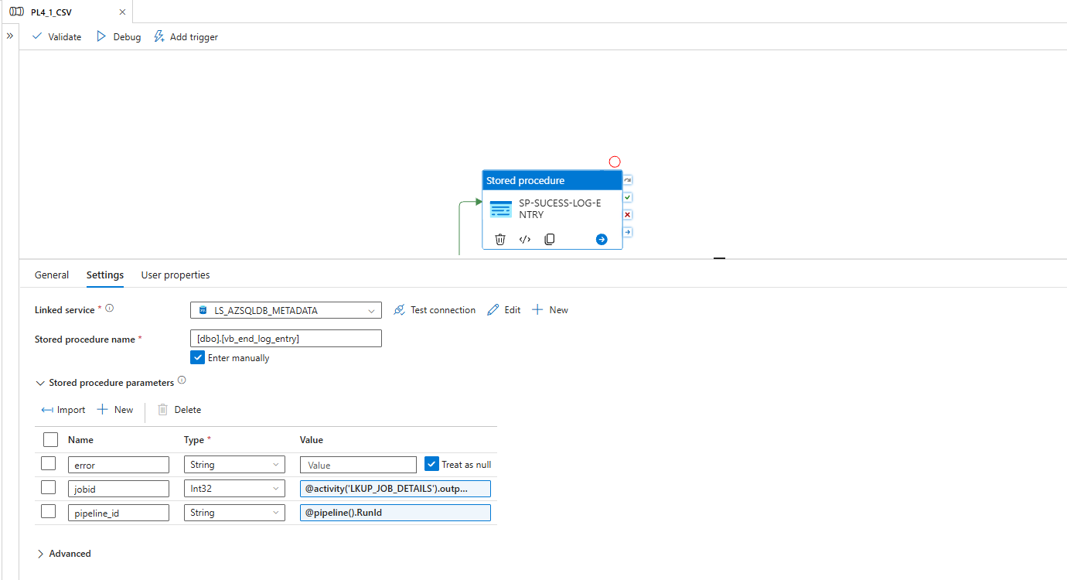

COPY-CSV Source
filename=@activity('LKUP_JOB_DETAILS').output.firstRow.SourceFile)

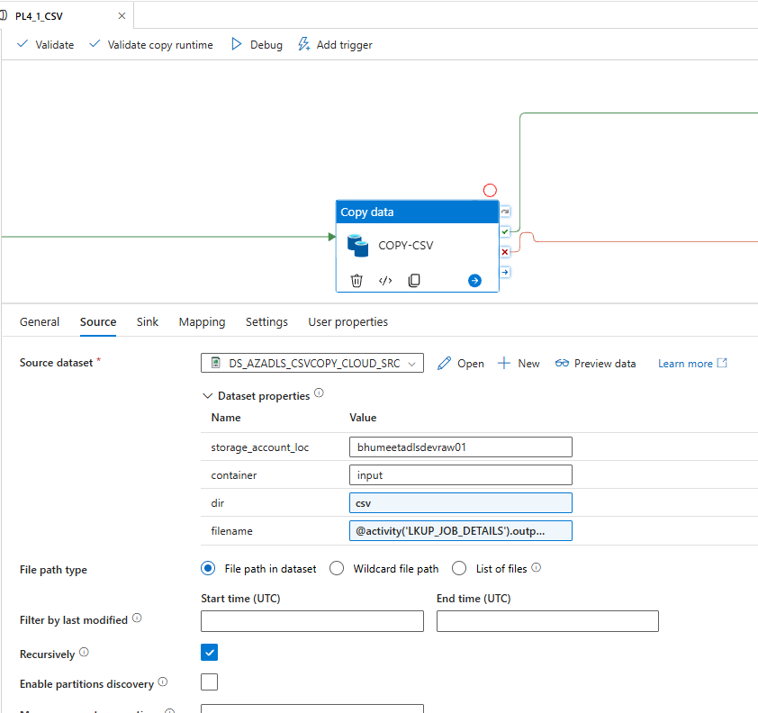
COPY-CSV Sink

Dir = @concat('csv/',formatDateTime(utcNow(),'yyyy'),'/',formatDateTime(utcNow(),'MM'),'/',formatDateTime(utcNow(),'dd'))

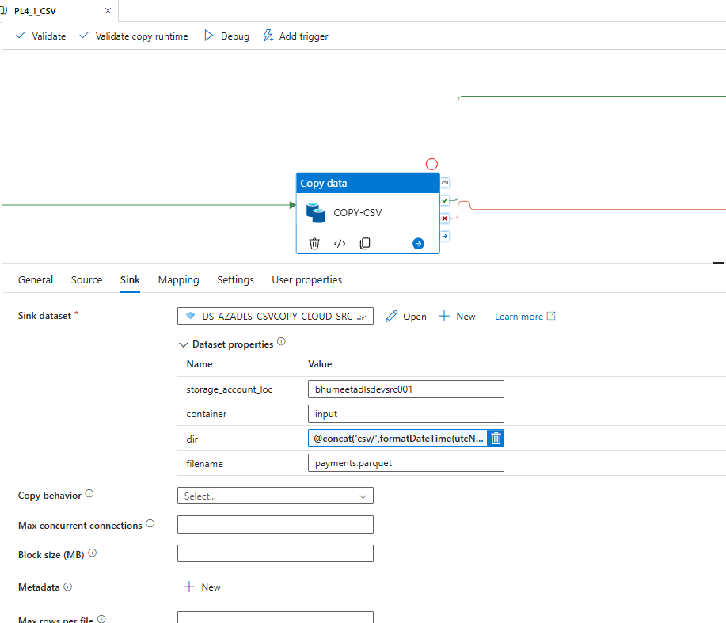

Log table — jobid=1 Completed

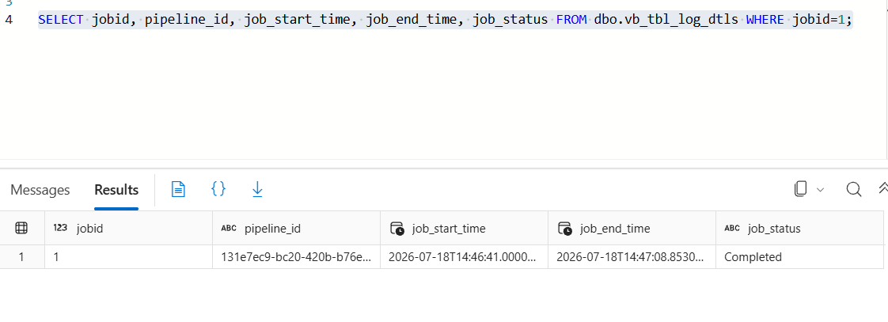

Portal — payments.parquet

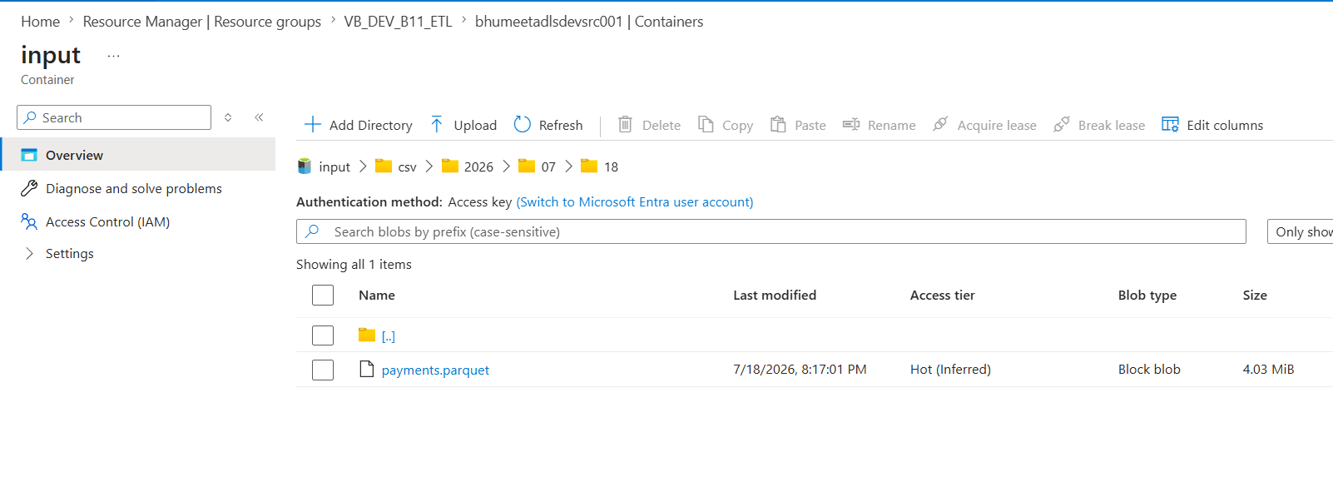

8.5 PL4_2_EXCEL (Excel ingestion created via cloning CSV Version with deltas)

COPY-EXCEL Source — Excel dataset w/ sheetname param

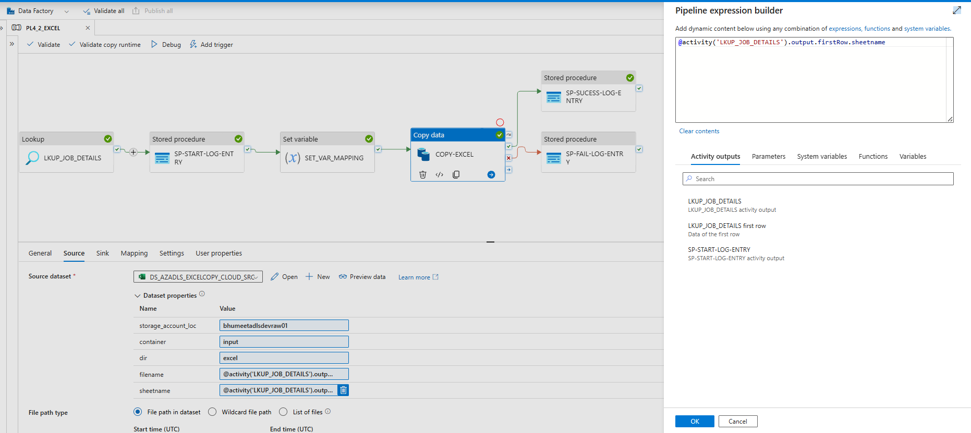

reviews.parquet at input/excel/yyyy/MM/dd/

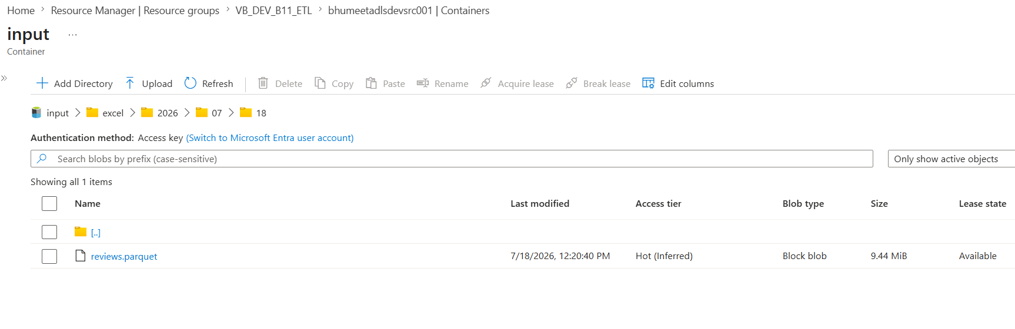

8.6 PL_JSON + PL_RESTAPI (each standalone )
PL_JSON: JSON (Array of documents) -> Parquet json/yyyy/MM/dd. PL_RESTAPI: GET w/ RFC5988 pagination -> Parquet rest/yyyy/MM/dd.
PL_JSON + COPY-JSON Source
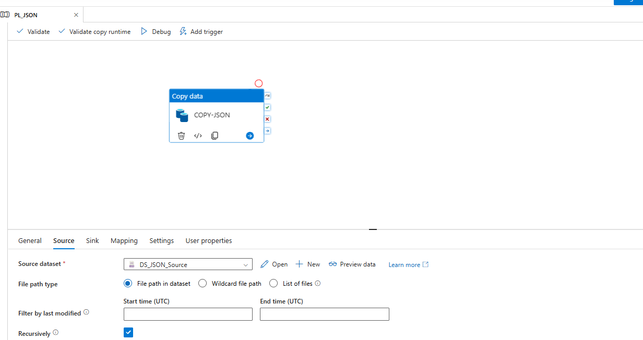

PL_RESTAPI COPY-REST Source

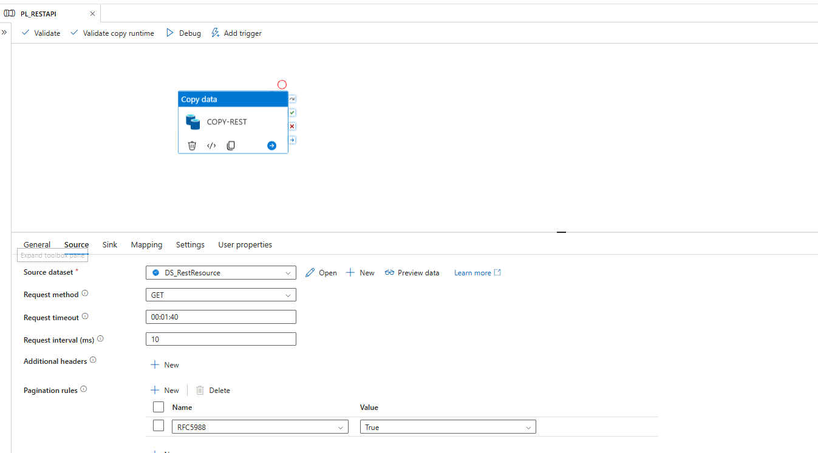

rest/ + json/ dated parquet in src container

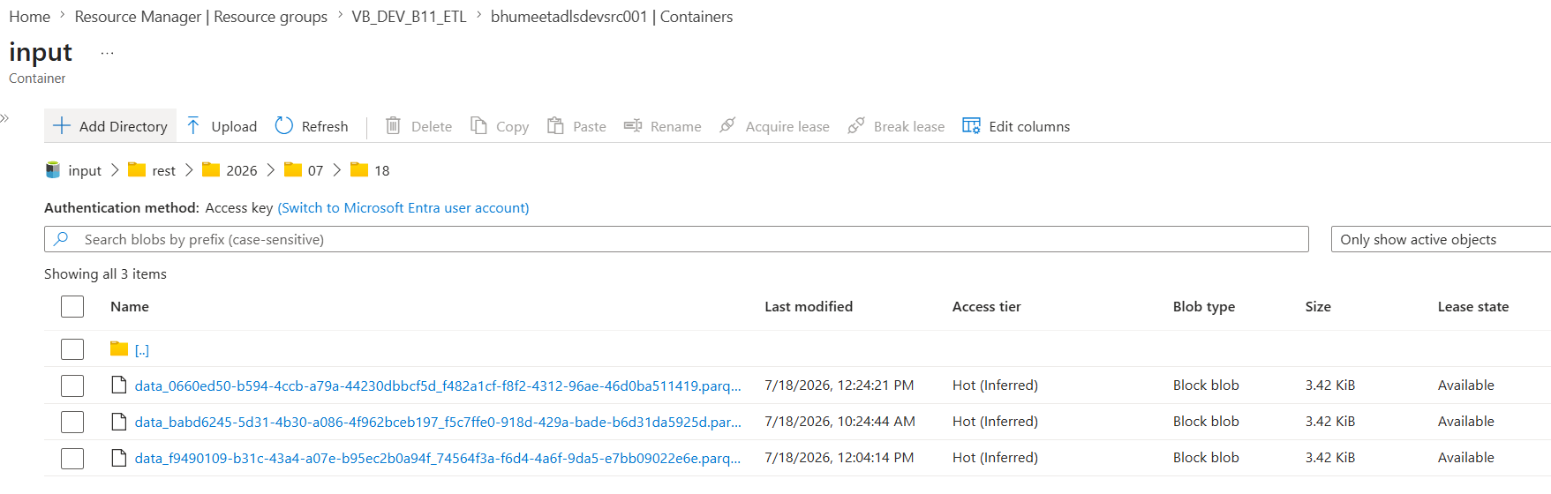

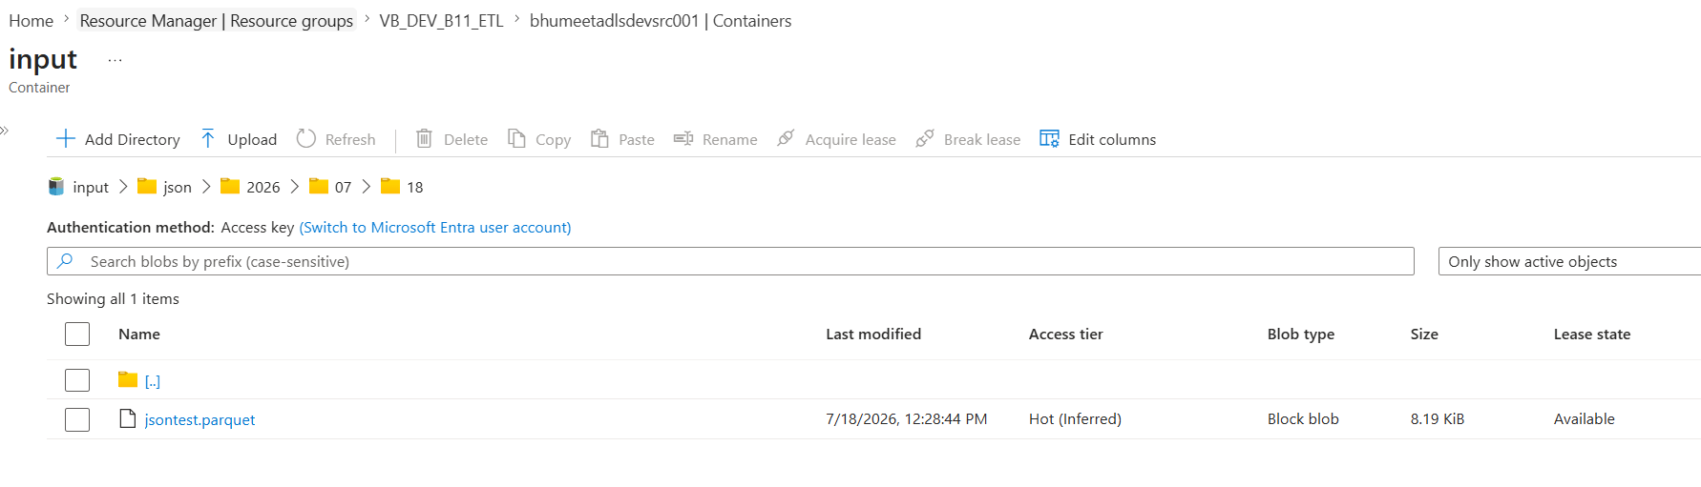

8.7 Failure-path proof
Source filename set to wrong.csv -> UserErrorFileNotFound -> SP-FAIL-LOG-ENTRY wrote Failed row w/ full error text in error_dtls. Reverted after test.

Log table — jobid=1, job_status=Failed, error_dtls = UserErrorFileNotFound...

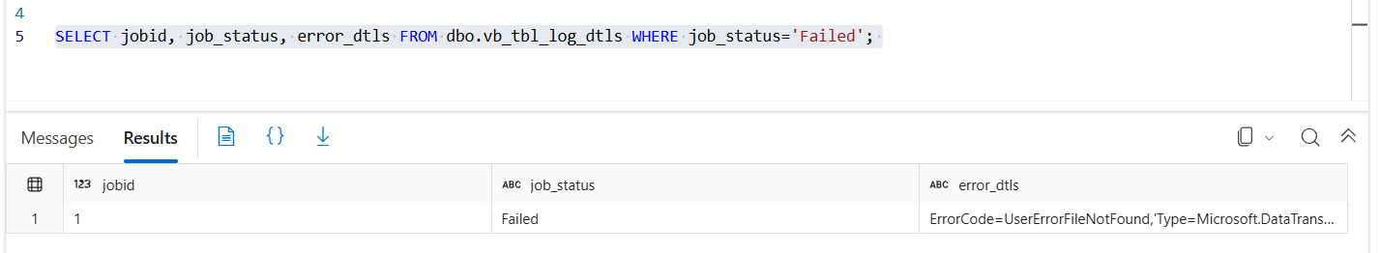

9. Migration Pipelines

9.1 PL_SQL_PARQ (on-prem SQL -> src, via SHIR)

LS_SqlServerTable — Connect via IR-B11-SelfHosted + local serverdb]

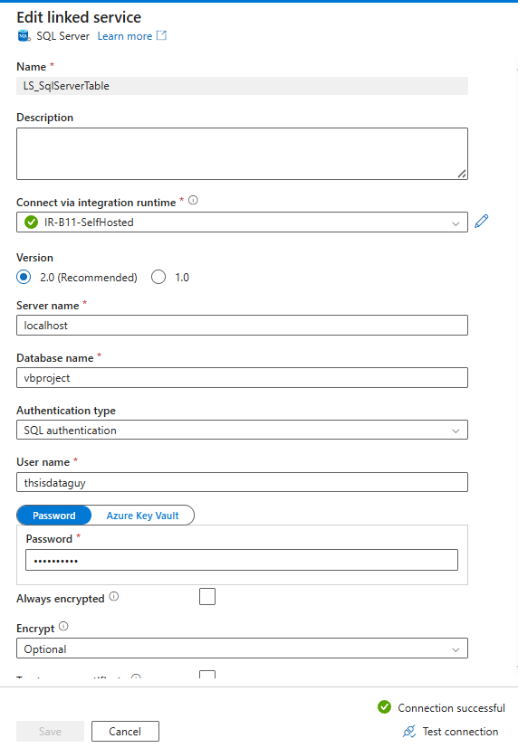

orders.parquet + sellers.parquet at input/sql/yyyy/MM/dd/

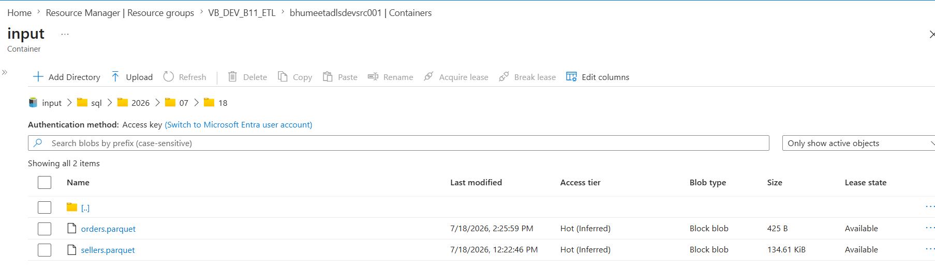

9.2 PL_SFTP (raw sftp landing -> src)

customers.parquet at input/sftp/yyyy/MM/dd/

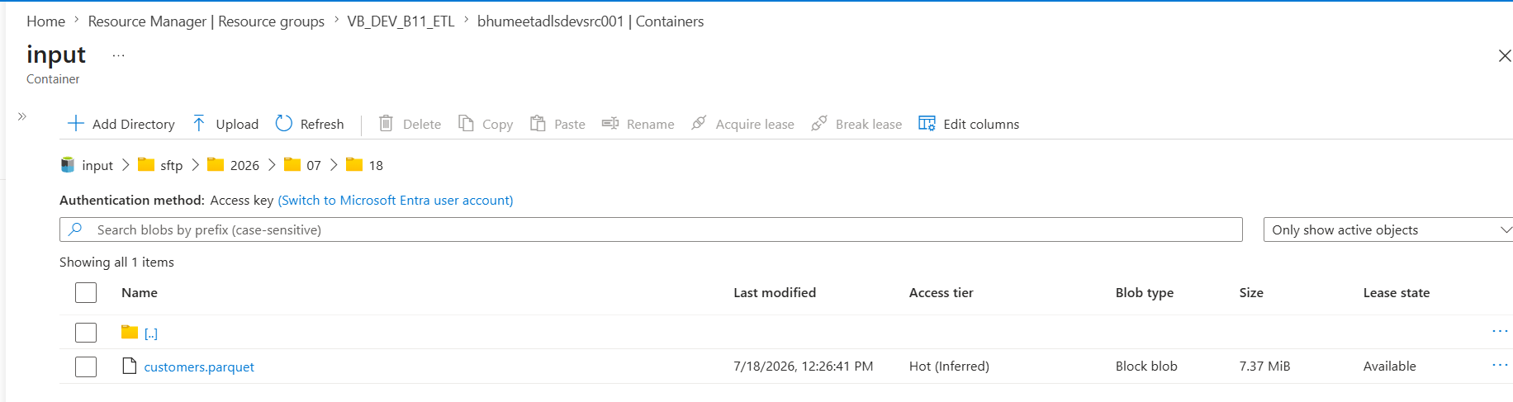

9.3 PL_SNOWFLAKE 2-hop + storage event trigger
Hop 1: Snowflake -> staging Blob (LS_BLOB_STAGE auth = SAS URI — connector validation requires it). Hop 2: PL_BLOB_ADLS (wildcard *.parquet source, Copy behavior = Merge files) -> ADLS src snowflake/yyyy/MM/dd. Blob-created event trigger Tr_sample_snowflake_evt auto-fires hop 2. Prereq: Microsoft.EventGrid provider registered.

PL_SNOWFLAKE Debug — rows copied = Snowflake source count (112,650 full load), parquet in snowstage

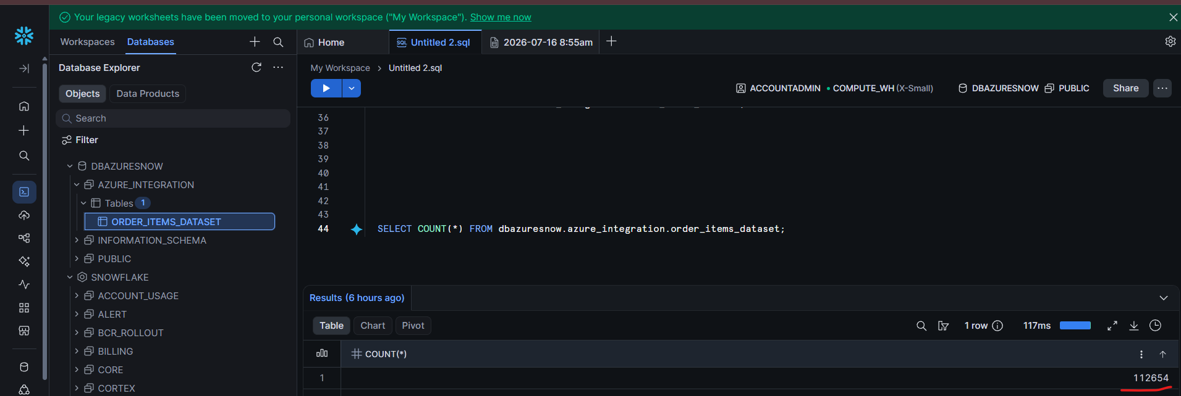

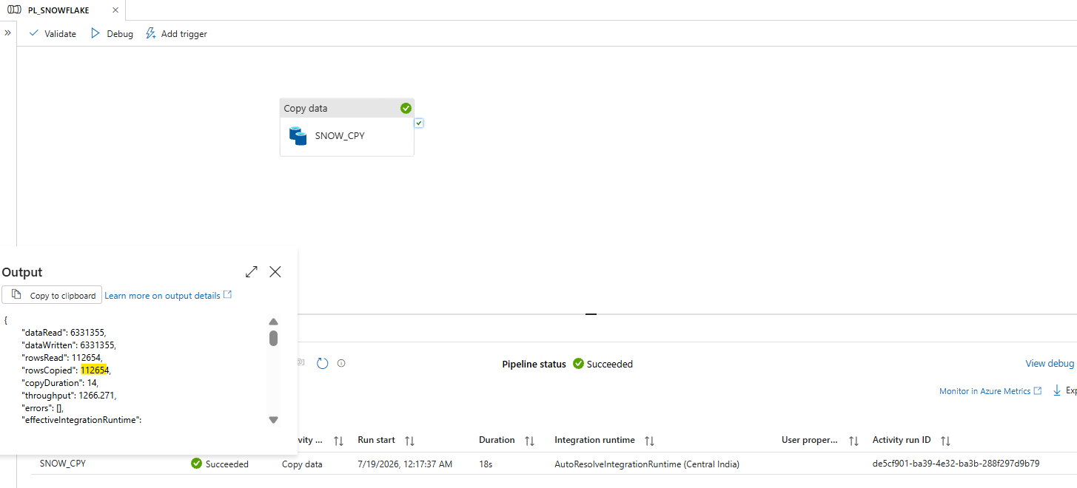

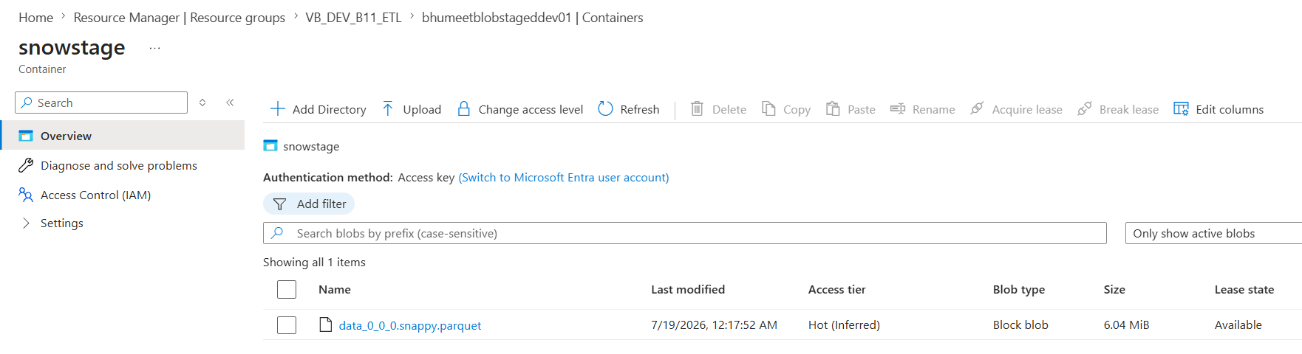

Storage Event Trigger Tr_sample_snowflake_evt config — Blob created, ends with .parquet

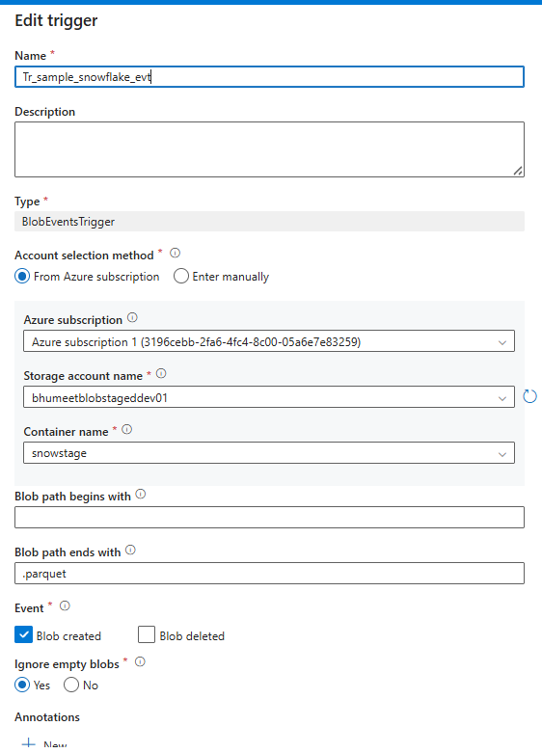

Success Trigger Runs

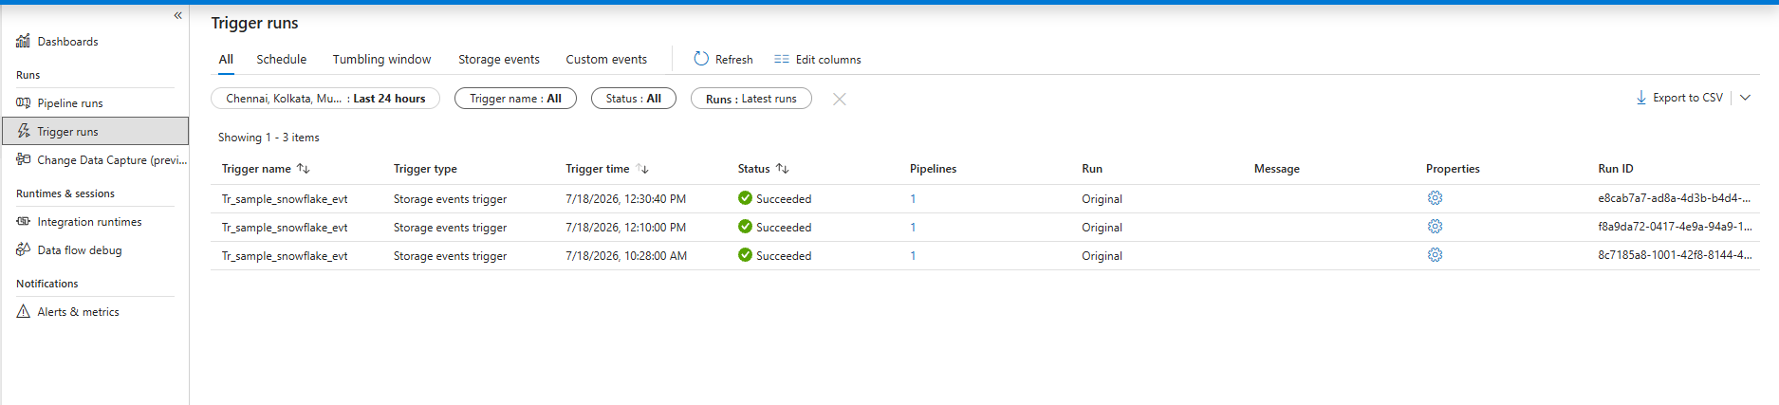

order_items.parquet at input/snowflake/yyyy/MM/dd/

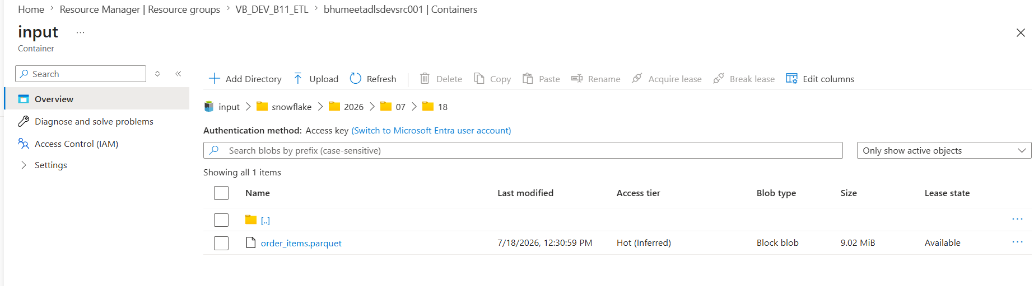

10. Incremental Load — Watermark Pattern (PL_SQL_INCR)
Watermark table stores last-loaded timestamp; two parallel lookups (old WM, MAX(modified_date)); copy filters the delta window; usp_write_watermark advances the mark on success.
SELECT * FROM dbo.olist_orders_dataset WHERE modified_date > '@{...LKUP_OLD_WM...}' AND modified_date <= '@{...LKUP_NEW_WM...}'

PL_SQL_INCR canvas — 2 parallel lookups -> COPY_INCR -> SP_UPDATE_WM

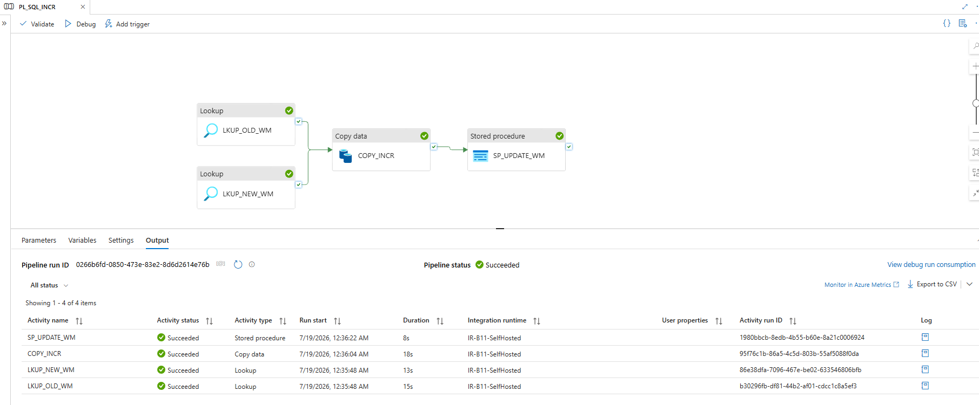

Touch 3 rows:

UPDATE TOP (3) dbo.olist_orders_dataset SET modified_date = GETDATE();

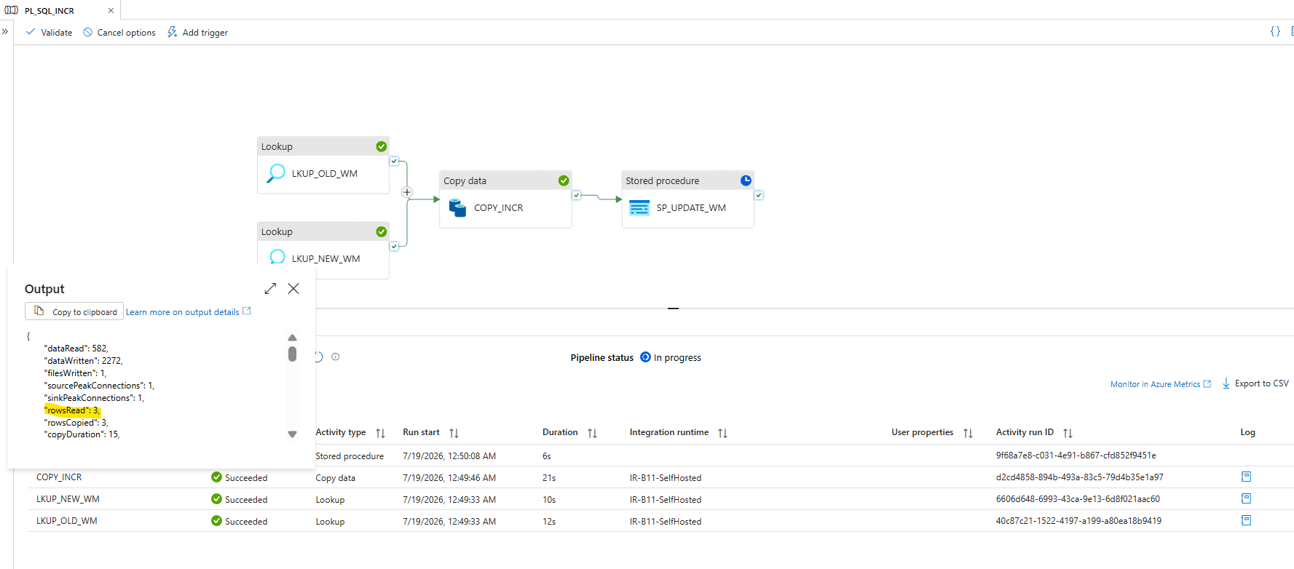

Update Watermark in Watermark Rable on On Prem DB

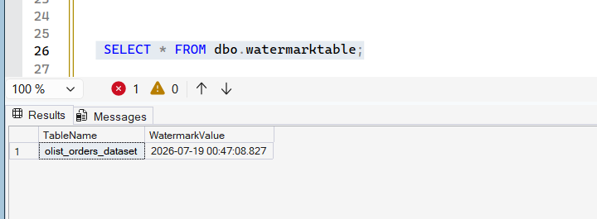

11. Triggers (8 scheduled + 1 event)
8 schedule triggers named exactly as vb_tbl_trigger rows (name = metadata key), daily, 15-min stagger, all attached to PL1_Master only; each passes its own name as the Trigger parameter. Event trigger covers Snowflake hop 2.

Triggers — 9 triggers, Status Started

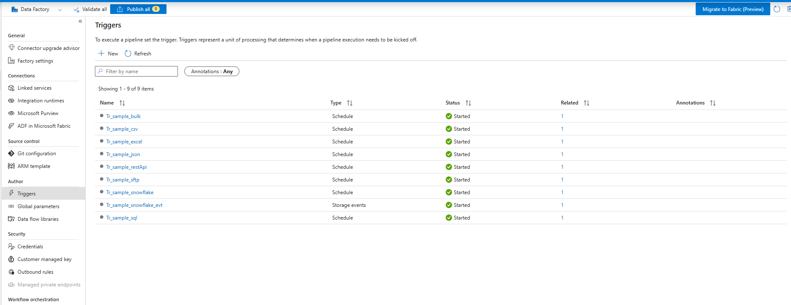

PL1_Master and child Pipeline success

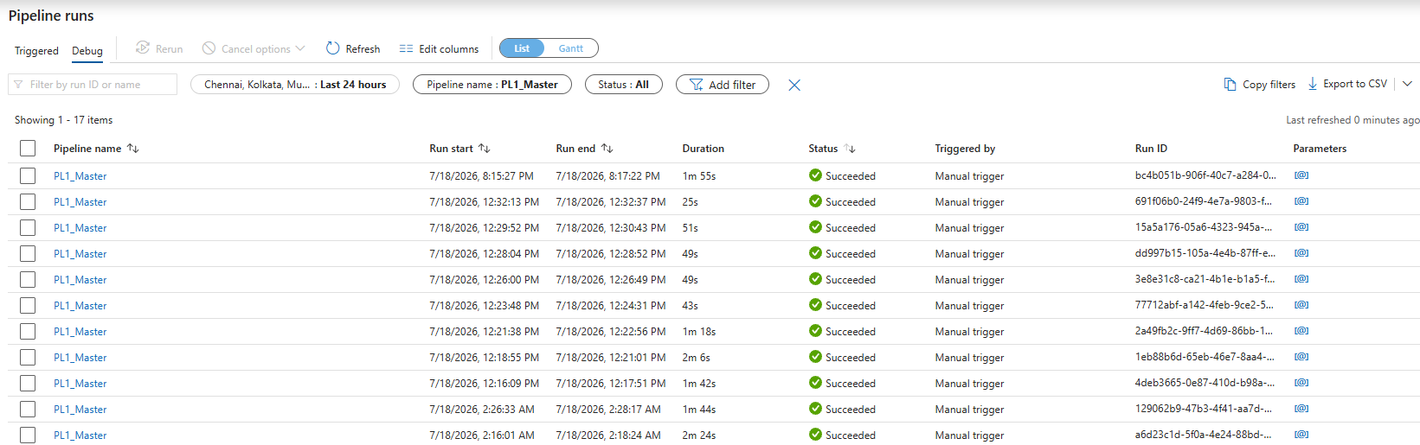

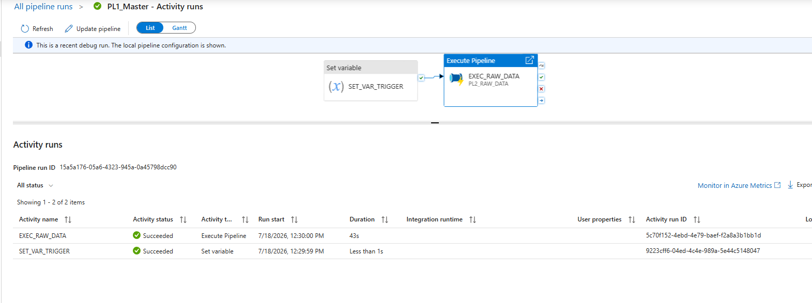

12. Databricks — SCD1 + SCD2 to Delta

12.1 Setup
Workspace dbw-vb-dev-b11 (Trial Premium, Hybrid), single-node cluster (Standard_D4s_v3, DBR 17.3 LTS, 120-min auto-terminate). Service principal sp-dbw-adls-b11 w/ Storage Blob Data Contributor on src+std; secret in Databricks scope vb-scope; abfss:// direct access via spark.conf notebooks use SRC/STD abfss path variables.

Cluster config

runtime 17.3 LTS, node Standard_D4s_v3, state Running

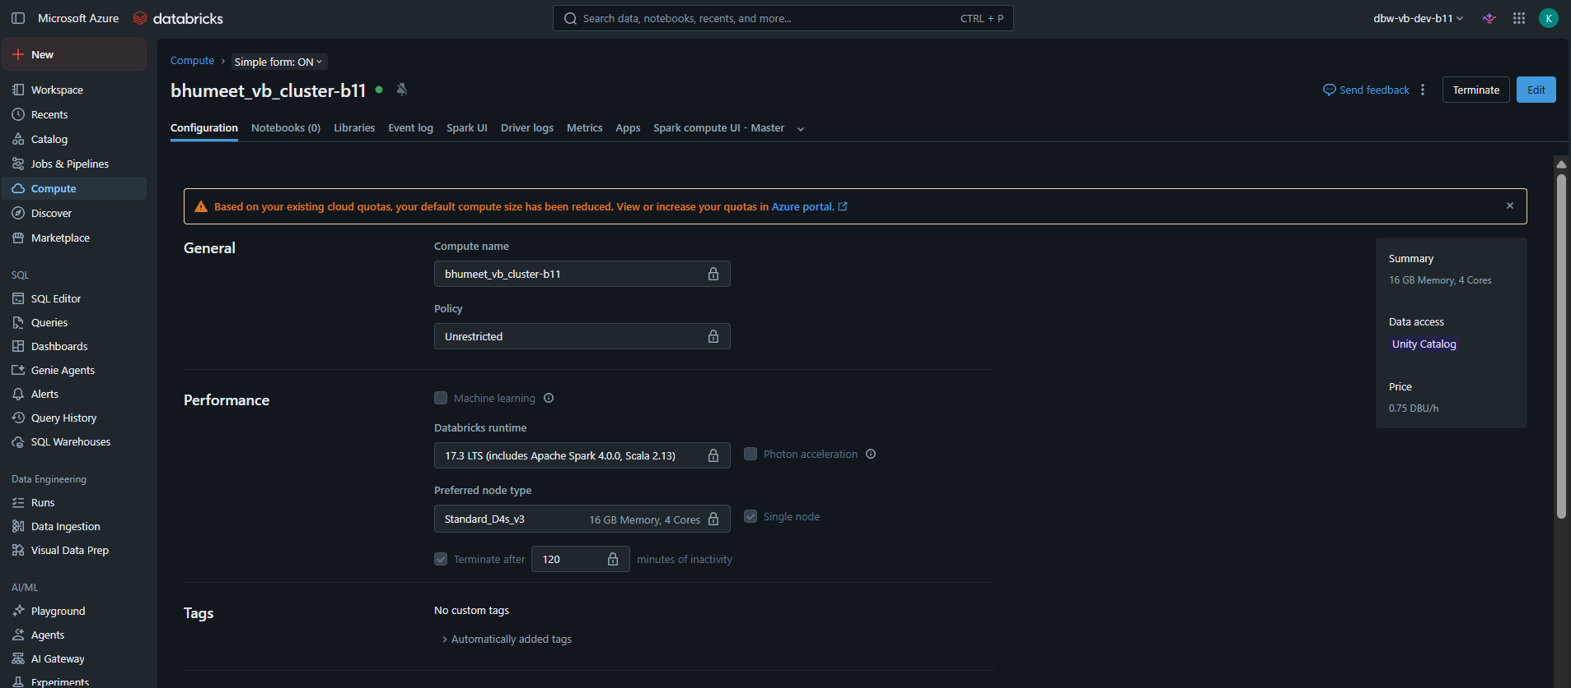

IAM role — SP on both accounts SRC and STD
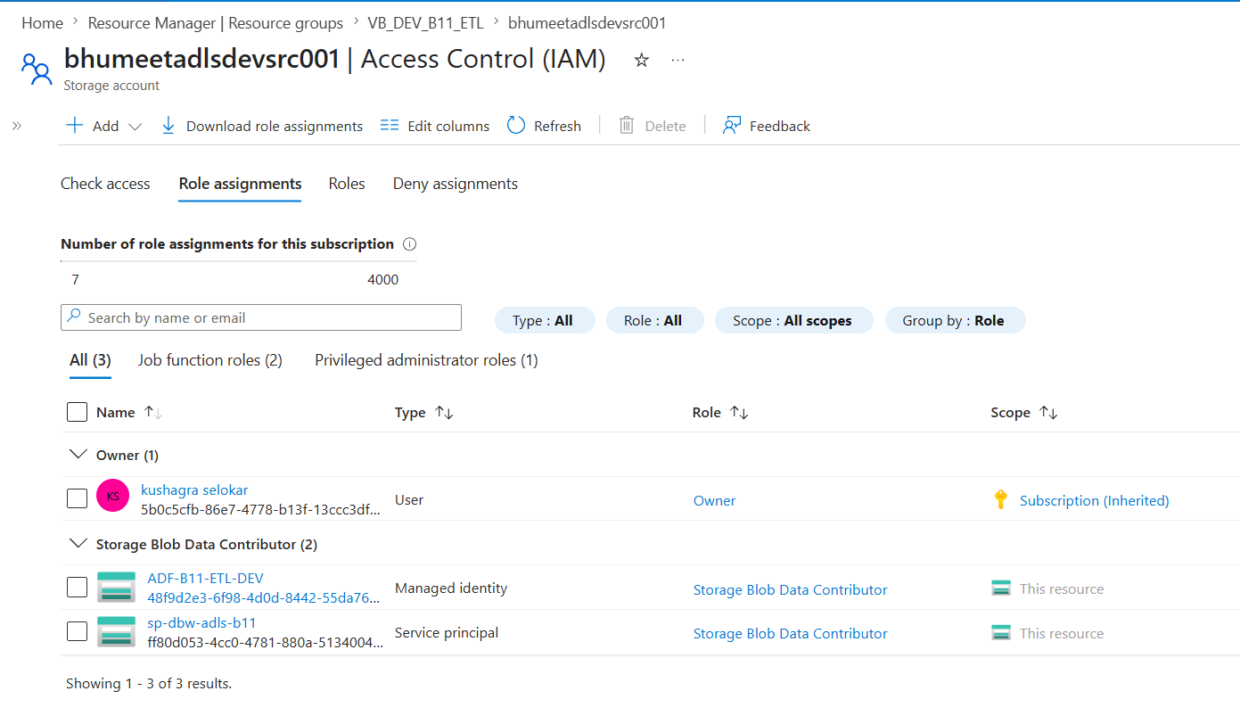
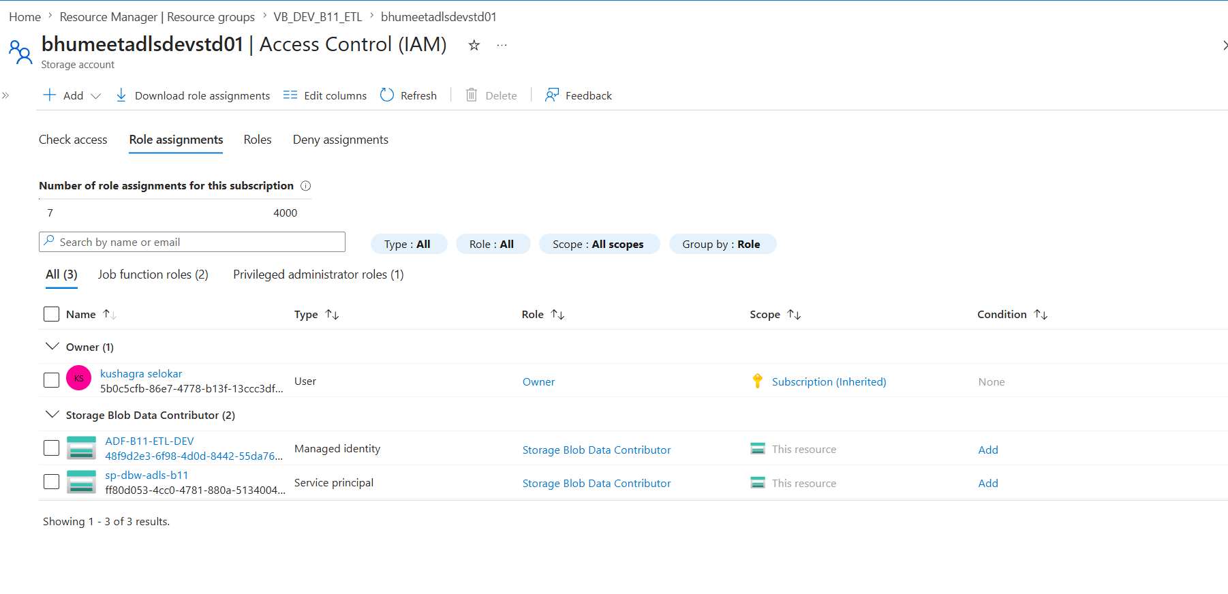

Databricks → src zone access verified (dated Parquet partition visible)

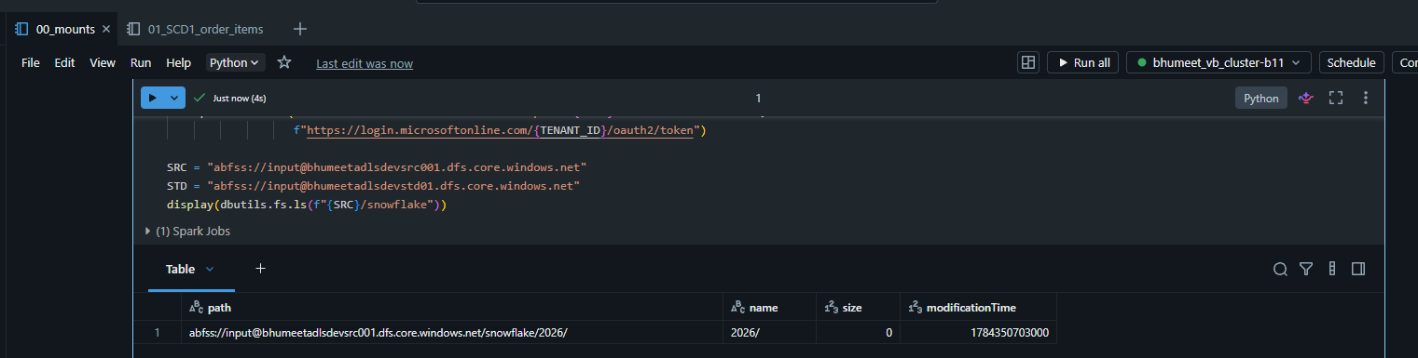

12.2 SCD1 — cust_order_delta (fact: order_items)

Order

Find latest partition — auto-picks the newest dated folder (max year/month/day), so it always reads the freshest ADF load.

Audit columns — adds `ingest_date`/`file_date` to tag each row's origin.

Dedup — a window on (ORDER_ID, ORDER_ITEM_ID) keeps one row per key, so the merge key is unique (Delta MERGE fails on duplicate keys).

Delta MERGE — SCD Type 1 upsert: existing order-item → overwrite; new → insert. Latest value wins, no history.

Idempotent — first run WRITEs, reruns MERGE in place; count stays 112,654 (proven by DESCRIBE HISTORY: one WRITE, then MERGEs, no row growth).

UC quirk — Unity Catalog blocks registering a named table on a raw path, so the table is queried by path (`` delta.`abfss://...` ``) instead of by name. Data is unaffected.

Notebook run — merge cell output + COUNT(*) = 112,654

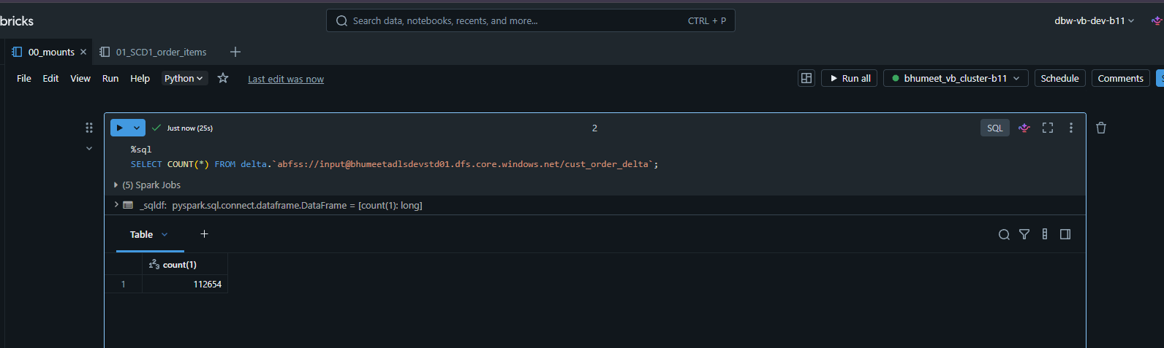

12.3 SCD2 — orderpay_scd2_delta (dim: payments)

SCD2 notebook :

Tagincoming rows — each gets a unique 'payment_dim_id' (uuid), 'is_active=1', 'start_date=today', 'end_date=NULL' (open/current record).

MERGE on (orderid, paymentsequential) — the business key identifying a payment:

Matched + a tracked value changed → expire the old row ('is_active=0', set 'end_date') instead of overwriting — the old version is kept.

Not matched (new payment) → insert.

History preserved — unlike SCD1, past versions stay in the table; the current one is 'is_active=1', superseded ones are 'is_active=0' with an end date.

On first load every row is brand new, so all 103,886 are 'is_active=1' (no history yet). History rows ('is_active=0') only appear once an upstream value changes and the notebook reruns.

SCD2 dimension verified — 103,886 rows, all is_active=1 (current-only on first load; history versions appear after an upstream change + rerun)

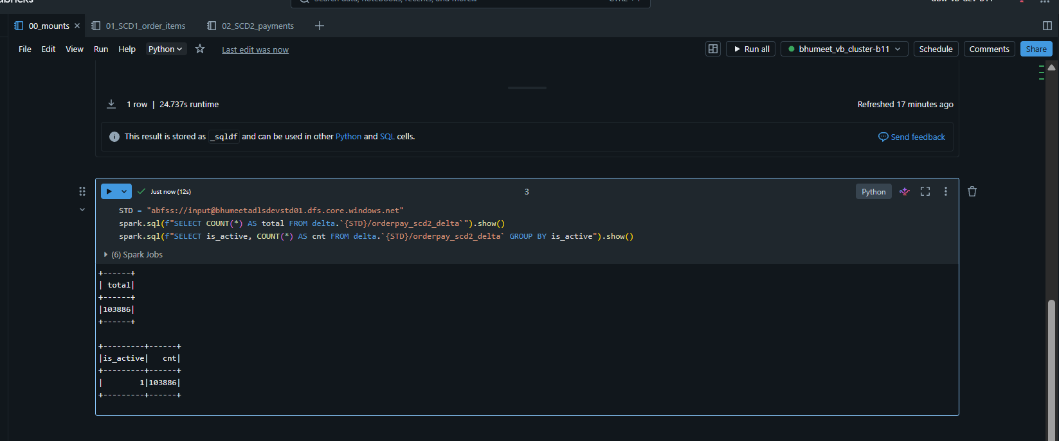

13. Issue & Resolutions

