DESIGN AND IMPLEMENTATION OF A SECURED NETWORK MODEL FOR MITIGATING CYBERCRIME (A SIMULATION OF VLAN USING PACKET TRACER)

BY
UKWUEZE MARTINS ONYEKACHI
IMT/UNN/B.SC/CS/2022/040

BEING A PROJECT SUBMITTED TO THE DEPARTMENT OF COMPUTER SCIENCE, FACULTY OF SCIENCES, INSTITUTE FOR MANAGEMENT AND TECHNOLOGY
(IN AFFILIATION WITH UNIVERSITY OF NIGERIA NSUKKA)

IN PARTIAL FULFILLMENT OF THE REQUIREMENTS FOR THE AWARD OF A BACHELOR OF SCIENCE DEGREE (B.SC.) IN COMPUTER SCIENCE

SEPTEMBER,2026
DECLARATION

I, Ukwueze Martins Onyekachi declare that this project has been written by me, and that it is a record of my own research work. To the best of my knowledge and belief, it has not been previously presented in any form what so ever in any application for Bachelor of Science Degree in Computer Science. All sources of information collected and material used in this project have been duly acknowledged by the means of references and bibliography.

_______________________________ ________________
UKWUEZE MARTINS ONYEKACHI DATE

CERTIFICATION
This research work titled Design and Implementation of a Secured Network Model for Mitigating Cybercrime was carried out by Ukwueze Martins Onyekachi with Matric number IMT/UNN/B.SC/CS/2022/040 and has been read and approved as meeting the requirements for the award of Bachelor degree in B.Sc. Computer Science in the Department of Computer Sciences, Faculty of Sciences, Institute for Management and Technology Enugu, in Affiliation to University of Nigeria Nsukka.

__________________ ________________
Dr. Chika Obi-Okonkwo .I. Date
(Project Supervisor)

__________________ __________________
Head of Department Date

__________________ ___________________
Dean, Faculty of Sciences Date

_________________ _________________
External Examiner Date

DEICATION
I dedicate this project to God Almighty my creator my strength, my source of inspiration wisdom knowledge and understanding bestowed upon me throughout my academic programme.

ACKNOWLEDGEMENT
I give thanks to Almighty God for His grace, wisdom, and strength throughout this project work. My sincere appreciation goes to my project supervisor, Dr. Chika Obi-Okonkwo, for the guidance, corrections, and support given during the completion of this research work. I also appreciate the lecturers of the Department of Computer Science, IMT/UNN degree programme, for their academic support and knowledge imparted throughout my studies. Special thanks to my parents, family, and friends for their prayers, encouragement, and support. And to anyone who contributed directly or indirectly to the success of this project. May God bless you all.

ABSTRACT

This research work Design and Implementionof a Secured Network Model For Mitigating Cybercrime with a detailed analysis of all forms of cybercrime on the internet and then looks at the motive of cyber-security violation and how to fight cybercrime using network tools such as virtual local area network, firewall. The research will enlighten the public at large on the dangers and effects of cybercrime and to take note of various forms of this cybercrime. In World today, numerous internet assisted crimes are committed daily in various forms such as identity theft, desktop counterfeiting, internet chat room, cyber harassment, fraudulent electronic mails, pornography, piracy, hacking, and spamming. Usually these crimes are committed in forms like sending of fraudulent and fake financial proposals from cyber criminals to innocent Internet users.

TABLE OF CONTENT
Title page
Declaration Error! Bookmark not defined.
Certification Error! Bookmark not defined.
Dedication Error! Bookmark not defined.
Acknowledgement Error! Bookmark not defined.
Abstract………………………………………………………………………………………..v
Table of content vii
List of figures ix
List of tables x
CHAPTER ONE
INTRODUCTION 1
1.1 Background of Study 1
1.2 Problem Statement 2
1.3 Purpose of the Study 3
1.4 Aim and Objectives 4
1.5Methodology of Research 4
1.6 Significance of the Study 4
1.7 Scope and Limitation 5
CHARPTER TWO 6
LITERATURE REVIEW 6
2.1 Introduction 6
2.2 First Cyber Crime in The World 6
2.3 Types of Cyber Crimes 9
2.3.1 Theft of Telecommunication Services 9
2.3.2 Telecommunications Piracy 10
2.3.3 Dissemination of Offensive Materials 10
2.3.4 Electronic Money Laundering and Taxes Evasion 11
2.3.5 Electronic Vandalism, Terrorism and Extortion 11
2.4 Related Works 11
2.5 Limitations 12
CHAPTER THREE 14
DESIGN OF A SECURED NETWORK MODEL 14
3.1 Introduction 14
3.2 Architecture 14
3.2.1 Communications Infrastructure 16
3.2.1 Virtual Local Area Network Creation 17
3.3 Practical Design of a Secured Network Using Packet Tracer 18
3.4 Configuration 19
3.5 Snap short of Configured Network 23
3.6 Tools 25
CHAPTER FOUR 27
IMPLEMENTATION OF A SECURED NETWORK MODEL 27
4.1 Introduction 27
4.2 System Requirement 28
4.3 System Implementation 29
4.4 Implementation of Project Objectives in Details 35
CHAPTER FIVE
SUMMARY, CONCLUSION AND RECOMENDATION 38
5.1 Summary 38
5.2 Conclusion 38
5.3 Recommendation 40
References 41

LIST OF FIGURES
Figure 3.1 network management architecture……………………………………………14
Figure 3.2 Basic Client/Server Mode…………………………………………………….15
Figure 3.3Communications Infrastructure………………………………………………..17
Figure 3.4Snap Short Showing VLAN interface on Packet Tracer software.....................18
Figure3.5assigning individual ports to VLANs………………………………….............24
Figure3.6 assigning a range ports to VLANs………………………………………….....24
Figure 3.7. Structure of the suggested network security model………………………….26
Figure 4.1 Cisco Packet Tracer……………………………………………………………28
Figure 4.2 Router Configuration………………………………………………………….29
Figure 4.3 Router Configuration………………………………………………………….31
Figure 4.4 Switch Configuration…………………………………………………………32
Figure 4.5 Pinging Command to showsConfigured ip Address………………………….33
Figure 4.6Pinging Command to showsConfigured ip Address………………………….33
Figure 4.7 Firewall Configuration showing file system………………………………….34
Figure 4.8 Firewall Configuration showing the vlan ip address………………………….35

LIST OFTABLES
Table 4.1 Router Configuration……………………………………………………………30
Table 4.2 Router Configuration on fast Ethernet…………………………………………....3
CHAPTER ONE

INTRODUCTION

1.1 Background of Study
A design and implementation of a secured network model for mitigating against cybercrime covers a secured way of using network tools like packet tracer to explain cyber activity as well as a careful analysis and understanding different cybercrime fraud today. Cybercrime is a major concern in the global community. The introduction, growth and utilization of information and communication technologies have been accompanied by an increase in criminal activities. Take a look at the cyberspace, the internet is frequently and increasingly used as a means to commit or transact organized crime. Cybercrime is an obvious form of international crime with continual negative effects on global revolution in ICTs. A recent study noticed cybercrime differ from terrestrial crimes in four ways. “They are easy to learn how to commit; they can be committed in a jurisdiction without being physically present in it; they require few resources prior to the damage they caused; and they are often not clearly illegal.” (Sam Lumpkin, 2009). On such a basis, the new forms of cybercrime present new challenges to the computer scientist, law-makers, law enforcement agencies and international institutions. Therefore, this makes it necessary for an effective supra-natural as well as domestic mechanism to watch the use of ICTs for criminal activities in cyberspace. The advent and development of networking technologies, and the internet in particular, has created a new way to share information across time and space. While computer network has enhanced the quality of life in many aspects they have also opened a new avenue for criminal activities.
These activities have spawned the concepts of cybercrime which refers to illegal computer mediated activities that can be conducted through global electronic networks, such as the internet. One predominant type of cybercrime is distribution of illegal materials in the cyberspace. Such material; include private software, child pornography materials, stolen properties.
These criminals use various channels to distribute illegal materials such as email, instant messengers, internet chat room, and internet newsgroups. A common characteristic of these channels is anonymity. People usually do not need to provide their real identity information to participate in these cyber activities. Compared to conventional crimes, cybercrime conducted through unknown channels imposed unique crime challenges for law enforcement agencies. In criminal identity tracing in cyberspace and allow investigators to prioritize their task and forms to the major criminals.
The project is organized as follows. Chapter two surveys and describe computer and internet related crimes and selected method to combat cybercrime fraud using VLAN, and firewall, including a detail research exercise on cybercrime. Chapter three describes design and methodology. Chapter four deals with practical implementation. And chapter five summarizes the project and produce recommendation and conclusion.

1.2 Problem Statement
Crime remains elusive and ever strives to hide itself in the face of development. Different nations have adopted different strategies to contend with crime depending on their nature and extend. One thing is certain, it is that a nation with high incidence of crime cannot grow or develop. This is because crime is the direct opposite of development. It leaves a negative social and economic consequence. Cybercrime is defined as crime committed on the internet using the computer as either a tool or a targeted victim. It is very difficult to classify crimes in general in to distinct groups as many crimes evolve on a daily basis. Even in the in the real world, crimes like rape, murder or theft need not necessarily be separated. However, all the computer and the person behind it as victims, it just depends on which of the two is the main target. Hence, simplicity’s sake. For example, hacking involves attacking the computer’s information and other resources. It is important to take note that overlapping occurs in many cases and it is impossible to have a perfect classification system.
The term ‘cybercrime’ is a misnomer. This term has nowhere been defined in any statute/Act passed or enacted by the Indian parliament. The concept of conventional crime. Both include conduct where act or omission, which cause breach of rules of law and counterbalanced by the sanction of the states. Before evaluating the concept of cybercrime it is obvious that the concept of conventional crime be discussed and the points of similarly and deviance between both these forms may be discussed.

1.3 Purpose of the Study
Today cybercrime has become a disease in every field ranging from governmental organization, industries, corporate organization, government agency, education sector, private user etc. The gracing danger for crimes committed against computers, or against information computers, has claimed attention in national capitals. Countries around the world, however, existing laws are likely to be unenforceable against such crimes. The lack of protection means that business and governments must rely solely on technical measures to protect themselves from those who steal, deny access to or destroy information. Headlines of cyber-attacks command our attention with increasing frequency. According to the Computer Emergency Response Team Coordination Centre (CERT/CC), the number of repeated incidences of security branches in the first three quarter of 2000 has risen by 54 percent over the total number of reported incidences in 2009 (Awe, (2009).Fighting Cybercrime in NigeriaMoreover countless instances of illegal access and damage around the world remain unreported, as victims for the exposure of vulnerability, the potential for copycat crimes and the loss of public confidence.
In Nigeria the rise of cybercrime popularly known as yahoo-yahoo (internet scamming) would be understood by student in this department. This would increase the level of awareness about cybercrime and the challenges of how computer scientist can solve cybercrime. (Ayantokun, O. 2006).Fighting Cyber-Crime inNigeria.

1.4 Aim and Objectives
The aims of this study is to developed a secured model to prevent cybercrime. The following are the objectives
(i) to design and implementation of a secured network model
(ii)To implement the developed model.
(iii) To apply firewall to protect network against security breach.
(iv) To configure the model so as to reduce cybercrime.

1.5 Methodology of Research
A critical study reported and literature forms the foundation of this project for better understanding. The following methodologies were employed:
- Using packet tracer to design a secured network model
- To create network using packet tracer
- To configure a network using packet tracer
The internet was consulted to get relevant materials on network security, VLAN, and Firewalls. This project used available information from journals, e-books and literature material gotten from the library.
Packet tracer is used for all the designs in this work and local café operators and owners, corporate organization including government organization were interacted with and the information derived was used in the of the research.

1.6 Significance of the Study
Criminal investigation has been a topic of study for academics and practitioners alike, and is defined or is being committed (Brown, 2001). It seeks to identity the truth associated with how and why a crime occurred, and workers towards building a case that may lead to the successful prosecution of the offenders many research studies have sought to determine the best way in which the investigative process can be conducted and to enable police departments to reflect upon their own practice against the backdrop of the findings, and then to implement salient positive changes which would improve day to day operation of their organization.

1.7 Scope and Limitation
This study focused on how to reduce the rate of cybercrime using VLAN, how cybercrime is done and its effects in our life and society with categories of cybercrimes.
Limitationsof the study is that I can’t collaborate and cooperate in improving hackers speed and ability in achieving their goal, spreading viruses, malwares and worms to expose computers so that hackers will find it easier to access data will not be supported. (word press 1990). Cross Domain solutions.

CHARPTER TWO

LITERATURE REVIEW

2.1 Introduction
In examining cybercrime, the various types of cybercrime fraud are enumerated and explained, these cybercrime activities disturb communication through the internet. Rating information from a source to destination are disrupted and used to commit serious havoc and denying the free flow of internet network service on the super highway.
To create communication between cyber network and combat cybercrime a VLAN is used.
Common varieties of cybercrime used for causing havoc and fraud are: first cybercrime in the world, theft of telecommunication, telecommunication piracy, dissemination of offensive materials, electronic money laundry and taxes evasion, electronic vandalism, terrorism and extortion, sales and investment fraud, illegal interception of telecommunications, electronic fund transfer, Hacking, denial of service, related works, limitations. (Technopedia,2016). Securities institute.

2.2 First Cyber Crime in The World
The use of computers and computer networks to commit criminal acts, starting in the 1970's to the present day (John,1970).The first recorded cybercrime took place in the year 1820. That is not surprising considering the fact that the abacus, which is thought to be the earliest form of a computer,has been around since 3500 B.C. in India, Japan and China. The era of modern computers, however, began with the analytical engine of Charles Babbage. In 1820. Joseph Marie Jacquard, a textile manufacturer in France, produced the loom. This device allowed the repetition of a series of steps in the weaving of special fabrics. This resulted in a fear amongst Jacquard's employees that their traditional employment and livelihood were being threatened. They committed acts of sabotage to discourage Jacquard from further use of the new technology. This is the first recorded cyber-crime.
The modern thief can steal more with a computer than with a gun. Tomorrow's terrorist may be able to do more damage with a keyboard than with a bomb” (Pavan,1991).
What is this Cybercrime? We read about it in newspapers very often. Let's look at the dictionary definition of Cybercrime: "It is a criminal activity committed on the internet. This is a broad term that describes everything from electronic cracking to denial of service attacks that cause electronic commerce sites to lose money".
Cybercrime is defined as a crime in which a computer is the object of the crime (hacking, phishing, spamming) or is used as a tool to commit an offense child pornography, hate crimes. Cybercriminals may use computer technology to access personal information, business trade secrets, or use the Internet for exploitive or malicious purposes. Criminals can also use computers for communication and document or data storage. Criminals who perform these illegal activities are often referred to as hackers(Pavan,1991). Who is the president of cyberlaws.net?
Cybercrime may also be referred to as computer crime.Cybercrimes committed against persons include various crimes like transmission of child-pornography, harassment of any one with the use of a computer such as e-mail. The trafficking, distribution, posting, and dissemination of obscene material including pornography and indecent exposure, constitutes one of the most important Cybercrimes known today. The potential harm of such a crime to humanity can hardly be amplified(Pavan, 1991).
Before the Internet, criminals had to dig through people's trash or intercept their mail to steal their personal information Now that all of this information is available online, criminals also use the Internet to steal people's identities, hack into their accounts, trick them into revealing the information, or infect their devices with malware.
Most cybercrimes are committed by individuals or small groups. However, large organized crime groups also take advantage of the Internet. These professional criminals find new ways to commit old crimes, treating cybercrime like a business and forming global criminal communities.Criminal communities share strategies and tools and can combine forces to launch coordinated attacks. They even have an underground marketplace where cyber criminals can buy and sell stolen information and identities.
It's very easy to crack down on cyber criminals because the Internet makes it easier for people to do things anonymously and from any location on the globe when they online we can use (GPS). Global Positioning System to track them. Many computers used in cyber attacks have actually been hacked and are being controlled by someone far away. Crime laws are different in every country too, which can make things really complicated when a criminal launches an attack in another country.
Here are a few types of attacks cyber criminals use to commit crimes. You may recognize a few of them:
- Botnet - a network of software robots, or bots, that automatically spread malware
- Fast Flux - moving data quickly among the computers in a botnet to make it difficult to trace the source of malware or phishing websites
- Zombie Computer - a computer that has been hacked into and is used to launch malicious attacks or to become part of a botnet
- Social Engineering - using lies and manipulation to trick people into revealing their personal information. Phishing is a form of social engineering
Some identity thieves target organizations that store people's personal information, like schools or credit card companies. But most cyber criminals willtarget home computers rather than trying to break into a big institution's network because it's much easier.
By taking measures to secure your own computer and protect your personal information, you are not only preventing cyber criminals from stealing your identity, but also protecting others by preventing your computer from becoming part of a botnet.
To create communication between cyber network and combat cybercrime a VLAN is used. Common varieties of cybercrime used for causing havoc and fraud are: Hacking, denial of service, software piracy, and credit card fraud.

2.3 Types of Cyber Crimes

2.3.1 Theft of Telecommunication Services
The “phone phreakers” of three decades ago set a precedent for what has become a major criminal industry. By gaining access to an organizational telephone switchboard individuals or criminal organization can obtain access to dial-in/dial-out circuits and then makes their own calls or sell call time to third parties. Offenders may gain access to the switchboard by impersonating a technician, by fraudulently obtaining an employee’s access code, or by using software available on the internet. Some sophisticated offenders loop between systems to evade detection. Additional forms of service theft include capturing “calling card” details and on selling calls charge to the calling card account, and counterfeiting or illicit reprogramming of stored valued telephone cards. It has been suggested that as long ago as security failures at one major telecommunications carrier cost approximately £290millions, and that more recently up to 5% of total industry turnover has been lost to fraud (schiek,1995 Newman,1998). Cost to individual’s subscribers can also be significant in one case, computer hackers in United States illegally obtained Scotland yard’s telephone network and made £620,000 worth of international calls for which Scotland yard.

2.3.2 Telecommunications Piracy
Digital technology permits perfect reproduction and easy dissemination of print, graphics, sound and multimedia combinations. The temptation to reproduce copyrighted materials, for personal use for sale at a lower price, or indeed, for free distribution, has proven irresistible to many. This has course considerable concern to owners of copyrighted materials. Each year, it has been estimated loses between US$15 and US$17 billion are sustained by industry by reason of copyright infringement. United States, information infrastructure task force. The software publishers association has estimated that $7.4 billion worth of software was lost to piracy in 1993 with $2billion of that being stolen from the internet (Meyers and underwood,1994). According to the straits times a copy of the most recent James bond film the world is not enough, was available free on the internet before it’s officials release.

2.3.3 Dissemination of Offensive Materials
Content considered by some to be objectionable exist in abundance in cyberspace. This includes among much else, sexually explicit materials, racist propaganda, and instructions for the fabrication of incendiary and explosive devices. Telecommunications systems can also be used for harassing, threatening or intrusive communications, from the traditional obscene telephone call to its contemporary manifestations in “cyber stalking”, in which persistent messages are sent to an unwilling recipient. One former university student in California used email to harass 5female students in 1998. He bought information on the internet about women using a professor’s credit card and then sent 100 messages including death threats, graphics sexual description and references to their daily activities. He apparently made the threat in response perceived teasing about his appearance, associated press (Spice and Sink,1999). Computer networks may also be used in furtherance extortion. The Sunday times (London) reported in1996 (Spice and Sink,1999). that over 40 financial institutions in Britain and United States had been attached electronically over the previous three years.

2.3.4 Electronic Money Laundering and Taxes Evasion
For some time now, electronic fund transfers have assisted in concealing and in moving the proceed of crimes. Emerging technologies will greatly assist in concealing the origin of ill-gotten gains. Legitimately derived income may also be more easily concealed from taxations authorities. Large financial institutions will no longer be the only the one with the ability to achieves electronic funds transfer transiting numerous jurisdiction reporting at the speed of light. The development of informal banking institutions and parallel banking system may permit central bank supervision to be bypassed, but can also facilitate the evasion of cash transaction reporting requirements in those nations which have them. Traditional underground banks, which have flourished in Asian countries for centuries, will enjoy even great capacity through the use of telecommunications (Wahlert,1996).

2.3.5 Electronic Vandalism, Terrorism and Extortion
As never before western industry society is dependent upon complex data processing and telecommunication system. Damage to, or interface with any of these systems can lead to catastrophic consequences. Whether motivated by curiosity or vindictiveness intruders’ inconveniences. At best, and have the potential for inflicting massive harm. While this potential has yet to be released, a number of individuals and protest groups have hacked the official web pages of various government commercial organization (Rathmell,1997). This may also operate reverse; early in 1999 an organized hacking incident was apparently directed at a sever which hosted the internet domain for east Timor, which at the time was seeking his independence for Indonesia.

2.4 Related Works
(a) network security using firewall technology to restrict unauthorized access to network by Isyaku Abdulkadir Ada’ava of Department of Mathematic Abu Zaria (U10CS1037)
Limitations of This research work is carried out to understand how these threats affect computer networks and use of a device to scan all devices within specified subnets, draw and layout a map of the network. Monitor services of the services and alert the user in case some services are in problems. A router is the device to be used and packet filtering are the key features configured to make network hidden from unauthorized access.
(b) consequences of cybercrime in tertiary institution: by Kazeem Abimbola ADETA
(M.SC/SOC-SCI/5795/2009-2010) of Department of Sociology School of Postgraduate Studies ABU Zaria.
limitation to students of 3 selected tertiary institutions namely;
Ahmadu Bello University, Federal College of Education and Nuhu Bamalli Polytechnic.In addition, other respondents that participated in the study were operators of cyber café, lecturers from Computer Science Department of the selected tertiary institution and individuals who indulge in cyber-crime. The study was conducted from August 2011 to May 2013.
(c) perception of cybercrime among Nigerian youths: by Umeozulu Frances of Department Mass Communication Caritas University Amorji-Nike Enugu State.
A major limitation of the group is the samples were only from Caritas University where it was chosen as the area in carrying out this research. This finding is based on the results gathered from Caritas University students on the perception of cybercrime among Nigerian youths.

2.5 Limitations
Cybercrime is usually conducted in a structured and organized manner, usually as part of a penetration test or security audit. Ethical hackers need to be judicious with their hacking skills and recognize the consequences of misusing those skills. The depth and breadth of the systems and applications to be tested are usually determined by the needs and concerns of the client. Many ethical hackers are members of a tiger team. A tiger team works together to perform a full scale test covering all aspects of network, physical, and systems intrusion cybercrime have the following limitations:
- Cybercrime perpetrators must have authorization from the client and have signed contract giving the test permission to perform the test.
- Cybercrime experts must maintain and follow a nondisclosure agreement (NDA) with the client in the case of confidential information disclose during the test.
- Cybercrime professionals must maintain confidentiality when performing the test. Information gathered may contain sensitive information. No information about the test or company confidential data should ever be disclosed to a third party.
(d) Talk to the client, and discuss the needs to be addressed during the testing. Prepare and sign NDA documents with the client.
(e) Organize an ethical hacking team, and prepare a schedule for testing

CHAPTER THREE

DESIGN OF A SECURED NETWORK MODEL

3.1 Introduction
One of the key factors in building a successful network security design is to identify and enforce a proper trust model. The proper trust model defines who needs to talk to whom and what kind of traffic needs to be exchanged; all other traffic should be denied. Once the proper trust model has been identified, then the security designer should decide how to enforce the model. As more critical resources are globally available and new forms of network attacks evolve, the network security infrastructure tends to become more sophisticated, and more products are available. Firewalls, routers, LAN switches, intrusion detection systems. The design will include: the architecture, data flow diagram, design data base, the tools. the overall emphasis is to determine an efficient and effective way of achieving cybercrime prevention.(Cisco Security Network 2008).

3.2 Architecture
In order to design and build a well-secured network, many factors must be taken into consideration, such as the topology and placement of hosts within the network, the selection of hardware and software technologies, and the careful configuration of each component. This project will be an examination of some of the issues in designing a secure Local Area Network (LAN) and some of the best practices suggested by security experts. (Daniel Oxenhandler, 2003). Designing a Secure Local Area Network.
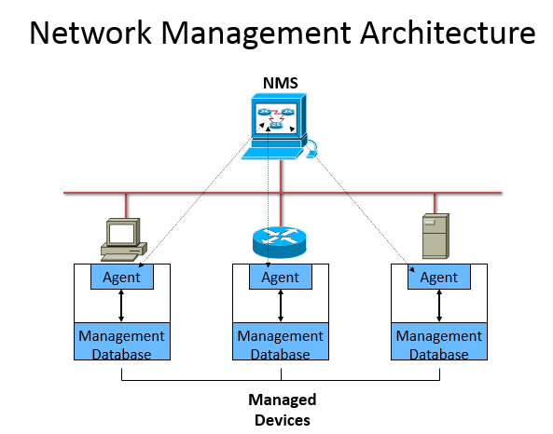

Figure 3.1 network management architecture

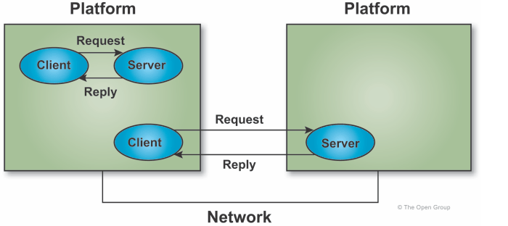
Figure 3.2/ Basic Client/Server Mode
Client/server processing is a special type of distributed computing termed "co-operative processing" because the clients and servers co-operate in the processing of a total application (presentation, functional processing, data management). In the model, clients are processes that request services, and servers are processes that provide services. Clients and servers can be located on the same processor, different multi-processor nodes, or on separate processors at remote locations. The client typically initiates communications with the server. The server typically does not initiate a request with a client. A server may support many clients and may act as a client to another server. Depicts a basic client/server model, which emphasizes the request-reply relationships. shows the same model drawn on how the various entities and interfaces can be used to support a client/server model, whether the server is local or remote to the client. In these representations, the request-reply relationships would be defined in the client/server model.

3.2.1 Communications Infrastructure
The Communications Infrastructure may contain up to three levels of transport - local, regional/metropolitan, and global - as shown infigure bellow The names of the transport components are based on their respective geographic extent, but there is also a hierarchical relationship among them. The transport components correspond to a network management structure in which management and control of network resources are distributed across the different levels.
The local components relate to assets that are located relatively close together geographically. This component contains fixed communications equipment and small units of mobile communications equipment. LANs, to which the majority of end devices will be connected, are included in this component. Standard interfaces will facilitate portability, flexibility, and interoperability of LANs and end devices. Regional and Metropolitan Area Networks (MANs) are geographically dispersed over a large area. A regional or metropolitan network could connect local components at several fixed bases or connect separate remote outposts. In most cases, regional and metropolitan networks are used to connect local networks. However, shared databases, regional processing platforms, and network management centers may connect directly or through a LAN. Standard interfaces will be provided to connect local networks and end devices. Global or Wide Area Networks (WANs) are located throughout the world, providing connectivity for regional and metropolitan networks in the fixed and deployed environment. In addition, mobile units, shared databases, and central processing centers can connect directly to the global network as required. Standard interfaces will be provided to connect regional and metropolitan networks and end devices.
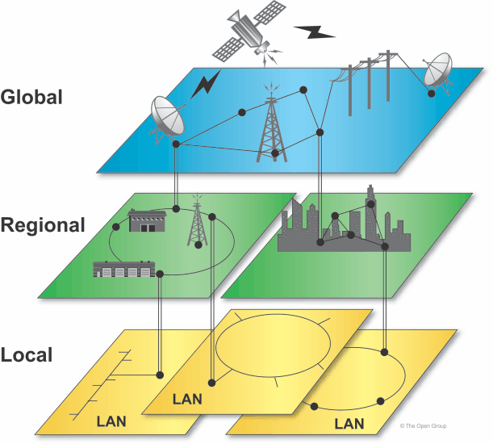

Figure 3.3Communications Infrastructure

3.2.1 Virtual Local Area Network Creation
This is the process of creating Virtual Local Area. Network, which is the allocation network resources and users to administrative ports of a switch to smaller broadcast domains and subnets. VLANs are created to provide the segmentation services traditionally provided by routers in LAN configurations. VLANs provide scalability, security, and network management. Routers in VLAN topologies provide broadcast filtering, security, address summarization, and traffic flow management. This is also useful if one wants to create multiple networks on the same switch.

3.3 Practical Design of a Secured Network Using Packet Tracer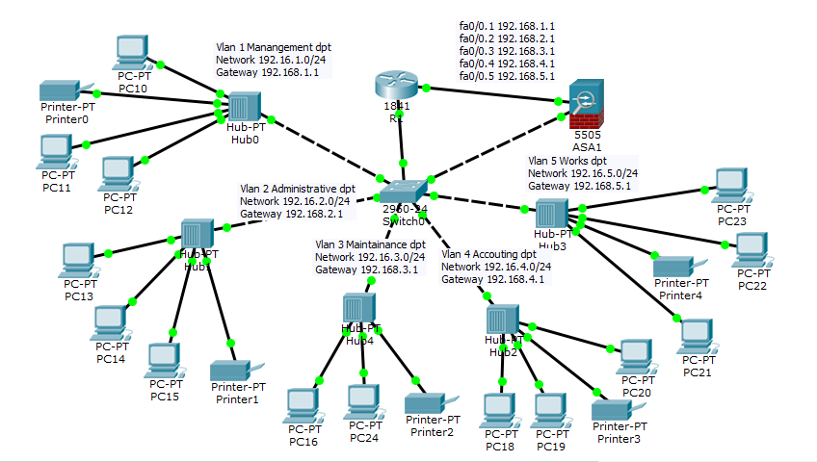

Figure 3.4Snap Short ShowingVLAN interface on Packet Tracer software
Shows the VLAN configuration design consisting of three switches (catalyst 3560-24ps) including the switch server (core switch), and a router (Cisco 2811).
Virtual LANs operate at layer 2(Data link layer) of the OSI model. Administrators often configure a VLAN to map directly to an II¹ network, which gives the appearance of involving layer 3 (Network layer). In the context of VLANs, the term trunk denotes a network link carrying multiple VLANs which are identified by labels or tagsinserted into their packets. Such trunks must run between "tagged ports" of VLAN-hardware devices, so they are often switch-to-switch or switch-to-router links rather than links to hosts.

3.4 Configuration
Configuration:- -The following commands were used to create a VLAN using globalconfiguration mode for switch:
To assign ports to the members of the VLAN. By default, all ports are initially members of VLAN1. Assign ports one at a time or as a range.
Use the following commands to assign individual ports to VLANs
Wide Area Network Design, Morgan Kaufmann (1998)
Switch>enable
Switch#configure terminal
Switch(config)# vlan 1
Switch(config-vlan)#exit
Switch(config)# vlan 2
Switch(conflg-if)#name pc10
Switch(config-if)# exit
Switch(config-vlan)# vlan 3
Switch(conflg-if)#name pc11
Switch(config-if)# exit
Switch(conflg-if)# vlan 4
Switch(config-vlan)#name pc12
Switch(config-if)# exit
Switch(conflg-if)# vlan 5
Switch (config-vlan)#name pc13
Switch (config-if)# exit
Switch#conf t
Switch(config-if-range)#interface range fastEthernet0/24
Switch(config-if-range)#switchport mode access
Switch(config-if-range)#switchport access vlan 1
Switch(config-if-range)#spanning-tree portfast
Switch(config-if-range)#exit
Switch(config-if-range)#interface range fastEthernet0/24
Switch(config-if-range)#switchport mode access
Switch(config-if-range)#switchport access vlan 2
Switch(config-if-range)#exit
Switch(config-if-range)#interface fastEthernet0/24
Switch(config-if-range)#switchport mode trunk
Switch(config-if)#
Switch(config-if-range)#interface fastEthernet0/24
Switch(config-if-range)#switchport mode trunk
Switch(config-if-range)#interface fastEthernet0/24
Switch(config-if-range)#switchport mode trunk
Switch(config-if)# exit
The following commands were used to create a VLAN using global configuration mode for Routers:
Router>enable
Router#configure terminal
Enter configuration commands, one per line. End with CNTL/Z
Router(config)#interface fastethernet0/0.1
Router(config-subif)#encapsulation dot1Q 1
Router(config-subif)#ip address 192.168.1.1 255.255.255.0
Router(config-subif)#no shut
Router(config-subif)#exit
Router(config)#interface fastethernet0/0.2
Router(config-subif)#encapsulation dot1Q 2
Router(config-subif)#ip address 192.168.2.1 255.255.255.0
Router(config-subif)#no shut
Router(config-subif)#exit
Router(config)#interface fastethernet0/0.3
Router(config-subif)#encapsulation dot1Q 3
Router(config-subif)#ip address 192.168.3.1 255.255.255.0
Router(config-subif)#no shut
Router(config-subif)#exit
Router(config)#interface fastethernet0/0.4
Router(config-subif)#encapsulation dot1Q 4
Router(config-subif)#ip address 192.168.4.1 255.255.255.0
Router(config-subif)#no shut
Router(config-subif)#exit
Router(config)#interface fastethernet0/0.5
Router(config-subif)#encapsulation dot1Q 5
Router(config-subif)#ip address 192.168.5.1 255.255.255.0
Router(config-subif)#no shut
Router(config-subif)#exit
Router(config)#exit.
ASA (Adaptive Security Appliance) Firewall Configuration
!
hostname ciscoasa
names
!
Interface Ethernet0/0
Switchport access Vlan 2
!
Interface Ethernet0/1
Switchport access Vlan
!
Interface Ethernet0/2
Switchport access Vlan 1
!
Interface Ethernet0/3
Switchport access Vlan 1
!
Interface Ethernet0/4
Switchport access Vlan 1
!
Interface Ethernet0/5
Switchport access Vlan 1
!
Interface Vlan1
nameif inside
Security-Level 100
Ip address 192.168.1.1 255.255.255.0
!
Interface Vlan 2
nameif outside
Security-Level 0
Ip address dhcpd
!
!
!
talnet timeout 5
ssh timeout 5
!
dhcpd address 192.168.5-192.168.1.35 inside
dhcpd enable inside
!
dhcpd auto_config outside
!
!

3.5 Snap short of Configured Network
The following commands were used to create a VLAN using global configuration mode:
Switch(config)#vlanvlan_number
Switch(config-vlan)#name vlan_name
Switch(config-vlan)#exit
Assign ports to be members of the VLAN. By default, all ports are initially members of VLAN1. Assign ports one at a time or as a range.
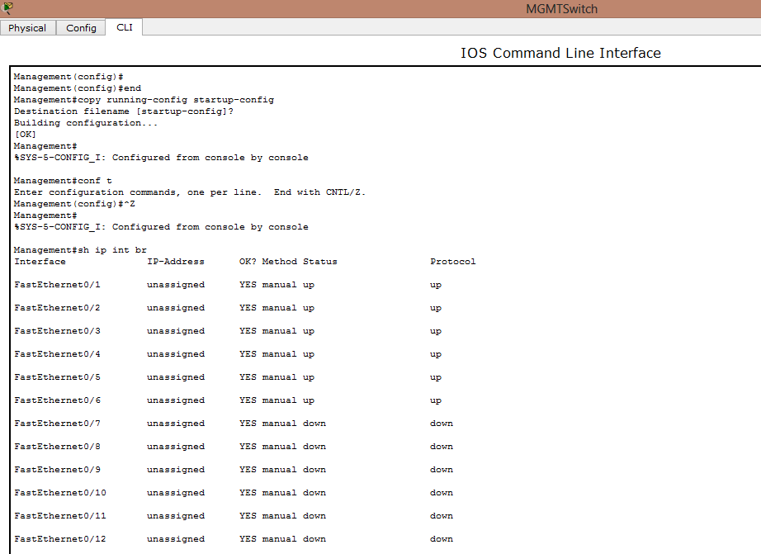
Figure 3.5Assigning ports one at a time or as a range.
Use the following commands to assign individual ports to VLANs:
Switch(config)#interface fa#/#
Switch(conflg-if)#switchport access vlanvlan_number
Switch(config-if)# exit
.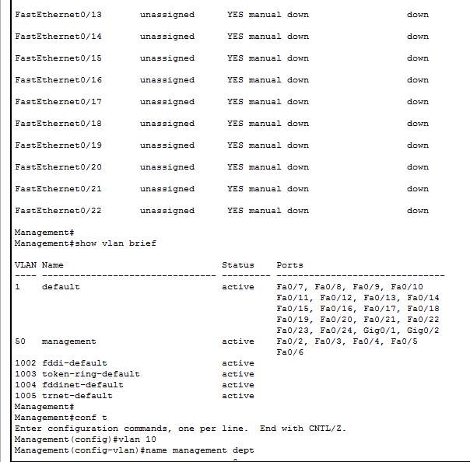
Figure3.6 assigning individual ports to VLANs
The following commands were used to assigna range ports to VLANs
Switch(config)#interface fa#/#/start_of_range-end_of_range
Switch(conflg-if)#switchport access vlanvlan_number
Switch(config-if)# exit.
3.6 Tools
Security on the Internet and on Local Area Networks is now at the forefront of computer network related issues. The evolution of networking and the Internet, the threats to information and networks have risen dramatically. Many of these threats have become cleverly exercised attacks causing damage or committing theft. The Internet continues to grow exponentially. As personal,government and businesscritical applications become more prevalent on the Internet, there are many immediate benefits. However, these network-based applications and services can pose security risks to individuals as well as to the information resources of companies and government.In many cases, the rush to get connected comes at the expense of adequate network security. Information is an asset that must be protected. Without adequate protection or network security, many individuals, businesses, and governments are at risk of losing that asset. Network security is the process by which digital information assets are protected, the goals of security are to protect confidentiality, maintain integrity, and assure availability. A router is similar to many computers in that it has many services enabled by default. Many of these services are unnecessary and may be used by an attacker for information gathering or for exploitation. All unnecessary services should be disabled in the router configuration to prevent the attacker from using it to damage the network or to stealing the important information, or network devices configuration.(Akin.," Hardening Cisco Routers," O’Reilly & Associates,2002).
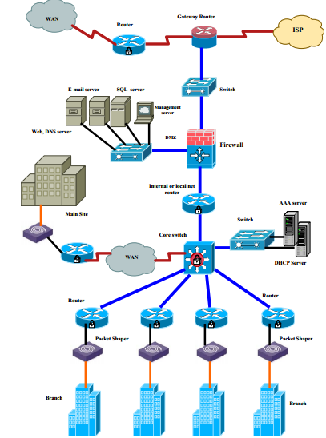
Figure 3.7. Structure of the suggested network security mode
CHAPTER FOUR

IMPLEMENTATION OF A SECURED NETWORK MODEL

4.1 Introduction
Security on the Internet and on Local Area Networks is now at the forefront of computer network related issues. The evolution of networking and the Internet, the threats to information and networks have risen dramatically. Many of these threats have become cleverly exercised attacks causing damage or committing theft. The Internet continues to grow exponentially. As personal,government and businesscritical applications become more prevalent on the internet, there are many immediate benefits. However, these network-based applications and services can pose security risks to individuals as well as to the information resources of companies and government. In many cases, the rush to get connected comes at theexpense of adequate network security. Information is an asset that must be protected. Without adequate protection or network security, many individuals, businesses, and governments are at risk of losing that asset. Network security is the process by which digital information assets are protected, the goals of security are to protect confidentiality, maintain integrity, and assure availability. With this in mind, it is imperative that all networks be protected from threats and vulnerabilities in order for a business to achieve its fullest potential. Some of the implementation model that will be discus are: System requirement that is the software use for implementation, System implementation that is the real network design and some snap short of the network, discussion of all the objectives, and finally the conclusion of what has been done in all chapters.

4.2 System Requirement
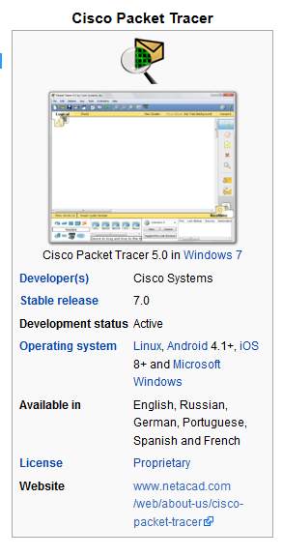
Figure 4.1 Cisco Packet Tracer
Packet Tracer is across-platform visual simulation program designed by Cisco Systems that allows users to createnetwork topologies and imitate modern computer networks. The software allows users to simulate the configuration of Cisco routers and switches using a simulated command line interface. Packet Tracer makes use of a drag and drop user interface, allowing users to add and remove simulated network devices as they see fit. The software is mainly focused towards Certified Cisco Network Associate Academy students as an educational tool for helping them learn fundamental CCNA concepts. Students enrolled in CCNA Academy program can freely download and use the tool free of charge for educational use. In addition to simulating certain aspects of computer networks, Packet Tracer can also be used for collaboration. As of Packet Tracer 6.3, Packet Tracer supports a multi-user system that enables multiple users to connect multiple topologies together over a computer network.

4.3 System Implementation
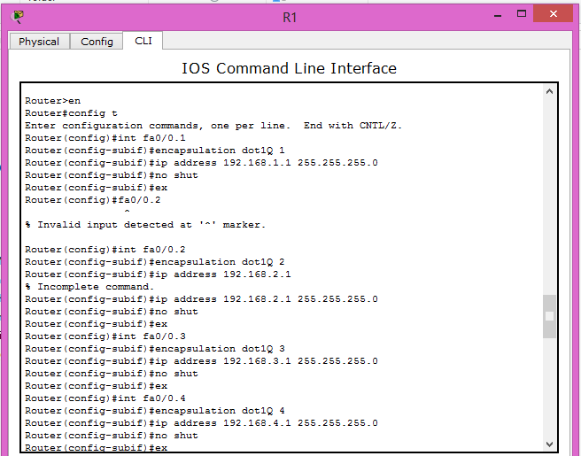

Figure 4.2 Router Configuration showing the fastEthernet and ip address from cli command and fastethernet ports that configure the routers.

Table 4.1 Router Configuration and command in configuring the router in to the Vlans
 | Command | Purpose
Step 1 | configure terminal  Example:  Router> enable  Router# configure terminal  Router(config)# | Enters global configuration mode, when using the console port.  If you are connecting to the router using a remote terminal, use the following:  telnet router name or address  Login: login id  Password: *********  Router> enable
Step 2 | hostnamename  Example:  Router(config)# hostname Router  Router(config)# | Specifies the name for the router.

Step 3 | enable secretpassword  Example:  Router(config)# enable secret cr1ny5ho  Router(config)# | Specifies an encrypted password to prevent unauthorized access to the router.
Step 4 | no ip domain-lookup  Example:  Router(config)# no ip domain-lookup Router(config)# | Disables the router from translating unfamiliar words (typos) into IP addresses.

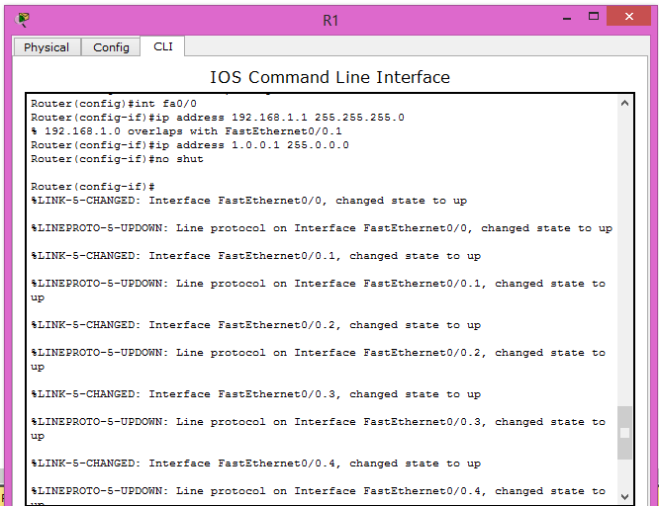
Figure 4.3 Router Configuration showing all the available interface and fastethernet using the cli package for configurations.
Table 4.2 Router Configuration on fast Ethernet and allocating of ip address to each router.
 | Command | Purpose
Step 1 | interface type number  Example:  Router(config)# interface fastethernet 0  Router(config-int)# | Enters the configuration mode for a Fast Ethernet WAN interface on the router.  Note Fast Ethernet WAN ports are numbered 0–1 on the Cisco 1800 series routers.
Step 2 | ip address ip-address mask  Example:  Router(config-int)# ip address 192.1.12.2 255.255.255.0  Router(config-int)# | Sets the IP address and subnet mask for the specified Fast Ethernet interface.
Step 3 | no shutdown  Example:  Router(config-int)# no shutdown  Router(config-int)# | Enables the Ethernet interface, changing its state from administratively down to administratively up.
Step 4 | exit  Example:  Router(config-int)# exit  Router(config)# | Exits interface configuration mode and returns to global configuration mode.

Repeat these steps for the other Fast Ethernet LAN interface if desired. Router Configuration on fast Ethernet and allocating of ip address to each router.
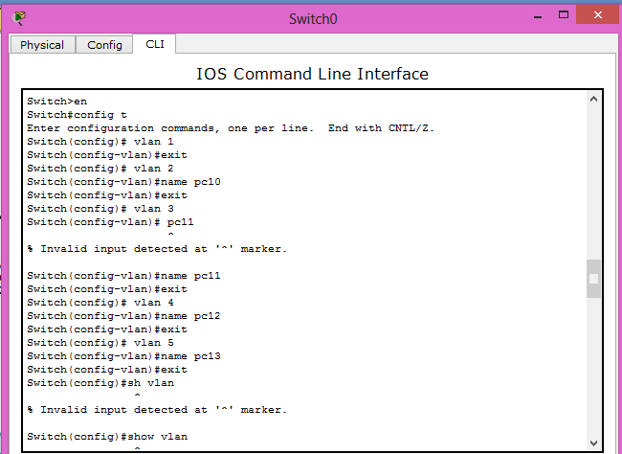

Figure 4.4 Switch Configuration
The switch command line for switch enable command switch configure terminals switch configure interface on fast Ethernet, switchport mode access, switchport access vlans that is assigning VLAN name and numbers in the switch command figure 4.7 explain the switch command.
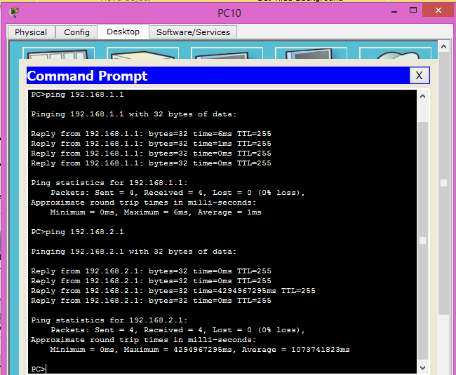
Figure 4.5 Pinging Command to showConfigured ip Address
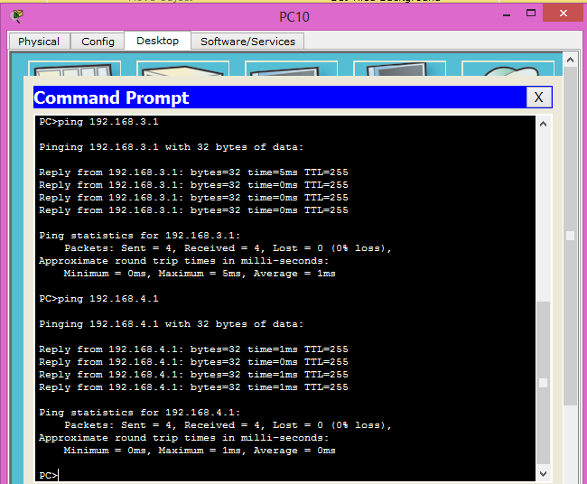
Figure 4.6 Pinging Command to showConfigured ip Address
The above command in figure 4.5 and 4.6 they are the pinging command use to confirm the connectivity in the configuration of the network ip address using command prompt the packet send, the packet receive and the packet lost during network delivery.
The switch command above shows all the VLAN names available, VLAN status, VLAN ports available and active VLAN in the command line. VLAN is a logical of grouping switches in to different network by breaking down large part of switch in to smaller one.
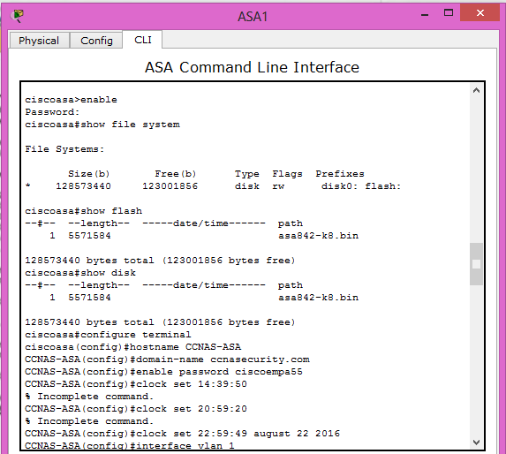
Figure 4.7 Firewall Configurationcommand showing file system size, type, and length of the files.
The ASA firewall command
The Cisco ASA (Adaptive Security Appliance) Family of security devices protects corporate networks and data centers of all sizes. It provides users with highly secure access to data and network resources - anytime, anywhere, using any device. It has some command that enable password which display vlan interface host name and terminal configuration.
The command shows the vlan that is inside and outside the firewall which set the security level to 100 for the inner vlan and 0 security level for the outer vlan ASA configuration which show interface protocol, ip address and method status for command in ASA
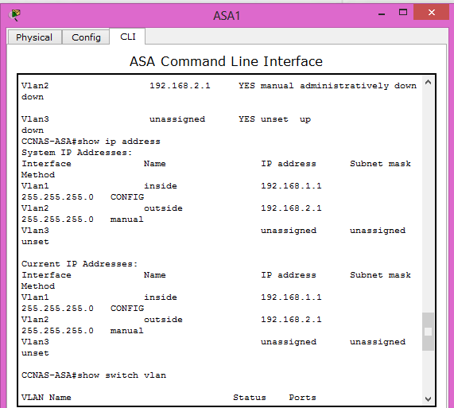
Figure 4.8 Firewall Configurationcommand showing the vlan and ip address
And the vlan 1 and vlan 2 ip address with name of their interface.

4.4 Implementation of Project Objectives in Details
(a) Design and Implementation of a Secured Network
The objective of design and implementation was to evaluate whether network devices are protected and managed, the design was done successfully to secure operations with some devices such as router, switch, hub, printer, ASA firewall, PC, and automatic connection type that helps in connecting one device to another during the network design process
Special security devices and technologies must be implemented to achieve the required network by configuring the ASA firewall, router and switch with the configuring command in chapter three that help in achieving the design, and the implementation will be discussed in the next heading, tittle practical implementation of Vlans.
(b) Practical Implementation of VLAN
VLAN is a logical grouping of networking devices. When we create VLAN, we actually break large broadcast domain in smaller broadcast domains. The VLANs was created and configured in to five different Department such asVLAN 1 as Management Department, VLAN 2 as Administrative Department, VLAN 3 as Maintenance Department, VLAN 4 as Account Department, and finally VLAN 5 as Works Department, which has been successfully configured. There is a test that show how message is transfer from one department to another,
Once a massage is send for the first time it will fail because the department sending does not have the authorization to the other department server, after two to five minutes when the message is re-send again it will deliver successful which has been achieved, and is applicable to all VLANs in the practical implementation of VLANs.
(c) The use of Firewall to Protect Network against breach
we have to limit communications between two vlan interfaces to make the creation of the third vlan interface possible. This can be done for example using the command no forward interface vlan 1on the "interface vlan 3" to deny communications between the inside network that is why when we try to login to some website it show the site you requested is not available or it will display an error occurred or 404 error found and the DMZ (Demilitarize Zone). The purpose of a DMZ is to add an additional layer of security to an organization's local area network (LAN).
A firewall is a typical border control mechanism or perimeter defense. The purpose of a firewall is to block traffic from the outside, but it could also beused to block traffic from the inside.
The same methodologies are being used with the addition of biometric identification. Biometrics provides a better method of authentication than passwords. Example is the Bank Verification Number (BVN). This might greatly reduce the unauthorized access of secure systems.
(d) To create a Secured Network Configuration in Reducing Cybercrime
Network security configuration management is to provide necessary protection to ensure attackers does not have access to our networksfor their selfish interest, whenever a hacker does not have an authorization for some time they change to another location, continuously when they are facing such challenges definitely their numbers will be reducing in any environment. When they try to break in to an organization’s information they keep on seeing fail then the network is secured for the that organization all intruders will not have any authorization for a while, because some hackers never give up they keep on trying until they achieve their aim.
A secured network should have the following:
(a). Access – authorized users are provided the means to communicate to and from a particular network
(b). Confidentiality – Information in the network remains private
(c). Authentication– Ensure the users of the network are who they say they are because we always have malicious insiders in every organization that leak out organization information’s
(d). Confidentiality:Ensure that the secrecy is enforced and the information is not read by unauthorized users. Cryptography and encryption may ensure the confidentiality of the transferred data.

CHAPTER FIVE

SUMMARY, CONCLUSION AND RECOMENDATION

5.1 Summary
In the course of this project the major focus has been identifying different forms of cybercrime and finding ways to prevent this network intrusion using Virtual Local Area network (VLAN) and Extended Access control list. VLAN's allows the formation of virtual workgroups, better security, improved performance, simplified administration, and reduced costs and by using extended access list, one can effectively allow user access to physical LAN and stop them from accessing specific hosts or even specific services on those hosts.

5.2 Conclusion
Cybercrime is a global phenomenal that is threatening the economy of nations, it has become one of the most dangerous crimes in today's society, and the most dangerous aspect of cybercrime is that the victims fail to acknowledge the cause of their unfortunate fate.
The category and nature of cybercrime in the world is endless. Without proper security methods in place on a network, it is just like building a house without locks. Any person can gain access.
With today's advanced technology the urgent need of information security, ethical education and awareness programs cannot be emphasizing enough in order to achieve the maximum protection from the hackers and also to protect Cyber world from our own abusive use.
As new technology develops every day, cybercrime follows along with it. Perpetrators of cybercrime that keep up with new technology and it became a fun challenge for them to try and commit crimes involving the latest technology. Without the proper protection it will become harder to detect and prevent cybercrime. For this reason, it is very important to have international organizations communicating and cooperating with each other to stop such crimes. It is also very important for the society to be well informed about such terrible acts, because the more informed a society is, the better each and every person will be able to protect themselves from being victims of cybercrime.
Like we discussed in Chapter Two, VLAN is a logical network used to logically group users and network resources to administratively configured port of a switch.
The network design logically groups Management, Administration, Works, Account, and Maintenancedepartments to different group of ports in a switch. With this grouping in place hackers find it difficult to know exact port a particular host is assigned to on a switch. Considering the fact that with VLAN the network user is not physically bounded by location; that is a user can move his/her personal computer around within the premises and still belong to the same VLAN. But the ugly truth is that VLAN is not a total security solution provider. Thatis to say that network users on the internet with no VLAN ID can still access the internal network through the management domain, VLAN 1.
. This gave a remarkable security level in the sense that it can be used as a strong preventive measure in blocking off unauthorized users in the Network. To make things even better, it can be used to block communication between two or more VLANs within the Network.
All depends on where and how it's being placed; otherwise it creates more harm than good. With the implementation used in this project, confidentiality and integrity of sensitive documents is ensured.

5.3 Recommendation
Based on the findings of this project, the following recommendations are made:
- Cybercrime can vary in form and degree, but nevertheless cybercrimes affect innocent people every day therefore one of the best ways of preventing cybercrime is to be informed about it, base on my findings I recommend that public aware ness on the negative effect of cybercrime.
- Basic security features should be applied to all switches to ensure that only authorized personnel access the device.
- The creation of Virtual Local Area Network should be considered to ensure network security and VLAN Trunking protocol should be used to provide a method for the centralized control, distribution and maintenance of the VLAN database
- Extended ACL (Access Control List) enables management of traffic and secure access to and from a network and its resources. Therefore, it should be applied on the correct router and interface/sub interfaces and in the correct direction (inbound or outbound) to examine all packets.

References
Akin,T. (2002). Hardening Cisco Router.
Awe,J. (2011). Fighting Cybercrime in Nigeria. Retrieved from http://www.jidaw.com/itsolutions/security3.html .
Ayankokun,O. (2006). Fighting Cybercrime in Nigeria, information system, Retrieved from 2011 .
Brown,M.F. (2001)Criminal Investigation, law and practice 2nd Edition.
Daniel,O. (2003). Designing a Secured Local Area Network.
Isyaku,A.A. (2014). Network Security Using Firewall Technology to Restrict Unauthorized acess to Network.
John,D. (1970). Computer Crime Studies.
Kazeem,A.A. (2010). Consequences of Cybercrime in Tartiary Institution.
Morgan,K. (1998). Wide Area Network Design.
Network, C. S. (2008.). Achieving Cybercrime Preparation.
Newman, S. a. (1995,1998.). Additional forms of service of theft "calling card".
Pavan,D. (1991). National Reseach Council, Computer at Risk.
Rathmell. (1997). The hackers Succeed in gaining Police Operational Intelligence, and in distrupting Police Communication.
Sam,L. (2009). Cybercrime and Challenges of how a computer scientist can solve cybercrime. www.2ab.com.
Sink, S. a. (1999). Computer Network May also be used in Futherance extortion.
Sisters, S. (2006). Technopedial, Security Institute. Guwahati.
Umeozuzlu,F. (2011). Perception of Cybercrime Among Nigeria Youths.
Underwood, M. a. (1994). The Software Publishers Association. .
Wahlert. (1996). Smart card, which i then download ananymously to my account in a financial institution stuated in an oversea jurisdiction which protects the privacy of banking client. .

