Recommender Systems - Course Project Report
Cumulative report template - Parts 1, 2, and 3
Team | Group 15
Members | Charleen Lang, Felix Weber, Vinicius Martins
For Part 3 track: select one | A / B / C
GitHub repository link | https://github.com/thisisfel1x/tuni-recommender-systems

How to use this template
- This is one cumulative report. Extend and revise the same document at each project stage.
- Maximum length: 4 pages at Part 1, 8 pages at Part 2, and 12 pages for the final report, excluding references.
- Keep the section headings below. You may add subsections where useful.
- All explanations and justifications requested in the project specification belong in this report.
- The Results Sheet contains the complete standardized numerical record. In the report, include only the tables and figures needed to support your analysis.
- Delete all italic instructional text before the final submission.

1. Part 1 - Data, Protocol and Baselines

1.1 Data characterization
MovieLens 1M contains 1,000,209 ratings (1-5 stars) by 6,040 users on 3,706 of the 3,883 movies listed in movies.dat, entered between 25 April 2000 and 28 February 2003. The user-item matrix is 4.47% filled, much denser than the typical case discussed in Lecture 1.1.
Activity is very unevenly distributed (Figures 1 and 2). Every user has at least 20 ratings (median 96, maximum 2,314). Items range from 1 to 3,428 ratings (median 123.5), and 446 items have fewer than 10 ratings. The 10% most popular items receive 44.4% of all ratings and the top 20% receive 65.2%. The long tail (Lecture 5.1) is therefore clearly present, but it is milder than in sparse implicit-feedback datasets.
Ratings are skewed towards the positive end (Figure 3): 4 stars is the most common value (34.9%), and 57.5% of all ratings are 4 or 5.
The timestamps are extremely bursty (Figure 4). About 90% of all ratings were entered in 2000, and November 2000 alone accounts for 29%. After January 2001 only a few thousand ratings per month remain. Most users rated everything in a single session: the median time between a user's first and last rating is about one hour. Timestamps therefore mostly record when a user joined, not when a film was watched. This shapes the temporal split (Section 1.3).
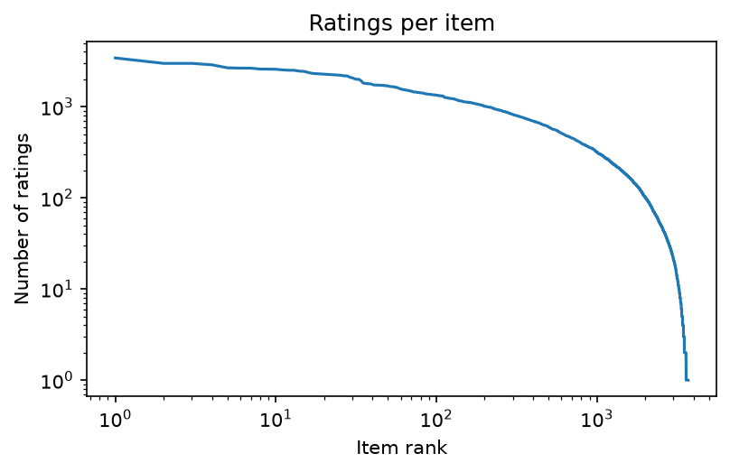  Figure 1: Ratings per item (log-log, items sorted by popularity) | 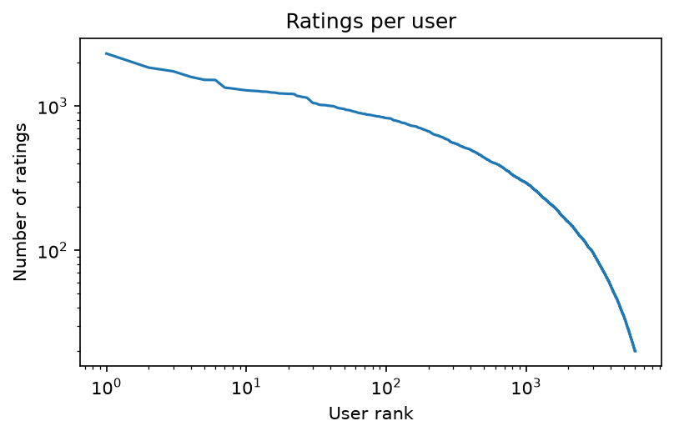  Figure 2: Ratings per user (log-log, users sorted by activity)
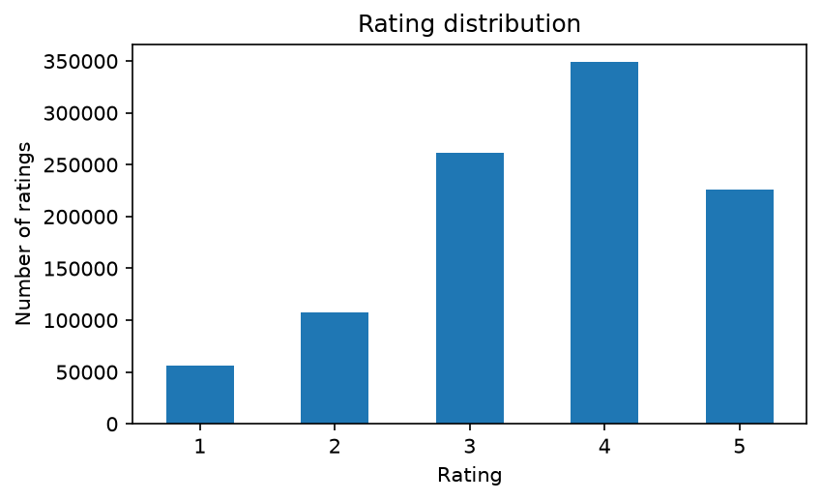  Figure 3: Rating distribution | 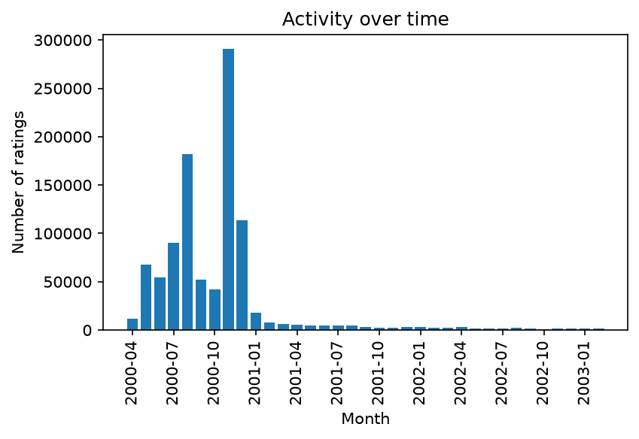  Figure 4: Ratings per month

1.2 Preprocessing and feedback treatment
- Filtering: no users or items were removed (0 rows). MovieLens 1M already guarantees at least 20 ratings per user, and removing rare items would shrink the full-catalogue candidate set that Part 1 asks for.
- Feedback treatment: the explicit ratings are converted into binary relevance. A held-out rating of 4 or 5 counts as relevant, and ratings of 1-3 count as not relevant. Given the positive skew of the ratings (Section 1.1), a threshold of 4 separates "liked" from "watched but not liked". The same threshold defines the "liked" items that form a user's profile in item-based kNN. Every rated item, whatever its rating, counts as already seen and is never recommended again to that user.

1.3 Train/validation/test split
We use a global temporal split and all ratings are ordered by timestamp. The oldest 90% form the training set, the next 5% the validation set, and the newest 5% the test set:
- Train: 900,188 ratings, 25 Apr 2000 - 29 Dec 2000
- Validation: 50,010 ratings, 29 Dec 2000 - 20 Jun 2001 (948 users)
- Test: 50,011 ratings, 20 Jun 2001 - 28 Feb 2003 (813 users)
The cut points are the 90% and 95% quantiles of the timestamps. A global cut guarantees that no information from the future is used for training, and it mirrors deployment, where only past interactions are known.
Hyper-parameters are chosen on the validation set only, with models trained on the training set. For the final test run, every model is retrained on train + validation with the selected settings and evaluated exactly once on the test set.
The split proportions follow from the bursty timestamps. With a conventional 80/10/10 split, the validation period falls inside the main burst, so only 24% of the validation ratings come from users who appear in the training data. Validation would then mostly measure cold-start behavior, which none of the baselines can handle. With 90/5/5, 93.5% of the validation ratings and 98.1% of the test ratings come from users with a training history. The price is a long, sparse test period (20 months for 5% of the data) and few test users. The results are therefore noisy, and confidence intervals will be added in Part 2.

1.4 Evaluation protocol
- Candidate set: for every user we rank the full catalogue of 3,883 movies from movies.dat, excluding the items that user rated in the data the model was trained on. No sampling of negative items is used.
- Evaluated users: users with at least one relevant (rating >= 4) item in the evaluation period and a history in the training data. This gives 891 users on validation and 795 users on test. Four test users have no history and are skipped.
- Metrics (Lecture 3.1, slides 7-9): Precision@10, Recall@10 and NDCG@10 with binary relevance are computed per user and averaged over users. Catalogue coverage is the share of the 3,883 movies that appear in at least one top-10 list.
- Tuning criterion: NDCG@10 on the validation set. Ties in the ranking are broken by all-time popularity and item id, so all results are deterministic (seed 123).

1.5 Baseline methods and settings
- Most Popular: Every user receives the items with the most ratings in the training data, minus the items they have already seen. We report four variants, crossing two choices:
  - time window: all-time vs. only the last 30 days of the training data
  - what is counted: all ratings vs. only positive ratings (>= 4)
- Item-based kNN: We work on the binary "liked" matrix (rating >= 4). The similarity between two items is computed from the users who liked both, using either cosine or Jaccard similarity. For each item only its k most similar neighbors are kept. The score of an item for a user is the sum of its similarities to the items the user liked.
- Tuning: k in {10, 20, 50, 100, 200, 500, 1000} x similarity in {cosine, Jaccard}, i.e. 14 configurations evaluated on the validation set. Cosine with k = 500 reached the highest validation NDCG@10 (0.169; Jaccard peaked at 0.163 with k = 200). Performance rises steadily up to k = 500 and drops slightly at k = 1000. A large neighborhood fits this dataset because user profiles are long and the matrix is dense, so many neighbors carry useful co-rating evidence.

1.6 Results and analysis
Model | P@10 | R@10 | NDCG@10 | Coverage
Most Popular, all-time, all ratings | 0.154 | 0.057 | 0.169 | 3.9%
Most Popular, all-time, ratings >= 4 | 0.159 | 0.061 | 0.177 | 3.9%
Most Popular, last 30 days, all | 0.104 | 0.074 | 0.136 | 1.4%
Most Popular, last 30 days, >= 4 | 0.116 | 0.071 | 0.151 | 2.0%
Item-based kNN (cosine, k = 500) | 0.183 | 0.074 | 0.208 | 8.9%

Item-based kNN performs best on every metric, but its lead over the best popularity variant is modest (NDCG@10 0.208 vs. 0.177). Counting only positive ratings improves Most Popular in both time settings, because it matches the relevance definition used in evaluation.
The most interesting observation is that the time window flips its effect between validation and test. On validation, the 30-day variants were the best popularity baselines (NDCG@10 0.158 vs. 0.141 for all-time). On test they are clearly worse (0.151 vs. 0.177). The validation period starts right after the main burst, so the last 30 days of training data are representative of it. For the test run the window covers the sparse period before June 2001, which contains few ratings, and it must predict a test period that stretches over 20 months. This illustrates how strongly the bursty timestamps affect conclusions drawn from a temporal split.
Coverage stays low for all baselines. For kNN it also shrinks as k grows: on validation it fell from 17.9% (k = 10) to 8.0% (k = 1000) while NDCG@10 increased. Larger neighborhoods push the recommendations towards popular items, so accuracy and coverage pull in opposite directions already for this simple model.

2. Part 2 - Models and Honest Comparison

2.1 Models
Describe the additional models and paradigms. Clearly identify the self-implemented algorithm and explain its implementation.

2.2 Hyperparameter tuning and variability
Describe the validation-only tuning procedure, search spaces/budgets, random seeds, and confidence intervals or statistical testing.

2.3 Overall results
Present and discuss the main comparison. Explain important differences and avoid unsupported claims.

2.4 Disaggregated analysis
Report and interpret results broken down by at least two of the required dimensions: items with few vs. many training interactions, low- vs. high-activity users, popular vs. long-tail items, and early vs. late test period. Define any thresholds used and focus on findings that change or qualify the overall conclusions.

2.5 Sparsity ablation
Report and discuss the 100%, 50%, and 20% training-interaction experiments, including changes in the ranking between models.

3. Part 3 - Beyond Accuracy

3.1 Selected track and motivation
State Track A, B, or C and briefly motivate the selected intervention/extension.

3.2 Method
Describe only your selected track. The Track A/B/C guidance below is provided as instructions; delete the guidance for the two tracks you did not select before submission.

If Track A - Diversity and popularity bias
State the base recommender, selected re-ranking method, genre-vector item representation, trade-off parameter, and exact item-distance measure. Describe how the parameter was swept.

If Track B - Fairness
Define the release-decade provider proxy, report and justify the final decade boundaries and group sizes, state and justify the adopted fairness notion, describe the consumer groups based on MovieLens user attributes, and identify the stage and form of the mitigation.

If Track C - Group recommendations
State the selected synthetic group type and justify the chosen group size (3-5). Describe the three aggregation strategies. Identify which strategy was extended to the sequential scenario and explain how satisfaction is carried forward between recommendation rounds.

3.3 Results and trade-offs
Present the required track-specific results. Track A: report intra-list diversity, catalogue coverage, Gini and calibration error across the parameter sweep, and discuss the accuracy-diversity frontier. Track B: report position-weighted exposure against catalogue share, per-group consumer-side accuracy, and the fairness-performance frontier. Track C: compare group satisfaction, disagreement and minimum member satisfaction across the three aggregation strategies, then analyse how member and group satisfaction develop in the sequential scenario.

3.4 Cost and interpretation
State what is gained, what is lost, and who bears the cost where applicable. Explain what operating choice or strategy you would select and why.

3.5 "One number we cannot explain"
Identify one result you do not fully understand and describe how you would investigate it.

4. Discussion and Conclusions
Summarize the main findings across the project. Discuss limitations, failed approaches where relevant, and what the experiments support.

5. Contribution Statement
Part 1:
- Felix Weber: Set up the repository and Python environment, implemented data loading, the data characterization and plots, the temporal split, the evaluation metrics and the reproducible pipeline (run_all.py). Integrated the team's branches for the submission.
- Charleen Lang: Wrote the unit tests for the metrics and the temporal split and extended the evaluation to rank the full movie catalogue. Reviewed the protocol decisions and some further investigations on different split possibilities.
- Vinicius Martins: Wrote the data characterization and split sections of the report, prepared the figures for the report and filled in the results template, writing of the entire group report.

6. Use of AI Assistants
We utilized Google Gemini to get some in-depth explanations regarding implementing parts of the pipeline (evaluation loop as well as item-based kNN) and also to get some help for setting-up, debugging and executing the Python project environment.
DeepL was used to improve the writing style and to fix some grammar mistakes.

References
List references used in the report. References do not count toward the page limit.

