Recommender Systems - Course Project Report
Cumulative report template - Parts 1, 2, and 3
Team | Group 15
Members | Charleen Lang, Felix Weber, Vinicius Martins
For Part 3 track: select one | A / B / C
GitHub repository link | https://github.com/thisisfel1x/tuni-recommender-systems

How to use this template
- This is one cumulative report. Extend and revise the same document at each project stage.
- Maximum length: 4 pages at Part 1, 8 pages at Part 2, and 12 pages for the final report, excluding references.
- Keep the section headings below. You may add subsections where useful.
- All explanations and justifications requested in the project specification belong in this report.
- The Results Sheet contains the complete standardized numerical record. In the report, include only the tables and figures needed to support your analysis.
- Delete all italic instructional text before the final submission.

1. Part 1 - Data, Protocol and Baselines

1.1 Data characterization

The MovieLens 1M data is a dataset containg 3 different dataframes: movies, users and ratings. The focus lies on the ratings dataset as this is what describes how the users rate the movies they watch.
For the ratings dataset there are 1,000,209 iteractions/rows in total, created between 25/04/2000 until 28/02/2003. These interactions were made 6040 users in total of whom rated 3706 items/movies.
The ratings are not equally divided and present a long tail phenomenon, as the most rated movie has around 3500 ratings, and the user who rated the most has over 2000 movies. This clearly influences how we need to perceive the data as a film with a low amount of ratings may not be accurate enough to provide a good recommendation. As shown in Figure 1 and 2, the long tail is present, and for better visualization of this effect, the graphs are in log scale, because the lesser interacted items have a huge margin compared to those who are more interacted with.
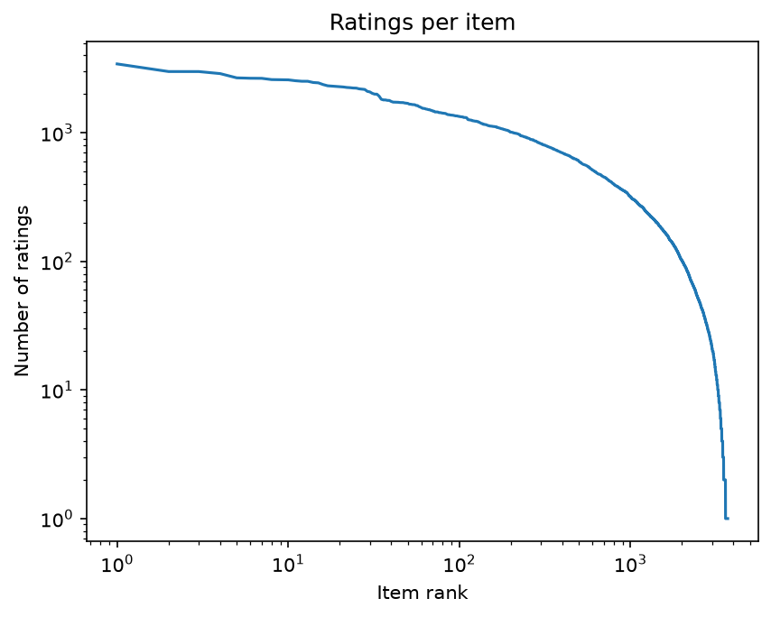
Figure 1: Ratings per item plot (log)
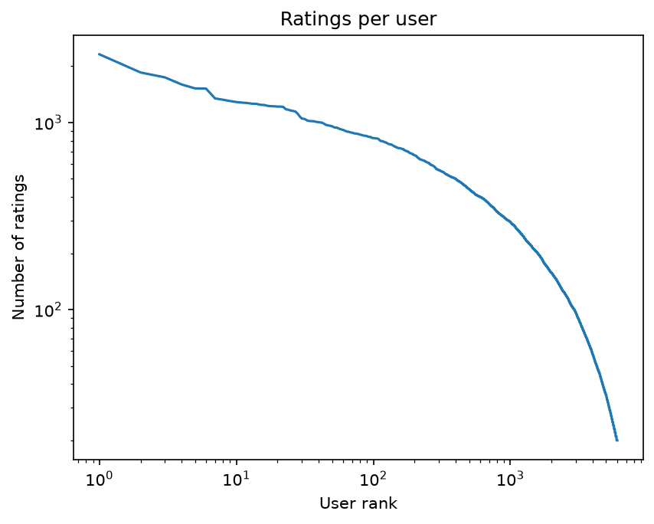
Figure 2: Ratings per user plot (log)
There are other properties from the data that require analysis, one of these is the rating distribution, as the ratings don’t present an even distribution between ratings, so a film rated 3, because of human decision might be a worse film then that rating might suggest, this can be measured by the rating distribution, on how many times each grade appears in the dataset:
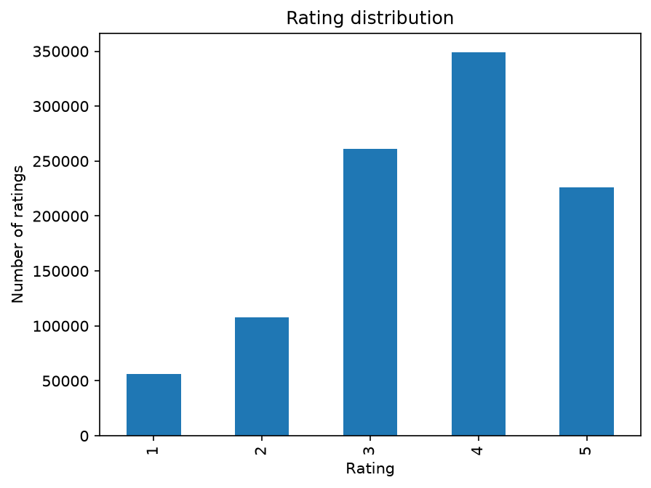
Figure 3: Rating Distribution plot
Another possible issue that need to be accounted for is the activity over time as the ratings are not from an even timeframe, as shown in figure 4, the ratings happened mostly in the year 2000, so despite the existence of ratings from 2001-2003, most of the dataset is from 2000, which can influence results.
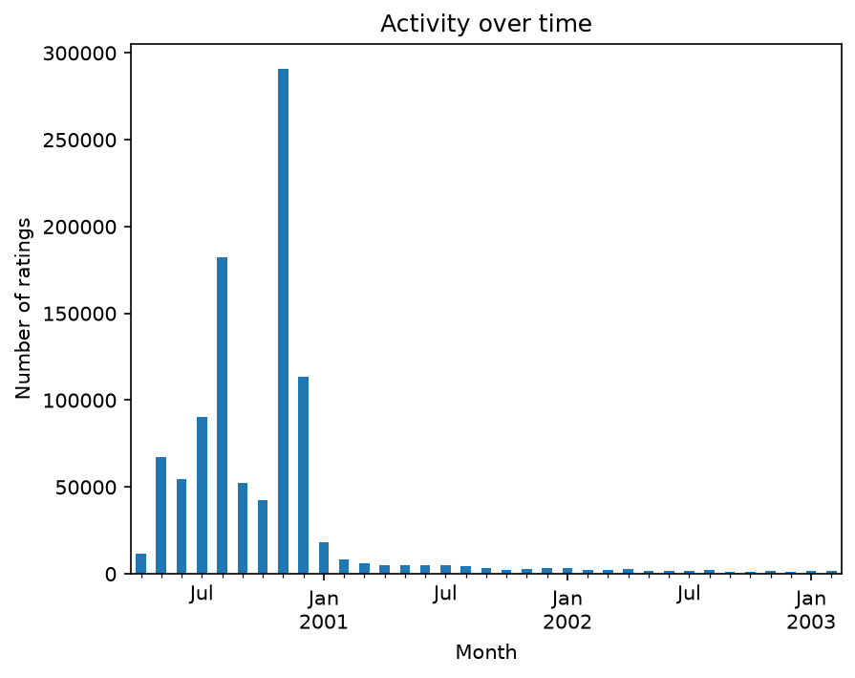
Figure 4: Activity over time plot

Characterize the MovieLens 1M data as required in Part 1. Include the requested distributions/plots and discuss any non-obvious properties relevant to the experiments.

1.2 Preprocessing and feedback treatment
Describe filtering, treatment of ratings/feedback, and any preprocessing decisions. Report thresholds and their effect on the data.

1.3 Train/validation/test split

The temporal split works by splitting the dataframe into 3 sections: train/validation/test, the train secton will be used for training are requires the most amount of rows, the validation section is used to validate results and improve training, this section is seen during training. The test section is extremely important and must never be seen by the model, as it is used in testing to check the results produced and the quality of the model. The temporal split is specific to using time, so older interactions are used in training, the newer interactions are left for testing and the rest is validation.
As the train requires lots of interactions it should have >60% of the data, the validation guarantees a good training and requires a reasonable amount of rows, if it is too low the training will not pinpoint its mistakes and may carry them into further training stages, which the kills the quality of the system. So reserving >10% of the dataset is good for validation, the test section does not need to be big, but a small amount is certainly necessary to guarantee that the testing can be trusted.
After testing, the split which wielded the best results were:
Train: 75% of the dataset;
Validation: 20% of the dataset;
Test: 5% of the dataset.

Specify the temporal split exactly and justify it.

1.4 Evaluation protocol
Specify the candidate set, ranking setup, metrics, and other protocol decisions. Justify the major choices with reference to the relevant lecture material.

1.5 Baseline methods and settings
Describe item-based kNN and the Most Popular variants, including the settings that were evaluated. For item-based kNN, report and justify the selected neighborhood size k and similarity measure.

1.6 Results and analysis
Present the important Part 1 results. Interpret them rather than reproducing the entire Results Sheet.

2. Part 2 - Models and Honest Comparison

2.1 Models
Describe the additional models and paradigms. Clearly identify the self-implemented algorithm and explain its implementation.

2.2 Hyperparameter tuning and variability
Describe the validation-only tuning procedure, search spaces/budgets, random seeds, and confidence intervals or statistical testing.

2.3 Overall results
Present and discuss the main comparison. Explain important differences and avoid unsupported claims.

2.4 Disaggregated analysis
Report and interpret results broken down by at least two of the required dimensions: items with few vs. many training interactions, low- vs. high-activity users, popular vs. long-tail items, and early vs. late test period. Define any thresholds used and focus on findings that change or qualify the overall conclusions.

2.5 Sparsity ablation
Report and discuss the 100%, 50%, and 20% training-interaction experiments, including changes in the ranking between models.

3. Part 3 - Beyond Accuracy

3.1 Selected track and motivation
State Track A, B, or C and briefly motivate the selected intervention/extension.

3.2 Method
Describe only your selected track. The Track A/B/C guidance below is provided as instructions; delete the guidance for the two tracks you did not select before submission.

If Track A - Diversity and popularity bias
State the base recommender, selected re-ranking method, genre-vector item representation, trade-off parameter, and exact item-distance measure. Describe how the parameter was swept.

If Track B - Fairness
Define the release-decade provider proxy, report and justify the final decade boundaries and group sizes, state and justify the adopted fairness notion, describe the consumer groups based on MovieLens user attributes, and identify the stage and form of the mitigation.

If Track C - Group recommendations
State the selected synthetic group type and justify the chosen group size (3-5). Describe the three aggregation strategies. Identify which strategy was extended to the sequential scenario and explain how satisfaction is carried forward between recommendation rounds.

3.3 Results and trade-offs
Present the required track-specific results. Track A: report intra-list diversity, catalogue coverage, Gini and calibration error across the parameter sweep, and discuss the accuracy-diversity frontier. Track B: report position-weighted exposure against catalogue share, per-group consumer-side accuracy, and the fairness-performance frontier. Track C: compare group satisfaction, disagreement and minimum member satisfaction across the three aggregation strategies, then analyse how member and group satisfaction develop in the sequential scenario.

3.4 Cost and interpretation
State what is gained, what is lost, and who bears the cost where applicable. Explain what operating choice or strategy you would select and why.

3.5 "One number we cannot explain"
Identify one result you do not fully understand and describe how you would investigate it.

4. Discussion and Conclusions
Summarize the main findings across the project. Discuss limitations, failed approaches where relevant, and what the experiments support.

5. Contribution Statement
For each team member, provide two or three sentences describing their contribution.

6. Use of AI Assistants
State which AI tools were used and for what. If none were used, state that explicitly.

References
List references used in the report. References do not count toward the page limit.

