COMPS358F Lab 09: SQL Data Definition II

In this lab we will continue using PostgreSQL DBMS and please refer to the following for connection details:
- Go to Program -> PostgreSQL -> pgAdmin III
- Double click the PostgreSQL Database Server and then enter the password: pass123
- Go to Databases -> postgres -> schemas -> public -> table, click the SQL command prompt (), then create the tables by running SQL codes from the following link:

http://learn.ouhk.edu.hk/~t810870/358f/StuRelation-SQL.html

15. a) Create a View studentMark with the following attributes:

student ID, student name, course code, course title and mark

Check your result below:
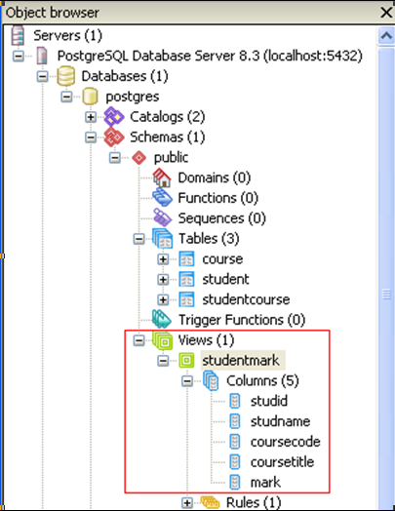

[Note]
- Since PostgreSQL database is case sensitive, it is suggested to use lower case for naming all tables, views and columns.
[Hint]
- Check out http://www.postgresql.org/docs/9.3/static/sql-createview.html for more details
- Also refer to http://www.postgresql.org/docs/9.3/static/tutorial-views.html for the advantages using Views

b) Retrieve the record of View studentMark using a SELECT SQL Statement. The result is:

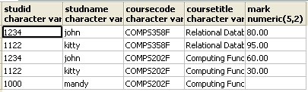

16. Show the student name, course title and mark of "john".
[Hint]
- Consider using the view studentMark

17. a) Create a View studentAverageMark with the attributes:

student ID, student name, average mark (named as averagemark) of each student
[Note]
- Select the related tables for the view creation, do not make use of view studentMark

b) Retrieve the record of View studentAverageMark using a SELECT SQL Statement. The result is:

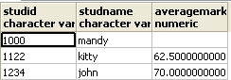

18. Show the student name and average mark of students whose average is not null.
[Hint]
- Consider using the view studentAverageMark

19. Insert the data ('1000', 'COMPS358F', 2015, 88) into studentCourse and
Repeat question 18. Notice a new row appears.

20. a) Delete the information with studID 1122 from studentCourse and repeat question 18. Notice a row disappears.

b) Drop the views studentMark and studentAverageMark using two separate SQL statements for each view.
21. Create user "guest" with password 'guest123'.
[Hint]
- Refer to http://www.postgresql.org/docs/7.3/static/sql-createuser.html for examples

Check your result below:
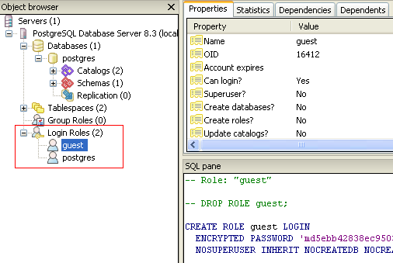

22. a) Run another copy of pgAdminIII (go to Start->Program->PostgreSQL->PgAdminIII), change the user to "guest”:

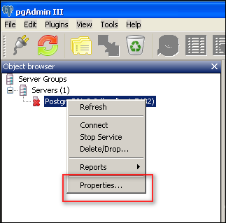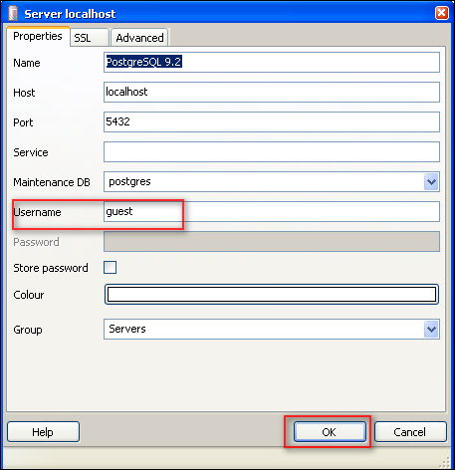

b) Right click the PostgreSQL DB server, and enter password ‘guest123’ to login:

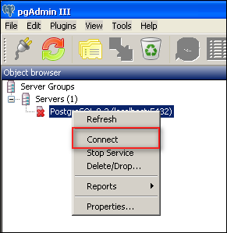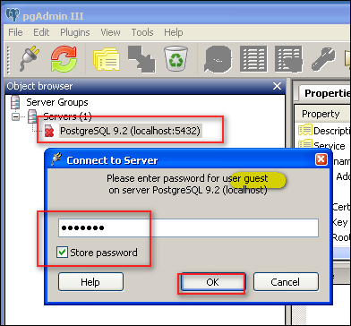
c) Using the guest account, go to Databases -> postgres -> schemas -> public -> table, then click the SQL command prompt () . Now also open the SQL command prompt using postgres account:
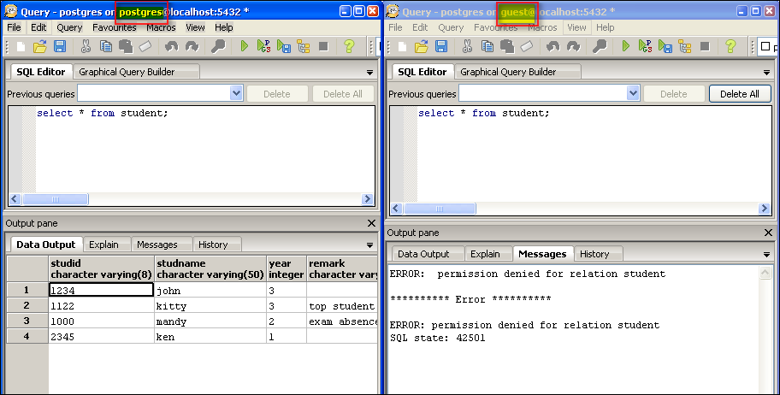
23. (Using the guest account) Show the information of student using select statement. It should give an error message.
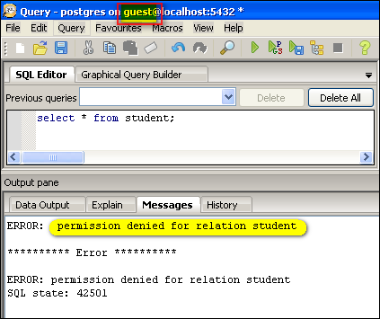

24. (Using the postgres account) Grant the Select privilege of student to guest.
[Hint]
- Refer to http://www.postgresql.org/docs/9.3/static/sql-grant.html for examples

25. Re-do question 23 again. Now the information should be shown.

26. (Using the postgres account) Revoke the Select privilege of student from guest.
[Hint]
- Refer to http://www.postgresql.org/docs/9.3/static/sql-revoke.html for examples

27. Re-do question 23 again. Now the same error message appears.

28. (Using the guest account) replace the year to 3 in the table student using an Update SQL statement. It should give an error message as below:
ERROR: permission denied for relation student
********** Error **********
ERROR: permission denied for relation student
SQL state: 42501

29. (Using the postgres account) grant the update privilege of student to guest.

30. Re-do question 28 again. The operation should be successful now.

31. i) (Using the guest account) replace the name of 'john' by 'johnny' using an Update SQL statement. It should give an error message as below:
ERROR: permission denied for relation student
********** Error **********
ERROR: permission denied for relation student
SQL state: 42501

ii) Explain briefly the problem and solve it.
[Hint]
- Refer to http://www.postgresql.org/docs/9.3/static/sql-grant.html , look for the privileges details of Update
- (Using the postgres account) Grant the additional privilege of student to guest.

32. i) (Using the postgres account) Delete the user “guest” using a DROP SQL statement. It should give an error message as below:
ERROR: role "guest" cannot be dropped because some objects depend on it
DETAIL: access to table student

********** Error **********

ERROR: role "guest" cannot be dropped because some objects depend on it
SQL state: 2BP01
Detail: access to table student

ii) Explain briefly the problem and solve it.
[Hint]
- Revoke the privileges before dropping the user

