|  |  |
| --- | --- |
|  |  |
| Resume Parser |  |

***2320090014***

***Nadendla Chervi***

***2320030046***

***Joshi Jeevan Sai***

***2320030258***

***Pothuri Rahul Varma***

*In today’s competitive job market, candidates face significant challenges in effectively navigating their career paths. Many individuals lack personalized guidance and resources, hindering their ability to secure employment. This project aims to develop a comprehensive machine learning model that addresses these challenges by providing tailored tools for resume optimization, job matching, and interview preparation.*

*Key challenges include:*

*Ineffective Resume Presentation: Many job seekers struggle to craft compelling resumes that accurately showcase their qualifications, often leading to missed opportunities.*

*Difficulties in Job Matching: The vast number of job listings can overwhelm candidates, making it challenging to identify roles that align with their skills and career aspirations.*

*Insufficient Interview Preparation: Candidates frequently lack access to relevant interview questions and constructive feedback, leaving them unprepared for crucial interactions with potential employers.*

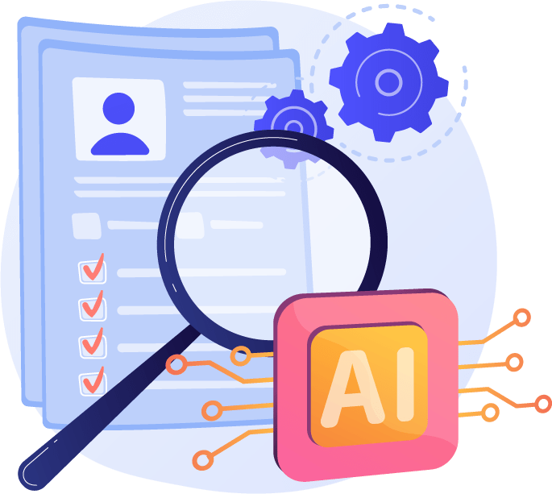

*To tackle these issues, the proposed system will leverage Natural Language Processing (NLP) techniques to parse and analyze resumes, generating tailored suggestions for improvement. It will also employ advanced algorithms to analyze candidates' profiles and match them with suitable job openings. Furthermore, the model will generate personalized interview questions and provide feedback to enhance candidates' performance.*

*By empowering job seekers with these essential tools, this project seeks to streamline the job search process, alleviate the challenges faced by candidates, and facilitate their success in securing rewarding career opportunities.*