Project Report
On
Anna Daan / अन्नदान
(CS VI Semester Mini project PCS-604)
2020-21


Submitted to: Submitted by:
Dr. Naveen Tewari(associate prof.) Ankit Rajwar
Guided by: Bhupesh Joshi
Dr. Naveen Tewari Manoj Rawat
Rajani Manral
Mohd.Musab
STUDENT’S DECLARATION

We Ankit Rajwar ,Bhupesh Joshi, Manoj Rawat, Mohd.Musab, Rajani Manral hereby declare the work, which is being presented in the project, entitled “ANNADAAN” in partial fulfillment of the requirement in the session 2020-2021, is an authentic record of our own work carried out under the supervision of Graphic Era Hill University, Bhimtal college guide name Dr.NaveenTewari.
The matter embodied in this project has not been submitted by us for the award of any other degree.

Date: 22/05/2021
ANKIT RAJWAR
BHUPESH JOSHI
MANOJ RAWAT
MOHD.MUSAB
RAJANI MANRAL

DEPARTMENT OF COMPUTER SCIENCE AND ENGINEERING
GRAPHIC ERA HILL UNVERSITY, BHIMTAL
CERTIFICATE

Certified that Mr.Ankit Rajwar (Roll No.- 2071355),Mr. Bhupesh Jopshi(Roll No.- 2071359), Mr.Manoj Rawat (Roll No.-2072025),Mr.MohdMusab (Roll No.- 2071378) and Ms.Rajani Manral (Roll No.- 2072024) have submitted mini project synopsis report on “ANNA DAAN” for the CS VI Semester Mini Project Lab (BCP-601) in Graphic Era Hill University, Bhimtal under my supervision. The project carried out by Students is their own work as best of my knowledge.

Date: 22-05-2021
(Dr.Naveen Tewari)
Project Guide
Associate Professor
Department of CS/IT GEHU, Bhimtal

ACKNOWLEDGEMENT

Here by we are submitting the project report on “Anna Daan”, as per the scheme of Graphic Era Hill University, Bhimtal.
In this connection, we would like to express our deep sense of gratitude to our beloved institution Graphic Era Hill University and also we like to express our sincere gratitude and indebtedness to Dr.R. C. S. Mehta, Dean, GEHU, Bhimtal.
We would like to express our sincere gratitude to Mr. S.K. Budhani, Head of Dept. of Computer Science and Application, for providing a congenial environment to work in and carry out our project.
We consider it our cardinal duty to express the deepest sense of gratitude to Mr Naveen Tewari , Associate. Professor, Department of Computer Science and Application for the invaluable guidance extended at every stage and in every possible way.
ANKIT RAJWAR
BHUPESH JOSHI
MANOJ RAWAT
MOHD.MUSAB
RAJANI MANRAL

Contents
1. Introduction 2
2. Objective and Scope 2
3. Methodology/Process Description 2
4. Requirements (hardware & software) 2
5. Modules 2
6. Conclusion 2

INTRODUCTION

  - About Project
Observing our surrounding we precieve that there are many hungry people who sleep famished regularly/ sometimes.
The projects aims to provide food to the needy people by the volunteers(users) of ANNA DAAN.
Includes:
  - Hotels
  - Active clients
  - Extra cooked food
  - Digital platform
  - Android app
  - Website

OBJECTIVE
The objective behind developing the website and app is to bring up the idea of food donation through electronic medium. In this there are 2 modes of registration i.e, register as DONOR and register as Volunteer.
Donor will be the one belonging to the hotel/food counter who will serve the food to the volunteer to distribute among the poor.
The website also have the additional option of FUND RAISING. All the collected amount deposited will destributed in the poor people.

This website and app will be like the helping hand between the donor and volunteer.

Methodology/Process Description

The method we followed to develop our website is pretty straightforward. All of us quite well versed in web development but none of us have enough experience to ship code that could be counted on . So we decided to slowly and steadily read online material for developing our website. so We started with studying bootstrap as it is the de-fecto standard for creating website these days . We studied bootstrap and created alluring front end which could scale in all types of devices . Initially we were facing problem when we had not studied bootstrap as we were counting on media queries so that our website could fit in all devices but it didn’t work as even after using so many media queries we could not make perfect looking front end . But then one we started studying bootstrap and it reduced our stresss and helped us to write good front end without much of an hassle .

After writing a basic front end we wrote the database schema which was pretty straightforward too. We created a database called canteen and we created 3 tables ( customers, orders, items )
and we created fields and perfect combinations of keys to access data easily .
We are using mysql as the database .

Requirement of Project
    - Hardware Requirement
- Configured Laptop/Desktop .
- External Hard drive for backup.
- Server
- Mobile
    - Software Requirement
- Vs code (To code Html 5, Css, Bootstrap , javascript,Backend)
- Figma (for designing)
- Adobe Photoshop (for image editing and logo designing)
- Android Studio

LOGO DESIGN


Modules of Project
    - Module 1
      - Creating website using HTML 5 in vs code.
      - Designing through Css .
      - Designing a responsive web site using bootstrap.
      - Responsive using javascript
      - Design by Bhupesh Joshi, Manoj Rawat, Rajni Manral

We created the front end pages i.e HOME , ABOUT, RESGISTRATION & CONTACU US page using bootstrap ,css and Html , we used vs code for this as it provide the function of live server by which we can see all immediate changes made in our code. We later link each pages with each other to make it preety good and attractive.

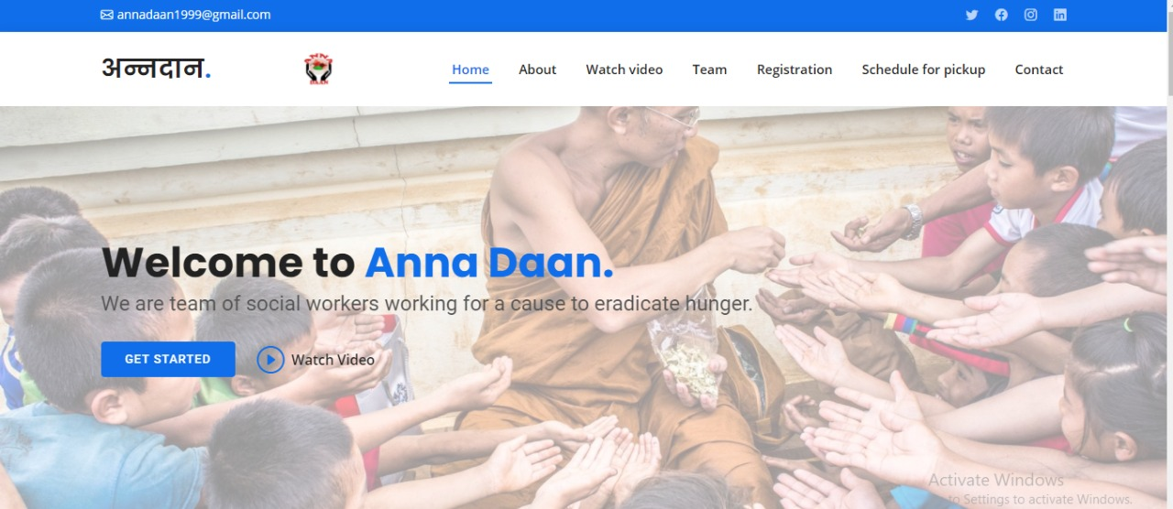

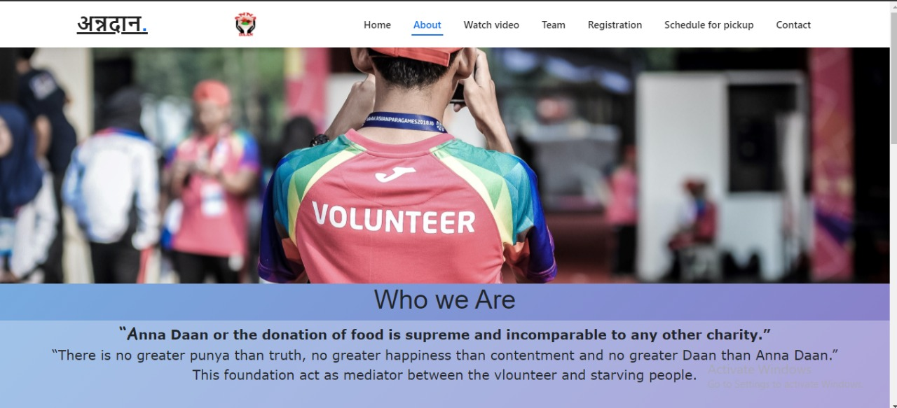

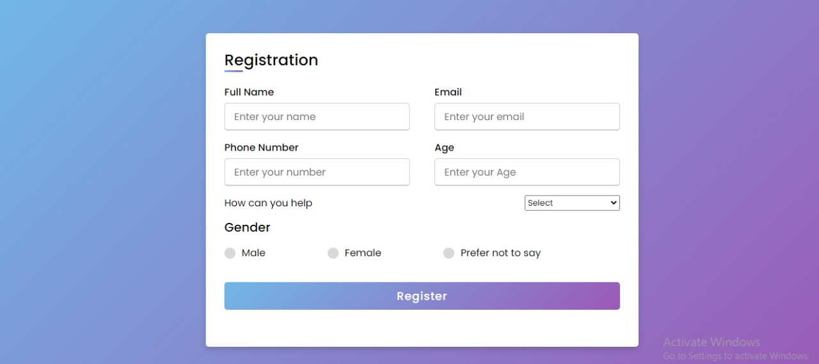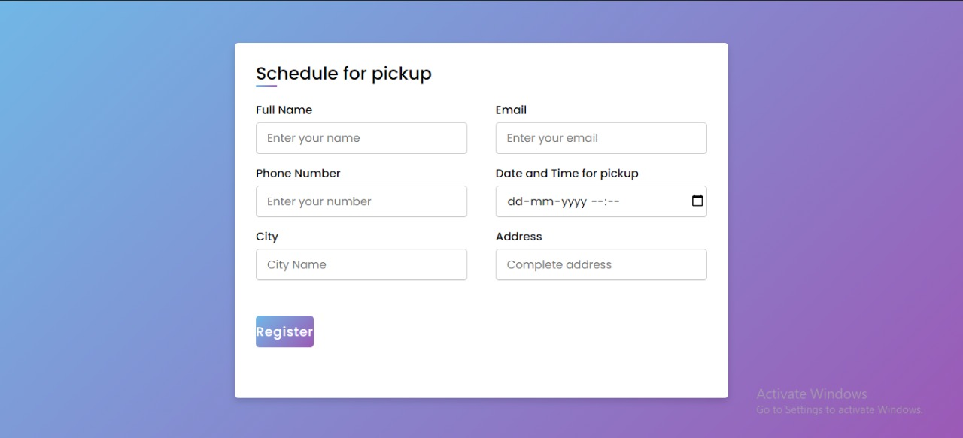

    - Module 2
        - Database development using Mongo dB .
        - Content on the site is constantly changing and updating
        - Queries database for information and processing any logic
        - Design by Ankit Rajwar , Mohd. Musab.

    - Module 3
        - Converting website into mobile application
        - Design by Bhupesh Joshi.
I converted website to mobile application through ANDRID STUDIO.
By creating small browser which opens the link which was given in java code during the coding process om android studio. Later the the link that was given in the code become the only link which the browser can access.
At the last I bundled all the codes and converted them to the apk.

    - Module 4
        - Creating logo and animation
        - Design by Manoj rawat
I created logo using adobe photoshop and animation using adobe premiere pro.
I created favicon using online tool i.e, image converter.

Conclusion

The projects were pretty easy to begin with but we did face a number of problems in developing the projects as were did not have enough experience back then but now we do have some experience and in the aftermath it can be said that working on both the projects helped us to get a better understanding of computers and program development in general.

REFERENCE

- Learning Android studio by online free course
- Html css javascript by geeks of geeks.
- Dbms online course offered by udemy.
- Java from javatpoint.
5 Android studio code with harry.

