**KWAME NKRUMAH UNIVERSITY OF SCIENCE AND TECHNOLOGY**

**COLLEGE OF ENGINEERING**

**FACULTY OF COMPUTER AND ELECTRICAL ENGINEERING**

**DEPARTMENT OF COMPUTER ENGINEERING**

**BIOMEDICAL 3**



**DESIGN OF A HEART BEAT AND TEMPERATURE MONTORING DEVICE WITH MEDICAL RISK ASSESSMENT FEATURES.**

**BY TEAM 7 AND 8**

**TEAM MEMBERS**

|  |  |
| --- | --- |
| **Group Members** | **Index Number** |
| Esther Owusu-Bekoe | 1806922 |
| McGovern Twumasi Owusu-Bekoe | 1807022 |
| Cheryl Akorfa Tetteh | 1807722 |
| Osei Kwaku Tanoh | 1807622 |
| Mba Bacha Jemima Nsanyaan | 1805622 |
| Azorliade Elinam Erika | 1802622 |
| Nyaaba Adalebse Turibius | 1806322 |
| Jane-Belle Fafa Agbeti | 1800222 |
| Baidoo Theophilus Boakye | 1802722 |
| Raphael Darkwa Adjei | 1799722 |

Table of Contents

**1.INTRODUCTION** 3

**1.1 Overview** 3

**1.2 Objectives** 3

**2.METHODOLOGY** 4

**2.1Components** 4

**2.2 Circuit design** 5

**3. CODE DESIGN** 6

**3.1Pseudocode** 6

**4.CONCLUSION** 10

**4.1Advantages of the Health Monitoring System** 10

# 

# **1.INTRODUCTION**

## **1.1 Overview**

With the rapid advancement of electronic and computer technology, automated health monitoring systems are becoming essential in modern healthcare. Early detection of potential health issues can significantly improve patient outcomes, making real-time health monitoring crucial in both clinical and personal settings. Among various health parameters, heartbeat and body temperature are fundamental indicators of a person’s well-being.

* Heartbeat irregularities can indicate conditions such as arrhythmia, heart disease, or even stress and fatigue.
* Abnormal body temperature can signal infections, fevers, or underlying medical conditions that require immediate attention.

Given the increasing prevalence of cardiovascular diseases and infectious illnesses, there is a growing need for real-time monitoring systems that can detect early warning signs and alert users before their conditions worsen.

Traditional health assessments rely on periodic checkups which creates gaps in monitoring, allowing sudden changes in heartbeat or body temperature to go unnoticed. For individuals with conditions such as cardiovascular diseases or fever-prone illnesses, the absence of continuous monitoring can result in delayed diagnosis and treatment. Individuals therefore remain unaware of potential health risk until symptoms of diseases worsen increasing chances of succumbing to the disease

## **1.2 Objectives**

This project aims to develop an Arduino-based biosensor system that;

* Continuously monitors a user’s heartbeat and temperature,
* Calculates a risk score in real time.
* Provides warning alerts if abnormalities are detected.

# 

# **2.METHODOLOGY**

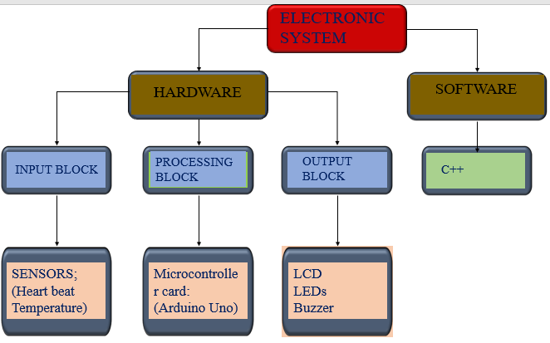*Figure 1: Block diagram of major components used in our system design*

# **2.1Components**

The emergency alert system was designed to monitor and display the temperature and heart rate of the user. The first step in developing an emergency system for patients was finding specific components that meets the systems requirement. The components selected included:

* A 16x2 LCD Display to provide real time visualization of the temperature value and heart rate to the user
* LED indicators to represent the risk level and alert the user when there is any reading. The green led indicates safe and low risk, the yellow led indicates medium risk and the user should take caution and the red led indicates danger and high risk.
* A microcontroller, specifically an Arduino Uno which reads and processes data, calculates the health risk score and also controls the system operations.
* A HB1 heart rate sensor that continuously measures the heart beats per minute and sends analog signal to the microcontroller
* A temperature sensor to read body temperature of the user and send it to the microcontroller.
* A 5V power source to supply power for stable operation
* GSM Module SIM 900D to send alerts via SMS to users contact.
* A buzzer that sounds an alarm when abnormal conditions are detected
* A push button to start and stop the process.

## **2.2 Circuit design**

The schematic and PCB layout was designed using proteus and easyeda respectively. The sensor inputs from the heart sensor provides pulse counted and the temperature sensor ouputs a voltage that corresponds to the body temperature. The microcontroller processes these inputs and compares them to the defined threshold limits then activates the buzzer and LEDs indicators. When the heart or temperature rate is above the normal range the red LED light and the buzzer are triggered and the LCD displays the reading. The whole process begins when the push button is pushed.

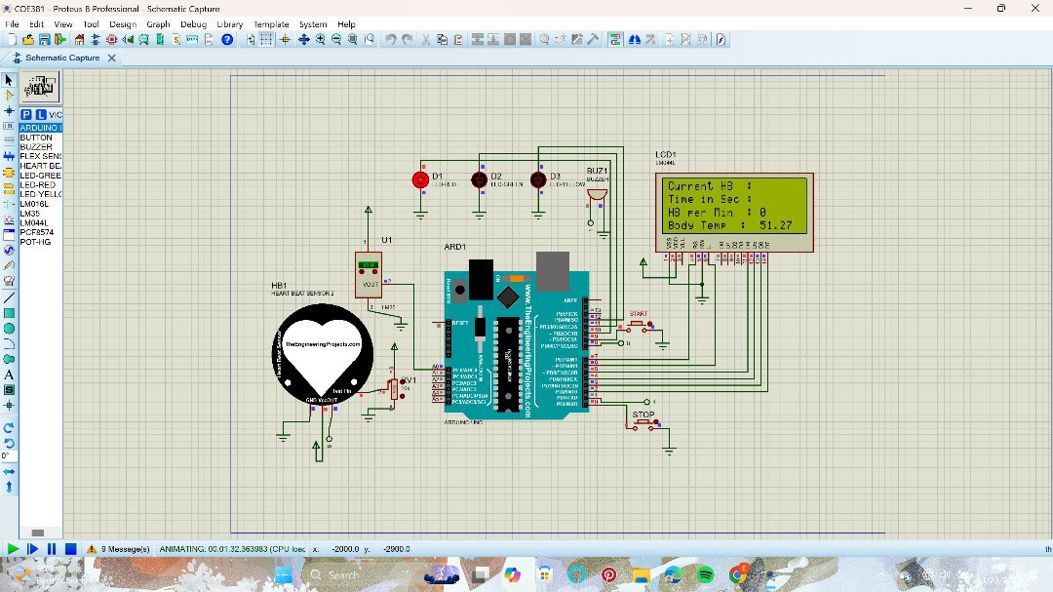

Schematics of the emergency system.

The system works due to a code written in the Arduino IDE, implementing the following key functionalities:

Data from the heart rate sensor is read via an analog input pin, the converted into a value and displayed on the LCD. The system continuously checks the heart rate against a predefined threshold value and triggers an alert depending on whether the heart rate exceeds or falls below the threshold. The GSM module is activated and an SMS containing the alert is sent to the user when the threshold is exceeded.

The system was tested to make sure the components were properly integrated with the code, the sensors accurately read and provided consistent readings, the alerts where triggered once the limits were exceeded and the GSM sent alerts to the users.

# **3. CODE DESIGN**

## **3.1Psuedocode**

Initialize LCD dimensions

Initialize all pins

Display startup message on LCD

READ start Button

If the start Button is pressed;

Start monitoring

Reset heartbeats and timer

Reset LCD and buzzer

READ stop Button

If the stop Button is pressed;

Stop monitoring

Turn off LEDs and buzzer

READ Stop Buzzer Button

If stop buzzer button is pressed;

Mute buzzer

If monitoring is active;

READ currentMillis

IF current time > interval;

RESET interval timer

READ temperature sensor

CONVERT analogue value to Celsius

READ pulse sensor

IF pulse detected;

heartbeat counter ++

Store time of last heartbeat captured

CALCULATE heart rate

CALCULATE risk score based on heart rate and temperature

DISPLAY heart rate, temperature, and risk score on LCD

CHECK risk score

SET LED colours and buzzer based on risk level

The Temperature and heart rate monitoring system is designed to find the heart rate and body temperature, calculate a risk score, and provide alerts through LEDs, a buzzer, and an LCD. The C++ code compiled in the Arduino IDE the microcontroller thereby dictating the behaviour of the system and integrating with sensors, buttons, and output devices to ensure real-time monitoring and feedback. Below is an explanation for the sections of code used.

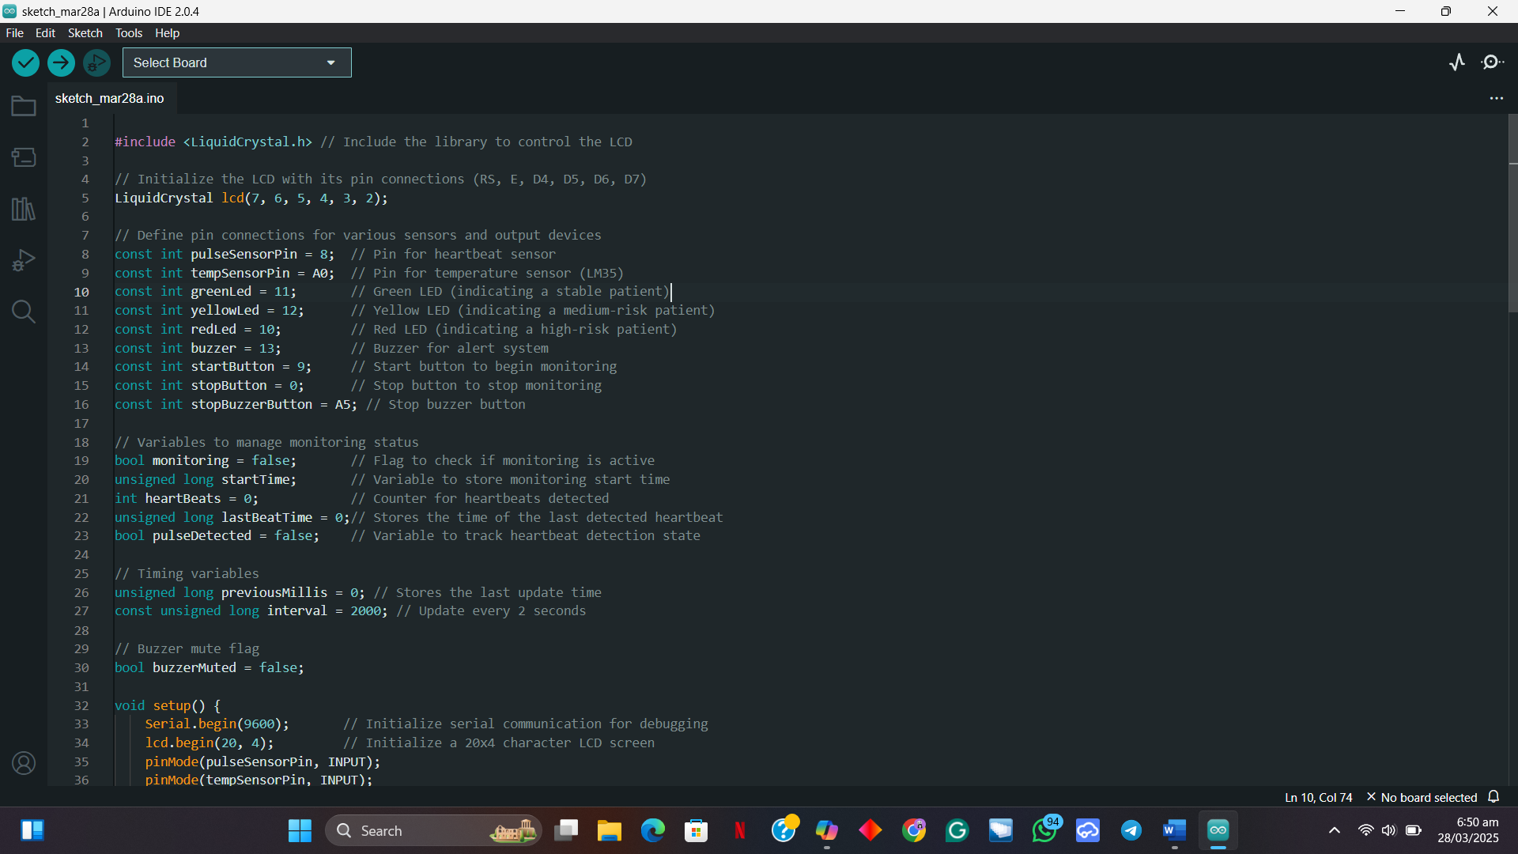

* In the first line, LCD library is included to control the LCD.
* The LCD is initialized with pins (RS, E, D4, D5, D6, D7) which are connected to the microcontroller.



* The pins are defined for the input (sensors and buttons) and output (LEDs and buzzer).

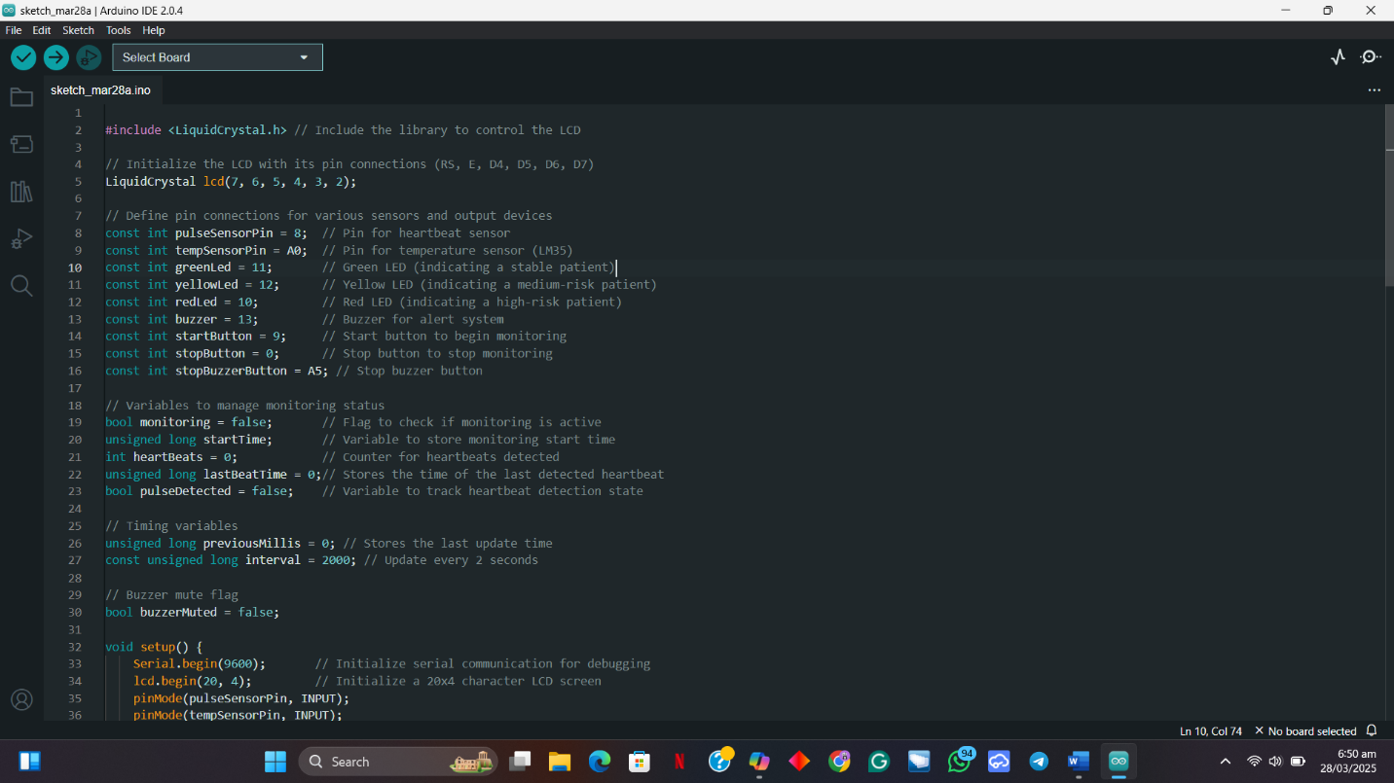

Variables are made to manage monitoring and to store heartbeats, Timing for periodic updates and buzzer.

4. 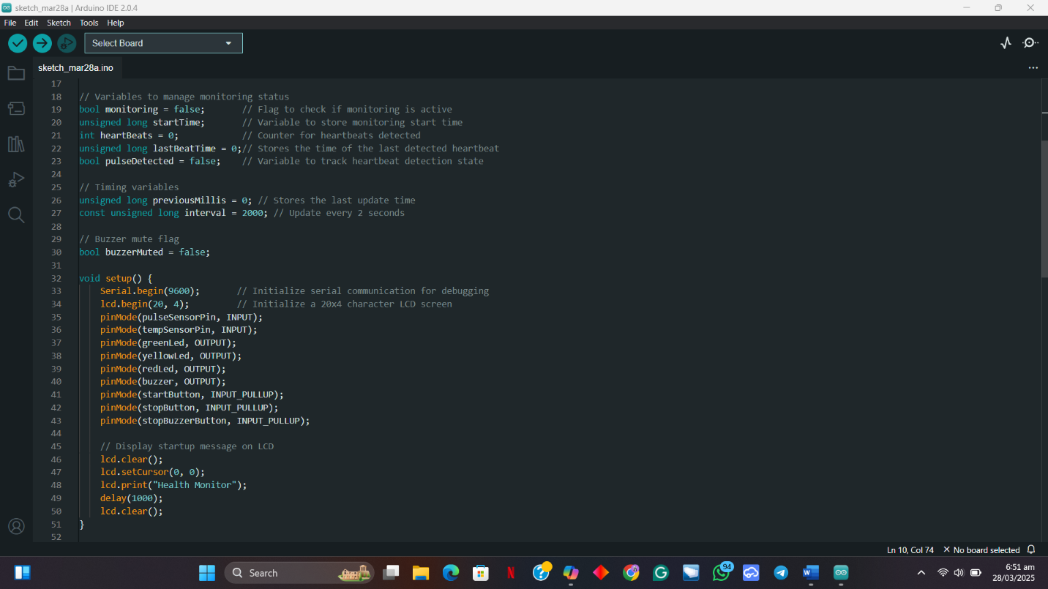

Set up function for Initializing LCD and setting the pin modes for the sensors (pulse sensor and LM35 temperature sensor), LEDs and Buzzer. It also displays start up message on LCD.

5.

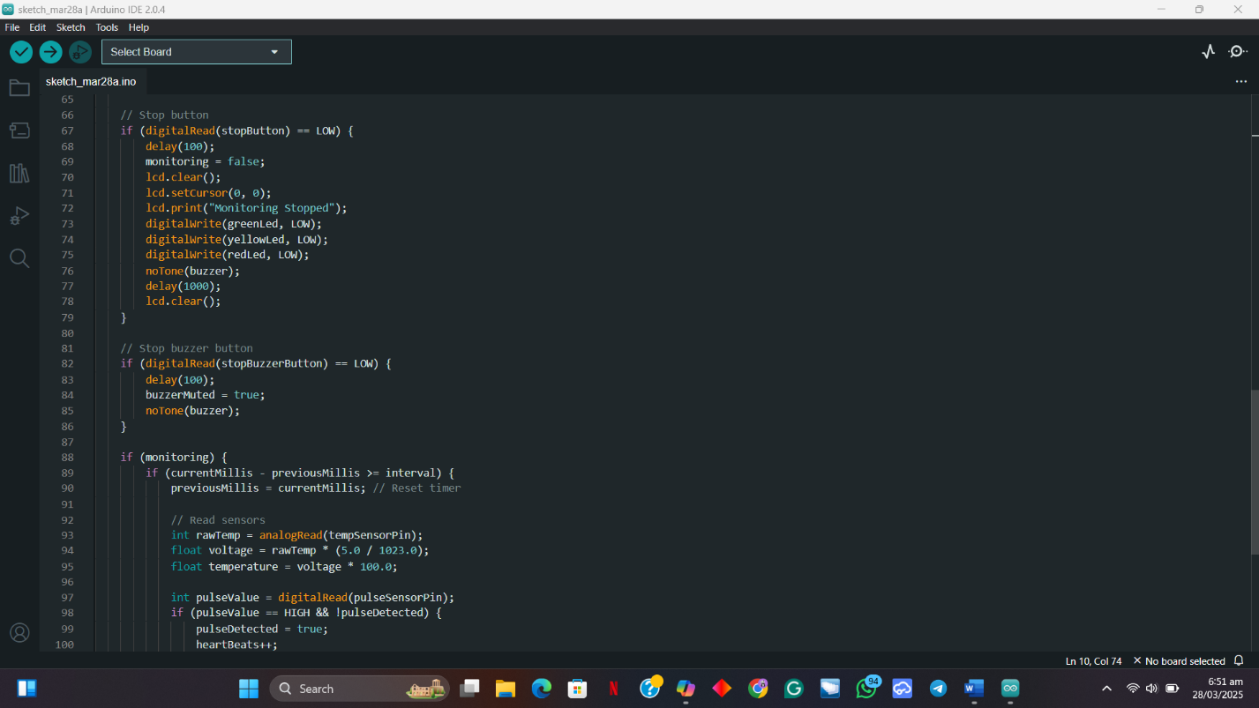

This loop checks for start button, stop button or buzzer button press and executes the instruction assigned to the button pressed. When the **stop button** is pressed, monitoring stops, LEDs and the buzzer are turned off and a message is displayed on the LCD to confirm the system has stopped.

When the Start button is pressed,

When the **stop buzzer button** is pressed, the buzzer is muted.

6. 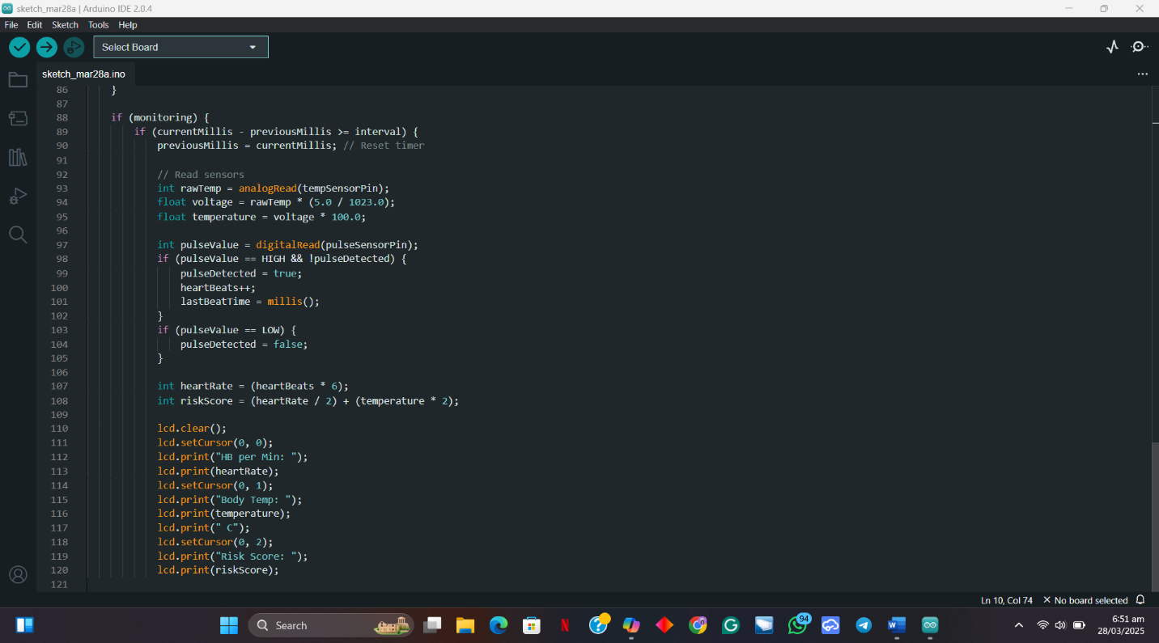

Reads Pulse and temperature sensors and calculates risk score.

* **Temperature Sensor**: Reads an analog value from the LM35 sensor, converts it to voltage, and then calculates the temperature in Celsius.
* **Heartbeat Detection**: Detects pulses from the heartbeat sensor, increments the heartbeat counter.
* **Heartrate Rate**: Calculates the beats per minute.
* **Risk Score**: Calculates risk score based on the heart rate and body temperature.

7.

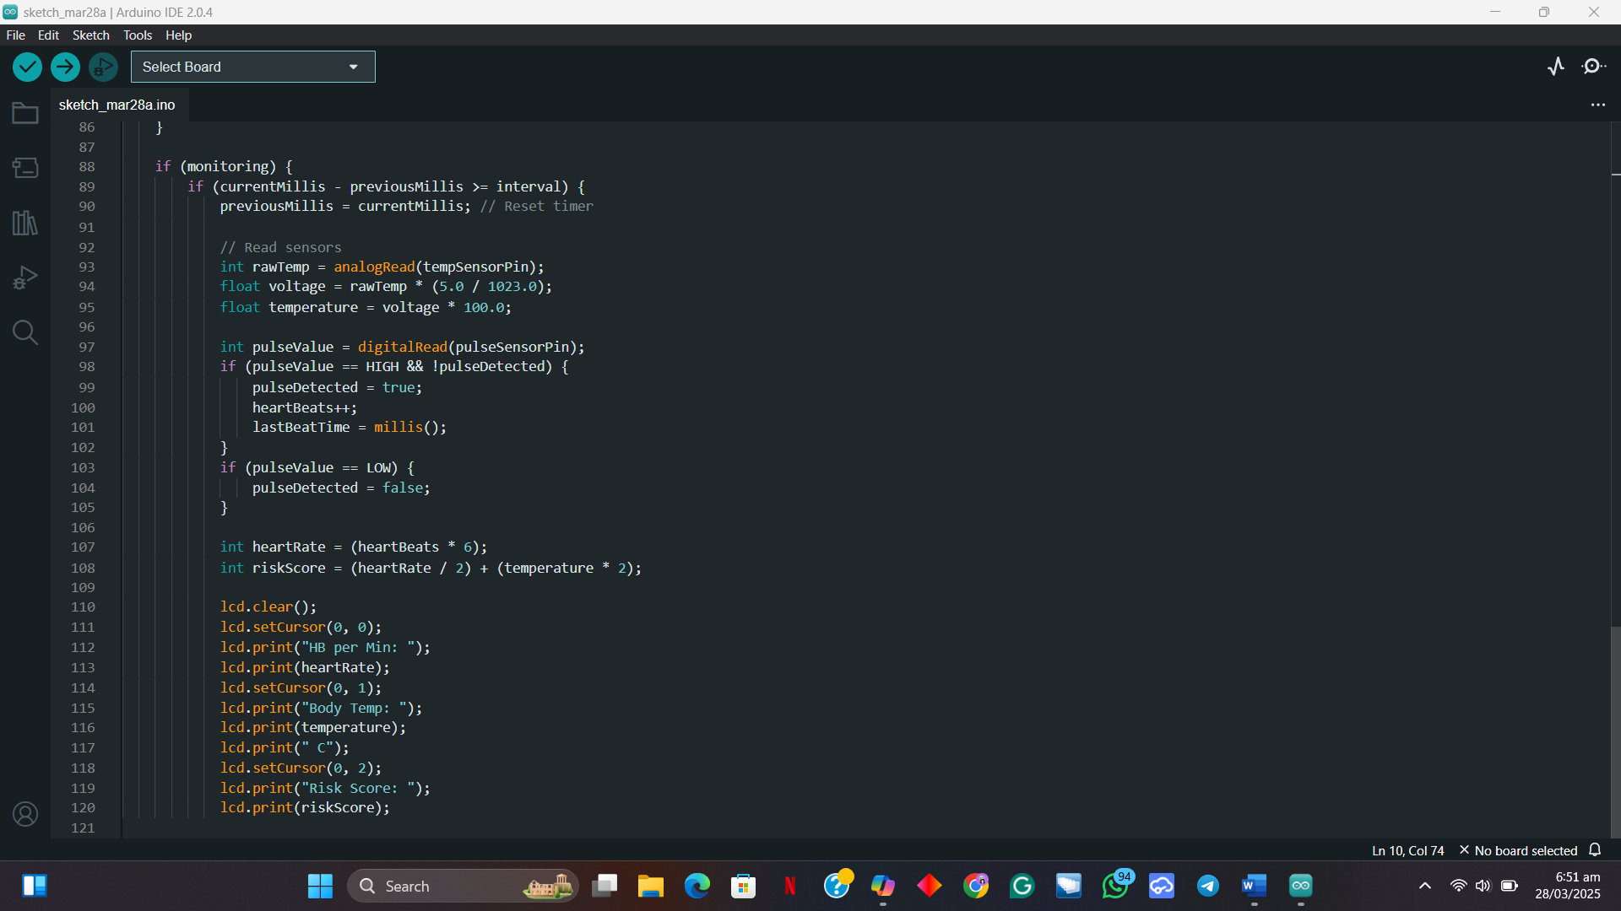

Produces real-time display of heartrate, Temperature and Risk score on the LCD screen.

## 

## 

## **4.CONCLUSION**

The Smart Health Monitoring System with Dynamic Risk Assessment successfully demonstrates the potential of real-time health monitoring using microprocessor-based simulations. By integrating heart rate and temperature sensors with an Arduino-based system, the project provides a simulated approach to early detection of abnormal health conditions.

Although the project was entirely software-based, using Proteus for circuit simulation, it effectively validated the system’s functionality. The transition from EasyEDA to Proteus presented challenges but ultimately led to a more reliable simulation environment. Despite the limitations of software-based testing, the project showcases a viable framework that could be further developed with hardware implementation in the future.

This work highlights the importance of accessible health monitoring solutions, which could be integrated into telemedicine systems to improve healthcare accessibility. Future improvements could include adding wireless communication for remote monitoring and enhancing the system’s accuracy through further calibration.

## **4.1Advantages of the Health Monitoring System**

* Real-Time Monitoring – Provides instant feedback on heart rate and body temperature, allowing for timely intervention.
* Early Risk Detection – The dynamic risk assessment feature alerts users to potential health issues through LED indicators and a buzzer.
* User-Friendly Interface – The system’s display and visual alerts make it easy to understand, even for non-technical users.
* Cost-Effective Solution – Since it relies on readily available microcontrollers and sensors, it is a low-cost alternative to expensive medical monitoring devices.
* Scalability & Integration – Can be further developed to include additional health parameters, wireless transmission, or integration with telemedicine applications.
* Simulation-Based Validation – The use of Proteus allowed for thorough testing without needing physical hardware, saving resources while ensuring functionality.